Mineral Titles Act 2010
NOTICE OF LAND CEASING TO BE A MINERAL TITLE AREA
Title Type and Number: | Exploration Licence 32436
Area Ceased on: | 22 July 2026
Area: | 13 Blocks, 20.75 km²
Locality: | McKINLAY RIVER
Name of Applicant(s)/Holder(s): | 50% KARIOTIS Stefanos, 50% KARIOTIS John
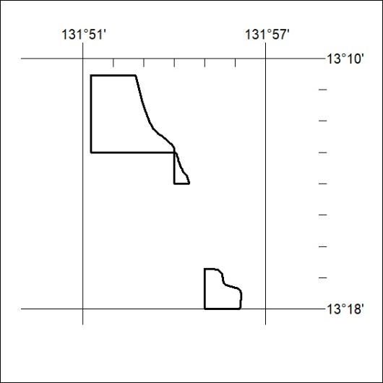

217/26

Mineral Titles Act
NOTICE OF GRANT OF A MINERAL TITLE
Title Type and Number: | Exploration Licence 33428
Granted: | 21 July 2026, for a period of 6 Years
Area: | 133 Blocks, 419.68 km²
Locality: | NEWRY
Name of Holder/s: | 100% ROSEWOOD MINERALS PTY LTD [ACN. 653 271 179]
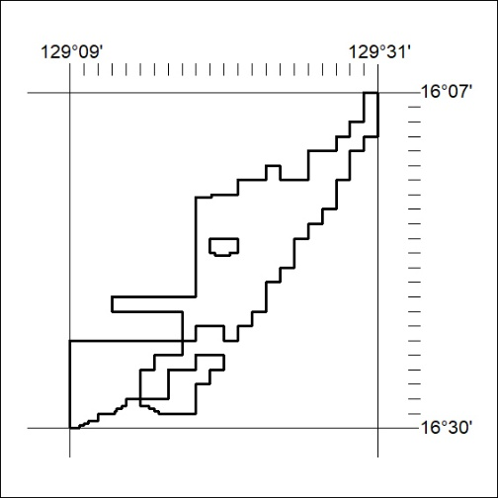
Area granted is indicated above. The titleholder is not permitted to exercise occupational rights on any land that is subject to a development title, or an application for a development title. Any land the subject of a Reserved Land gazettal under the Mineral Titles Act and all land vested in the Commonwealth of Australia is also excluded by description but not excised from the grant area.

218/26

Mineral Titles Act
NOTICE OF GRANT OF A MINERAL TITLE
Title Type and Number: | Exploration Licence 33430
Granted: | 21 July 2026, for a period of 6 Years
Area: | 59 Blocks, 194.70 km²
Locality: | NEWRY
Name of Holder/s: | 100% ROSEWOOD MINERALS PTY LTD [ACN. 653 271 179]
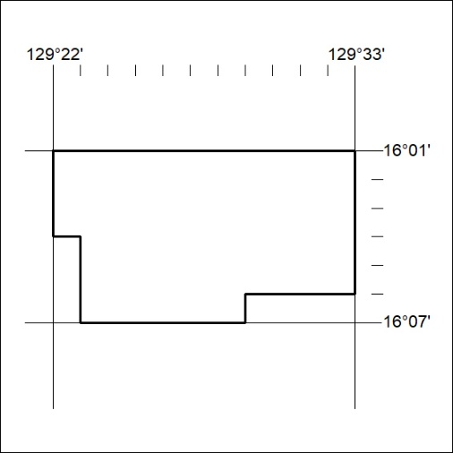
Area granted is indicated above. The titleholder is not permitted to exercise occupational rights on any land that is subject to a development title, or an application for a development title. Any land the subject of a Reserved Land gazettal under the Mineral Titles Act and all land vested in the Commonwealth of Australia is also excluded by description but not excised from the grant area.

219/26

Mineral Titles Act
NOTICE OF GRANT OF A MINERAL TITLE
Title Type and Number: | Exploration Licence 33852
Granted: | 21 July 2026, for a period of 6 Years
Area: | 66 Blocks, 217.65 km²
Locality: | KILDURK
Name of Holder/s: | 100% ROSEWOOD MINERALS PTY LTD [ACN. 653 271 179]
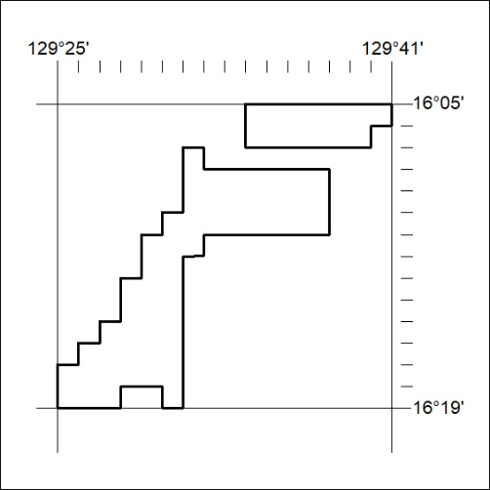
Area granted is indicated above. The titleholder is not permitted to exercise occupational rights on any land that is subject to a development title, or an application for a development title. Any land the subject of a Reserved Land gazettal under the Mineral Titles Act and all land vested in the Commonwealth of Australia is also excluded by description but not excised from the grant area.

220/26

Mineral Titles Act
NOTICE OF GRANT OF A MINERAL TITLE
Title Type and Number: | Exploration Licence 33993
Granted: | 21 July 2026, for a period of 6 Years
Area: | 82 Blocks, 270.16 km²
Locality: | NEWRY
Name of Holder/s: | 100% ROSEWOOD MINERALS PTY LTD [ACN. 653 271 179]
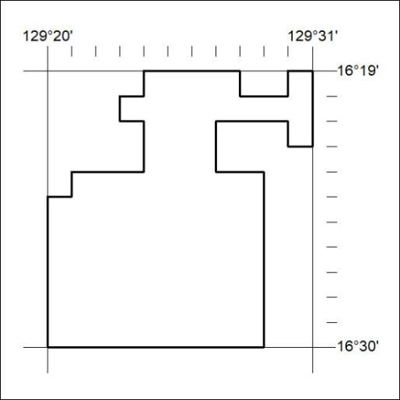
Area granted is indicated above. The titleholder is not permitted to exercise occupational rights on any land that is subject to a development title, or an application for a development title. Any land the subject of a Reserved Land gazettal under the Mineral Titles Act and all land vested in the Commonwealth of Australia is also excluded by description but not excised from the grant area.

221/26

Mineral Titles Act
NOTICE OF GRANT OF A MINERAL TITLE
Title Type and Number: | Exploration Licence 34122
Granted: | 20 July 2026, for a period of 6 Years
Area: | 26 Blocks, 82.71 km²
Locality: | VAUGHAN
Name of Holder/s: | 100% GSW RESOURCES PTY LTD [ACN. 653 791 130]
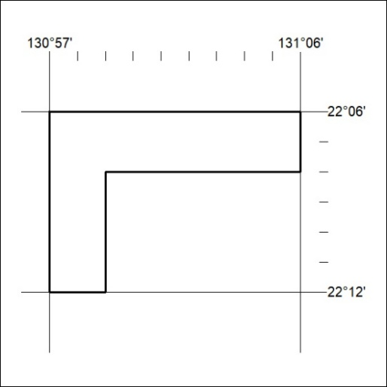
Area granted is indicated above. The titleholder is not permitted to exercise occupational rights on any land that is subject to a development title, or an application for a development title. Any land the subject of a Reserved Land gazettal under the Mineral Titles Act and all land vested in the Commonwealth of Australia is also excluded by description but not excised from the grant area.

222/26

Mineral Titles Act
NOTICE OF GRANT OF A MINERAL TITLE
Title Type and Number: | Exploration Licence 34243
Granted: | 22 July 2026, for a period of 6 Years
Area: | 221 Blocks, 716.03 km²
Locality: | ALEXANDRIA
Name of Holder/s: | 100% BREMA RESOURCES PTY LTD [ACN. 643 480 693]
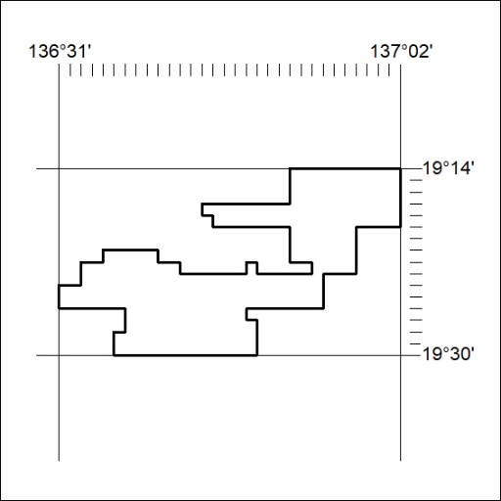
Area granted is indicated above. The titleholder is not permitted to exercise occupational rights on any land that is subject to a development title, or an application for a development title. Any land the subject of a Reserved Land gazettal under the Mineral Titles Act and all land vested in the Commonwealth of Australia is also excluded by description but not excised from the grant area.

223/26

