Mineral Titles Act 2010
NOTICE OF LAND CEASING TO BE A MINERAL TITLE APPLICATION AREA
Title Type and Number: | Exploration Licence 30194
Area Ceased on: | 27 July 2026
Area: | 70 Blocks, 218.00 km²
Locality: | WINNALL RIDGE
Name of Applicant(s)/Holder(s): | 100% TERRITORY POTASH PTY LTD* [ACN. 116 070 207]
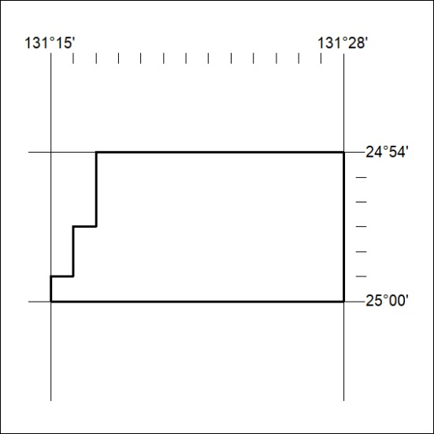

200/26

Mineral Titles Act 2010
NOTICE OF LAND CEASING TO BE A MINERAL TITLE APPLICATION AREA
Title Type and Number: | Exploration Licence 30195
Area Ceased on: | 27 July 2026
Area: | 200 Blocks, 622.88 km²
Locality: | WINNALL RIDGE
Name of Applicant(s)/Holder(s): | 100% TERRITORY POTASH PTY LTD* [ACN. 116 070 207]
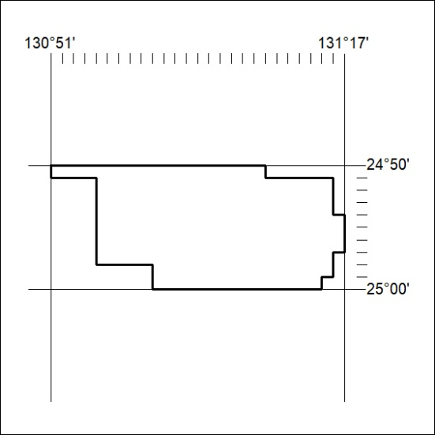

201/26

Mineral Titles Act 2010
NOTICE OF LAND CEASING TO BE A MINERAL TITLE APPLICATION AREA
Title Type and Number: | Exploration Licence 30196
Area Ceased on: | 27 July 2026
Area: | 143 Blocks, 446.18 km²
Locality: | AMADEUS
Name of Applicant(s)/Holder(s): | 100% TERRITORY POTASH PTY LTD* [ACN. 116 070 207]
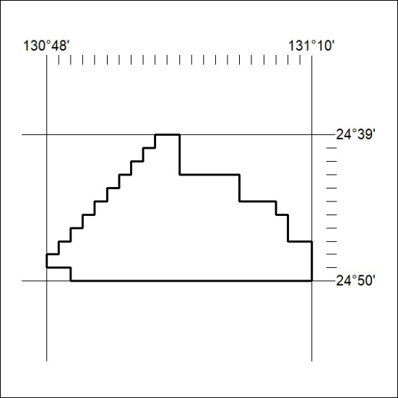

202/26

Mineral Titles Act 2010
NOTICE OF LAND CEASING TO BE A MINERAL TITLE APPLICATION AREA
Title Type and Number: | Exploration Licence 30197
Area Ceased on: | 27 July 2026
Area: | 203 Blocks, 633.44 km²
Locality: | AMADEUS
Name of Applicant(s)/Holder(s): | 100% TERRITORY POTASH PTY LTD* [ACN. 116 070 207]
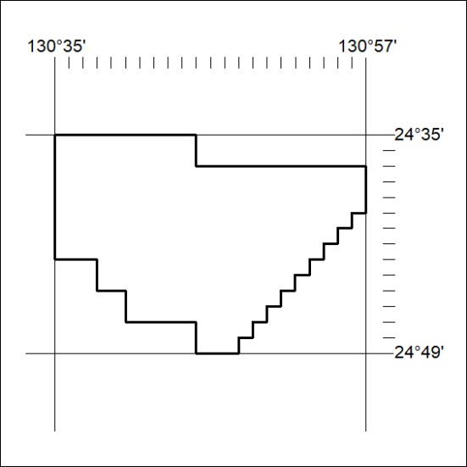

203/26

Mineral Titles Act 2010
NOTICE OF LAND CEASING TO BE A MINERAL TITLE APPLICATION AREA
Title Type and Number: | Exploration Licence 30389
Area Ceased on: | 27 July 2026
Area: | 186 Blocks, 527.56 km²
Locality: | ININDIA
Name of Applicant(s)/Holder(s): | 100% TERRITORY POTASH PTY LTD* [ACN. 116 070 207]
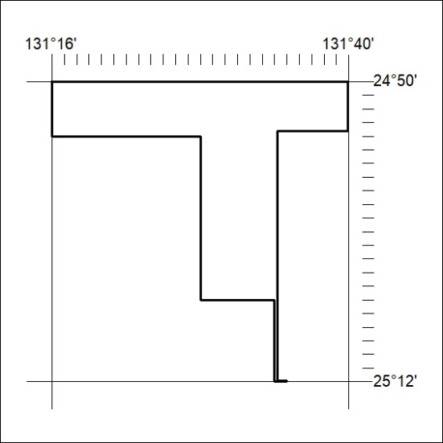

204/26

Mineral Titles Act 2010
NOTICE OF LAND CEASING TO BE A MINERAL TITLE APPLICATION AREA
Title Type and Number: | Exploration Licence 30650
Area Ceased on: | 27 July 2026
Area: | 61 Blocks, 190.51 km²
Locality: | IMBUMBUNNA
Name of Applicant(s)/Holder(s): | 100% TERRITORY POTASH PTY LTD* [ACN. 116 070 207]
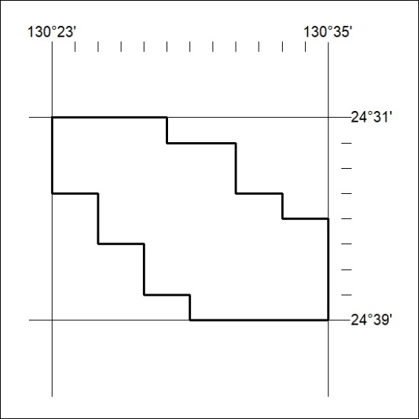

205/26

Mineral Titles Act 2010
NOTICE OF LAND CEASING TO BE A MINERAL TITLE APPLICATION AREA
Title Type and Number: | Exploration Licence 34094
Area Ceased on: | 27 July 2026
Area: | 250 Blocks, 801.17 km²
Locality: | STYLES
Name of Applicant(s)/Holder(s): | 100% RIO TINTO EXPLORATION PTY LIMITED [ACN. 000 057 125]
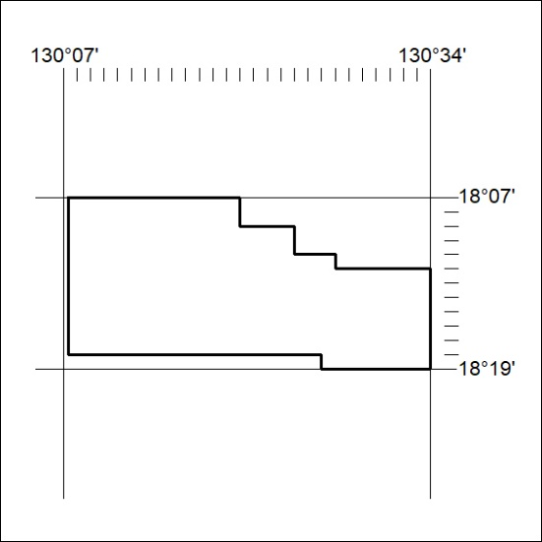

206/26

Mineral Titles Act 2010
NOTICE OF LAND CEASING TO BE A MINERAL TITLE APPLICATION AREA
Title Type and Number: | Exploration Licence 34095
Area Ceased on: | 27 July 2026
Area: | 90 Blocks, 293.48 km²
Locality: | STYLES
Name of Applicant(s)/Holder(s): | 100% RIO TINTO EXPLORATION PTY LIMITED [ACN. 000 057 125]
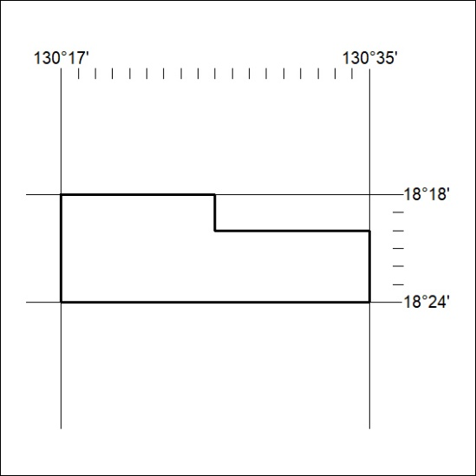

207/26

Mineral Titles Act 2010
NOTICE OF LAND CEASING TO BE A MINERAL TITLE APPLICATION AREA
Title Type and Number: | Exploration Licence 34096
Area Ceased on: | 27 July 2026
Area: | 172 Blocks, 547.93 km²
Locality: | STYLES
Name of Applicant(s)/Holder(s): | 100% RIO TINTO EXPLORATION PTY LIMITED [ACN. 000 057 125]
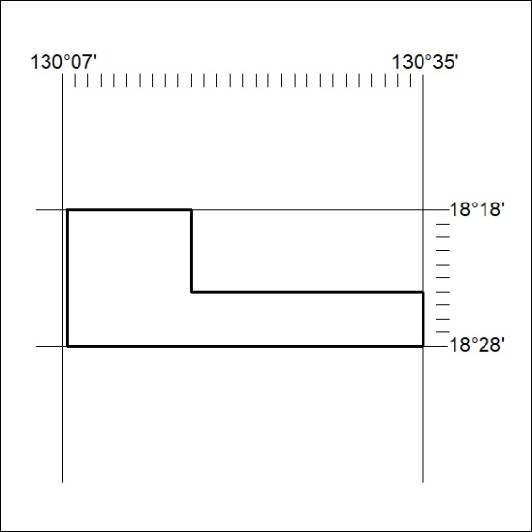

208/26

Mineral Titles Act 2010
NOTICE OF LAND CEASING TO BE A MINERAL TITLE APPLICATION AREA
Title Type and Number: | Exploration Licence 34097
Area Ceased on: | 27 July 2026
Area: | 224 Blocks, 718.93 km²
Locality: | MOUNT WINNECKE
Name of Applicant(s)/Holder(s): | 100% RIO TINTO EXPLORATION PTY LIMITED [ACN. 000 057 125]
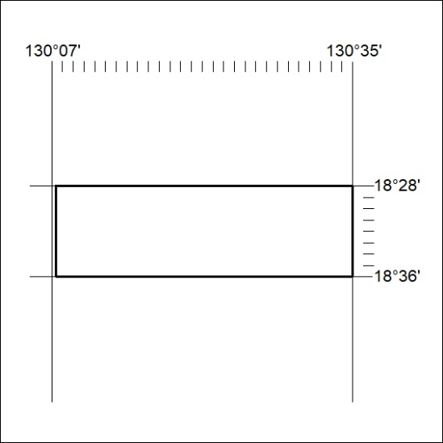

209/26

Mineral Titles Act 2010
NOTICE OF LAND CEASING TO BE A MINERAL TITLE APPLICATION AREA
Title Type and Number: | Exploration Licence 34098
Area Ceased on: | 27 July 2026
Area: | 224 Blocks, 722.33 km²
Locality: | MOUNT WINNECKE
Name of Applicant(s)/Holder(s): | 100% RIO TINTO EXPLORATION PTY LIMITED [ACN. 000 057 125]
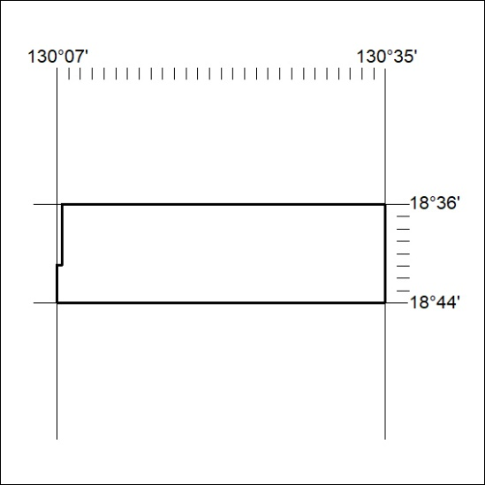

210/26

Mineral Titles Act 2010
NOTICE OF LAND CEASING TO BE A MINERAL TITLE APPLICATION AREA
Title Type and Number: | Exploration Licence 34099
Area Ceased on: | 27 July 2026
Area: | 224 Blocks, 728.29 km²
Locality: | MOUNT WINNECKE
Name of Applicant(s)/Holder(s): | 100% RIO TINTO EXPLORATION PTY LIMITED [ACN. 000 057 125]
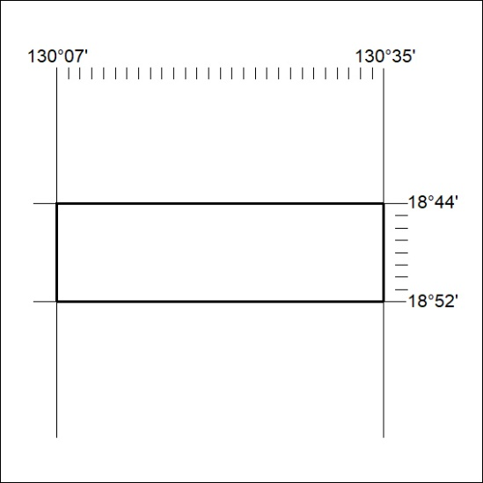

211/26

Mineral Titles Act 2010
NOTICE OF LAND CEASING TO BE A MINERAL TITLE APPLICATION AREA
Title Type and Number: | Exploration Licence 34100
Area Ceased on: | 27 July 2026
Area: | 234 Blocks, 760.02 km²
Locality: | MOUNT WINNECKE
Name of Applicant(s)/Holder(s): | 100% RIO TINTO EXPLORATION PTY LIMITED [ACN. 000 057 125]
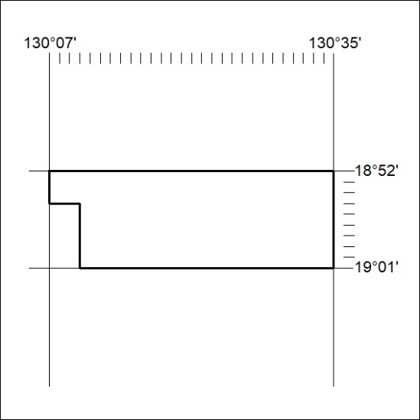

212/26

Mineral Titles Act 2010
NOTICE OF LAND CEASING TO BE A MINERAL TITLE APPLICATION AREA
Title Type and Number: | Exploration Licence 34101
Area Ceased on: | 27 July 2026
Area: | 250 Blocks, 811.37 km²
Locality: | WILSON CREEK
Name of Applicant(s)/Holder(s): | 100% RIO TINTO EXPLORATION PTY LIMITED [ACN. 000 057 125]
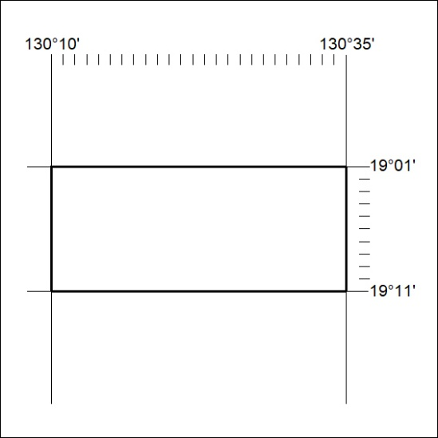

213/26

Mineral Titles Act 2010
NOTICE OF LAND CEASING TO BE A MINERAL TITLE APPLICATION AREA
Title Type and Number: | Exploration Licence 34102
Area Ceased on: | 27 July 2026
Area: | 250 Blocks, 810.55 km²
Locality: | WILSON CREEK
Name of Applicant(s)/Holder(s): | 100% RIO TINTO EXPLORATION PTY LIMITED [ACN. 000 057 125]
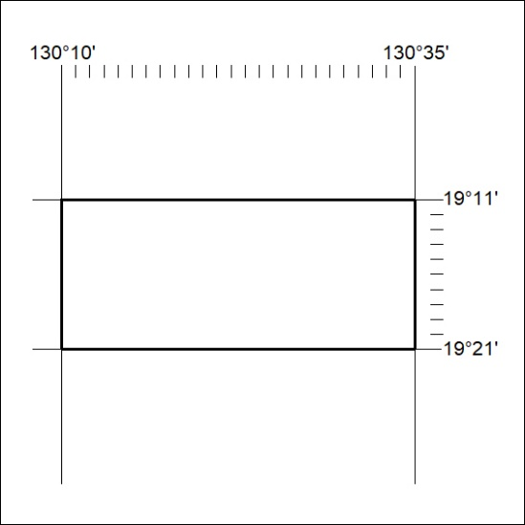

214/26

Mineral Titles Act 2010
NOTICE OF LAND CEASING TO BE A MINERAL TITLE APPLICATION AREA
Title Type and Number: | Exploration Licence 34103
Area Ceased on: | 27 July 2026
Area: | 228 Blocks, 716.35 km²
Locality: | WILSON CREEK
Name of Applicant(s)/Holder(s): | 100% RIO TINTO EXPLORATION PTY LIMITED [ACN. 000 057 125]
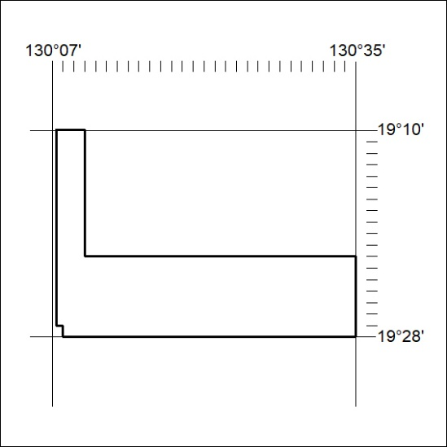

215/26

Mineral Titles Act
NOTICE OF GRANT OF A MINERAL TITLE
Title Type and Number: | Exploration Licence 34196
Granted: | 21 July 2026, for a period of 6 Years
Area: | 68 Blocks, 221.73 km²
Locality: | BOXER
Name of Holder/s: | 100% INDAMINE EXPLORATION PTY LTD [ACN. 690 408 210]
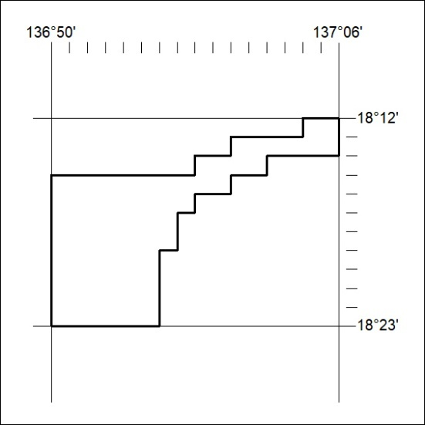
Area granted is indicated above. The titleholder is not permitted to exercise occupational rights on any land that is subject to a development title, or an application for a development title. Any land the subject of a Reserved Land gazettal under the Mineral Titles Act and all land vested in the Commonwealth of Australia is also excluded by description but not excised from the grant area.

216/26

