Guidance Note No: 31/97 Revision No: 1
This Guidance Notice only applies to vessels that were operating commercially on 30 June 2013

Navigation and fishing lights for small commercial fishing vessels
The International Regulations for Preventing Collisions at Sea 1972 contains regulatory details for lights, shapes and the conduct of vessels of all types internationally. These Regulations are contained in Section 16 of the Uniform Shipping Laws (USL) Code and are called up as the Marine (Prevention of Collision) Regulations in the Northern Territory’s legislation.
In order to clarify the lights required for commercial fishing vessels specifically, this Guidance Note illustrates the position and type specification of navigation and fishing lights for smaller sizes of vessels, namely:
- Fishing Vessels LESS than 7 metres in length.
- Seagoing Fishing Vessels of between 7 and 12 metres in length.
- Seagoing Fishing Vessels of between 12 and 20 metres in length.
- Seagoing Fishing Vessels of between 20 and 50 metres in length.
Specifications and positioning details are attached for NOT UNDER COMMAND and FISHING day shapes and lights as applicable to the types of vessel noted [a] to [d] above.
Should any difficulty be experienced in the positioning of lights in compliance with the foregoing guidelines, the Marine Adviser (Nautical) and Surveyors of Marine Safety Branch are available to assist owners in interpreting the requirements of the Regulations.
Nothing in this Guidance Note should be considered in any way to amend or override the contents or interpretation of the International Regulations for Preventing Collisions at Sea.

Navigation and fishing lights – Small fishing vessels under 7m
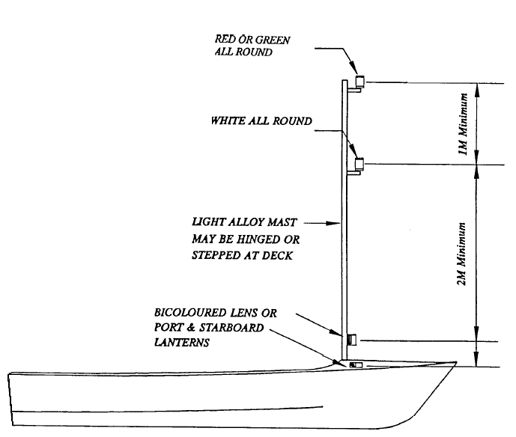Daylight Fishing Signal is either one basket or 2 cones as per 12-20m fishing vessels. See Table for more information.

Navigation and fishing lights for seagoing fishing vessels less than 12m
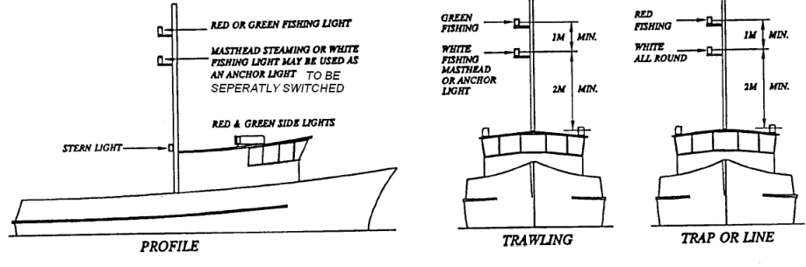
Daylight Fishing Signal is either one basket or 2 cones as per 12-20m fishing vessels. See Table for more information.

Navigation and fishing lights & Day shapes for seagoing fishing vessels 12-20m
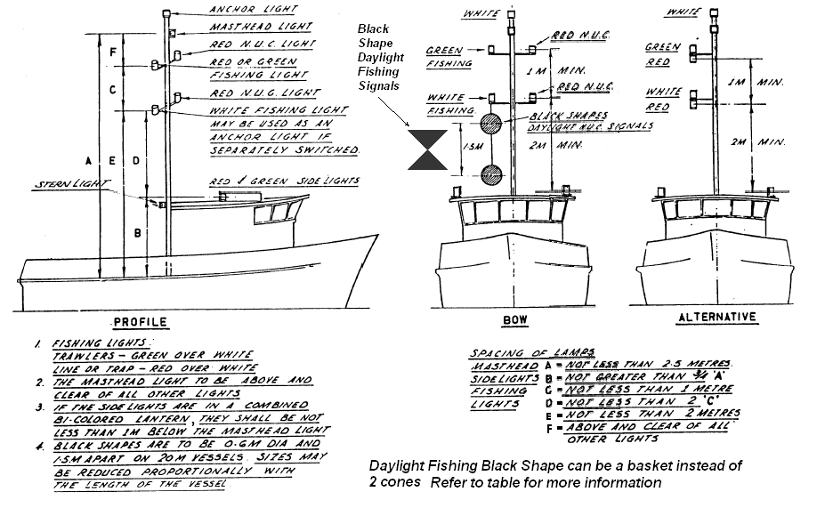

Navigation and fishing lights & Day shapes for seagoing fishing vessels 20-50m
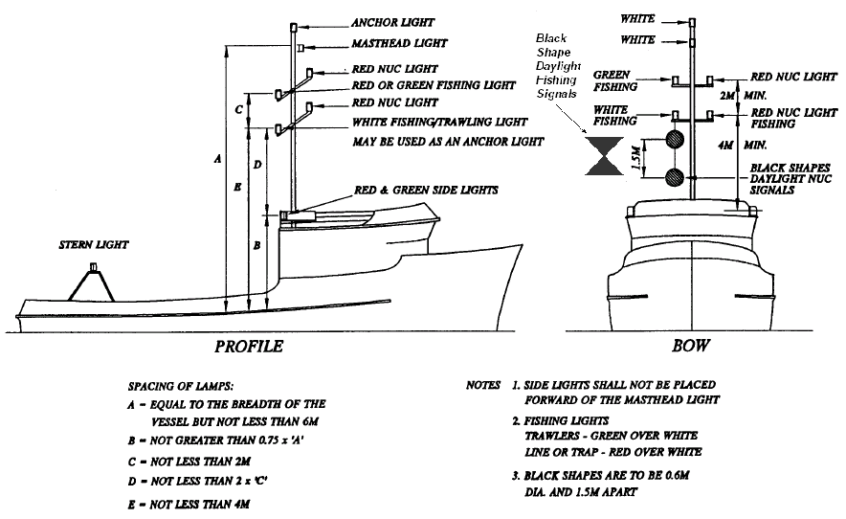

Table for daylight NUC signals & Daylight fishing signals
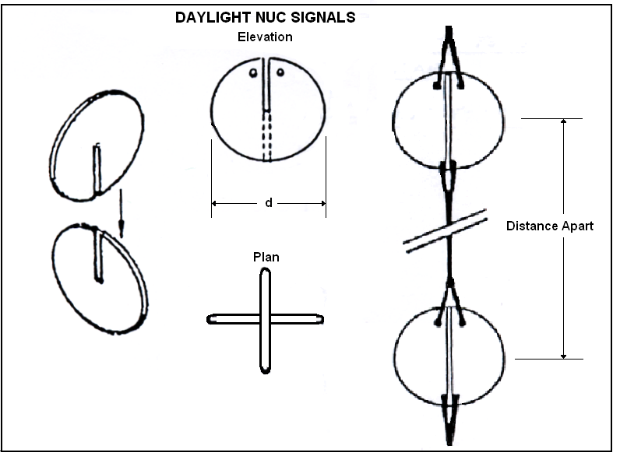
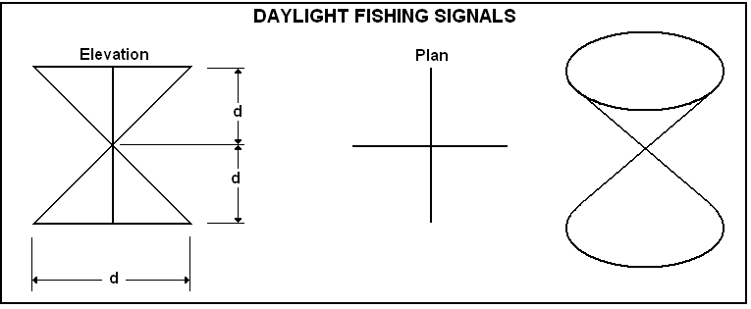
Length of Vessels (metres) | Diameter (d) mm | Distance Apart  mm
12.00 | 360 | 900
13.00 | 390 | 975
14.00 | 420 | 1050
15.00 | 450 | 1125
16.00 | 480 | 1200
17.00 | 510 | 1275
18.00 | 540 | 1350
19.00 | 570 | 1425
20.00 | 600 | 1500

NUC lights
Portable lights to be displayed in a vertical line where they can best be seen
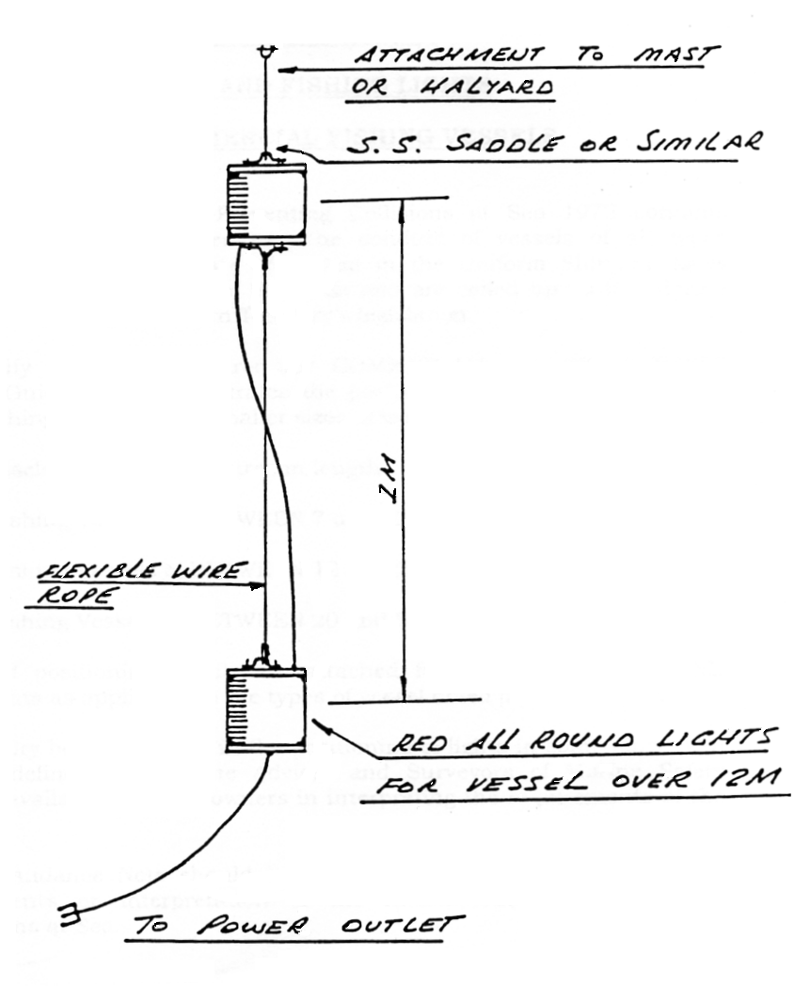

Signed by: Sri Srinivas
Date Issued: 23 March 2009
For further information contact Marine Safety Branch:
2nd Floor, Energy House, 18-20 Cavenagh, Darwin NT 0800, GPO Box 2520, Darwin NT 0801
Telephone: 08 8924 7100, Facsimile: 08 8924 7009
Email: marinesafety@nt.gov.au
Disclaimer: While care is taken to ensure that information contained in NT Government publications is true and correct at the time of the publication, this information is provided on the basis that users undertake responsibility for assessing the relevance, accuracy and currency of its content. The Northern Territory of Australia gives no warranty or assurance and makes no representation, express or implied, as to the accuracy of this information or that it is suitable for your intended use. To the maximum extent permitted by law, each user waives and releases the Territory from any and all claims relating to the use of this information and in no event shall the Territory of Australia be liable for loss or damage arising directly or indirectly from the use of or reliance on it for whatever purpose.

