Mineral Titles Act 2010
NOTICE OF LAND CEASING TO BE A MINERAL TITLE AREA
Title Type and Number: | Exploration Licence 33189
Area Ceased on: | 25 May 2026
Area: | 12 Blocks, 40.03 km²
Locality: | PINE CREEK
Name of Applicant(s)/Holder(s): | 100% MANGUSTA MINERALS PTY LTD [ACN. 653 950 522]
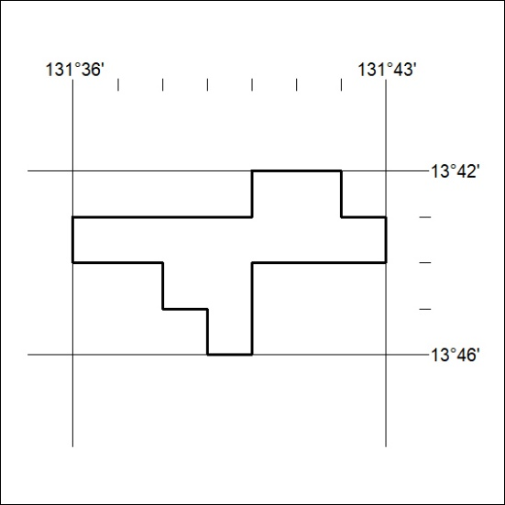

156/26

Mineral Titles Act 2010
NOTICE OF LAND CEASING TO BE A MINERAL TITLE AREA
Title Type and Number: | Extractive Mineral Exploration Licence 33700
Area Ceased on: | 23 May 2026
Area: | 4 Blocks, 13.16 km²
Locality: | DUNMARRA
Name of Applicant(s)/Holder(s): | 100% TAMBORAN INFRASTRUCTURE PTY LTD [ACN. 163 215 156]
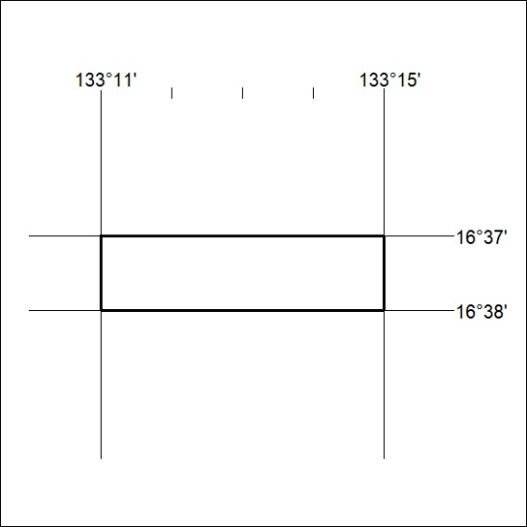

157/26

Mineral Titles Act 2010
NOTICE OF LAND CEASING TO BE A MINERAL TITLE AREA
Title Type and Number: | Extractive Mineral Exploration Licence 33701
Area Ceased on: | 23 May 2026
Area: | 4 Blocks, 13.16 km²
Locality: | DUNMARRA
Name of Applicant(s)/Holder(s): | 100% TAMBORAN INFRASTRUCTURE PTY LTD [ACN. 163 215 156]
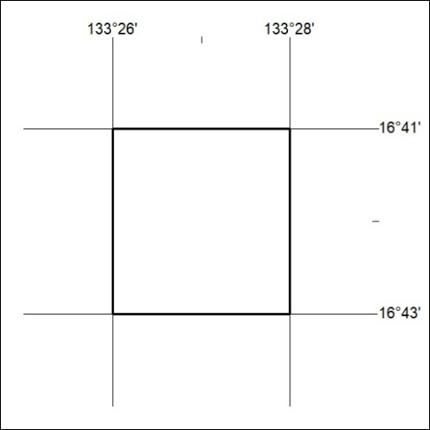

158/26

Mineral Titles Act 2010
NOTICE OF LAND CEASING TO BE A MINERAL TITLE AREA
Title Type and Number: | Extractive Mineral Exploration Licence 33702
Area Ceased on: | 23 May 2026
Area: | 4 Blocks, 13.16 km²
Locality: | WARRAMBAN
Name of Applicant(s)/Holder(s): | 100% TAMBORAN INFRASTRUCTURE PTY LTD [ACN. 163 215 156]
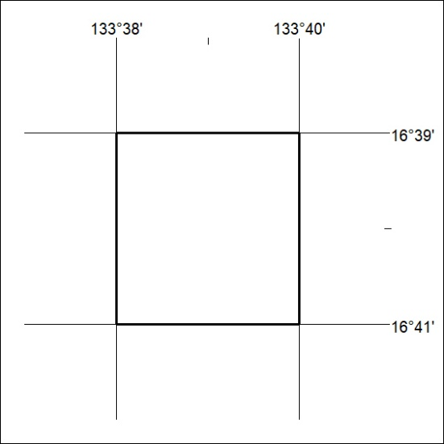

159/26

Mineral Titles Act 2010
NOTICE OF LAND CEASING TO BE A MINERAL TITLE AREA
Title Type and Number: | Extractive Mineral Exploration Licence 33703
Area Ceased on: | 23 May 2026
Area: | 4 Blocks, 13.16 km²
Locality: | WARRAMBAN
Name of Applicant(s)/Holder(s): | 100% TAMBORAN INFRASTRUCTURE PTY LTD [ACN. 163 215 156]
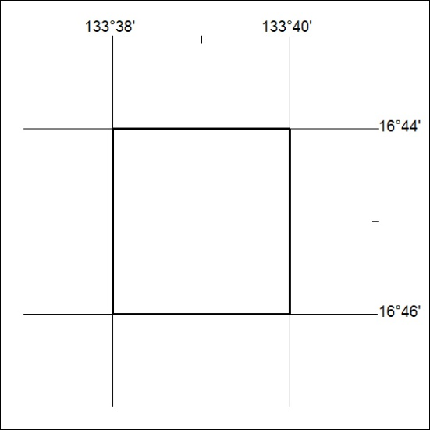

160/26

Mineral Titles Act 2010
NOTICE OF LAND CEASING TO BE A MINERAL TITLE AREA
Title Type and Number: | Extractive Mineral Exploration Licence 33704
Area Ceased on: | 23 May 2026
Area: | 4 Blocks, 13.15 km²
Locality: | WARRAMBAN
Name of Applicant(s)/Holder(s): | 100% TAMBORAN INFRASTRUCTURE PTY LTD [ACN. 163 215 156]
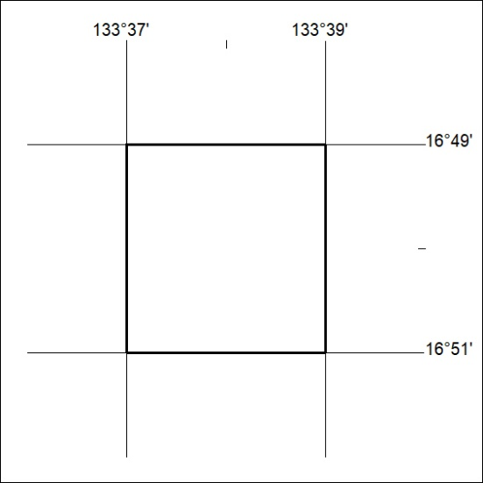

161/26

Mineral Titles Act 2010
NOTICE OF LAND CEASING TO BE A MINERAL TITLE AREA
Title Type and Number: | Extractive Mineral Exploration Licence 33705
Area Ceased on: | 23 May 2026
Area: | 4 Blocks, 13.15 km²
Locality: | DUNMARRA
Name of Applicant(s)/Holder(s): | 100% TAMBORAN INFRASTRUCTURE PTY LTD [ACN. 163 215 156]
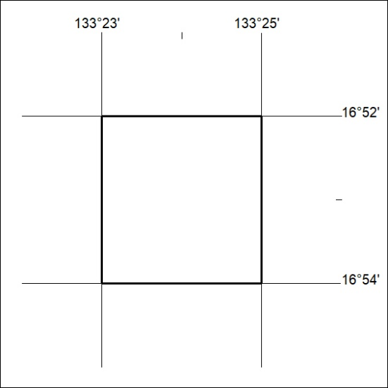

162/26

Mineral Titles Act 2010
NOTICE OF LAND CEASING TO BE A MINERAL TITLE AREA
Title Type and Number: | Extractive Mineral Exploration Licence 33706
Area Ceased on: | 23 May 2026
Area: | 4 Blocks, 13.15 km²
Locality: | DUNMARRA
Name of Applicant(s)/Holder(s): | 100% TAMBORAN INFRASTRUCTURE PTY LTD [ACN. 163 215 156]
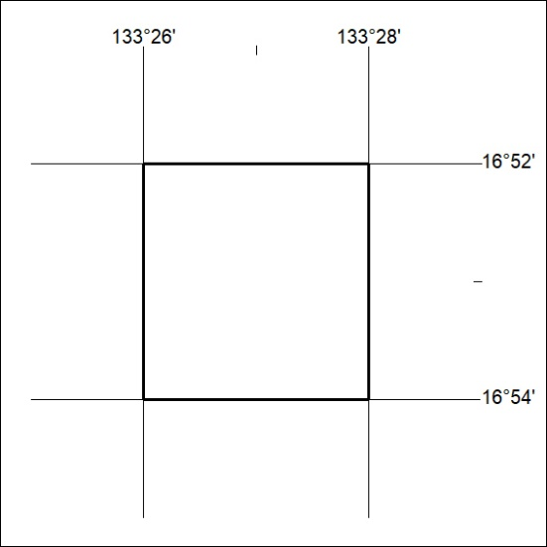

163/26

Mineral Titles Act 2010
NOTICE OF LAND CEASING TO BE A MINERAL TITLE AREA
Title Type and Number: | Extractive Mineral Exploration Licence 33707
Area Ceased on: | 23 May 2026
Area: | 4 Blocks, 13.15 km²
Locality: | WARRAMBAN
Name of Applicant(s)/Holder(s): | 100% TAMBORAN INFRASTRUCTURE PTY LTD [ACN. 163 215 156]
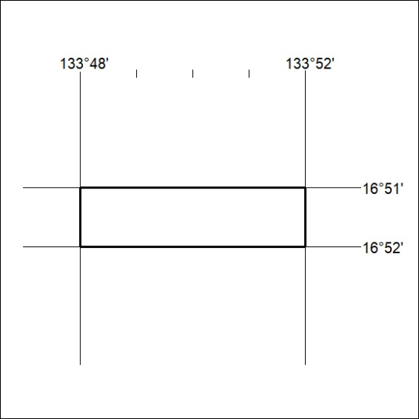

164/26

Mineral Titles Act 2010
NOTICE OF LAND CEASING TO BE A MINERAL TITLE AREA
Title Type and Number: | Extractive Mineral Exploration Licence 33708
Area Ceased on: | 23 May 2026
Area: | 4 Blocks, 13.15 km²
Locality: | WARRAMBAN
Name of Applicant(s)/Holder(s): | 100% TAMBORAN INFRASTRUCTURE PTY LTD [ACN. 163 215 156]
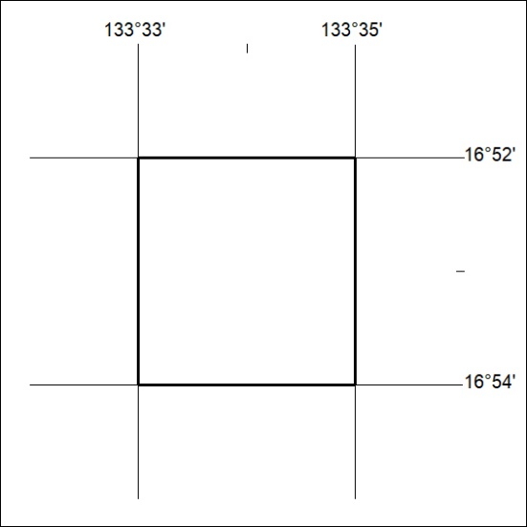

165/26

Mineral Titles Act 2010
NOTICE OF LAND CEASING TO BE A MINERAL TITLE AREA
Title Type and Number: | Extractive Mineral Exploration Licence 33709
Area Ceased on: | 23 May 2026
Area: | 4 Blocks, 13.14 km²
Locality: | NEWCASTLE WATERS
Name of Applicant(s)/Holder(s): | 100% TAMBORAN INFRASTRUCTURE PTY LTD [ACN. 163 215 156]
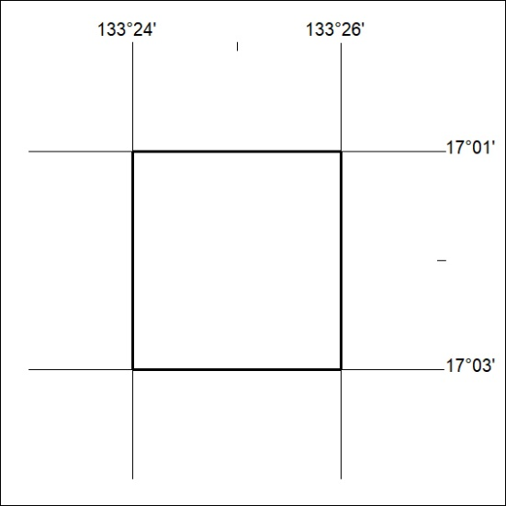

166/26

Mineral Titles Act 2010
NOTICE OF LAND CEASING TO BE A MINERAL TITLE AREA
Title Type and Number: | Extractive Mineral Exploration Licence 33710
Area Ceased on: | 23 May 2026
Area: | 4 Blocks, 13.13 km²
Locality: | NEWCASTLE WATERS
Name of Applicant(s)/Holder(s): | 100% TAMBORAN INFRASTRUCTURE PTY LTD [ACN. 163 215 156]
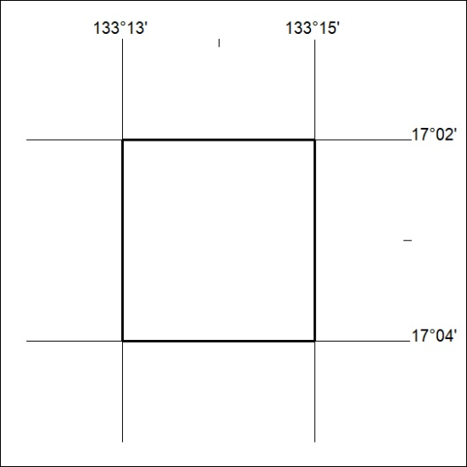

167/26

Mineral Titles Act 2010
NOTICE OF LAND CEASING TO BE A MINERAL TITLE AREA
Title Type and Number: | Extractive Mineral Exploration Licence 33711
Area Ceased on: | 23 May 2026
Area: | 4 Blocks, 13.16 km²
Locality: | DUNMARRA
Name of Applicant(s)/Holder(s): | 100% TAMBORAN INFRASTRUCTURE PTY LTD [ACN. 163 215 156]
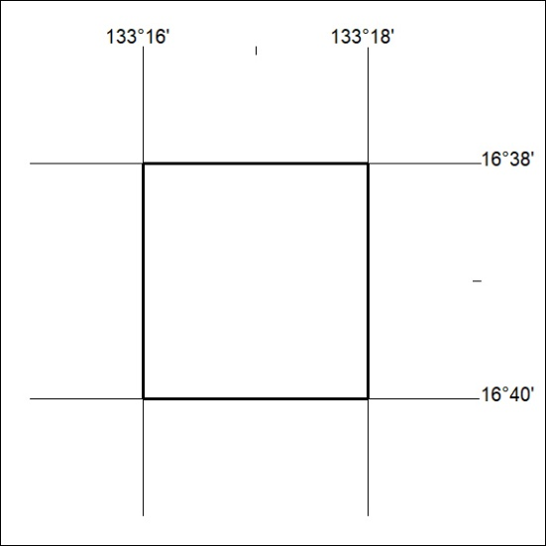

168/26

