Mineral Titles Act
NOTICE OF GRANT OF A MINERAL TITLE
Title Type and Number: | Mineral Lease 29881
Granted: | 24 April 2026, for a period of 17 Years
Area: | 787.40 Hectares
Locality: | BING BONG
Name of Holder/s: | 100% MOUNT ISA MINES LIMITED [ACN. 009 661 447]
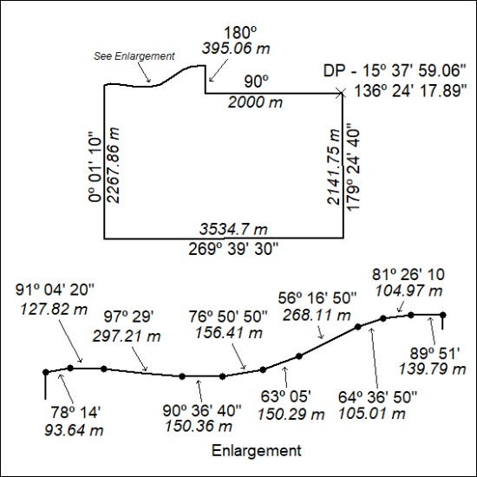

132/26

