Mineral Titles Act 2010
NOTICE OF LAND CEASING TO BE A MINERAL TITLE AREA
Title Type and Number: | Exploration Licence 33467
Area Ceased on: | 11 March 2026
Area: | 20 Blocks, 62.61 km²
Locality: | BLOODWOOD CREEK
Name of Applicant(s)/Holder(s): | 100% GCM COPORATION LIMITED* [ACN. 118 788 846]
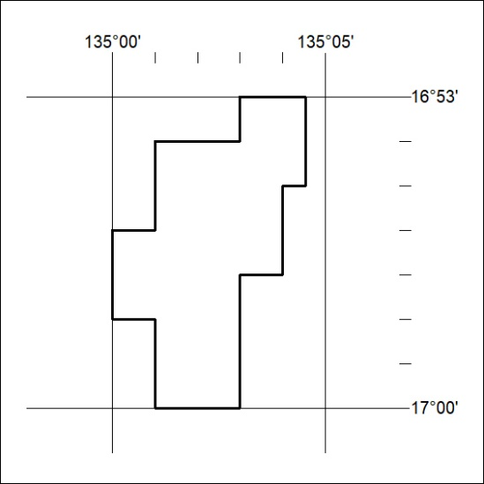

83/26

Mineral Titles Act
NOTICE OF GRANT OF A MINERAL TITLE
Title Type and Number: | Extractive Mineral Permit 34135
Granted: | 11 March 2026, for a period of 5 Years
Area: | 33.38 Hectares
Locality: | BING BONG
Name of Holder/s: | 100% CAIRNS INDUSTRIES PTY LTD [ACN. 120 694 484]
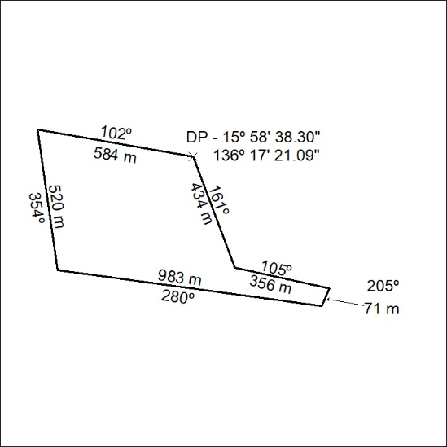

84/26

