Mineral Titles Act 2010
NOTICE OF LAND CEASING TO BE A MINERAL TITLE AREA
Title Type and Number: | Extractive Mineral Permit 25102
Area ceased on: | 18 February 2026
Area: | 36.89 Hectare
Locality: | BYNOE
Name of Applicants(s)Holder(s): | 100% EAST ARM CIVIL PTY LTD [ACN. 073 382 251]
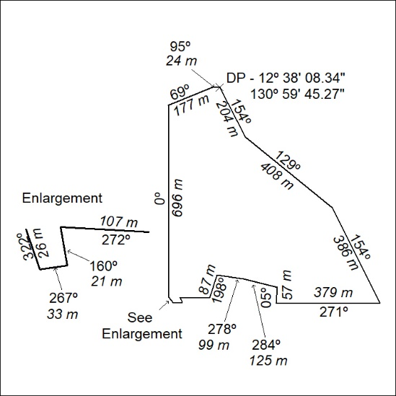

63/26

Mineral Titles Act 2010
NOTICE OF LAND CEASING TO BE A MINERAL TITLE AREA
Title Type and Number: | Exploration Licence 32804
Area Ceased on: | 23 February 2026
Area: | 48 Blocks, 145.81 km²
Locality: | BARROW
Name of Applicant(s)/Holder(s): | 100% GEOSMART CONSULTING PTY LTD [ACN. 603 263 672]
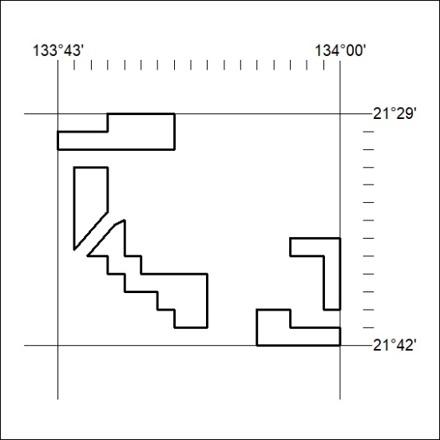

64/26

Corrigendum
Notice Number 59/26 appearing in MN23/26 on 17 February 2026 is hereby cancelled and replaced by the following:

Mineral Titles Act 2010
NOTICE OF LAND CEASING TO BE A MINERAL TITLE AREA
Title Type and Number: | Exploration Licence 30818
Area Ceased on: | 17 February 2026
Area: | 57 Blocks, 184.61 km²
Locality: | VICTORIA RIVER DOWNS
Name of Applicant(s)/Holder(s): | 100% RIPPLE RESOURCES PTY LTD [ACN. 127 220 768]
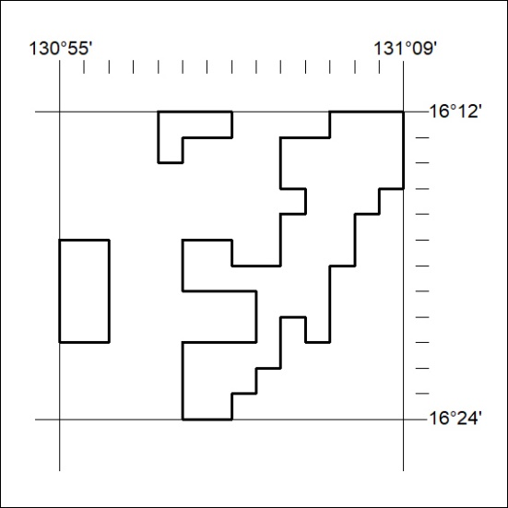

65/26

