Mineral Titles Act 2010
NOTICE OF LAND CEASING TO BE A MINERAL TITLE AREA
Title Type and Number: | Exploration Licence 32329
Area Ceased on: | 05 February 2026
Area: | 22 Blocks, 71.76 km²
Locality: | HELEN
Name of Applicant(s)/Holder(s): | 100% BAUDIN RESOURCES PTY LTD [ACN. 618 455 593]
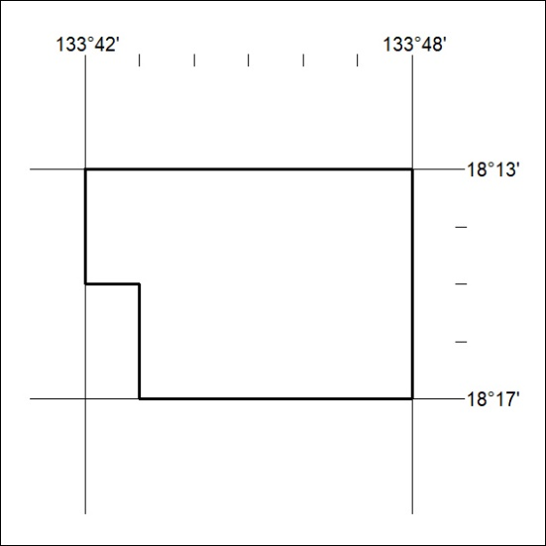

47/26

Mineral Titles Act 2010
NOTICE OF LAND CEASING TO BE A MINERAL TITLE AREA
Title Type and Number: | Exploration Licence 33276
Area Ceased on: | 05 February 2026
Area: | 61 Blocks, 197.46 km²
Locality: | DALMORE
Name of Applicant(s)/Holder(s): | 100% BARKLY OPERATIONS PTY LTD [ACN. 641 856 706]
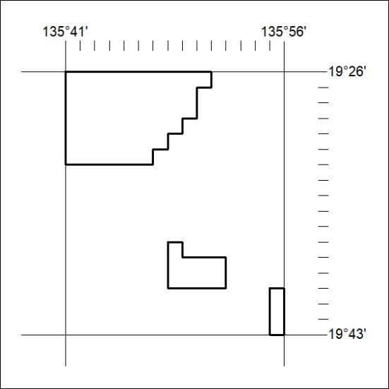

48/26

Mineral Titles Act 2010
NOTICE OF LAND CEASING TO BE A MINERAL TITLE APPLICATION AREA
Title Type and Number: | Exploration Licence 33429
Area Ceased on: | 04 February 2026
Area: | 91 Blocks, 295.31 km²
Locality: | NEWRY
Name of Applicant(s)/Holder(s): | 100% ROSEWOOD MINERALS PTY LTD [ACN. 653 271 179]
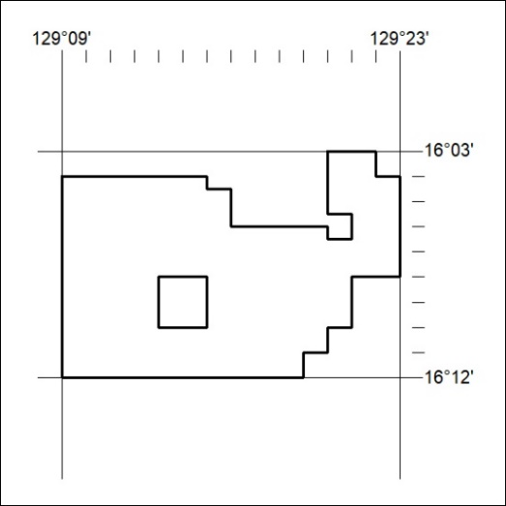

49/26

Mineral Titles Act 2010
NOTICE OF LAND CEASING TO BE A MINERAL TITLE APPLICATION AREA
Title Type and Number: | Exploration Licence 33442
Area Ceased on: | 04 February 2026
Area: | 139 Blocks, 453.62 km²
Locality: | WATERLOO
Name of Applicant(s)/Holder(s): | 100% ROSEWOOD MINERALS PTY LTD [ACN. 653 271 179]
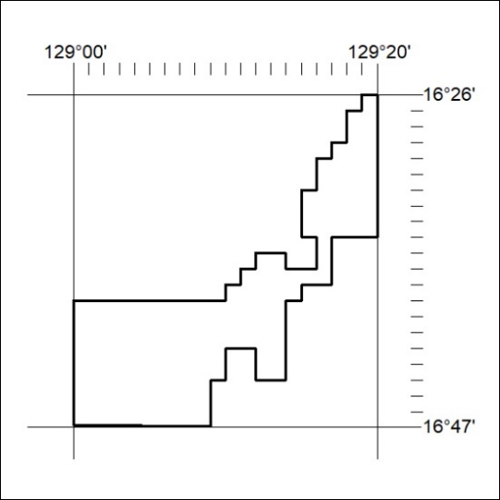

50/26

