Mineral Titles Act
NOTICE OF GRANT OF A MINERAL TITLE
Title Type and Number: | Mineral Authority 33261
Granted: | 14 January 2026, for a period of 5 Years
Area: | 28.00 Hectares
Locality: | KOOLPINYAH
Name of Holder/s: | 100% OSTOJIC GROUP PTY LTD* [ACN. 009 629 805]
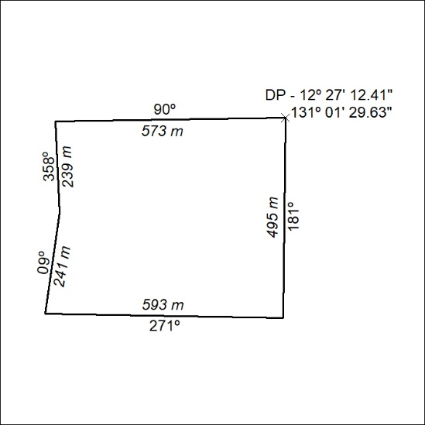

10/26

Mineral Titles Act
NOTICE OF GRANT OF A MINERAL TITLE
Title Type and Number: | Extractive Mineral Permit 33940
Granted: | 14 January 2026, for a period of 5 Years
Area: | 68.86 Hectares
Locality: | NOONAMAH
Name of Holder/s: | 50% OSTOJIC GROUP PTY LTD* [ACN. 009 629 805], 50% TRISTAR INDUSTRIES PTY LTD [ACN. 009 647 321]
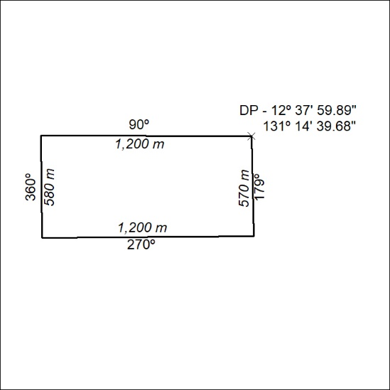

11/26

Mineral Titles Act
NOTICE OF GRANT OF A MINERAL TITLE
Title Type and Number: | Extractive Mineral Permit 33941
Granted: | 14 January 2026, for a period of 5 Years
Area: | 77.62 Hectares
Locality: | NOONAMAH
Name of Holder/s: | 50% OSTOJIC GROUP PTY LTD* [ACN. 009 629 805], 50% TRISTAR INDUSTRIES PTY LTD [ACN. 009 647 321]
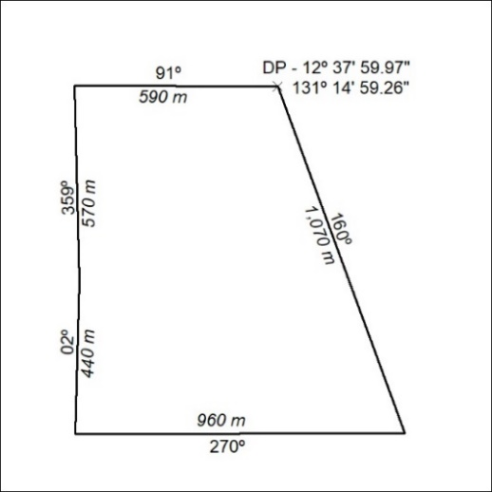

12/26

