Parks and Wildlife - ABN: 71 599 574 122
LT0521
Official Use Only:
Receipt No:...................................................................................................
Officer: ................................................ Date: .......... / .......... / ....................

POSTAGE: $18 (including Mailing Tube) (Overseas - Price advised on enquiry to larapinta.trail@nt.gov.au)

FREE PICKUP available from the Parks and Wildlife
Regional Office in Alice Springs Mon-Fri, 8am-4pm
Total Postage $ .......................

TOTAL $

NAME: ................................................................................................................................................
ADDRESS: ....................................................................................................................................
.......................................................................................................................................................
................................................................................................... POST CODE: ............................. DAYTIME PHONE: (........) ............................ AFTER HRS PHONE: (........) ....................................
MOBILE PHONE: ......................................... EMAIL: .......................................................................
PROPOSED DATE OF WALK: .....................................................................................................
.....

METHOD OF PAYMENT: PAY OVER PHONE

Request Parks and Wildlife to call you on your preferred contact number PCN:

Alternatively, you can call Parks and Wildlife on 8951 8250 during business hours only. Monday to Friday 0800 - 4:00 CST

On completion of this form, please email to larapinta.trail@nt.gov.au

OR post to:
Larapinta Trail Package Parks and Wildlife
PO Box 1120
ALICE SPRINGS NT 0871 AUSTRALIA
OR email to: larapinta.trail@nt.gov.au

OR fax to: + 61 8 8951 8290
ATT: Admin

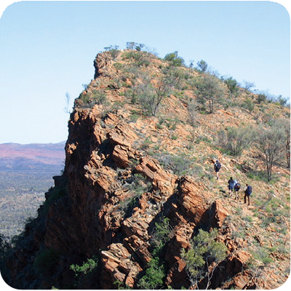

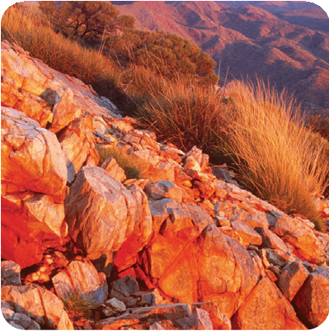
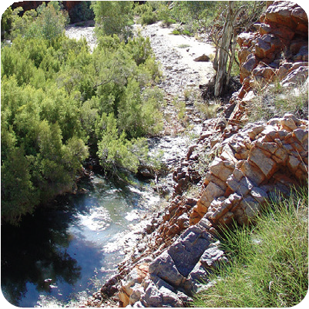

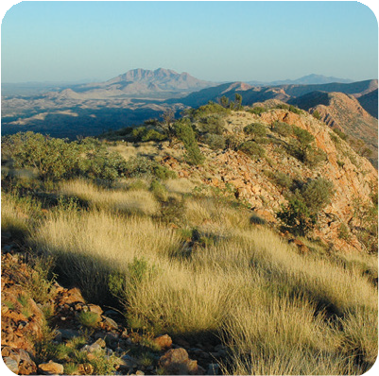
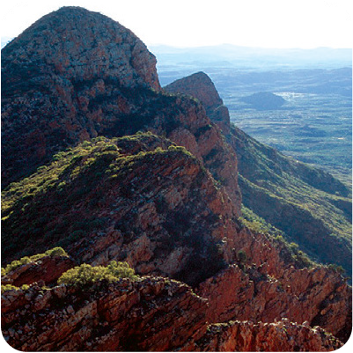





For enquiries contact Parks and Wildlife on the details below or email: larapinta.trail@nt.gov.au
Larapinta Trail Map Order Form
Unfolded poster size trail map now available
Perfect for laminating, mounting or framing as a memento of your Larapinta Trail experience
MAP PRICE $11.00 (inc. GST) per copy
Number of copies: .................. $ .......................
Parks and Wildlife are collecting this information to acquit your request for information regarding the Larapinta Trail. The information will not be utilised for any other purpose and will be disposed of and managed in accordance with the Privacy Principles of the Northern Territory Government. Should you wish to access the information you can contact Parks and Wildlife via PO Box 496, Palmerston, NT 0831.

Parks and Wildlife

