Mineral Titles Act 2010
NOTICE OF LAND CEASING TO BE A MINERAL TITLE APPLICATION AREA
Title Type and Number: | Exploration Licence 33731
Area Ceased on: | 07 April 2025
Area: | 11 Blocks, 30.98 km²
Locality: | FERGUSSON RIVER
Name of Applicant(s)/Holder(s): | 100% BACCHUS RESOURCES PTY LTD [ACN. 606 340 872]
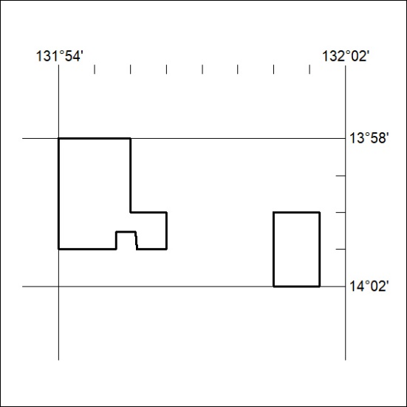

246/25

Mineral Titles Act
NOTICE OF GRANT OF A MINERAL TITLE
Title Type and Number: | Exploration Licence 33784
Granted: | 04 April 2025, for a period of 6 Years
Area: | 15 Blocks, 50.15 km²
Locality: | BATCHELOR
Name of Holder/s: | 100% PNX METALS LIMITED* [ACN. 127 446 271]
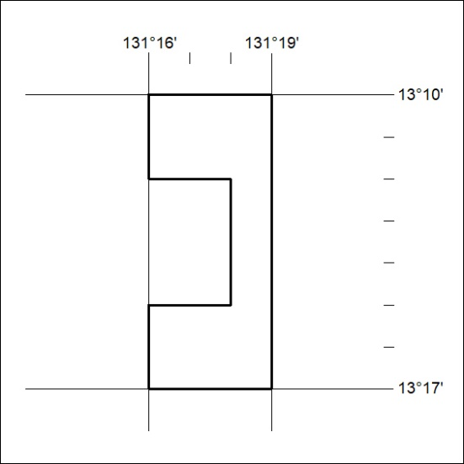
Area granted is indicated above. The titleholder is not permitted to exercise occupational rights on any land that is subject to a development title, or an application for a development title. Any land the subject of a Reserved Land gazettal under the Mineral Titles Act and all land vested in the Commonwealth of Australia is also excluded by description but not excised from the grant area.

247/25

