Mineral Titles Act 2010
NOTICE OF LAND CEASING TO BE A MINERAL TITLE AREA
Title Type and Number: | Exploration Licence 31633
Area Ceased on: | 18 March 2025
Area: | 15 Blocks, 36.57 km²
Locality: | EPENARRA
Name of Applicant(s)/Holder(s): | 100% TREASURE CREEK PTY LTD [ACN. 619 057 644]
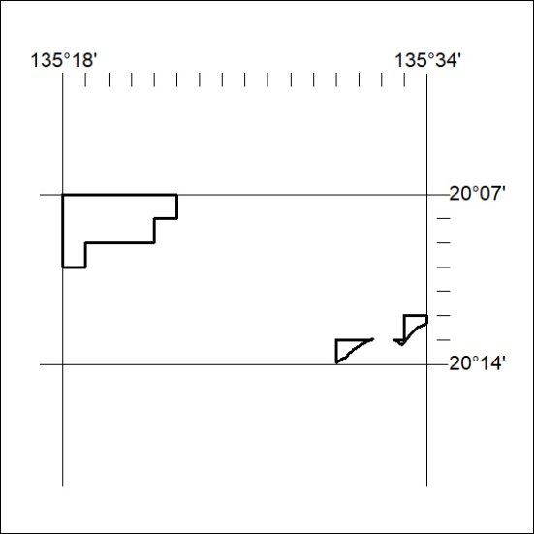

116/25

Mineral Titles Act 2010
NOTICE OF LAND CEASING TO BE A MINERAL TITLE AREA
Title Type and Number: | Exploration Licence 31634
Area Ceased on: | 18 March 2025
Area: | 12 Blocks, 35.97 km²
Locality: | EPENARRA
Name of Applicant(s)/Holder(s): | 100% TREASURE CREEK PTY LTD [ACN. 619 057 644]
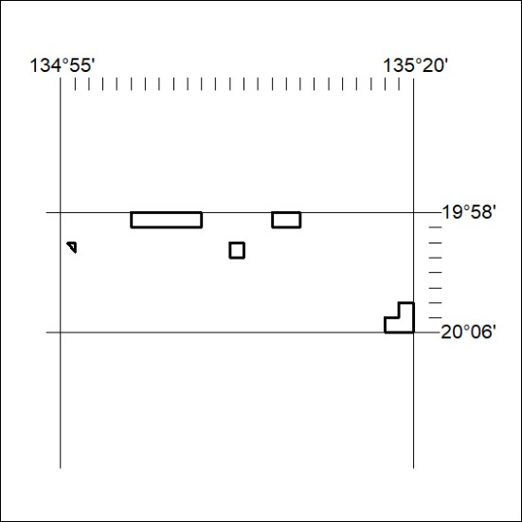

117/25

Mineral Titles Act 2010
NOTICE OF LAND CEASING TO BE A MINERAL TITLE AREA
Title Type and Number: | Exploration Licence 33449
Area Ceased on: | 20 March 2025
Area: | 10 Blocks, 31.82 km²
Locality: | REYNOLDS RANGE
Name of Applicant(s)/Holder(s): | 100% WILUNA WEST GOLD PTY LTD [ACN. 116 550 111]
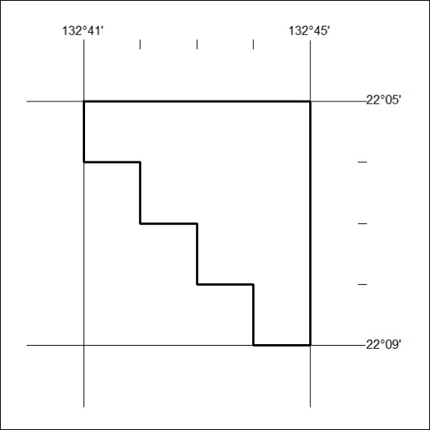

118/25

Mineral Titles Act 2010
NOTICE OF LAND CEASING TO BE A MINERAL TITLE AREA
Title Type and Number: | Exploration Licence 33642
Area Ceased on: | 20 March 2025
Area: | 53 Blocks, 151.92 km²
Locality: | DOREEN
Name of Applicant(s)/Holder(s): | 100% CHALCO RESOURCES PTY LTD [ACN. 648 662 346]
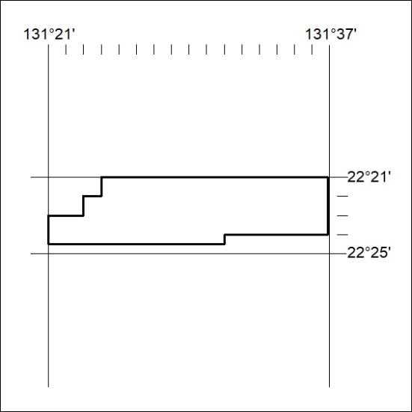

119/25

Mineral Titles Act 2010
NOTICE OF LAND CEASING TO BE A MINERAL TITLE APPLICATION AREA
Title Type and Number: | Exploration Licence 33643
Area Ceased on: | 19 March 2025
Area: | 34 Blocks, 90.08 km²
Locality: | DOREEN
Name of Applicant(s)/Holder(s): | 100% CHALCO RESOURCES PTY LTD [ACN. 648 662 346]
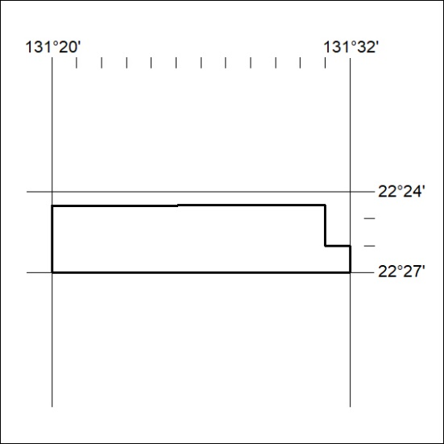

220/25

Mineral Titles Act 2010
NOTICE OF LAND CEASING TO BE A MINERAL TITLE APPLICATION AREA
Title Type and Number: | Exploration Licence 33645
Area Ceased on: | 19 March 2025
Area: | 15 Blocks, 39.30 km²
Locality: | DOREEN
Name of Applicant(s)/Holder(s): | 100% CHALCO RESOURCES PTY LTD [ACN. 648 662 346]
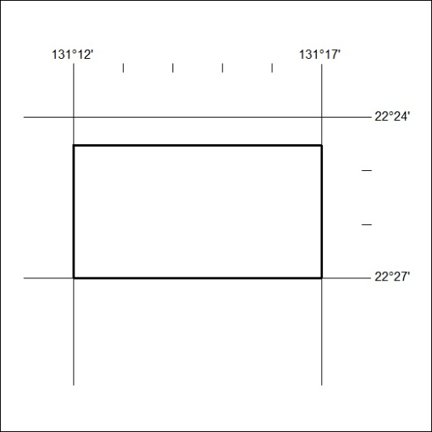

221/25

Mineral Titles Act 2010
NOTICE OF LAND CEASING TO BE A MINERAL TITLE AREA
Title Type and Number: | Exploration Licence 33653
Area Ceased on: | 20 March 2025
Area: | 30 Blocks, 92.27 km²
Locality: | LAUGHLEN
Name of Applicant(s)/Holder(s): | 100% WILUNA WEST GOLD PTY LTD [ACN. 116 550 111]
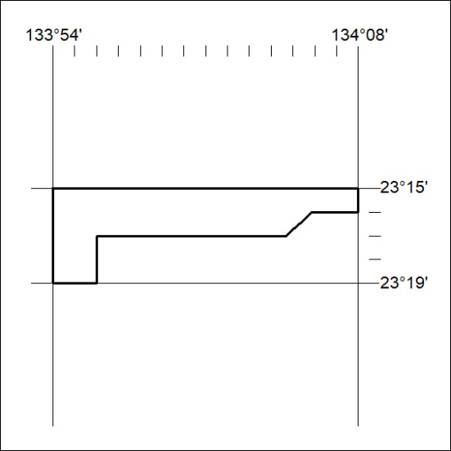

222/25

Mineral Titles Act 2010
NOTICE OF LAND CEASING TO BE A MINERAL TITLE AREA
Title Type and Number: | Exploration Licence 33684
Area Ceased on: | 20 March 2025
Area: | 57 Blocks, 179.04 km²
Locality: | CRAWFORD
Name of Applicant(s)/Holder(s): | 100% WILUNA WEST GOLD PTY LTD [ACN. 116 550 111]
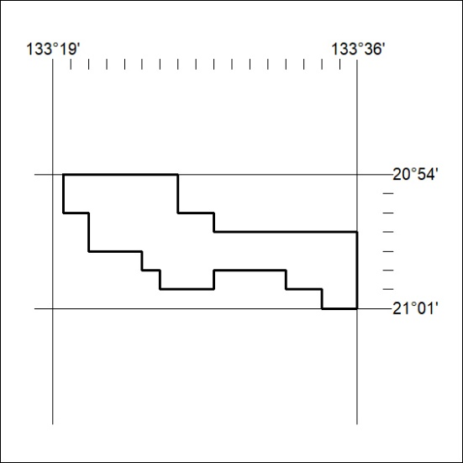

223/25

Mineral Titles Act 2010
NOTICE OF LAND CEASING TO BE A MINERAL TITLE AREA
Title Type and Number: | Exploration Licence 33695
Area Ceased on: | 20 March 2025
Area: | 13 Blocks, 41.01 km²
Locality: | LAUGHLEN
Name of Applicant(s)/Holder(s): | 100% WILUNA WEST GOLD PTY LTD [ACN. 116 550 111]
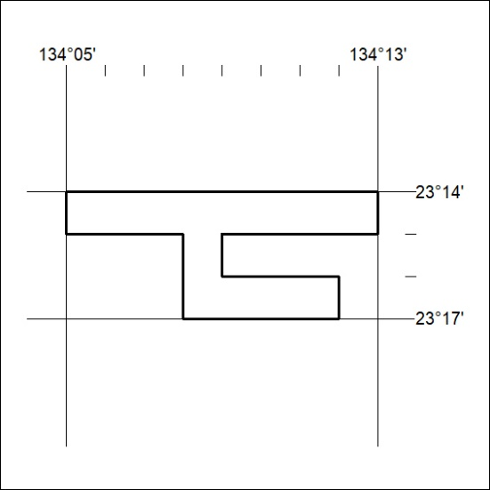

224/25

Mineral Titles Act 2010
NOTICE OF LAND CEASING TO BE A MINERAL TITLE AREA
Title Type and Number: | Exploration Licence 33732
Area Ceased on: | 20 March 2025
Area: | 5 Blocks, 11.68 km²
Locality: | ALCOOTA
Name of Applicant(s)/Holder(s): | 100% WILUNA WEST GOLD PTY LTD [ACN. 116 550 111]
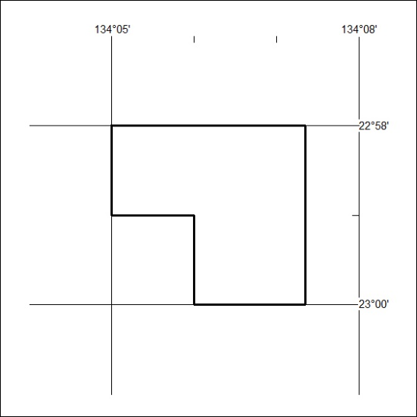

225/25

