Mineral Titles Act 2010
NOTICE OF LAND CEASING TO BE A MINERAL TITLE APPLICATION AREA
Title Type and Number: | Extractive Mineral Permit 33362
Area ceased on: | 20 February 2025
Area: | 98.00 Hectare
Locality: | NOONAMAH
Name of Applicants(s)Holder(s): | 100% AKJ SERVICES PTY LTD [ACN. 625 846 031]
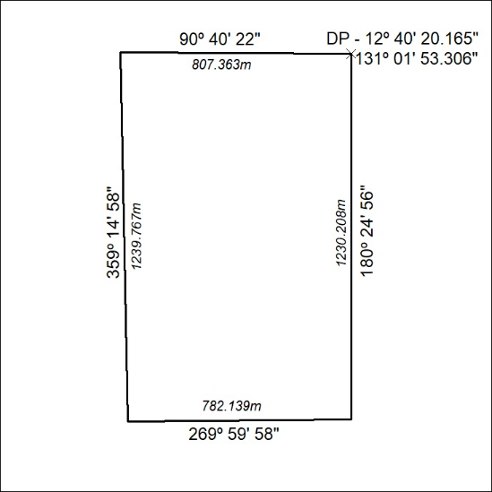

53/25

Mineral Titles Act 2010
NOTICE OF LAND CEASING TO BE A MINERAL TITLE APPLICATION AREA
Title Type and Number: | Extractive Mineral Permit 33363
Area ceased on: | 20 February 2025
Area: | 99.00 Hectare
Locality: | NOONAMAH
Name of Applicants(s)Holder(s): | 100% AKJ SERVICES PTY LTD [ACN. 625 846 031]
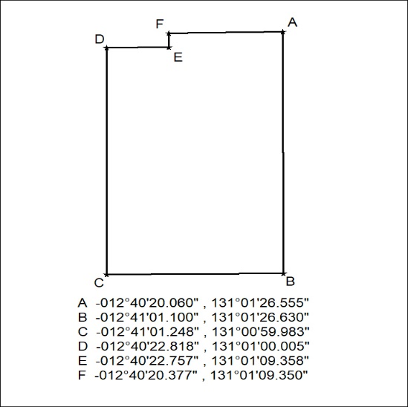

54/25

Mineral Titles Act 2010
NOTICE OF LAND CEASING TO BE A MINERAL TITLE APPLICATION AREA
Title Type and Number: | Extractive Mineral Permit 33364
Area ceased on: | 20 February 2025
Area: | 101.00 Hectares
Locality: | NOONAMAH
Name of Applicants(s)Holder(s): | 100% AKJ SERVICES PTY LTD [ACN. 625 846 031]
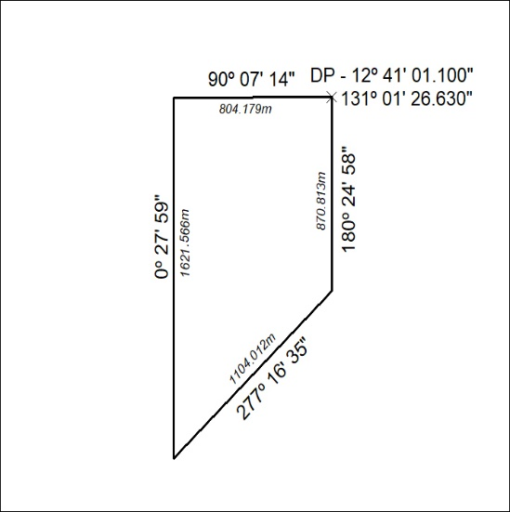

55/25

Mineral Titles Act 2010
NOTICE OF LAND CEASING TO BE A MINERAL TITLE APPLICATION AREA
Title Type and Number: | Extractive Mineral Permit 33365
Area ceased on: | 20 February 2025
Area: | 96.00 Hectare
Locality: | NOONAMAH
Name of Applicants(s)Holder(s): | 100% AKJ SERVICES PTY LTD [ACN. 625 846 031]
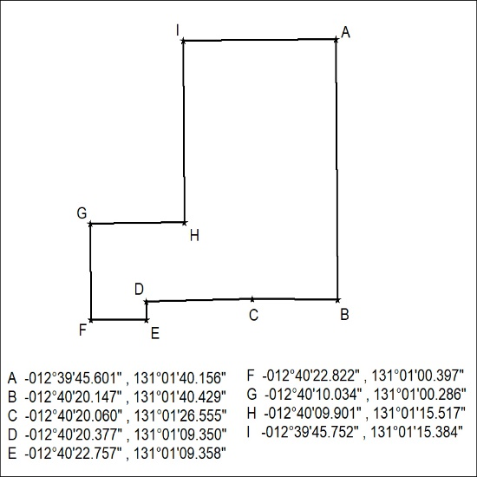

56/25

Mineral Titles Act 2010
NOTICE OF LAND CEASING TO BE A MINERAL TITLE APPLICATION AREA
Title Type and Number: | Extractive Mineral Permit 33366
Area ceased on: | 20 February 2025
Area: | 30.00 Hectare
Locality: | NOONAMAH
Name of Applicants(s)Holder(s): | 100% AKJ SERVICES PTY LTD [ACN. 625 846 031]
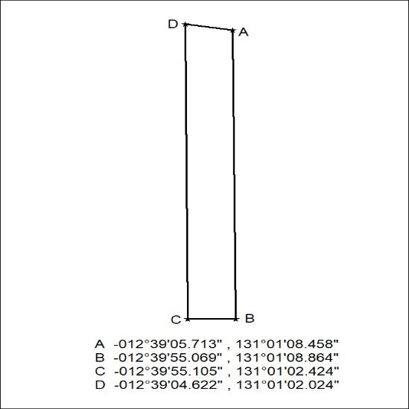

57/25

