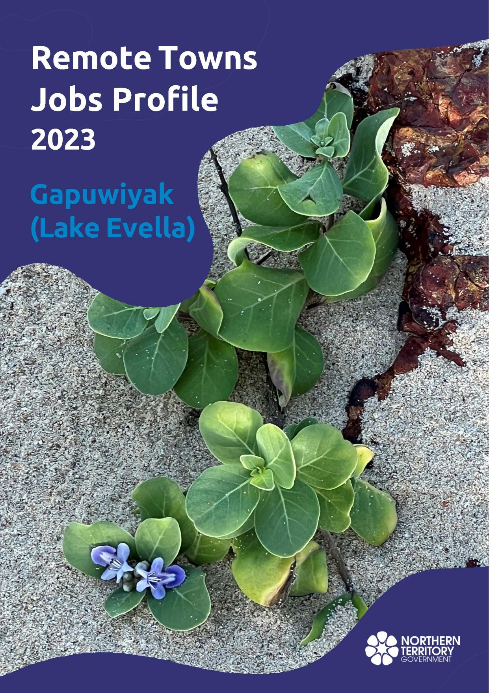

**© Territory of Australia 2025**

**Preferred Reference:** Department of Trade, Business and Asian Relations, 2023 Remote Towns Jobs Profiles, Northern Territory Government, January 2025, Darwin.

**Front cover image:** *Vitex rotundifolia* – known commonly as Beach Vitex

**Image credit:** Robyn Wing

**Disclaimer**

The data in this publication was collected by conducting a survey of businesses located in the 28 remote town boundaries. This body of work was completed in 2023 by the former Northern Territory Department of Industry, Tourism and Trade.

The collection methodology was created in accordance with Australian Bureau of Statistics data quality framework principles. Data in this publication is only reflective of those businesses reported on as operating in the town at the time of data collection (see table at the end of publication for list of businesses reported on). To comply with privacy legislation or where appropriate, some data in this publication may have been adjusted and will not reflect the actual data reported by businesses. As a result of this, combined with certain data not being reported by some businesses, some components may not add to totals. Changes over time may also reflect change in business propensity to report on certain data items rather than actual changes over time. Total figures have generally not been adjusted. Caution is advised when interpreting the comparisons made to the earlier 2011, 2014 and 2017 publications as the businesses identified and reported on and the corresponding jobs may differ between publications. The surveys have not always gathered data on training and jobs in the same years.

**Notes for each table and chart are ordered alphabetically and listed at the end of the publication.**

The Northern Territory of Australia exercised due care and skill to ensure that at the time of publication the information contained in this publication is true and correct. However, it is not intended to be relied on as professional advice or used for commercial purposes. The Territory gives no warranty or assurances as to the accuracy of the information contained in the publication and to the maximum extent permitted by law accepts no direct or indirect liability for reliance on its content.

Any use of this report for commercial purposes is not endorsed by the Department of Trade, Business and Asian Relations.

Contents

Gapuwiyak 4

Introduction 5

Summary 6

Jobs Overview 7

Jobs filled by Aboriginality 8

Jobs by Sector: Private and Public 10

Job Status: Permanent and Temporary 15

Job Vacancies 19

Jobs by Industry 21

Jobs by Occupation 27

Jobs by Industry by Occupation 31

Jobs by Gender 34

Jobs by Age 39

Vocational Education and Training 45

Population 52

Community Development Program 54

Businesses 55

Notes 56

Abbreviations and Acronyms 57

# Gapuwiyak

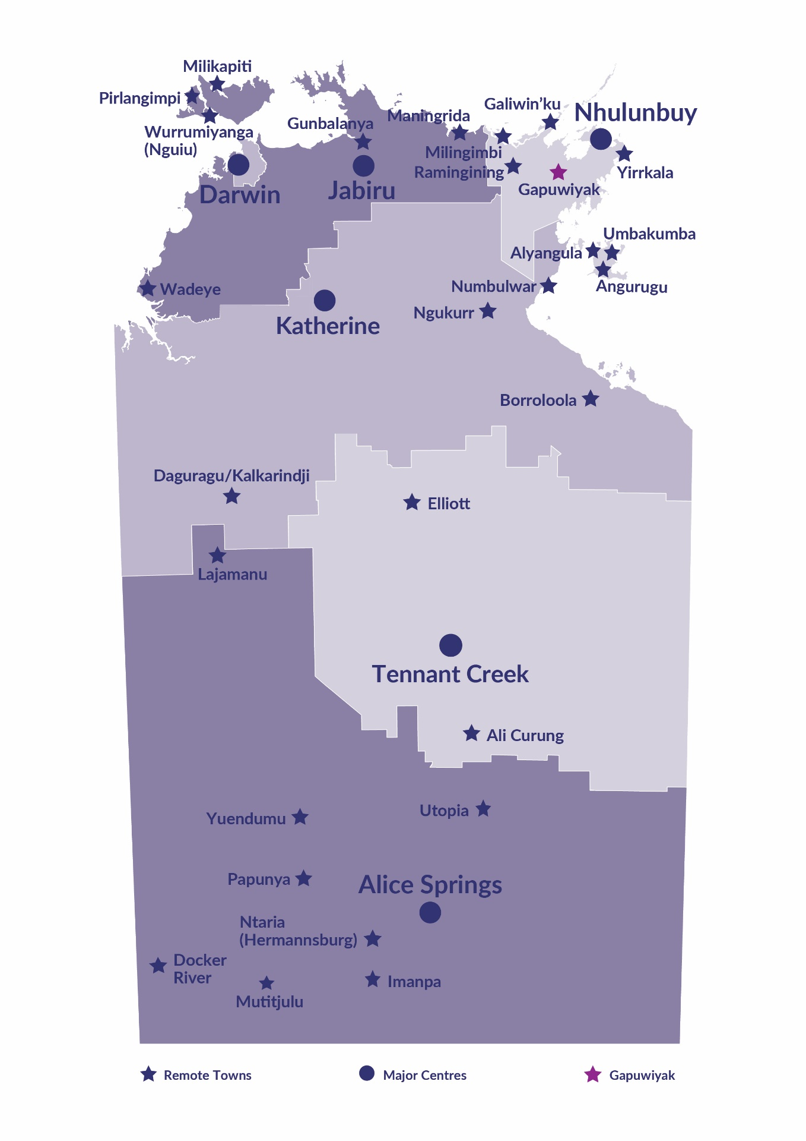Gapuwiyak is located approximately 540 kilometres east of Darwin and 220 kilometres southwest of Nhulunbuy. It lies adjacent to Lake Evella and the upper reaches of the Buckingham River; with a population of 706 residents.

*Source: Northern Territory Department of Industry, Tourism and Trade*

# Introduction

This jobs profile provides a snapshot of jobs and the characteristics of job holders in Gapuwiyak as of September 2023. Trends from the surveys conducted in 2011, 2014, and 2017 are also described. Additionally, it presents data on Community Development Program activity, Population, and Vocational Education and Training.

This job profile is one of 28 profiles developed for remote towns in the Northern Territory. It is anticipated these, and subsequent profiles will contribute to a robust evidence base to inform decision making in and relating to these remote Territory towns.

This profile contains information collected by the Northern Territory Department of Industry, Tourism and Trade from businesses operating within the town and is supplemented by other administrative data sets and information.

Each profile provides up-to-date information that is intended to inform the planning and design of current and future government programs and as an evidence base to inform decision making relating to workforce development, enterprise and job opportunities.

The profile may best be understood as a point-in-time tool. The number of business surveys from which the data was drawn is significantly less than in earlier surveys, and business participation has decreased with each survey. For Gapuwiyak, 31% fewer businesses than in 2017 are reported here.

The data collection methodology and corresponding questionnaire were created in partnership with the Australian Bureau of Statistics (ABS) and in accordance with ABS data quality framework and survey principles.

The Northern Territory Northern Territory Department of Industry, Tourism and Trades’ Territory Engagement and Delivery, Skills Initiative and VET data teams collaborated with the Northern Institute at Charles Darwin University to facilitate the surveys and reports.

The information collected and reported on represents a significant goodwill investment by those businesses and organisations that participated. Each business is listed at the end of this publication.

# Summary

The 2023 jobs profile was developed based on responses from 9 businesses operating within the Gapuwiyak town boundary, 4 less than in the 2017 survey. Of these, there were:

* 5 businesses from the Private Sector, accounting for 138 filled jobs or 58% of total filled jobs
* 4 businesses from the Public Sector, accounting for 98 filled jobs or 42% of total filled jobs
* 5 businesses participated in all four surveys (completed in 2011, 2014, 2017 and 2023).

A total of 253 filled and vacant jobs in Gapuwiyak were reported, an increase of 55 jobs from 2017.[1]

The 2023 profile highlights:

* there were 236 filled jobs of which:
* 192 jobs (81%) were filled by Aboriginal people, an increase of 64 jobs from 2017
* 44 jobs (19%) were filled by non-Aboriginal people, an increase of 6 jobs from 2017
* 52% of employed Aboriginal people are working in the Private Sector
* Aboriginal people accounted for 81% of job holders in the town compared to 77% in 2017
* Aboriginal females made up 61% of totalled Aboriginal filled jobs in the town compared to 53% in 2017.
* there were 17 vacant jobs, of which:
* job vacancies as a percentage of jobs decreased to 6.7% in 2023 from 16.2% in 2017
* job vacancies equate to 1 in 15 jobs
* 12 of the vacancies were in the Community and Personal Service Workers and Professional areas
* Public Administration and Safety industry is the largest industry employer in 2023 with an increase of 35 filled jobs, followed by Retail Trade
* Education and Training industry had the 2nd highest increase in filled jobs (31) in 2023
* training had an increase in student numbers (57) between 2023 and 2016
* Primary Industry was the largest training activity sector in 2023, followed by Community Services, Health, and Education.

The overall population in Gapuwiyak decreased by 168 people (19.2%) between 2011 and 2021 to 706 people.

In comparison, the overall Northern Territory population increased by 9.7% between 2011 and 2021.

In 2021, the working age population (15 years and over) in Gapuwiyak was an estimated 554 people compared to 613 in 2011 a decrease of 9.6%.

There were 0.5 jobs in Gapuwiyak per working age person compared to 0.3 jobs per working age person across the 28 remote towns in the Northern Territory.

# Jobs Overview

Table 1: Count of filled jobs and vacancies, 2011, 2014, 2017 & 2023 (a)(b)

|  |  |  |  |  |  |  |  |
| --- | --- | --- | --- | --- | --- | --- | --- |
|  | **2011** | **2014** | **2017** | **2023** | **Change 2011-2014** | **Change 2014-2017** | **Change 2017-2023** |
| **Total All Jobs** | **145** | **156** | **198** | **253** | **11** | **42** | **55** |
| **Vacancies** | **22** | **13** | **32** | **17** | **-9** | **19** | **-15** |
| Vacancies as % of Total All Jobs | 15.2% | 8.3% | 16.2% | 6.7% | -6.8ppt | 7.8 ppt | -9.5 ppt |
| **Filled Jobs** | **123** | **143** | **166** | **236** | **20** | **23** | **70** |
| Full-time | 59 | 78 | 77 | 116 | 19 | -1 | 39 |
| Part-time | 64 | 65 | 89 | 120 | 1 | 24 | 31 |

Source: Northern Territory Department of Industry, Tourism and Trade

Chart 1: Count of vacant jobs and filled jobs by full-time/part-time status, 2011, 2014, 2017 & 2023 (a)(b)

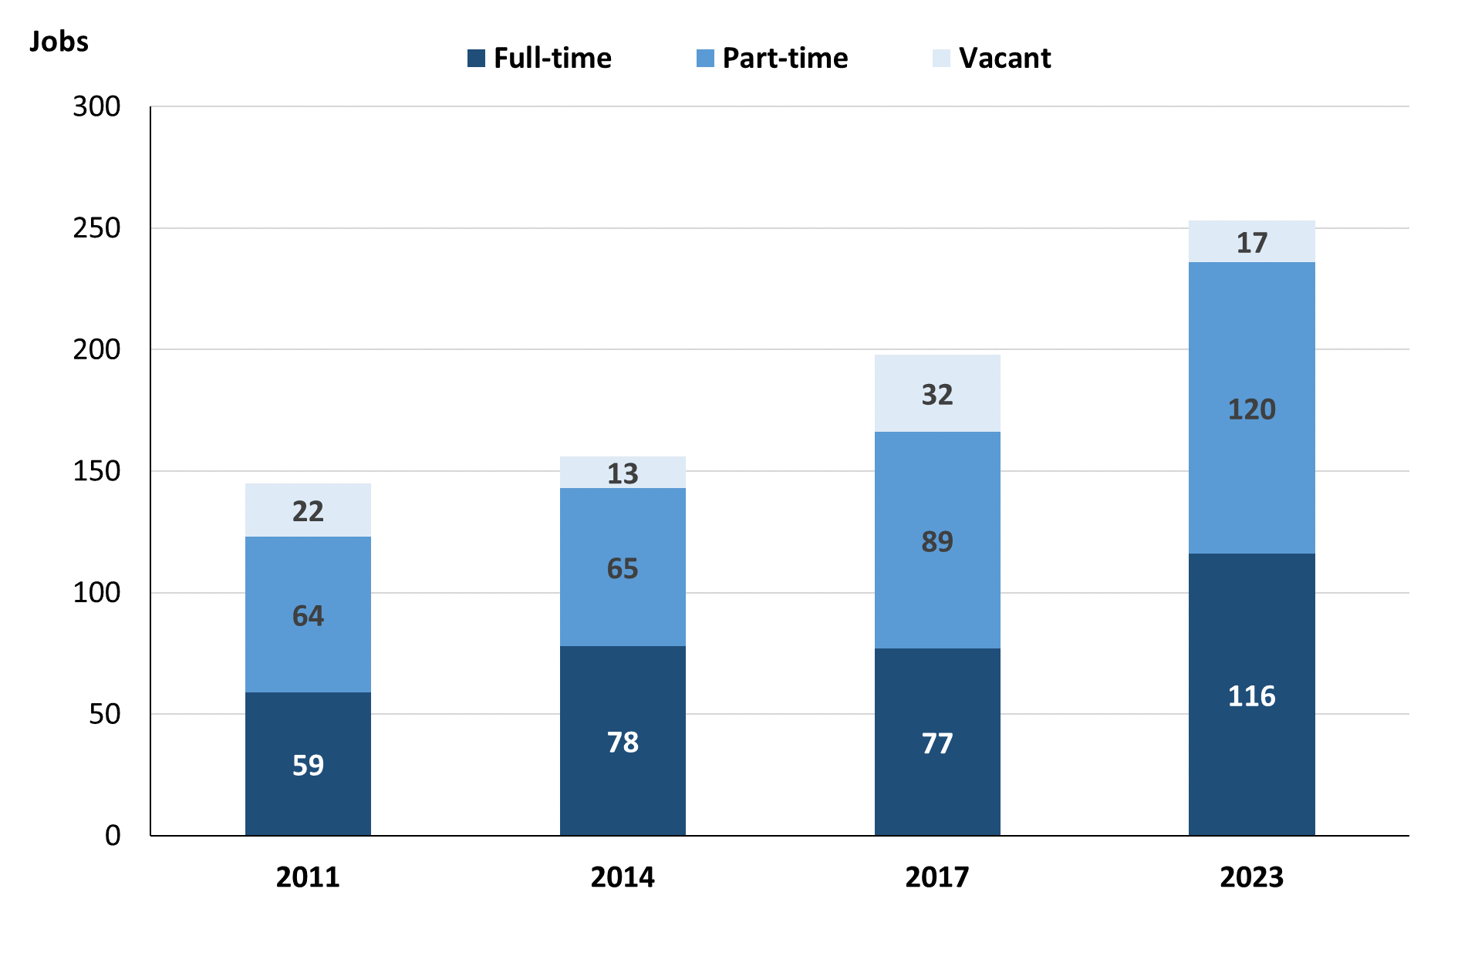

Source: Northern Territory Northern Territory Department of Industry, Tourism and Trade

In 2023 in Gapuwiyak:

* there was a total of 236 **filled jobs**, an increase of 70 jobs from 2017 and an increase of 93 jobs from 2014
* of the 236 **filled jobs** in 2023:
* 116 were full-time jobs, an increase of 39 job from 2017 and an increase of 38 jobs from 2014
* 120 were part-time jobs, an increase of 31 jobs from 2017 and an increase of 55 jobs from 2014
* there were 17 total **job vacancies** in 2023, a decrease of 15 vacancies from 2017 and an increase of 4 vacancies from 2014.

# Jobs filled by Aboriginality

Chart 2: Count of filled jobs by Aboriginality, 2011, 2014, 2017 & 2023 (a)(c)

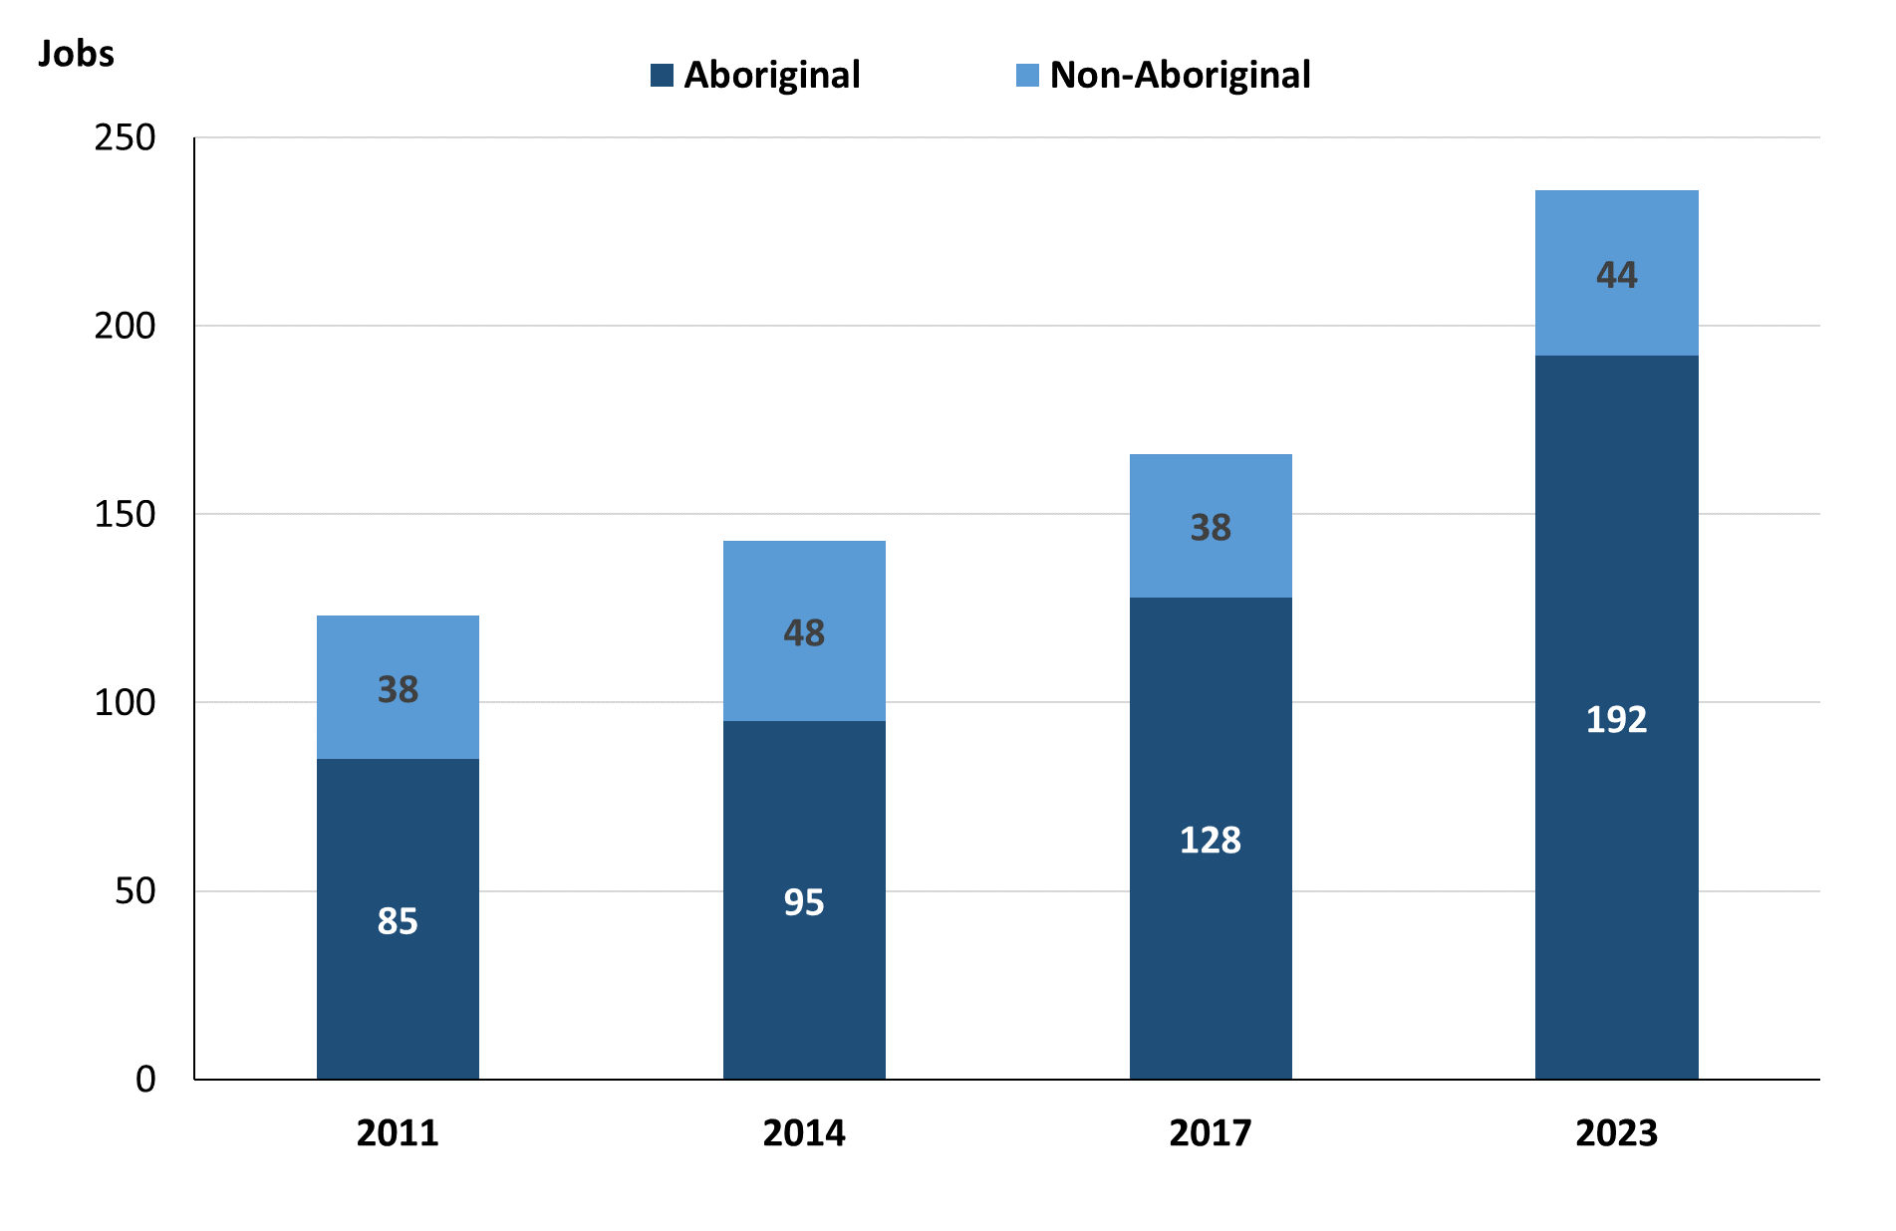

Source: Northern Territory Department of Industry, Tourism and Trade

In 2023 in Gapuwiyak:

* of the 236 **filled jobs**:
* **Aboriginal** people filled 192 jobs, an increase of 64 jobs from 2017 and an increase of 97 jobs from 2014
* **non-Aboriginal** people filled 44 jobs, an increase of 6 jobs from 2017 and a decrease of 4 jobs from 2014
* **Aboriginal** people accounted for 81% of job holders compared to 77% in 2017 and 66% in 2014.

Table 2a: Count of filled jobs by full-time/part-time status, 2011, 2014, 2017 & 2023 (a)(b)(c)

|  |  |  |  |  |  |  |  |  |  |  |  |  |
| --- | --- | --- | --- | --- | --- | --- | --- | --- | --- | --- | --- | --- |
| **Indicator** | **2011** | | | **2014** | | | **2017** | | | **2023** | | |
| **Aboriginal** | **Non-Aboriginal** | **Total** | **Aboriginal** | **Non-Aboriginal** | **Total** | **Aboriginal** | **Non-Aboriginal** | **Total** | **Aboriginal** | **Non-Aboriginal** | **Total** |
| Full-time | 25 | 34 | **59** | 34 | 44 | **78** | 42 | 35 | **77** | 77 | 39 | **116** |
| Part-time | 60 | 4 | **64** | 61 | 4 | **65** | 86 | 3 | **89** | 115 | 5 | **120** |
| **Total** | **85** | **38** | **123** | **95** | **48** | **143** | **128** | **38** | **166** | **192** | **44** | **236** |

Source: Northern Territory Department of Industry, Tourism and Trade

Table 2b: Count of filled jobs by full-time/part-time status, 2011-2014, 2014-2017 & 2017-2023 (a)(b)(c)

|  |  |  |  |  |  |  |  |  |  |
| --- | --- | --- | --- | --- | --- | --- | --- | --- | --- |
| **Indicator** | **Change 2011-2014** | | | **Change 2014-2017** | | | **Change 2017-2023** | | |
| **Aboriginal** | **Non-Aboriginal** | **Total** | **Aboriginal** | **Non-Aboriginal** | **Total** | **Aboriginal** | **Non-Aboriginal** | **Total** |
| Full-time | 9 | 10 | **19** | 8 | -9 | **-1** | 35 | 4 | **39** |
| Part-time | 1 | 0 | **1** | 25 | -1 | **24** | 29 | 2 | **31** |
| **Total** | **10** | **10** | **20** | **33** | **-10** | **23** | **64** | **6** | **70** |

Source: Northern Territory Department of Industry, Tourism and Trade

Chart 3: Count of filled jobs by full-time/part-time status, 2011, 2014, 2017 & 2023 (a)(b)(c)

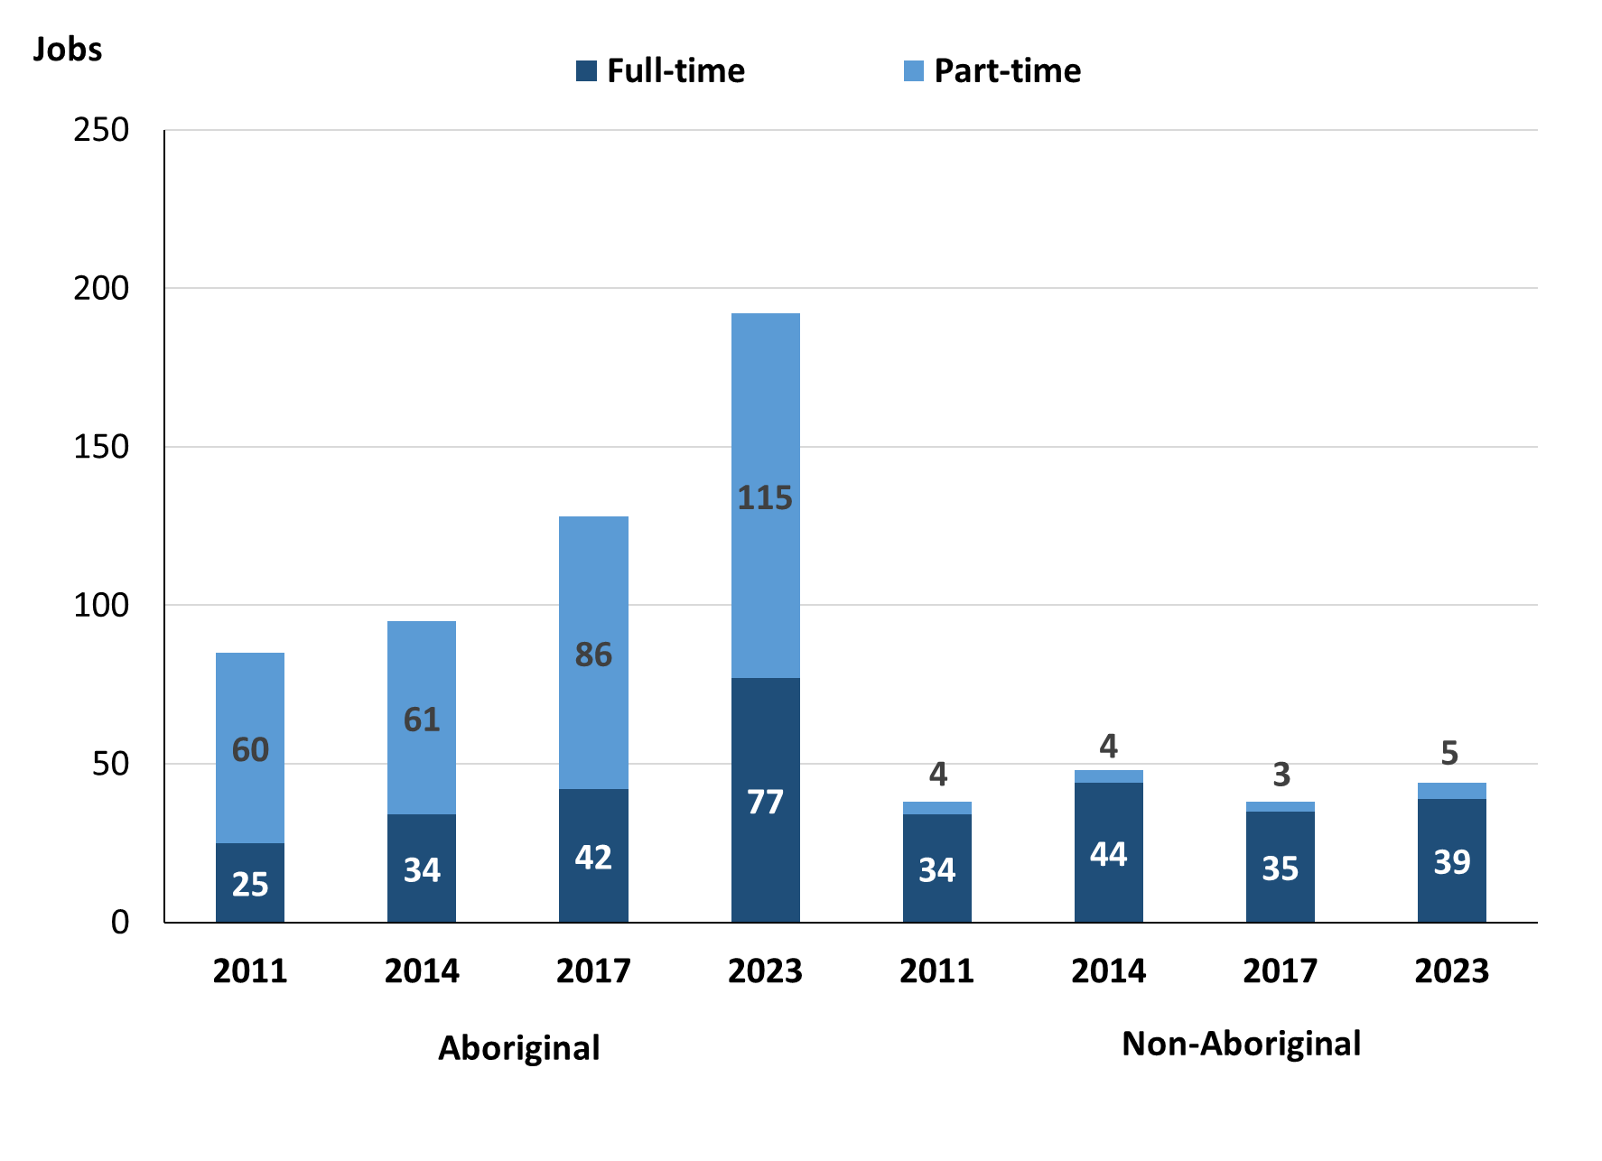

Source: Northern Territory Department of Industry, Tourism and Trade

In 2023 in Gapuwiyak:

* of the 236 filled jobs:
* 77 were **full-time** jobs filled by **Aboriginal** people, an increase of 35 jobs from 2017 and an increase of 43 jobs from 2014
* 115 were **part-time** jobs filled by **Aboriginal** people, an increase of 29 jobs from 2017 and an increase of 54 jobs from 2014
* 39 were **full-time** jobs filled by **non-Aboriginal** people, an increase of 4 jobs from 2017 and a decrease of 5 jobs from 2014
* 5 were **part-time** jobs filled by **non-Aboriginal** people, an increase of 2 jobs from 2017 and an increase of 1 job from 2014.

# Jobs by Sector: Private and Public

Table 3a: Count of filled jobs by business sector, 2011, 2014, 2017 & 2023 (a)(b)(c)

|  |  |  |  |  |  |  |  |  |  |  |  |  |
| --- | --- | --- | --- | --- | --- | --- | --- | --- | --- | --- | --- | --- |
| **Indicator** | **2011** | | | **2014** | | | **2017** | | | **2023** | | |
| **Aboriginal** | **Non-Aboriginal** | **Total** | **Aboriginal** | **Non-Aboriginal** | **Total** | **Aboriginal** | **Non-Aboriginal** | **Total** | **Aboriginal** | **Non-Aboriginal** | **Total** |
| **Public Sector** | 46 | 31 | **77** | 48 | 40 | **88** | 48 | 29 | **77** | 70 | 28 | **98** |
| Australian Government | 0 | 1 | **1** | 1 | 1 | **2** | 1 | 1 | **2** | 0 | 0 | **0** |
| Territory Government | 14 | 22 | **36** | 19 | 32 | **51** | 19 | 21 | **40** | 39 | 20 | **59** |
| Local Government | 32 | 8 | **40** | 28 | 7 | **35** | 28 | 7 | **35** | 31 | 8 | **39** |
| **Private Sector** | 39 | 7 | **46** | 47 | 8 | **55** | 80 | 9 | **89** | 122 | 16 | **138** |
| **Total** | **85** | **38** | **123** | **95** | **48** | **143** | **128** | **38** | **166** | **192** | **44** | **236** |

Source: Northern Territory Department of Industry, Tourism and Trade

Table 3b: Count of filled jobs by business sector, 2011-2014, 2014-2017 & 2017-2023 (a)(b)(c)

|  |  |  |  |  |  |  |  |  |  |
| --- | --- | --- | --- | --- | --- | --- | --- | --- | --- |
| **Indicator** | **Change 2011-2014** | | | **Change 2014-2017** | | | **Change 2017-2023** | | |
| **Aboriginal** | **Non-Aboriginal** | **Total** | **Aboriginal** | **Non-Aboriginal** | **Total** | **Aboriginal** | **Non-Aboriginal** | **Total** |
| **Public Sector** | 2 | 9 | **11** | 0 | -11 | **-11** | 22 | -1 | **21** |
| Australian Government | 1 | 0 | **1** | 0 | 0 | **0** | -1 | -1 | **-2** |
| Territory Government | 5 | 10 | **15** | 0 | -11 | **-11** | 20 | -1 | **19** |
| Local Government | -4 | -1 | **-5** | 0 | 0 | **0** | 3 | 1 | **4** |
| **Private Sector** | 8 | 1 | **9** | 33 | 1 | **34** | 42 | 7 | **49** |
| **Total** | **10** | **10** | **20** | **33** | **-10** | **23** | **64** | **6** | **70** |

Source: Northern Territory Department of Industry, Tourism and Trade

**Chart 4: Count of filled jobs by business sector, 2011, 2014, 2017 & 2023 (a)(d)**

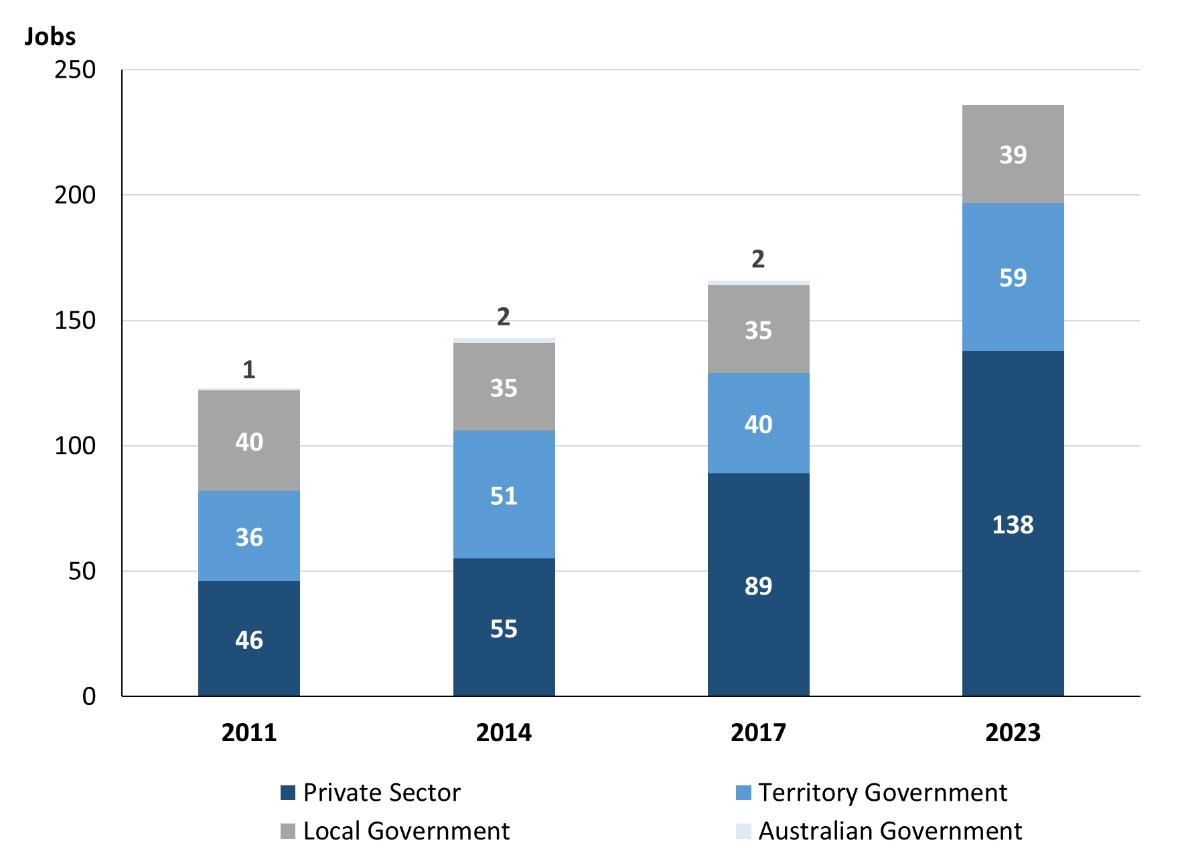

Source: Northern Territory Department of Industry, Tourism and Trade

Chart 5: Percentage of filled jobs by business sector in 2023 (a)(d)

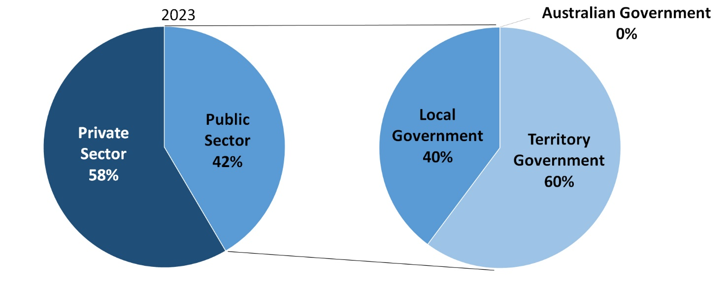

Source: Northern Territory Department of Industry, Tourism and Trade

In 2023 in Gapuwiyak:

* there were 98 jobs in the **Public Sector**, an increase of 21 jobs from 2017 and an increase of 10 jobs from 2014
* of the 98 jobs in the **Public Sector**:
* none were in the Australian Government, a decrease of 2 jobs from 2017 and a decrease of 2 jobs from 2014
* 59 jobs were in the Territory Government, an increase of 19 jobs from 2017 and an increase of 8 jobs from 2014
* 39 jobs were in the Local Government, an increase of 4 jobs from 2017 and an increase of 4 jobs from 2014
* there were 138 jobs in the **Private Sector**, an increase of 49 jobs from 2017 and an increase of 83 jobs from 2014.

Chart 6: Count of filled jobs by sector, 2011, 2014, 2017 & 2023 (a)(c)(d)

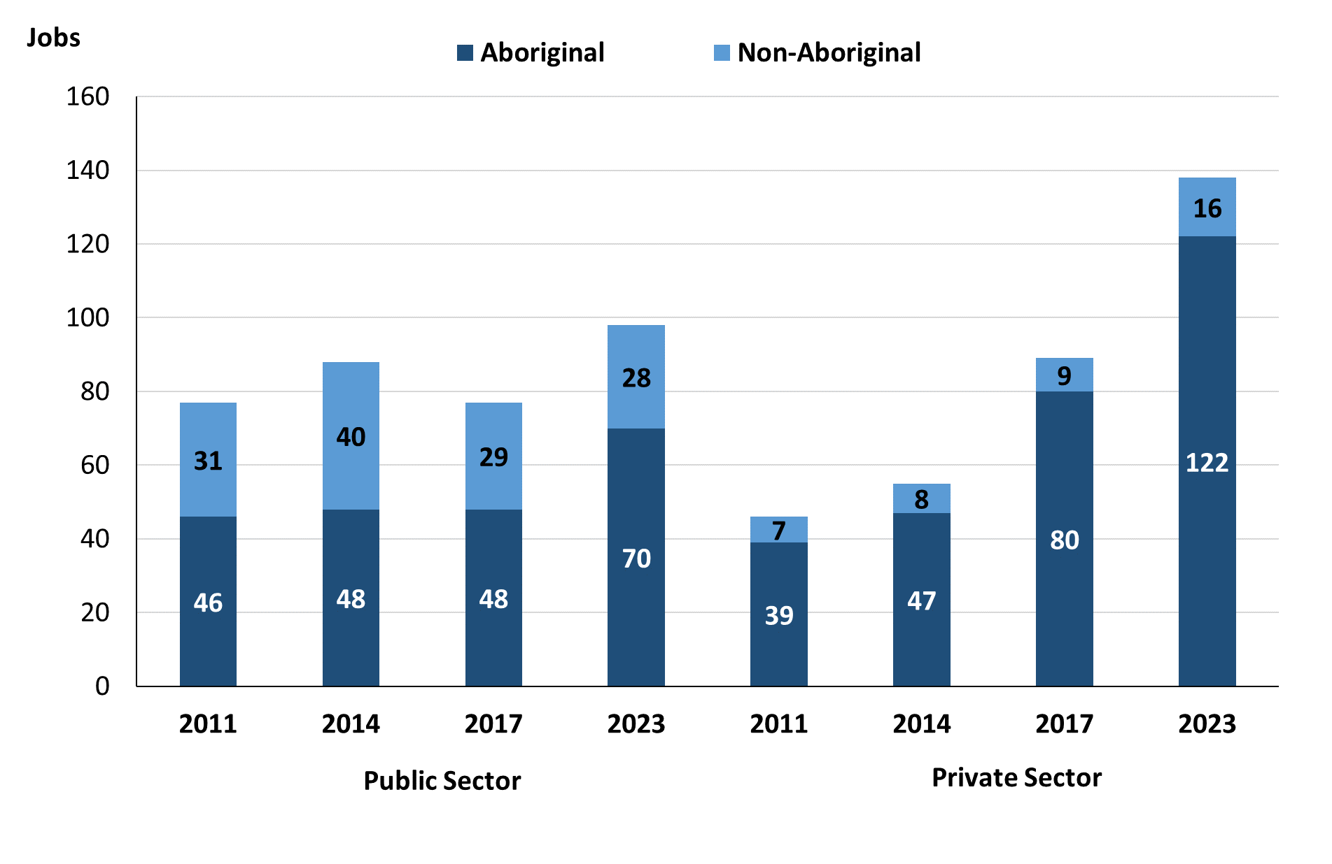

Source: Northern Territory Department of Industry, Tourism and Trade

In 2023 in Gapuwiyak:

* of the 98 jobs in the **Public Sector**:
* **Aboriginal** people filled 70 jobs, an increase of 22 jobs from 2017 and an increase of 22 jobs from 2014
* **non-Aboriginal** people filled 28 jobs, a decrease of 1 job from 2017 and a decrease of 12 jobs from 2014
* of the 138 jobs in the **Private Sector**:
* **Aboriginal** people filled 122 jobs, an increase of 42 jobs from 2017 and an increase of 75 jobs from 2014
* **non-Aboriginal** people filled 16 jobs, an increase of 7 jobs from 2017 and an increase of 8 jobs from 2014.

Chart 7: Count of filled jobs by sector and full-time/part-time status, 2011, 2014, 2017 & 2023

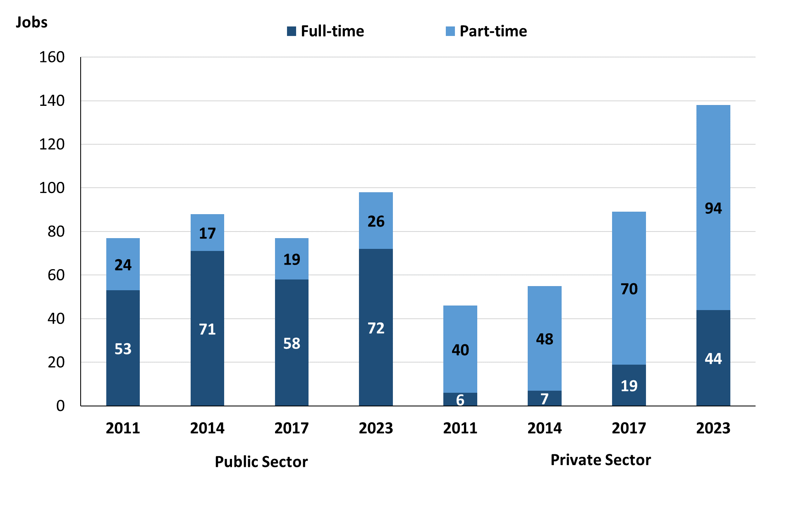

Source: Northern Territory Department of Industry, Tourism and Trade

In 2023 in Gapuwiyak:

* of the 98 jobs in the **Public Sector,** there were:
* 72 were **full-time** jobs, an increase of 14 jobs from 2017 and an increase of 1 job from 2014
* 26 were **part-time** jobs, an increase of 7 jobs from 2017 and an increase of 9 jobs from 2014
* of the 138 jobs in the **Private Sector,** there were:
* 44 were **full-time** jobs, an increase of 25 jobs from 2017 and an increase of 37 jobs from 2014
* 94 were **part-time** jobs, an increase of 24 jobs from 2017 and an increase of 46 jobs from 2014.

Table 4: Count of filled jobs by full-time/part-time status by sector, 2011, 2014, 2017 & 2023 (a)(b)(c)(d)

|  |  |  |  |  |  |  |  |  |  |  |
| --- | --- | --- | --- | --- | --- | --- | --- | --- | --- | --- |
| **Indicator** | **2011** | | | | | | | | | |
| **Aboriginal** | | | **Non-Aboriginal** | | | **Total** | | | |
| **Full-time** | **Part-time** | **Total** | **Full-time** | **Part-time** | **Total** | **Full-time** | **Part-time** | **Total** |
| Public Sector | 25 | 21 | **46** | 28 | 3 | **31** | 53 | 24 | **77** |
| Private Sector | 0 | 39 | **39** | 6 | 1 | **7** | 6 | 40 | **46** |
| **Total** | **25** | **60** | **85** | **34** | **4** | **38** | **59** | **64** | **123** |

|  |  |  |  |  |  |  |  |  |  |  |
| --- | --- | --- | --- | --- | --- | --- | --- | --- | --- | --- |
| **Indicator** | **2014** | | | | | | | | | |
| **Aboriginal** | | | **Non-Aboriginal** | | | **Total** | | | |
| **Full-time** | **Part-time** | **Total** | **Full-time** | **Part-time** | **Total** | **Full-time** | **Part-time** | **Total** |
| Public Sector | 34 | 14 | **48** | 37 | 3 | **40** | 71 | 17 | **88** |
| Private Sector | 0 | 47 | **47** | 7 | 1 | **8** | 7 | 48 | **55** |
| **Total** | **34** | **61** | **95** | **44** | **4** | **48** | **78** | **65** | **143** |

|  |  |  |  |  |  |  |  |  |  |  |
| --- | --- | --- | --- | --- | --- | --- | --- | --- | --- | --- |
| **Indicator** | **2017** | | | | | | | | | |
| **Aboriginal** | | | **Non-Aboriginal** | | | **Total** | | | |
| **Full-time** | **Part-time** | **Total** | **Full-time** | **Part-time** | **Total** | **Full-time** | **Part-time** | **Total** |
| Public Sector | 31 | 17 | **48** | 27 | 2 | **29** | 58 | 19 | **77** |
| Private Sector | 11 | 69 | **80** | 8 | 1 | **9** | 19 | 70 | **89** |
| **Total** | **34** | **61** | **128** | **35** | **3** | **38** | **77** | **89** | **166** |

|  |  |  |  |  |  |  |  |  |  |  |
| --- | --- | --- | --- | --- | --- | --- | --- | --- | --- | --- |
| **Indicator** | **2023** | | | | | | | | | |
| **Aboriginal** | | | **Non-Aboriginal** | | | **Total** | | | |
| **Full-time** | **Part-time** | **Total** | **Full-time** | **Part-time** | **Total** | **Full-time** | **Part-time** | **Total** |
| Public Sector | 47 | 23 | **70** | 25 | 3 | **28** | 72 | 26 | **98** |
| Private Sector | 30 | 92 | **122** | 14 | 2 | **16** | 44 | 94 | **138** |
| **Total** | **77** | **115** | **192** | **39** | **5** | **44** | **116** | **120** | **236** |

Source: Northern Territory Department of Industry, Tourism and Trade

In 2023 in Gapuwiyak:

* there were 70 jobs in the **Public Sector** filled by **Aboriginal** people, an increase of 22 jobs from 2017 and an increase of 22 jobs from 2014, of which:
* 47 were full-time jobs, an increase of 16 jobs from 2017 and an increase of 13 jobs from 2014
* 23 were part-time jobs, an increase of 6 jobs from 2017 and an increase of 9 jobs from 2014
* 122 jobs in the **Private Sector** filled by **Aboriginal** people, an increase of 42 jobs from 2017 and an increase of 75 jobs from 2014, of which:
* 30 were full-time jobs, an increase of 19 jobs from 2017 and an increase of 30 jobs from 2014
* 92 were part-time jobs, an increase of 23 jobs from 2017 and an increase of 45 jobs from 2014
* 28 jobs in the **Public Sector** filled by **non-Aboriginal** people, a decrease of 1 job from 2017 and a decrease of 12 jobs from 2014, of which:
* 25 were full-time jobs, a decrease of 2 jobs from 2017 and a decrease of 12 jobs from 2014
* 3 were part-time jobs, an increase of 1 job from 2017 and unchanged from 2014
* 16 jobs in the **Private Sector** filled by **non-Aboriginal** people, an increase of 7 job from 2017 and an increase of 8 jobs from 2014, of which:
* 14 were full-time jobs, an increase of 6 jobs from 2017 and an increase of 7 jobs from 2014
* 2 were part-time jobs, an increase of 1 job from 2017 and an increase of 1 job from 2014.

# Job Status: Permanent and Temporary

Table 5a: Count of filled jobs by employment status, 2011, 2014, 2017 & 2023 (a)(c)(e)

|  |  |  |  |  |  |  |  |  |  |  |  |  |
| --- | --- | --- | --- | --- | --- | --- | --- | --- | --- | --- | --- | --- |
| **Indicator** | **2011** | | | **2014** | | | **2017** | | | **2023** | | |
| **Aboriginal** | **Non-Aboriginal** | **Total** | **Aboriginal** | **Non-Aboriginal** | **Total** | **Aboriginal** | **Non-Aboriginal** | **Total** | **Aboriginal** | **Non-Aboriginal** | **Total** |
| Permanent | 52 | 21 | **73** | 42 | 35 | **77** | 70 | 14 | **84** | 147 | 29 | **176** |
| Temporary | 33 | 17 | **50** | 53 | 13 | **66** | 58 | 24 | **82** | 45 | 15 | **60** |
| **Total** | **85** | **38** | **123** | **95** | **48** | **143** | **128** | **38** | **166** | **192** | **44** | **236** |

Source: Northern Territory Department of Industry, Tourism and Trade

Table 5b: Count of filled jobs by employment status, 2011-2014, 2014-2017 & 2017-2023 (a)(c)(e)

|  |  |  |  |  |  |  |  |  |  |
| --- | --- | --- | --- | --- | --- | --- | --- | --- | --- |
| **Indicator** | **Change 2011-2014** | | | **Change 2014-2017** | | | **Change**  **2017-2023** | | |
| **Aboriginal** | **Non-Aboriginal** | **Total** | **Aboriginal** | **Non-Aboriginal** | **Total** | **Aboriginal** | **Non-Aboriginal** | **Total** |
| Permanent | -10 | 14 | **4** | 28 | -21 | **7** | 77 | 15 | **92** |
| Temporary | 20 | -4 | **16** | 5 | 11 | **16** | -13 | -9 | **-22** |
| **Total** | **10** | **10** | **20** | **33** | **-10** | **23** | **64** | **6** | **70** |

Source: Northern Territory Department of Industry, Tourism and Trade

**Chart 8: Count of filled jobs by employment status, 2011, 2014, 2017 & 2023 (a)(c)(e)**

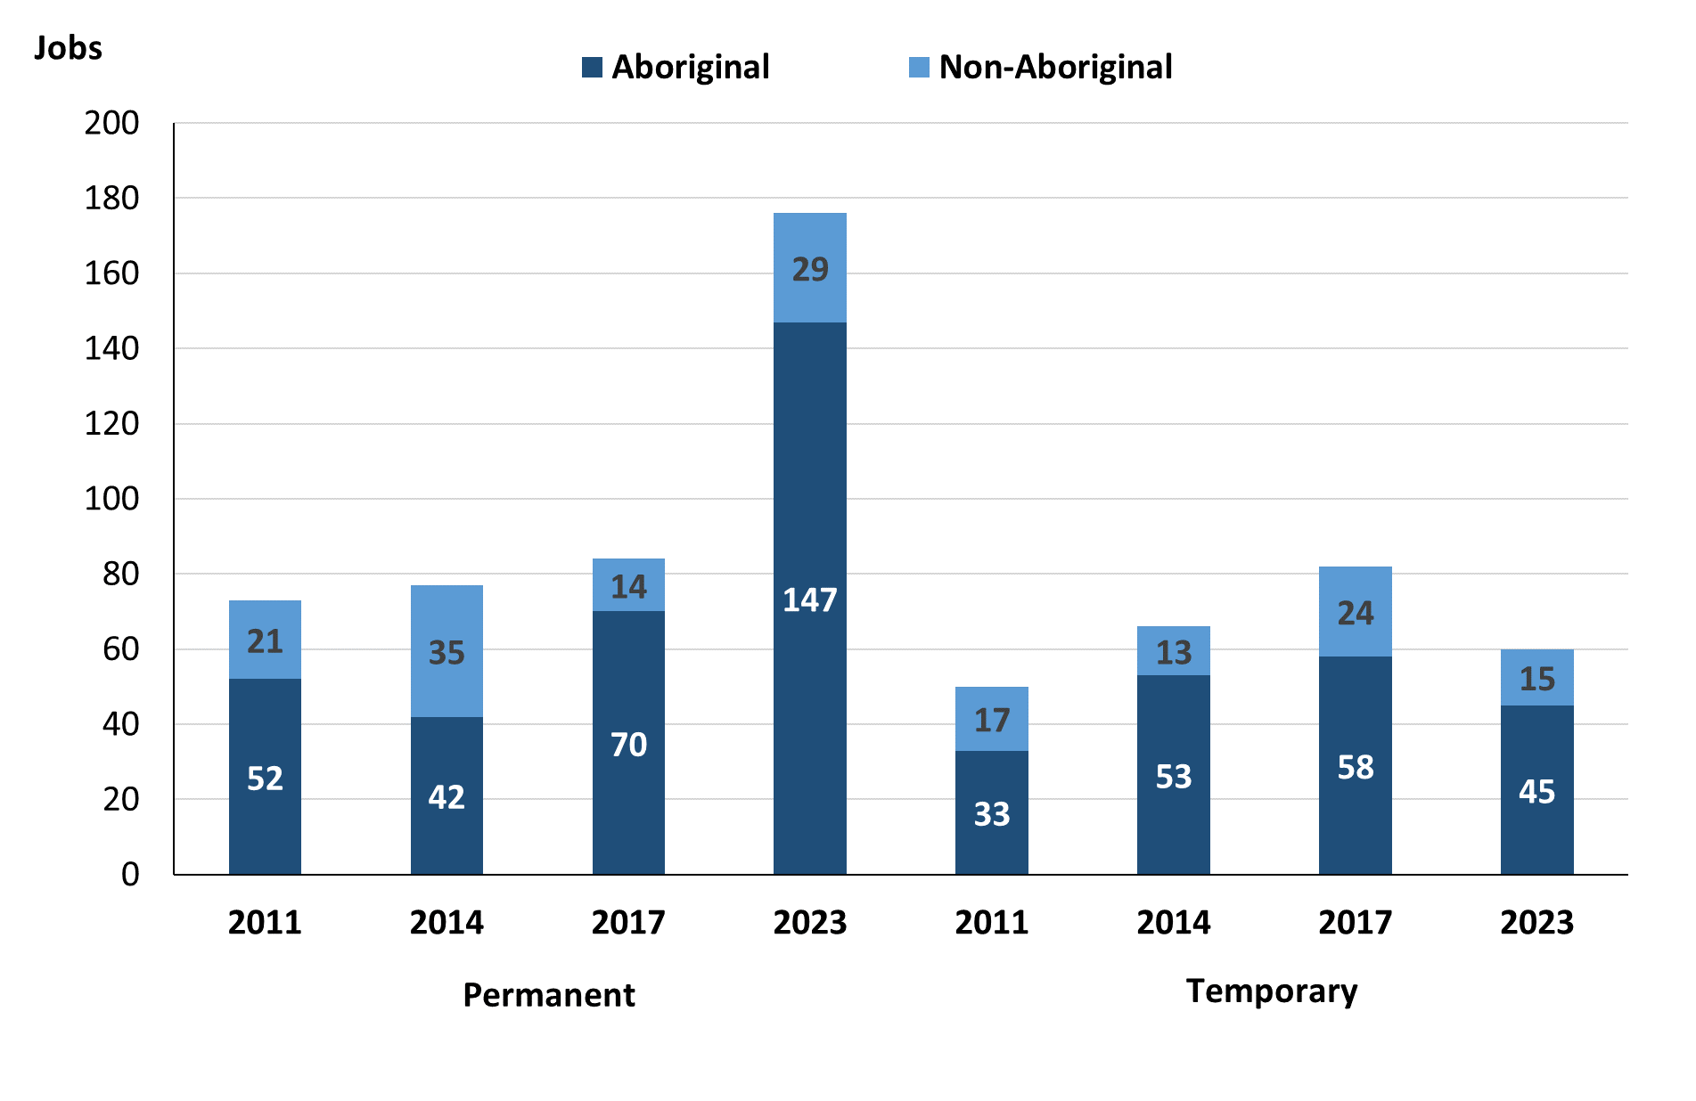

Source: Northern Territory Department of Industry, Tourism and Trade

In 2023 in Gapuwiyak:

* there were 176 **permanent** jobs, an increase of 92 jobs from 2017, and an increase of 99 jobs from 2014, of which:
* **Aboriginal** people filled 147 jobs, an increase of 77 jobs from 2017 and an increase of 105 jobs from 2014
* **non-Aboriginal** people filled 29 jobs, an increase of 15 jobs from 2017 and a decrease of 6 jobs from 2014
* there were 60 **temporary** jobs, a decrease of 22 jobs from 2017 and a decrease of 6 jobs from 2014, of which:
* **Aboriginal** people filled 45 jobs, a decrease of 13 jobs from 2017 and a decrease of 8 jobs from 2014
* **non-Aboriginal** people filled 15 jobs, a decrease of 9 jobs from 2017 and an increase of 2 jobs from 2014.

Table 6: Count of filled jobs by sector and employment status, 2011, 2014, 2017 & 2023 (a)(c)(d)(e)

|  |  |  |  |  |  |  |  |  |  |  |
| --- | --- | --- | --- | --- | --- | --- | --- | --- | --- | --- |
| **Indicator** | **2011** | | | | | | | | | |
| **Aboriginal** | | | **Non-Aboriginal** | | | **Total** | | | |
| **Perm** | **Temp** | **Total** | **Perm** | **Temp** | **Total** | **Perm** | **Temp** | **Total** |
| Public Sector | 35 | 11 | **46** | 20 | 11 | **31** | 55 | 22 | **77** |
| Private Sector | 17 | 22 | **39** | 1 | 6 | **7** | 18 | 28 | **46** |
| **Total** | **52** | **33** | **85** | **21** | **17** | **38** | **73** | **50** | **123** |

|  |  |  |  |  |  |  |  |  |  |
| --- | --- | --- | --- | --- | --- | --- | --- | --- | --- |
| **Indicator** | **2014** | | | | | | | | |
| **Aboriginal** | | | **Non-Aboriginal** | | | **Total** | | |
| **Perm** | **Temp** | **Total** | **Perm** | **Temp** | **Total** | **Perm** | **Temp** | **Total** |
| Public Sector | 21 | 27 | **48** | 30 | 10 | **40** | 51 | 37 | **88** |
| Private Sector | 21 | 26 | **47** | 5 | 3 | **8** | 26 | 29 | **55** |
| **Total** | **42** | **53** | **95** | **35** | **13** | **48** | **77** | **66** | **143** |

|  |  |  |  |  |  |  |  |  |  |
| --- | --- | --- | --- | --- | --- | --- | --- | --- | --- |
| **Indicator** | **2017** | | | | | | | | |
| **Aboriginal** | | | **Non-Aboriginal** | | | **Total** | | |
| **Perm** | **Temp** | **Total** | **Perm** | **Temp** | **Total** | **Perm** | **Temp** | **Total** |
| Public Sector | 32 | 16 | **48** | 13 | 16 | **29** | 45 | 32 | **77** |
| Private Sector | 38 | 42 | **80** | 1 | 8 | **9** | 39 | 50 | **89** |
| **Total** | **70** | **58** | **128** | **14** | **24** | **38** | **84** | **82** | **166** |

|  |  |  |  |  |  |  |  |  |  |
| --- | --- | --- | --- | --- | --- | --- | --- | --- | --- |
| **Indicator** | **2023** | | | | | | | | |
| **Aboriginal** | | | **Non-Aboriginal** | | | **Total** | | |
| **Perm** | **Temp** | **Total** | **Perm** | **Temp** | **Total** | **Perm** | **Temp** | **Total** |
| Public Sector | 39 | 31 | **70** | 16 | 12 | **28** | 55 | 43 | **98** |
| Private Sector | 108 | 14 | **122** | 13 | 3 | **16** | 121 | 17 | **138** |
| **Total** | **147** | **45** | **192** | **29** | **15** | **44** | **176** | **60** | **236** |

Source: Northern Territory Department of Industry, Tourism and Trade

In 2023 in Gapuwiyak there were:

* 98 jobs in the **Public Sector**, an increase of 21 jobs from 2017 and an increase of 10 jobs from 2014, of which:
* 55 jobs were **permanent**, an increase of 10 jobs from 2017 and an increase of 4 jobs from 2014, of which:
* **Aboriginal** people filled 39 jobs, an increase of 7 jobs from 2017 and an increase of 18 jobs from 2014
* **non-Aboriginal** people filled 16 jobs, an increase of 3 jobs from 2017 and a decrease of 14 jobs from 2014
* 43 jobs were **temporary**, an increase of 11 jobs from 2017 and an increase of 6 jobs from 2014, of which:
* **Aboriginal** people filled 31 jobs, an increase of 15 jobs from 2017 and an increase of 4 jobs from 2014
* **non-Aboriginal** people filled 12 jobs, a decrease of 4 jobs from 2017 and an increase of 2 jobs from 2014
* 138 jobs in the **Private Sector**, an increase of 49 jobs from 2017 and an increase of 83 jobs from 2014, of which:
* 121 jobs were **permanent**, an increase of 82 jobs from 2017 and an increase of 95 jobs from 2014, of which:
* **Aboriginal** people filled 108 jobs, an increase of 70 jobs from 2017 and an increase of 87 jobs from 2014
* **non-Aboriginal** people filled 13 jobs, an increase of 12 jobs from 2017 and an increase of 8 jobs from 2014
* 17 jobs were **temporary**, a decrease of 33 jobs from 2017 and a decrease of 12 jobs from 2014, of which:
* **Aboriginal** people filled 14 jobs, a decrease of 28 jobs from 2017 and a decrease of 12 jobs from 2014
* **non-Ab**original people filled 3 jobs, a decrease of 5 jobs from 2017 and unchanged from 2014.

# Job Vacancies

Table 7: Job vacancies, 2011, 2014, 2017 & 2023

|  |  |  |  |  |  |  |  |
| --- | --- | --- | --- | --- | --- | --- | --- |
| **Indicator** | **2011** | **2014** | **2017** | **2023** | **Change 2011-2014** | **Change 2014-2017** | **Change 2017-2023** |
| **Job vacancies** | **22** | **13** | **32** | **17** | **-9** | **19** | **-15** |

Source: Northern Territory Department of Industry, Tourism and Trade

Table 8a: Job vacancies by occupation, 2011, 2014, 2017 & 2023 (f)(g)

|  |  |  |  |  |  |
| --- | --- | --- | --- | --- | --- |
| **Occupation (ANZSCO major group)** | **2011** | **2014** | **2017** | **2023** | |
| Clerical and Administrative Workers | 4 | 1 | 5 | 3 | |
| Community and Personal Service Workers | 12 | 5 | 7 | 5 | |
| Labourers | 2 | 1 | 12 | 1 | |
| Managers | 1 | 1 | 1 | 0 | |
| Professionals | 2 | 5 | 7 | 7 | |
| Technicians and Trades Workers | 1 | 0 | 0 | 0 | |
| Other | 0 | 0 | 0 | 1 |
| **Total** | **22** | **13** | **32** | **17** | |

Source: Northern Territory Department of Industry, Tourism and Trade

Table 8b: Job vacancies by occupation, 2011-2014, 2014-2017 & 2017-2023 (f)(g)

|  |  |  |  |  |
| --- | --- | --- | --- | --- |
| **Occupation (ANZSCO major group)** | **Change 2011-2014** | **Change 2014-2017** | **Change 2017-2023** | |
| Clerical and Administrative Workers | -3 | 4 | -2 | |
| Community and Personal Service Workers | -7 | 2 | -2 | |
| Labourers | -1 | 11 | -11 | |
| Managers | 0 | 0 | -1 | |
| Professionals | 3 | 2 | 0 | |
| Technicians and Trades Workers | -1 | 0 | 0 | |
| Other | 0 | 0 | 1 |
| **Total** | **-9** | **19** | **-15** | |

Source: Northern Territory Department of Industry, Tourism and Trade

Table 9: Job vacancies by job title, 2023 profile (f)

|  |  |  |
| --- | --- | --- |
| **Job Vacancy** | **No.** | |
| Aboriginal and Torres Strait Islander Education Worker | 1 | |
| Assistant Principal | 1 | |
| Childcare Worker | 1 | |
| Classroom Teacher | 3 | |
| Commercial Cleaner | 1 | |
| Early Childhood Senior Teacher | 1 | |
| General Clerk | 2 | |
| Liaison Officer | 2 | |
| Media Producer | 1 | |
| Office Manager | 1 | |
| Recreation Officer | 1 | |
| Youth Worker | 1 | |
| Other (inadequately described) | 1 |
| **Total** | **17** | |

Source: Northern Territory Department of Industry, Tourism and Trade

In 2023 in Gapuwiyak:

* there were 17 **vacancies** reported, a decrease of 15 vacancies from 2017 and an increase of 4 vacancies from 2014
* Of the 17 reported vacancies, the largest requirements were for:
* 7 Professionals in the following jobs:
* Assistant Principal
* Classroom Teacher
* Early Childhood Senior Teacher
* Media Producer
* Recreation Officer
* 5 Community and Personal Service Workers in the following jobs:
* Aboriginal and Torres Strait Islander Education Worker
* Childcare Worker
* Liaison Officer
* Youth Worker
* 3 Clerical and Administrative Workers in the following jobs:
* General Clerk
* Office Manager.

# Jobs by Industry

Table 10: Count of filled jobs by industry of business, 2011, 2014, 2017, 2023 and change in count of filled jobs by industry 2011-2014, 2014-2017 & 2017-2023 (a)(h)

|  |  |  |  |  |  |  |  |  |  |  |  |
| --- | --- | --- | --- | --- | --- | --- | --- | --- | --- | --- | --- |
| **Industry (ANZSIC Division)** | **2011** | | **2014** | | **2017** | | **2023** | | **Change 2011-2014** | **Change 2014-2017** | **Change 2017-2023** |
| **Total** | **% of Total** | **Total** | **% of Total** | **Total** | **% of Total** | **Total** | **% of Total** | **Total** | **Total** | **Total** |
| Accommodation and food services | 0 | 0.0% | 0 | 0.0% | 0 | 0.0% | 4 | 1.7% | 0 | 0 | 4 |
| Administrative and Support Services | 0 | 0.0% | 0 | 0.0% | 24 | 14.5% | 0 | 0.0% | 0 | 24 | -24 |
| Arts and Recreation Services | 0 | 0.0% | 0 | 0.0% | 0 | 0.0% | 3 | 1.3% | 0 | 0 | 3 |
| Construction | 0 | 0.0% | 0 | 0.0% | 8 | 4.8% |  | 0.0% | 0 | 8 | -8 |
| Education and Training | 28 | 22.8% | 47 | 32.9% | 23 | 13.9% | 54 | 22.9% | 19 | -24 | 31 |
| Financial and Insurance Services | 4 | 3.3% | 2 | 1.4% | 3 | 1.8% | 4 | 1.7% | -2 | 1 | 1 |
| Health Care and Social Assistance | 7 | 5.7% | 10 | 7.0% | 15 | 9.0% | 31 | 13.1% | 3 | 5 | 16 |
| Public Administration and Safety | 43 | 35.0% | 43 | 30.1% | 41 | 24.7% | 76 | 32.2% | 0 | -2 | 35 |
| Retail Trade | 37 | 30.1% | 36 | 25.2% | 48 | 28.9% | 64 | 27.1% | -1 | 12 | 16 |
| Transport, Postal and Warehousing | 2 | 1.6% | 2 | 1.4% | 1 | 0.6% | 0 | 0.0% | 0 | -1 | -1 |
| **Total** | **123** | **100.0%** | **143** | **100.0%** | **166** | **100.0%** | **236** | **100.0%** | **20** | **23** | **70** |

Source: Northern Territory Department of Industry, Tourism and Trade

In 2023 in Gapuwiyak:

* the Public Administration and Safety industry was the **largest** **industry** **employer**, with 76 filled jobs or 32.2% of filled jobs, an increase of 35 jobs from 2017 and an increase of 33 jobs from 2014
* **other** **significant** industry employers were:
* Retail Trade with 64 jobs (or 27.1% of filled jobs), an increase of 16 jobs from 2017 and an increase of 28 jobs from 2014
* Education and Training with 54 jobs (or 22.9% of filled jobs), an increase of 31 jobs from 2017 and an increase of 7 jobs from 2014
* Health Care and Social Assistance with 31 jobs (or 13.1% of filled jobs), an increase of 16 jobs from 2017 and an increase of 21 jobs from 2014.

Table 11a: Count of filled jobs by industry of business, 2011, 2014, 2017 & 2023 (a)(c)(h)

|  |  |  |  |  |  |  |  |  |  |  |  |  |
| --- | --- | --- | --- | --- | --- | --- | --- | --- | --- | --- | --- | --- |
| **Industry (ANZSIC division)** | **2011** | | | **2014** | | | **2017** | | | **2023** | | |
| **Aboriginal** | **Non-Aboriginal** | **Total** | **Aboriginal** | **Non-Aboriginal** | **Total** | **Aboriginal** | **Non-Aboriginal** | **Total** | **Aboriginal** | **Non-Aboriginal** | **Total** |
| Accommodation and Food Services | 0 | 0 | **0** | 0 | 0 | **0** | 0 | 0 | **0** | 4 | 0 | **4** |
| Administrative and Support Services | 0 | 0 | **0** | 0 | 0 | **0** | 18 | 6 | **24** | 0 | 0 | **0** |
| Arts and Recreation Services | 0 | 0 | **0** | 0 | 0 | **0** | 0 | 0 | **0** | 2 | 1 | **3** |
| Construction | 0 | 0 | **0** | 0 | 0 | **0** | 7 | 1 | **8** | 0 | 0 | **0** |
| Education and Training | 10 | 18 | **28** | 26 | 21 | **47** | 12 | 11 | **23** | 36 | 18 | **54** |
| Financial and Insurance Services | 4 | 0 | **4** | 2 | 0 | **2** | 3 | 0 | **3** | 4 | 0 | **4** |
| Health Care and Social Assistance | 5 | 2 | **7** | 4 | 6 | **10** | 6 | 9 | **15** | 20 | 11 | **31** |
| Public Administration and Safety | 32 | 11 | **43** | 30 | 13 | **43** | 32 | 9 | **41** | 63 | 13 | **76** |
| Retail Trade | 33 | 4 | **37** | 31 | 5 | **36** | 48 | 0 | **48** | 63 | 1 | **64** |
| Transport, Postal and Warehousing | 0 | 2 | **2** | 0 | 2 | **2** | 0 | 1 | **1** | 0 | 0 | **0** |
| **Total** | **85** | **38** | **123** | **95** | **48** | **143** | **128** | **38** | **166** | **192** | **44** | **236** |

Source: Northern Territory Department of Industry, Tourism and Trade

Table 11b: Count of filled jobs by industry of business, 2011-2014, 2014-2017 & 2017-2023 (a)(c)(h)

|  |  |  |  |  |  |  |  |  |  |  |  |
| --- | --- | --- | --- | --- | --- | --- | --- | --- | --- | --- | --- |
| **Industry (ANZSIC division)** | **Change 2011-2014** | | | | **Change  2014-2017** | | | | **Change 2017-2023** | | |
| **Aboriginal** | **Non-Aboriginal** | **Total** | **Aboriginal** | | **Non-Aboriginal** | **Total** | **Aboriginal** | | **Non-Aboriginal** | **Total** | |
| Accommodation and Food Services | 0 | 0 | **0** | 0 | | 0 | **0** | 4 | | 0 | **4** | |
| Administrative and Support Services | 0 | 0 | **0** | 18 | | 6 | **24** | -18 | | -6 | **-24** | |
| Arts and Recreation Services | 0 | 0 | **0** | 0 | | 0 | **0** | 2 | | 1 | **3** | |
| Construction | 0 | 0 | **0** | 7 | | 1 | **8** | -7 | | -1 | **-8** | |
| Education and Training | 16 | 3 | **19** | -14 | | -10 | **-24** | 24 | | 7 | **31** | |
| Financial and Insurance Services | -2 | 0 | **-2** | 1 | | 0 | **1** | 1 | | 0 | **1** | |
| Health Care and Social Assistance | -1 | 4 | **3** | 2 | | 3 | **5** | 14 | | 2 | **16** | |
| Public Administration and Safety | -2 | 2 | **0** | 2 | | -4 | **-2** | 31 | | 4 | **35** | |
| Retail Trade | -2 | 1 | **-1** | 17 | | -5 | **12** | 15 | | 1 | **16** | |
| Transport, Postal and Warehousing | 0 | 0 | **0** | 0 | | -1 | **-1** | 0 | | -1 | **-1** | |
| **Total** | **10** | **10** | **20** | **33** | | **-10** | **23** | **64** | | **6** | **70** | |

Source: Northern Territory Department of Industry, Tourism and Trade

Chart 9: Count of filled jobs by top 5 industries, 2023 (a)(c)(h)

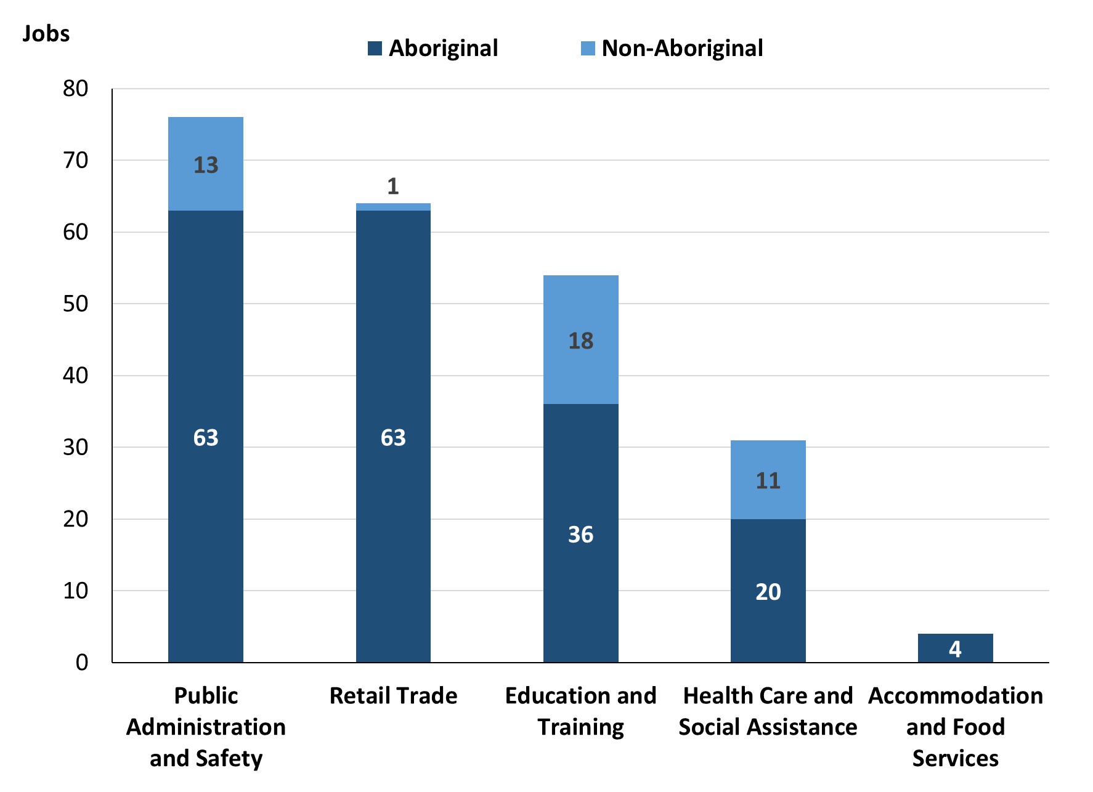

Source: Northern Territory Department of Industry, Tourism and Trade

In 2023 in Gapuwiyak:

* of the 192 **jobs filled** by **Aboriginal** people, there were:
* 63 jobs in Public Administration and Safety, an increase of 31 jobs from 2017 and an increase of 33 jobs from 2014
* 63 jobs in Retail Trade, an increase of 15 jobs from 2017 and an increase of 32 jobs from 2014
* 36 jobs in Education and Training, an increase of 24 jobs from 2017 and an increase of 10 jobs from 2014
* of the 44 **jobs filled** by **non-Aboriginal** people, there were:
* 18 were in Education and Training, an increase of 7 jobs from 2017 and a decrease of 3 jobs from 2014
* 13 jobs in Public Administration and Safety, an increase of 4 jobs from 2017 and unchanged from 2014
* 11 jobs in Health Care and Social Assistance, an increase of 2 jobs from 2017 and an increase of 5 jobs from 2014.

Table 12: Count of filled jobs by industry and employment status, 2011 (a)(c)(e)(h)

|  |  |  |  |  |  |  |  |  |  |  |
| --- | --- | --- | --- | --- | --- | --- | --- | --- | --- | --- |
| **Industry (ANZSIC division)** | **2011** | | | | | | | | | |
| **Aboriginal** | | | **Non-Aboriginal** | | | **Total** | | | |
| **Perm** | **Temp** | **Total** | **Perm** | **Temp** | **Total** | **Perm** | **Temp** | **Total** |
| Education and Training | 2 | 8 | **10** | 9 | 9 | **18** | 11 | 17 | **28** |
| Financial and Insurance Services | 3 | 1 | **4** | 0 | 0 | **0** | 3 | 1 | **4** |
| Health Care and Social Assistance | 4 | 1 | **5** | 1 | 1 | **2** | 5 | 2 | **7** |
| Public Administration and Safety | 29 | 3 | **32** | 10 | 1 | **11** | 39 | 4 | **43** |
| Retail Trade | 13 | 20 | **33** | 0 | 4 | **4** | 13 | 24 | **37** |
| Transport, Postal and Warehousing | 0 | 0 | **0** | 0 | 2 | **2** | 0 | 2 | **2** |
| **Total** | **52** | **33** | **85** | **21** | **17** | **38** | **73** | **50** | **123** |

Source: Northern Territory Department of Industry, Tourism and Trade

Table 13: Count of filled jobs by industry and employment status, 2014 (a)(c)(e)(h)

|  |  |  |  |  |  |  |  |  |  |
| --- | --- | --- | --- | --- | --- | --- | --- | --- | --- |
| **Industry (ANZSIC division)** | **2014** | | | | | | | | |
| **Aboriginal** | | | **Non-Aboriginal** | | | **Total** | | |
| **Perm** | **Temp** | **Total** | **Perm** | **Temp** | **Total** | **Perm** | **Temp** | **Total** |
| Arts and Recreation Services | 2 | 0 | **2** | 1 | 0 | **1** | 3 | 0 | **3** |
| Education and Training | 3 | 23 | **26** | 13 | 8 | **21** | 16 | 31 | **47** |
| Financial and Insurance Services | 2 | 0 | **2** | 0 | 0 | **0** | 2 | 0 | **2** |
| Health Care and Social Assistance | 4 | 0 | **4** | 6 | 0 | **6** | 10 | 0 | **10** |
| Public Administration and Safety | 14 | 16 | **30** | 11 | 2 | **13** | 25 | 18 | **43** |
| Retail Trade | 17 | 14 | **31** | 4 | 1 | **5** | 21 | 15 | **36** |
| **Total** | **42** | **53** | **95** | **35** | **13** | **48** | **77** | **66** | **143** |

Source: Northern Territory Department of Industry, Tourism and Trade

Table 14: Count of filled jobs by industry and employment status, 2017 (a)(c)(e)(h)

|  |  |  |  |  |  |  |  |  |  |
| --- | --- | --- | --- | --- | --- | --- | --- | --- | --- |
| **Industry (ANZSIC division)** | **2017** | | | | | | | | |
| **Aboriginal** | | | **Non-Aboriginal** | | | **Total** | | |
| **Perm** | **Temp** | **Total** | **Perm** | **Temp** | **Total** | **Perm** | **Temp** | **Total** |
| Administrative and Support Services | 0 | 18 | **18** | 0 | 6 | **6** | 0 | 24 | **24** |
| Arts and Recreation Services | 2 | 0 | **2** | 0 | 1 | **1** | 2 | 1 | **3** |
| Construction | 1 | 6 | **7** | 1 | 0 | **1** | 2 | 6 | **8** |
| Education and Training | 7 | 5 | **12** | 3 | 8 | **11** | 10 | 13 | **23** |
| Financial and Insurance Services | 2 | 1 | **3** | 0 | 0 | **0** | 2 | 1 | **3** |
| Health Care and Social Assistance | 2 | 4 | **6** | 2 | 7 | **9** | 4 | 11 | **15** |
| Public Administration and Safety | 25 | 7 | **32** | 8 | 1 | **9** | 33 | 8 | **41** |
| Retail Trade | 31 | 17 | **48** | 0 | 0 | **0** | 31 | 17 | **48** |
| Transport, Postal and Warehousing | 0 | 0 | **0** | 0 | 1 | **1** | 0 | 1 | **1** |
| **Total** | **70** | **58** | **128** | **14** | **24** | **38** | **84** | **82** | **166** |

Source: Northern Territory Department of Industry, Tourism and Trade

Table 15: Count of filled jobs by industry and employment status, 2023 (a)(c)(e)(h)

|  |  |  |  |  |  |  |  |  |  |
| --- | --- | --- | --- | --- | --- | --- | --- | --- | --- |
| **Industry (ANZSIC division)** | **2023** | | | | | | | | |
| **Aboriginal** | | | **Non-Aboriginal** | | | **Total** | | |
| **Perm** | **Temp** | **Total** | **Perm** | **Temp** | **Total** | **Perm** | **Temp** | **Total** |
| Accommodation and Food Services | 1 | 3 | **4** | 0 | 0 | **0** | 1 | 3 | **4** |
| Arts and Recreation Services | 0 | 2 | **2** | 0 | 1 | **1** | 0 | 3 | **3** |
| Education and Training | 6 | 30 | **36** | 6 | 12 | **18** | 12 | 42 | **54** |
| Financial and Insurance Services | 4 | 0 | **4** | 0 | 0 | **0** | 4 | 0 | **4** |
| Health Care and Social Assistance | 12 | 8 | **20** | 9 | 2 | **11** | 21 | 10 | **31** |
| Public Administration and Safety | 61 | 2 | **63** | 13 | 0 | **13** | 74 | 2 | **76** |
| Retail Trade | 63 | 0 | **63** | 1 | 0 | **1** | 64 | 0 | **64** |
| **Total** | **147** | **45** | **192** | **29** | **15** | **44** | **176** | **60** | **236** |

Source: Northern Territory Department of Industry, Tourism and Trade

In 2023 in Gapuwiyak:

* of the 176 **permanent** jobs, there were:
* 74 jobs in Public Administration and Safety, an increase of 41 jobs from 2017 and an increase of 49 jobs from 2014, including:
* **Aboriginal** people filled 61 jobs, an increase of 36 jobs from 2017 and an increase of 47 jobs from 2014
* **non-Aboriginal** people filled 13 jobs, an increase of 5 jobs from 2017 and an increase of 2 jobs from 2014
* 64 jobs in Retail Trade, an increase of 33 jobs from 2017 and an increase of 43 jobs from 2014, including:
* **Aboriginal** people filled 63 jobs, an increase of 32 jobs from 2017 and an increase of 46 jobs from 2014
* a **non-Aboriginal** person filled 1 job, an increase of 1 job from 2017 and a decrease of 3 jobs from 2014
* 21 jobs in Health Care and Social Assistance, an increase of 17 jobs from 2017 and an increase of 11 jobs from 2014, including:
* **Aboriginal** people filled 12 jobs, an increase of 10 jobs from 2017 and an increase of 8 jobs from 2014
* **non-Aboriginal** people filled 9 jobs, an increase of 7 jobs from 2017 and an increase of 3 jobs from 2014
* of the 60 **temporary** jobs, there were:
* 42 jobs in Education and Training, an increase of 29 jobs from 2017 and an increase of 11 jobs from 2014, including:
* **Aboriginal** people filled 30 jobs, an increase of 25 jobs from 2017 and an increase of 7 jobs from 2014
* **non-Aboriginal** people filled 12 jobs, an increase of 4 jobs from 2017 and an increase of 4 jobs from 2014
* 10 jobs in Health Care and Social Assistance, a decrease of 1 job from 2017 and an increase of 10 jobs from 2014, including:
* **Aboriginal** people filled 2 jobs, a decrease of 2 jobs from 2017 and an increase of 2 jobs from 2014
* **non-Aboriginal** people filled 2 jobs filled 3 jobs, a decrease of 5 jobs from 2017 and an increase of 2 jobs from 2014
* 3 jobs in Accommodation and food services, an increase of 3 jobs from 2017 and an increase of 3 jobs from 2014, including
* **Aboriginal** people filled 3 jobs, an increase of 3 jobs from 2017 and an increase of 3 jobs from 2014
* **non-Aboriginal** people filled 0 jobs, unchanged from 2017 and unchanged from 2014.

# Jobs by Occupation

Table 16a: Count of filled jobs by occupation, 2011, 2014, 2017 & 2023 (a)(f)(g)

|  |  |  |  |  |  |  |  |  |
| --- | --- | --- | --- | --- | --- | --- | --- | --- |
| **Occupation (ANZSCO major group)** | **2011** | | **2014** | | **2017** | | **2023** | |
| **Total** | **% of Total** | **Total** | **% of Total** | **Total** | **% of Total** | **Total** | **% of Total** |
| Clerical and Administrative Workers | 11 | 8.9% | 14 | 9.8% | 24 | 14.5% | 23 | 9.7% |
| Community and Personal Service Workers | 28 | 22.8% | 54 | 37.8% | 48 | 28.9% | 59 | 25.0% |
| Labourers | 16 | 13.0% | 10 | 7.0% | 12 | 7.2% | 14 | 5.9% |
| Machinery Operators and Drivers | 0 | 0.0% | 0 | 0.0% | 0 | 0.0% | 5 | 2.1% |
| Managers | 8 | 6.5% | 10 | 7.0% | 5 | 3.0% | 8 | 3.4% |
| Professionals | 24 | 19.5% | 33 | 23.1% | 39 | 23.5% | 56 | 23.7% |
| Sales Workers | 34 | 27.6% | 21 | 14.7% | 34 | 20.5% | 63 | 26.7% |
| Technicians and Trades Workers | 1 | 0.8% | 1 | 0.7% | 4 | 2.4% | 8 | 3.4% |
| Other Occupations | 1 | 0.8% | 0 | 0.0% | 0 | 0.0% | 0 | 0.0% |
| **Total** | **123** | **100.0%** | **143** | **100.0%** | **166** | **100.0%** | **236** | **100.0%** |

Source: Northern Territory Department of Industry, Tourism and Trade

Table 16b: Count of filled jobs by occupation, 2011, 2014, 2017 & 2023 (a)(f)(g)

|  |  |  |  |
| --- | --- | --- | --- |
| **Occupation (ANZSCO major group)** | **Change 2011-2014** | **Change 2014-2017** | **Change 2017-2023** |
| **Total** | **Total** | **Total** |
| Clerical and Administrative Workers | 3 | 10 | -1 |
| Community and Personal Service Workers | 26 | -6 | 11 |
| Labourers | -6 | 2 | 2 |
| Machinery Operators and Drivers | 0 | 0 | 5 |
| Managers | 2 | -5 | 3 |
| Professionals | 9 | 6 | 17 |
| Sales Workers | -13 | 13 | 29 |
| Technicians and Trades Workers | 0 | 3 | 4 |
| Other Occupations | -1 | 0 | 0 |
| **Total** | **20** | **23** | **70** |

Source: Northern Territory Department of Industry, Tourism and Trade

Chart 10: Percentage and count of top 6 filled jobs by occupation, 2011, 2014, 2017 & 2023 (a)(f)(g)

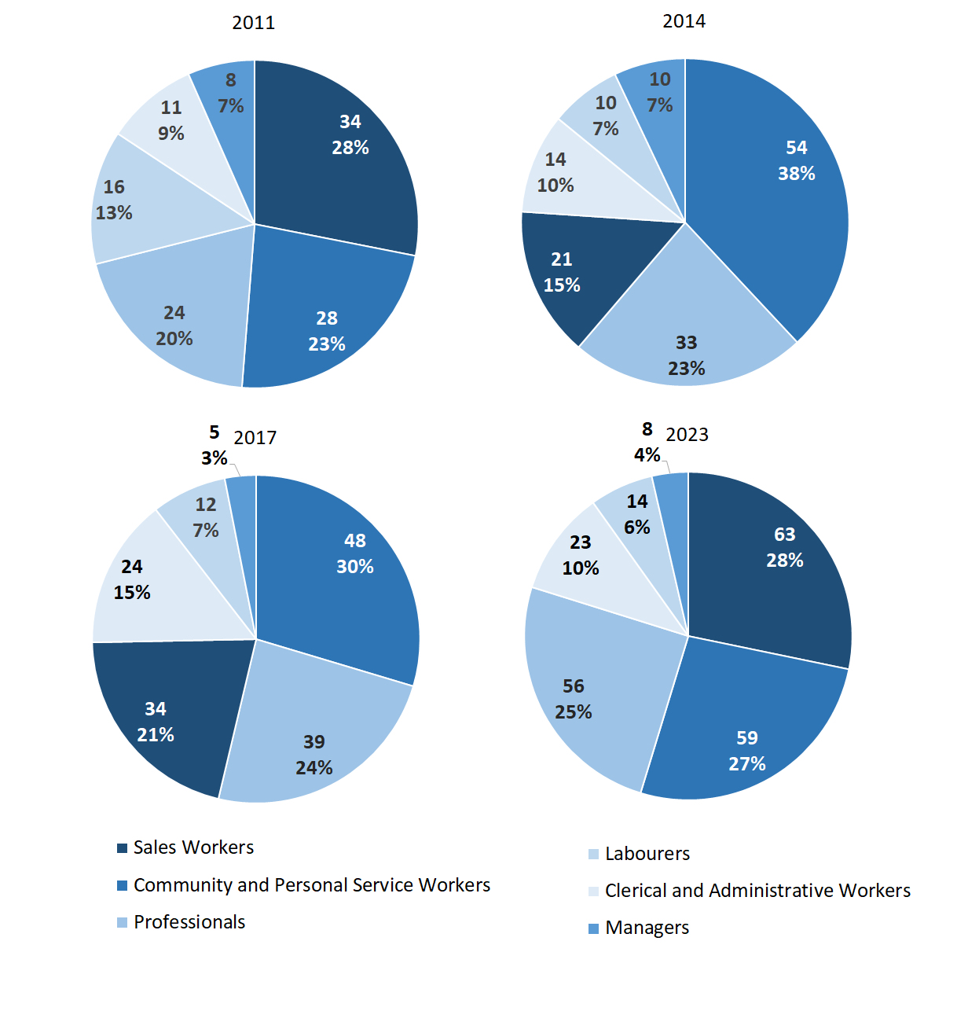

Source: Northern Territory Department of Industry, Tourism and Trade

In 2023 in Gapuwiyak:

* Sales Workers was the **largest** **occupation** **classification** in terms of filled jobs, accounting for 63 jobs (26.7% of total filled jobs), an increase of 29 jobs from 2017 and an increase of 42 jobs from 2014
* **other** **significant** occupation classifications were:
* Community and Personal Service Workers account for 59 jobs or 25.0% of total jobs an increase of 11 jobs from 2017 and an increase of 5 jobs from 2014
* Professionals account for 56 jobs or 23.7% of total jobs an increase of 17 jobs from 2017 and an increase of 23 jobs from 2014
* Clerical and Administrative Workers account for 23 jobs or 9.7% of total jobs a decrease of 1 job from 2017 and an increase of 9 jobs from 2014.

**Table 17a: Count of filled jobs by ANZSCO occupation, 2011, 2014, 2017 & 2023 (a)(c)(f)(g)**

|  |  |  |  |  |  |  |  |  |  |  |  |  |  |  |
| --- | --- | --- | --- | --- | --- | --- | --- | --- | --- | --- | --- | --- | --- | --- |
| **Occupation (ANZSCO major group)** | **2011** | | | | **2014** | | | | **2017** | | | **2023** | | |
| **Aboriginal** | **Non-Aboriginal** | **Total** | **Aboriginal** | | **Non-Aboriginal** | **Total** | **Aboriginal** | | **Non-Aboriginal** | **Total** | **Aboriginal** | **Non-Aboriginal** | **Total** |
| Clerical and Administrative Workers | 7 | 4 | **11** | 11 | | 3 | **14** | 18 | | 6 | **24** | 17 | 6 | **23** |
| Community and Personal Service Workers | 20 | 8 | **28** | 44 | | 10 | **54** | 42 | | 6 | **48** | 53 | 6 | **59** |
| Labourers | 12 | 4 | **16** | 8 | | 2 | **10** | 11 | | 1 | **12** | 12 | 2 | **14** |
| Machinery Operators and Drivers | 0 | 0 | **0** | 0 | | 0 | **0** | 0 | | 0 | **0** | 5 | 0 | **5** |
| Managers | 1 | 7 | **8** | 1 | | 9 | **10** | 2 | | 3 | **5** | 3 | 5 | **8** |
| Professionals | 10 | 14 | **24** | 9 | | 24 | **33** | 19 | | 20 | **39** | 33 | 23 | **56** |
| Sales Workers | 34 | 0 | **34** | 21 | | 0 | **21** | 34 | | 0 | **34** | 62 | 1 | **63** |
| Technicians and Trades Workers | 0 | 1 | **1** | 1 | | 0 | **1** | 2 | | 2 | **4** | 7 | 1 | **8** |
| Other Occupations | 1 | 0 | **1** | 0 | | 0 | **0** | 0 | | 0 | **0** | 0 | 0 | **0** |
| **Total** | **85** | **38** | **123** | **95** | | **48** | **143** | **128** | | **38** | **166** | **192** | **44** | **236** |

Source: Northern Territory Department of Industry, Tourism and Trade

**Table 17b: Count of filled jobs by ANZSCO occupation, 2011-2014, 2014-2017 & 2017-2023 (a)(c)(f)(g)**

|  |  |  |  |  |  |  |  |  |  |  |  |  |
| --- | --- | --- | --- | --- | --- | --- | --- | --- | --- | --- | --- | --- |
| **Occupation (ANZSCO major group)** | **Change 2011-2014** | | | | **Change 2014-2017** | | | | **Change 2017-2023** | | | |
| **Aboriginal** | **Non-Aboriginal** | **Total** | **Aboriginal** | | **Non-Aboriginal** | **Total** | **Aboriginal** | | **Non-Aboriginal** | **Total** |
| Clerical and Administrative Workers | 4 | -1 | **3** | 7 | | 3 | **10** | -1 | | 0 | **-1** |
| Community and Personal Service Workers | 24 | 2 | **26** | -2 | | -4 | **-6** | 11 | | 0 | **11** |
| Labourers | -4 | -2 | **-6** | 3 | | -1 | **2** | 1 | | 1 | **2** |
| Machinery Operators and Drivers | 0 | 0 | **0** | 0 | | 0 | **0** | 5 | | 0 | **5** |
| Managers | 0 | 2 | **2** | 1 | | -6 | **-5** | 1 | | 2 | **3** |
| Professionals | -1 | 10 | **9** | 10 | | -4 | **6** | 14 | | 3 | **17** |
| Sales Workers | -13 | 0 | **-13** | 13 | | 0 | **13** | 28 | | 1 | **29** |
| Technicians and Trades Workers | 1 | -1 | **0** | 1 | | 2 | **3** | 5 | | -1 | **4** |
| Other Occupations | -1 | 0 | **-1** | 0 | | 0 | **0** | 0 | | 0 | **0** |
| **Total** | **10** | **10** | **20** | **33** | | **-10** | **23** | **64** | | **6** | **70** |

Source: Northern Territory Department of Industry, Tourism and Trade

In 2023 in Gapuwiyak:

* of the 192 jobs filled by **Aboriginal** people, there were:
* 62 Sales Workers, an increase of 28 jobs from 2017 and an increase of 41 jobs from 2014
* 53 Community and Personal Service Workers, an increase of 11 jobs from 2017 and an increase of 9 jobs from 2014
* 33 Professionals, an increase of 14 jobs from 2017 and an increase of 24 jobs from 2014
* of the 44 jobs filled by **non-Aboriginal** people, there were:
* 23 Professionals, an increase of 3 jobs from 2017 and a decrease of 1 job from 2014
* 6 Clerical and Administrative Workers, unchanged from 2017 and an increase of 3 jobs from 2014
* 6 Community and Personal Service Workers, unchanged from 2017 and a decrease of 4 jobs from 2014.

# Jobs by Industry by Occupation

Table 18: Count of filled jobs by industry by occupation, 2011 (a)(f)(g)(h)

|  |  |  |  |  |  |  |  |  |  |  |
| --- | --- | --- | --- | --- | --- | --- | --- | --- | --- | --- |
| **Industry**  **(ANZSIC Division)** |  | **Occupation (ANZSCO major group)** | | | | | | | | |
| **Clerical and Administrative Workers** | **Community and Personal Service Workers** | **Labourers** | **Machinery Operators and Drivers** | **Managers** | **Professionals** | **Sales Workers** | **Technicians and Trades Workers** | **Other Occupations** | **Total** |
| Education and Training | 2 | 9 | 3 | 0 | 0 | 14 | 0 | 0 | 0 | **28** |
| Financial and Insurance Services | 3 | 0 | 0 | 0 | 0 | 1 | 0 | 0 | 0 | **4** |
| Health Care and Social Assistance | 0 | 1 | 2 | 0 | 0 | 3 | 0 | 0 | 1 | **7** |
| Public Administration and Safety | 6 | 18 | 11 | 0 | 3 | 3 | 1 | 1 | 0 | **43** |
| Retail Trade | 0 | 0 | 0 | 0 | 4 | 0 | 33 | 0 | 0 | **37** |
| Transport, Postal and Warehousing | 0 | 0 | 0 | 0 | 0 | 2 | 0 | 0 | 0 | **2** |
| **Total** | **11** | **28** | **16** | **0** | **8** | **24** | **34** | **1** | **1** | **123** |

Source: Northern Territory Department of Industry, Tourism and Trade

Table 19: Count of filled jobs by industry by occupation, 2014 (a)(f)(g)(h)

|  |  |  |  |  |  |  |  |  |  |  |
| --- | --- | --- | --- | --- | --- | --- | --- | --- | --- | --- |
| **2014** | | | | | | | | | | |
| **Industry**  **(ANZSIC Division)** |  | **Occupation (ANZSCO major group)** | | | | | | | | |
| **Clerical and Administrative Workers** | **Community and Personal Service Workers** | **Labourers** | **Machinery Operators and Drivers** | **Managers** | **Professionals** | **Sales Workers** | **Technicians and Trades Workers** | **Other Occupations** | **Total** |
| Arts and Recreation Services | 0 | 0 | 0 | 0 | 1 | 2 | 0 | 0 | 0 | **3** |
| Education and Training | 2 | 21 | 3 | 0 | 2 | 19 | 0 | 0 | 0 | **47** |
| Financial and Insurance Services | 2 | 0 | 0 | 0 | 0 | 0 | 0 | 0 | 0 | **2** |
| Health Care and Social Assistance | 1 | 5 | 1 | 0 | 0 | 3 | 0 | 0 | 0 | **10** |
| Public Administration and Safety | 3 | 25 | 6 | 0 | 1 | 7 | 0 | 1 | 0 | **43** |
| Retail Trade | 6 | 3 | 0 | 0 | 6 | 0 | 21 | 0 | 0 | **36** |
| Transport, Postal and Warehousing | 0 | 0 | 0 | 0 | 0 | 2 | 0 | 0 | 0 | **2** |
| **Total** | **14** | **54** | **10** | **0** | **10** | **33** | **21** | **1** | **0** | **143** |

Source: Northern Territory Department of Industry, Tourism and Trade

Table 20: Count of filled jobs by occupation and by industry, 2017 (a)(f)(g)(h)

|  |  |  |  |  |  |  |  |  |  |  |  |
| --- | --- | --- | --- | --- | --- | --- | --- | --- | --- | --- | --- |
| **2017** | | | | | | | | | | | |
| **Industry**  **(ANZSIC Division)** |  | **Occupation (ANZSCO major group)** | | | | | | | | | |
| **Clerical and Administrative Workers** | **Community and Personal Service Workers** | **Labourers** | **Machinery Operators and Drivers** | **Managers** | **Professionals** | **Sales Workers** | **Technicians and Trades Workers** | **Other Occupations** | **Total** |
| Administrative and Support Services | 12 | 1 | 0 | 0 | 0 | 11 | 0 | 0 | 0 | **24** |
| Arts and Recreation Services | 0 | 0 | 0 | 0 | 1 | 2 | 0 | 0 | 0 | **3** |
| Construction | 0 | 1 | 6 | 0 | 0 | 0 | 0 | 1 | 0 | **8** |
| Education and Training | 2 | 5 | 0 | 0 | 1 | 15 | 0 | 0 | 0 | **23** |
| Financial and Insurance Services | 3 | 0 | 0 | 0 | 0 | 0 | 0 | 0 | 0 | **3** |
| Health Care and Social Assistance | 3 | 5 | 1 | 0 | 1 | 5 | 0 | 0 | 0 | **15** |
| Public Administration and Safety | 4 | 22 | 5 | 0 | 2 | 5 | 0 | 3 | 0 | **41** |
| Retail Trade | 0 | 14 | 0 | 0 | 0 | 0 | 34 | 0 | 0 | **48** |
| Transport, Postal and Warehousing | 0 | 0 | 0 | 0 | 0 | 1 | 0 | 0 | 0 | **1** |
| **Total** | **24** | **48** | **12** | **0** | **5** | **39** | **34** | **4** | **0** | **166** |

Source: Northern Territory Department of Industry, Tourism and Trade

Table 21: Count of filled jobs by occupation and by industry, 2023 (a)(f)(g)(h)

|  |  |  |  |  |  |  |  |  |  |  |  |
| --- | --- | --- | --- | --- | --- | --- | --- | --- | --- | --- | --- |
| **2023** | | | | | | | | | | | |
| **Industry**  **(ANZSIC Division)** |  | **Occupation (ANZSCO major group)** | | | | | | | | | |
| **Clerical and Administrative Workers** | **Community and Personal Service Workers** | **Labourers** | **Machinery Operators and Drivers** | **Managers** | **Professionals** | **Sales Workers** | **Technicians and Trades Workers** | **Other Occupations** | **Total** |
| Accommodation and food services | 0 | 1 | 0 | 0 | 0 | 1 | 0 | 2 | 0 | **4** |
| Arts and Recreation Services | 0 | 0 | 0 | 0 | 0 | 3 | 0 | 0 | 0 | **3** |
| Education and Training | 9 | 17 | 11 | 0 | 0 | 16 | 0 | 1 | 0 | **54** |
| Financial and Insurance Services | 4 | 0 | 0 | 0 | 0 | 0 | 0 | 0 | 0 | **4** |
| Health Care and Social Assistance | 5 | 1 | 0 | 4 | 1 | 20 | 0 | 0 | 0 | **31** |
| Public Administration and Safety | 5 | 40 | 3 | 1 | 6 | 16 | 0 | 5 | 0 | **76** |
| Retail Trade | 0 | 0 | 0 | 0 | 1 | 0 | 63 | 0 | 0 | **64** |
| **Total** | **23** | **59** | **14** | **5** | **8** | **56** | **63** | **8** | **0** | **236** |

Source: Northern Territory Department of Industry, Tourism and Trade

In 2023 in Gapuwiyak:

* the largest **occupation group** was sales workers with 63 filled jobs,
* Public Administration and Safety (the largest industry), had 40 filled jobs for Community and Personal Service Workers,
* Professionals had 16 filled jobs, an increase of 18 jobs and 11 jobs respectively from 2017,
* Community and Personal Service Workers had the majority of 59 jobs (the second largest occupation group) and were shared across Public Administration and Safety with 40 jobs and Education and Training industries with 17 jobs,
* Administrative and Support Services, Construction and Transport, Postal and Warehousing showed a combined decrease in filled jobs of 33 between 2023 and 2017,
* Accommodation and food services was a new industry and had 4 filled jobs; this industry had zero jobs filled in 2017.

# Jobs by Gender

Table 22a: Count of filled jobs by gender, 2011, 2014, 2017 & 2023 (a)(c)(i)

|  |  |  |  |  |  |  |  |  |  |  |  |  |  |
| --- | --- | --- | --- | --- | --- | --- | --- | --- | --- | --- | --- | --- | --- |
| **Indicator** | **2011** | | | **2014** | | | **2017** | | | **2023** | | | |
| **Aboriginal** | **Non-Aboriginal** | **Total** | **Aboriginal** | **Non-Aboriginal** | **Total** | **Aboriginal** | **Non-Aboriginal** | **Total** | **Aboriginal** | **Non-Aboriginal** | **Total** |
| Male | 32 | 19 | **51** | 42 | 24 | **66** | 59 | 15 | **74** | 74 | 19 | **93** |
| Female | 53 | 19 | **72** | 53 | 24 | **77** | 66 | 23 | **89** | 115 | 25 | **140** |
| **Total** | **85** | **38** | **123** | **95** | **48** | **143** | **125** | **38** | **163** | **192** | **44** | **236** |

Source: Northern Territory Department of Industry, Tourism and Trade

Table 22b: Count of filled jobs by gender, 2011-2014, 2014-2017 & 2017-2023 2023 (a)(c)(i)

|  |  |  |  |  |  |  |  |  |  |
| --- | --- | --- | --- | --- | --- | --- | --- | --- | --- |
| **Indicator** | **2011-2014 Change** | | | **2014-2017 Change** | | | **2017-2023 Change** | | |
| **Aboriginal** | **Non-Aboriginal** | **Total** | **Aboriginal** | **Non-Aboriginal** | **Total** | **Aboriginal** | **Non-Aboriginal** | **Total** |
| Male | 10 | 5 | **15** | 17 | -9 | **8** | 15 | 4 | **19** |
| Female | 0 | 5 | **5** | 13 | -1 | **12** | 49 | 2 | **51** |
| **Total** | **10** | **10** | **20** | **30** | **-10** | **20** | **67** | **6** | **73** |

Source: Northern Territory Department of Industry, Tourism and Trade

Chart 11: Count of filled jobs by gender, 2011, 2014, 2017 & 2023 (a)(c)(i)

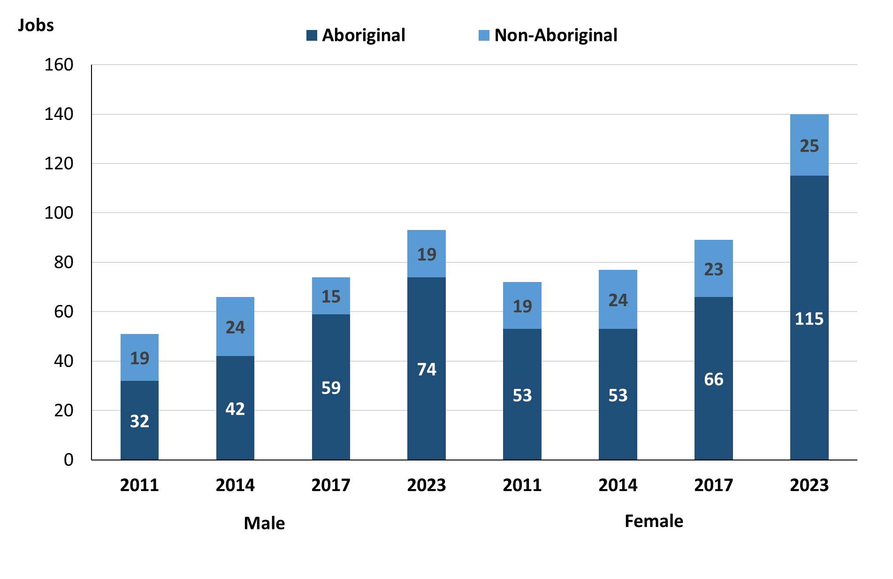

Source: Northern Territory Department of Industry, Tourism and Trade

In 2023 in Gapuwiyak:

* there were 93 **jobs** fil**l**ed **by** **males**, an increase of 19 jobs from 2017 and an increase of 27 jobs from 2014
* of the 93 jobs **filled by males:**
* 74 were **Aboriginal**, an increase of 15 jobs from 2017 and an increase of 32 jobs from 2014
* 19 were **non-Aboriginal**, an increase of 4 jobs from 2017 and a decrease of 5 jobs from 2014
* there were 140 **jobs** **filled** **by** **females**, an increase of 51 jobs from 2017 and an increase of 63 jobs from 2014
* of the 140 jobs **filled by females**:
* 115 were **Aboriginal**, an increase of 49 jobs from 2017 and an increase of 62 jobs from 2014
* 25 were **non-Aboriginal**, an increase of 2 jobs from 2017 and an increase of 1 job from 2014.

Table 23: Count of filled jobs by gender, by full-time/part-time status, by job permanency and by sector 2011 (a)(b)(c)(d)(e)(i)

|  |  |  |  |  |  |  |  |  |  |  |
| --- | --- | --- | --- | --- | --- | --- | --- | --- | --- | --- |
| **2011** | | | | | | | | | | |
| **Indicator** | **Male** | | | **Female** | | | **Total** | | | |
| **Aboriginal** | **Non-Aboriginal** | **Total** | **Aboriginal** | **Non-Aboriginal** | **Total** | **Aboriginal** | **Non-Aboriginal** | **Total** |
| Full-time | 12 | 18 | **30** | 13 | 16 | **29** | 25 | 34 | **59** |
| Part-time | 20 | 1 | **21** | 40 | 3 | **43** | 60 | 4 | **64** |
| **Total** | **32** | **19** | **51** | **53** | **19** | **72** | **85** | **38** | **123** |
|  | | | | | | | | | | |
| Permanent | 21 | 11 | **32** | 31 | 10 | **41** | 52 | 21 | **73** |
| Temporary | 11 | 8 | **19** | 22 | 9 | **31** | 33 | 17 | **50** |
| **Total** | **32** | **19** | **51** | **53** | **19** | **72** | **85** | **38** | **123** |
|  | | | | | | | | | | |
| Public Sector | 20 | 15 | **35** | 26 | 16 | **42** | 46 | 31 | **77** |
| Private Sector | 12 | 4 | **16** | 27 | 3 | **30** | 39 | 7 | **46** |
| **Total** | **32** | **19** | **51** | **53** | **19** | **72** | **85** | **38** | **123** |

Source: Northern Territory Department of Industry, Tourism and Trade

Table 24: Count of filled jobs by gender, by full-time/part-time status, by job permanency and by sector 2014 (a)(b)(c)(d)(e)(i)

|  |  |  |  |  |  |  |  |  |  |
| --- | --- | --- | --- | --- | --- | --- | --- | --- | --- |
| **2014** | | | | | | | | | |
| **Indicator** | **Male** | | | **Female** | | | **Total** | | |
| **Aboriginal** | **Non-Aboriginal** | **Total** | **Aboriginal** | **Non-Aboriginal** | **Total** | **Aboriginal** | **Non-Aboriginal** | **Total** |
| Full-time | 13 | 24 | **37** | 21 | 20 | **41** | 34 | 44 | **78** |
| Part-time | 29 | 0 | **29** | 32 | 4 | **36** | 61 | 4 | **65** |
| **Total** | **42** | **24** | **66** | **53** | **24** | **77** | **95** | **48** | **143** |
| Permanent | 17 | 19 | **36** | 25 | 16 | **41** | 42 | 35 | **77** |
| Temporary | 25 | 5 | **30** | 28 | 8 | **36** | 53 | 13 | **66** |
| **Total** | **42** | **24** | **66** | **53** | **24** | **77** | **95** | **48** | **143** |
| Public Sector | 19 | 20 | **39** | 29 | 20 | **49** | 48 | 40 | **88** |
| Private Sector | 23 | 4 | **27** | 24 | 4 | **28** | 47 | 8 | **55** |
| **Total** | **42** | **24** | **66** | **53** | **24** | **77** | **95** | **48** | **143** |

Source: Northern Territory Department of Industry, Tourism and Trade

Table 25: Count of filled jobs by gender[2], by full-time/part-time status, by job permanency and by sector 2017 (a)(b)(c)(d)(e)(i)

|  |  |  |  |  |  |  |  |  |  |  |
| --- | --- | --- | --- | --- | --- | --- | --- | --- | --- | --- |
| **2017** | | | | | | | | | | |
| **Indicator** | **Male** | | | **Female** | | | **Total** | | | |
| **Aboriginal** | **Non-Aboriginal** | **Total** | **Aboriginal** | **Non-Aboriginal** | **Total** | **Aboriginal** | **Non-Aboriginal** | **Total** |
| Full-time | 21 | 14 | **35** | 18 | 21 | **39** | 42 | 35 | **77** |
| Part-time | 38 | 1 | **39** | 48 | 2 | **50** | 86 | 3 | **89** |
| **Total** | **59** | **15** | **74** | **66** | **23** | **89** | **128** | **38** | **166** |
| Permanent | 32 | 6 | **38** | 35 | 8 | **43** | 70 | 14 | **84** |
| Temporary | 27 | 9 | **36** | 31 | 15 | **46** | 58 | 24 | **82** |
| **Total** | **59** | **15** | **74** | **66** | **23** | **89** | **128** | **38** | **166** |
| Public Sector | 21 | 10 | **31** | 24 | 19 | **43** | 48 | 29 | **77** |
| Private Sector | 38 | 5 | **43** | 42 | 4 | **46** | 80 | 9 | **89** |
| **Total** | **59** | **15** | **74** | **66** | **23** | **89** | **128** | **38** | **166** |

Source: Northern Territory Department of Industry, Tourism and Trade

Table 26: Count of filled jobs by gender, by full-time/part-time status, by job permanency and by sector 2023 (a)(b)(c)(d)(e)(i)

|  |  |  |  |  |  |  |  |  |  |  |
| --- | --- | --- | --- | --- | --- | --- | --- | --- | --- | --- |
| **2023** | | | | | | | | | | |
| **Indicator** | **Male** | | | **Female** | | | **Total** | | | |
| **Aboriginal** | **Non-Aboriginal** | **Total** | **Aboriginal** | **Non-Aboriginal** | **Total** | **Aboriginal** | **Non-Aboriginal** | **Total** |
| Full-time | 31 | 17 | **48** | 44 | 22 | **66** | 77 | 39 | **116** |
| Part-time | 43 | 2 | **45** | 71 | 3 | **74** | 115 | 5 | **120** |
| **Total** | **74** | **19** | **93** | **115** | **25** | **140** | **192** | **44** | **236** |
| Permanent | 62 | 12 | **74** | 85 | 17 | **102** | 147 | 29 | **176** |
| Temporary | 12 | 7 | **19** | 30 | 8 | **38** | 45 | 15 | **60** |
| **Total** | **74** | **19** | **93** | **115** | **25** | **140** | **192** | **44** | **236** |
| Public Sector | 23 | 14 | **37** | 45 | 14 | **59** | 70 | 28 | **98** |
| Private Sector | 51 | 5 | **56** | 70 | 11 | **81** | 122 | 16 | **138** |
| **Total** | **74** | **19** | **93** | **115** | **25** | **140** | **192** | **44** | **236** |

Source: Northern Territory Department of Industry, Tourism and Trade

In 2023 in Gapuwiyak:

* of the 93 **jobs filled by males**, there were:
* 74 jobs filled by **Aboriginal males**, an increase of 15 jobs from 2017 and an increase of 32 jobs from 2014, including:
* 31 full-time jobs, an increase of 10 jobs from 2017 and an increase of 18 jobs from 2014
* 43 part-time jobs, an increase of 5 jobs from 2017 and an increase of 14 jobs from 2014
* 62 permanent jobs, an increase of 30 jobs from 2017 and an increase of 45 jobs from 2014
* 12 temporary jobs, a decrease of 15 jobs from 2017 and a decrease of 13 jobs from 2014
* 23 Public Sector jobs, an increase of 2 jobs from 2017 and an increase of 4 jobs from 2014
* 51 Private Sector jobs, an increase of 13 jobs from 2017 and an increase of 28 jobs from 2014
* 19 jobs filled by **non-Aboriginal males,** an increase of 4 jobs from 2017 and a decrease of 5 jobs from 2014, including:
* 17 full-time jobs, an increase of 3 jobs from 2017 and a decrease of 7 jobs from 2014
* 2 part-time jobs, an increase of 1 job from 2017 and an increase of 2 jobs from 2014
* 12 permanent jobs, an increase of 6 jobs from 2017 and a decrease of 7 jobs from 2014
* 7 temporary jobs, a decrease of 2 jobs from 2017 and an increase of 2 jobs from 2014
* 14 Public Sector jobs, an increase of 4 jobs from 2017 and a decrease of 6 jobs from 2014
* 5 Private Sector jobs, unchanged from 2017 and an increase of 1 job from 2014
* of the 140 **jobs filled by females**, there were:
* 115 jobs filled by **Aboriginal** females, an increase of 49 jobs from 2017 and an increase of 62 jobs from 2014, including:
* 44 full-time jobs, an increase of 26 jobs from 2017 and an increase of 23 jobs from 2014
* 71 part-time jobs, an increase of 23 jobs from 2017 and an increase of 39 jobs from 2014
* 85 permanent jobs, an increase of 50 jobs from 2017 and an increase of 60 jobs from 2014
* 30 temporary jobs, a decrease of 1 job from 2017 and an increase of 2 jobs from 2014
* 45 Public Sector jobs, an increase of 21 jobs from 2017 and an increase of 16 jobs from 2014
* 70 Private Sector jobs, an increase of 28 jobs from 2017 and an increase of 46 jobs from 2014
* 25 jobs filled by **non-Aboriginal** females, an increase of 2 jobs from 2017 and an increase of 1 job from 2014, including:
* 22 full-time jobs, an increase of 1 job from 2017 and an increase of 2 jobs from 2014
* 3 part-time jobs, an increase of 1 job from 2017 and a decrease of 1 job from 2014
* 17 permanent jobs, an increase of 9 jobs from 2017 and an increase of 1 job from 2014
* 8 temporary jobs, a decrease of 7 jobs from 2017 and unchanged from 2014
* 14 Public Sector jobs, a decrease of 5 jobs from 2017 and a decrease of 6 jobs from 2014
* 11 Private Sector jobs, an increase of 7 jobs from 2017 and an increase of 7 jobs from 2014.

# Jobs by Age

Table 27a: Count of filled jobs by age, 2011, 2014, 2017 & 2023 (a)(c)(j)

|  |  |  |  |  |  |  |  |  |  |  |  |  |
| --- | --- | --- | --- | --- | --- | --- | --- | --- | --- | --- | --- | --- |
| **Indicator** | **2011** | | | **2014** | | | **2017** | | | **2023** | | |
| **Aboriginal** | **Non-Aboriginal** | **Total** | **Aboriginal** | **Non-Aboriginal** | **Total** | **Aboriginal** | **Non-Aboriginal** | **Total** | **Aboriginal** | **Non-Aboriginal** | **Total** |
| 15-24 years | 1 | 3 | **4** | 14 | 0 | **14** | 15 | 2 | **17** | 26 | 1 | **27** |
| 25-44 years | 59 | 19 | **78** | 58 | 31 | **89** | 72 | 20 | **92** | 106 | 22 | **128** |
| 45+ years | 25 | 16 | **41** | 23 | 17 | **40** | 38 | 16 | **54** | 58 | 21 | **79** |
| **Total** | **85** | **38** | **123** | **95** | **48** | **143** | **128** | **38** | **166** | **192** | **44** | **236** |

Source: Northern Territory Department of Industry, Tourism and Trade

Table 27b: Count of filled jobs by age, 2011-2014, 2014-2017 & 2017-2023 (a)(c)(j)

|  |  |  |  |  |  |  |  |  |  |
| --- | --- | --- | --- | --- | --- | --- | --- | --- | --- |
| **Indicator** | **Change 2011-2014** | | | **Change 2014-2017** | | | **Change 2017-2023** | | |
| **Aboriginal** | **Non-Aboriginal** | **Total** | **Aboriginal** | **Non-Aboriginal** | **Total** | **Aboriginal** | **Non-Aboriginal** | **Total** |
| 15-24 years | 13 | -3 | **10** | 1 | 2 | **3** | 11 | -1 | **10** |
| 25-44 years | -1 | 12 | **11** | 14 | -11 | **3** | 34 | 2 | **36** |
| 45+ years | -2 | 1 | **-1** | 15 | -1 | **14** | 20 | 5 | **25** |
| **Total** | **10** | **10** | **20** | **33** | **-10** | **23** | **67** | **6** | **73** |

Source: Northern Territory Department of Industry, Tourism and Trade

Chart 12: Count of filled jobs by age, 2011, 2014, 2017 & 2023 (a)(c)(j)

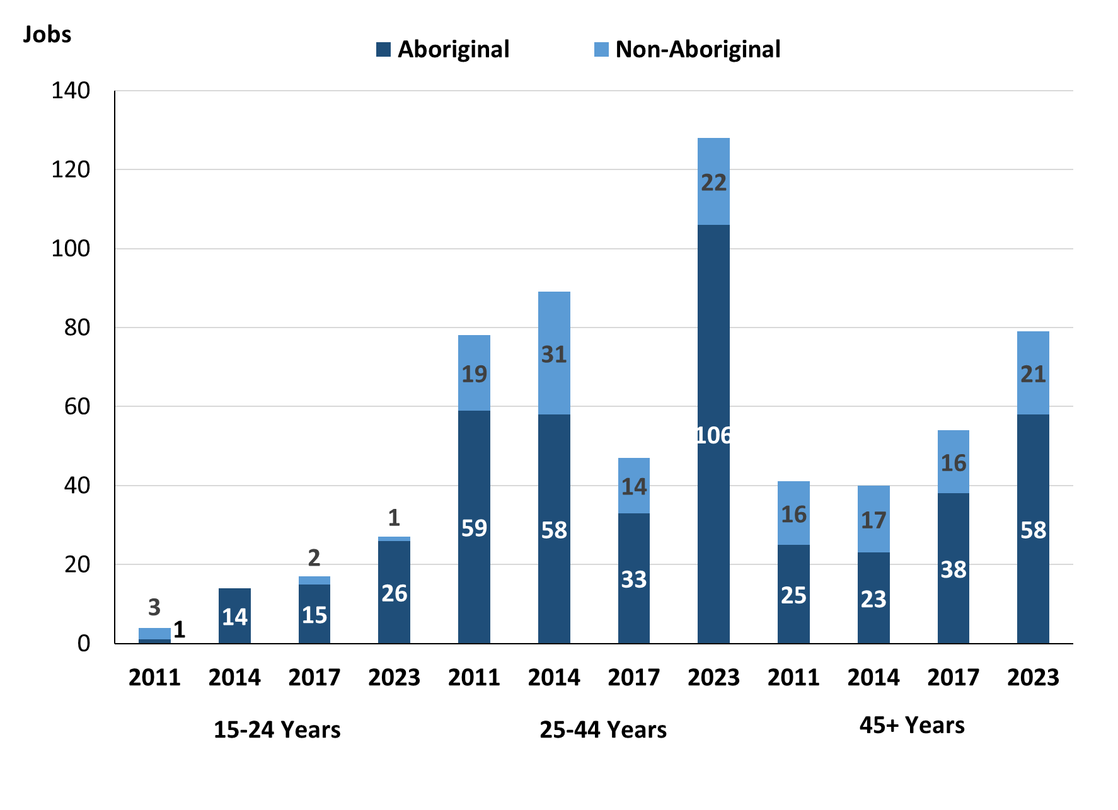

Source: Northern Territory Department of Industry, Tourism and Trade

In 2023 in Gapuwiyak:

* there were 27 **jobs** **filled** by people aged **15-24 years**, an increase of 10 jobs from 2017 and an increase of 13 jobs from 2014. Of these:
* **Aboriginal** people filled 26 jobs, an increase of 11 jobs from 2017 and an increase of 12 jobs from 2014
* a **non-Aboriginal** person filled 1 job, a decrease of 1 job from 2017 and an increase of 1 job from 2014
* there were 128 **jobs** **filled** by people aged **25-44 years**, an increase of 36 jobs from 2017 and an increase of 39 jobs from 2014. Of these:
* **Aboriginal** people filled 106 jobs, an increase of 34 jobs from 2017 and an increase of 48 jobs from 2014
* **non-Aboriginal** people filled 22 jobs, an increase of 2 jobs from 2017 and a decrease of 9 jobs from 2014
* there were 79 **jobs** **filled** by people aged **45+ years**, an increase of 25 jobs from 2017 and an increase of 39 jobs from 2014. Of these:
* **Aboriginal** people filled 58 jobs, an increase of 20 jobs from 2017 and an increase of 35 jobs from 2014
* **non-Aboriginal** people filled 21 jobs, an increase of 5 jobs from 2017 and an increase of 4 jobs from 2014.

Table 28: Count of filled jobs by age, by full-time/part-time status, by job permanency and by sector June-July 2011 (a)(b)(c)(d)(e)(i)

|  |  |  |  |  |  |  |  |  |  |  |  |  |  |
| --- | --- | --- | --- | --- | --- | --- | --- | --- | --- | --- | --- | --- | --- |
| **2011** | | | | | | | | | | | | | |
| **Indicator** | **15-24 years** | | | **25-44 years** | | | **45+ years** | | | **Total** | | | |
| **Aboriginal** | **Non-Aboriginal** | **Total** | **Aboriginal** | **Non-Aboriginal** | **Total** | **Aboriginal** | **Non-Aboriginal** | **Total** | **Aboriginal** | **Non-Aboriginal** | **Total** |
| Full-time | 0 | 3 | **3** | 11 | 15 | **26** | 14 | 16 | **30** | 25 | 34 | **59** |
| Part-time | 1 | 0 | **1** | 48 | 4 | **52** | 11 | 0 | **11** | 60 | 4 | **64** |
| **Total** | **1** | **3** | **4** | **59** | **19** | **78** | **25** | **16** | **41** | **85** | **38** | **123** |
| Permanent | 1 | 1 | **2** | 31 | 9 | **40** | 20 | 11 | **31** | 52 | 21 | **73** |
| Temporary | 0 | 2 | **2** | 28 | 10 | **38** | 5 | 5 | **10** | 33 | 17 | **50** |
| **Total** | **1** | **3** | **4** | **59** | **19** | **78** | **25** | **16** | **41** | **85** | **38** | **123** |
| Public Sector | 1 | 3 | **4** | 23 | 14 | **37** | 22 | 14 | **36** | 46 | 31 | **77** |
| Private Sector | 0 | 0 | **0** | 36 | 5 | **41** | 3 | 2 | **5** | 39 | 7 | **46** |
| **Total** | **1** | **3** | **4** | **59** | **19** | **78** | **25** | **16** | **41** | **85** | **38** | **123** |

Source: Northern Territory Department of Industry, Tourism and Trade

Table 29: Count of filled jobs by age, by full-time/part-time status, by job permanency and by sector June-July 2014 (a)(b)(c)(d)(e)(i)

|  |  |  |  |  |  |  |  |  |  |  |  |  |  |
| --- | --- | --- | --- | --- | --- | --- | --- | --- | --- | --- | --- | --- | --- |
| **2014** | | | | | | | | | | | | | |
| **Indicator** | **15-24 years** | | | **25-44 years** | | | **45+ years** | | | **Total** | | | |
| **Aboriginal** | **Non-Aboriginal** | **Total** | **Aboriginal** | **Non-Aboriginal** | **Total** | **Aboriginal** | **Non-Aboriginal** | **Total** | **Aboriginal** | **Non-Aboriginal** | **Total** |
| Full-time | 1 | 0 | **1** | 23 | 27 | **50** | 10 | 17 | **27** | 34 | 44 | **78** |
| Part-time | 13 | 0 | **13** | 35 | 4 | **39** | 13 | 0 | **13** | 61 | 4 | **65** |
| **Total** | **14** | **0** | **14** | **58** | **31** | **89** | **23** | **17** | **40** | **95** | **48** | **143** |
| Permanent | 2 | 0 | **2** | 27 | 21 | **48** | 13 | 14 | **27** | 42 | 35 | **77** |
| Temporary | 12 | 0 | **12** | 31 | 10 | **41** | 10 | 3 | **13** | 53 | 13 | **66** |
| **Total** | **14** | **0** | **14** | **58** | **31** | **89** | **23** | **17** | **40** | **95** | **48** | **143** |
| Public Sector | 5 | 0 | **5** | 28 | 25 | **53** | 15 | 15 | **30** | 48 | 40 | **88** |
| Private Sector | 9 | 0 | **9** | 30 | 6 | **36** | 8 | 2 | **10** | 47 | 8 | **55** |
| **Total** | **14** | **0** | **14** | **58** | **31** | **89** | **23** | **17** | **40** | **95** | **48** | **143** |

Source: Northern Territory Department of Industry, Tourism and Trade

Table 30: Count of filled jobs by age, by full-time/part-time status, by job permanency and by sector June-July 2017 (a)(b)(c)(d)(e)(i)

|  |  |  |  |  |  |  |  |  |  |  |  |  |  |  |
| --- | --- | --- | --- | --- | --- | --- | --- | --- | --- | --- | --- | --- | --- | --- |
| **2017** | | | | | | | | | | | | | | |
| **Indicator** | **15-24 years** | | | **25-44 years** | | | **45+ years** | | | | **Total** | | | |
| **Aboriginal** | **Non-Aboriginal** | **Total** | **Aboriginal** | **Non-Aboriginal** | **Total** | **Aboriginal** | **Non-Aboriginal** | **Total** | **Aboriginal** | | **Non-Aboriginal** | **Total** |
| Full-time | 2 | 1 | **3** | 23 | 18 | **41** | 14 | 16 | **30** | 42 | | 35 | **77** |
| Part-time | 13 | 1 | **14** | 49 | 2 | **51** | 24 | 0 | **24** | 86 | | 3 | **89** |
| **Total** | **15** | **2** | **17** | **72** | **20** | **92** | **38** | **16** | **54** | **128** | | **38** | **166** |
| Permanent | 5 | 0 | **5** | 41 | 12 | **53** | 21 | 2 | **23** | 70 | | 14 | **84** |
| Temporary | 10 | 2 | **12** | 31 | 8 | **39** | 17 | 14 | **31** | 58 | | 24 | **82** |
| **Total** | **15** | **2** | **17** | **72** | **20** | **92** | **38** | **16** | **54** | **128** | | **38** | **166** |
| Public Sector | 4 | 1 | **5** | 28 | 15 | **43** | 13 | 13 | **26** | 48 | | 29 | **77** |
| Private Sector | 11 | 1 | **12** | 44 | 5 | **49** | 25 | 3 | **28** | 80 | | 9 | **89** |
| **Total** | **15** | **2** | **17** | **72** | **20** | **92** | **38** | **16** | **54** | **128** | | **38** | **166** |

Source: Northern Territory Department of Industry, Tourism and Trade

Table 31: Count of filled jobs by age, by full-time/part-time status, by job permanency and by sector September 2023 (a)(b)(c)(d)(e)(i)

| **2023** | | | | | | | | | | | | |
| --- | --- | --- | --- | --- | --- | --- | --- | --- | --- | --- | --- | --- |
| **Indicator** | **15-24 years** | | | **25-44 years** | | | **45+ years** | | | **Total** | | |
| **Aboriginal** | **Non-Aboriginal** | **Total** | **Aboriginal** | **Non-Aboriginal** | **Total** | **Aboriginal** | **Non-Aboriginal** | **Total** | **Aboriginal** | **Non-Aboriginal** | **Total** |
| Full-time | 11 | 0 | **11** | 42 | 21 | **63** | 24 | 18 | **42** | 77 | 39 | **116** |
| Part-time | 15 | 1 | **16** | 64 | 1 | **65** | 34 | 3 | **37** | 115 | 5 | **120** |
| Total | **26** | **1** | **27** | **106** | **22** | **128** | **58** | **21** | **79** | **192** | **44** | **236** |
| Permanent | 16 | 1 | **17** | 83 | 14 | **97** | 48 | 14 | **62** | 147 | 29 | **176** |
| Temporary | 10 | 0 | **10** | 23 | 8 | **31** | 10 | 7 | **17** | 45 | 15 | **60** |
| Total | **26** | **1** | **27** | **106** | **22** | **128** | **58** | **21** | **79** | **192** | **44** | **236** |
| Public Sector | 12 | 0 | **12** | 37 | 15 | **52** | 21 | 13 | **34** | 70 | 28 | **98** |
| Private Sector | 14 | 1 | **15** | 69 | 7 | **76** | 37 | 8 | **45** | 122 | 16 | **138** |
| Total | **26** | **1** | **27** | **106** | **22** | **128** | **58** | **21** | **79** | **192** | **44** | **236** |

Source: Northern Territory Department of Industry, Tourism and Trade

In 2023 in Gapuwiyak:

* of the 27 **jobs** **filled** by people aged **15-24 years**, there were:
* 26 jobs filled by **Aboriginal** people, of which
* 11 were full-time jobs, an increase of 9 jobs from 2017 and an increase of 10 jobs from 2014
* 15 were part-time jobs, an increase of 2 jobs from 2017 and an increase of 2 jobs from 2014
* 16 were permanent jobs, an increase of 11 jobs from 2017 and an increase of 14 jobs from 2014
* 10 were temporary jobs, unchanged from 2017 and a decrease of 2 jobs from 2014
* 12 were Public Sector jobs, an increase of 8 jobs from 2017 and an increase of 7 jobs from 2014
* 14 were Private Sector jobs, an increase of 3 jobs from 2017 and an increase of 5 jobs from 2014
* 1 job filled by a **non-Aboriginal** people, of which:
* none were full-time jobs, a decrease of 1 job from 2017 and unchanged from 2014
* 1 was a part-time job, unchanged from 2017 and an increase of 1 job from 2014
* 1 was a permanent job, an increase of 1 job from 2017 and an increase of 1 job from 2014
* none were temporary jobs, a decrease of 2 jobs from 2017 and unchanged from 2014
* none were Public Sector jobs, a decrease of 1 job from 2017 and unchanged from 2014
* 1 was a Private Sector job, unchanged from 2017 and an increase of 1 job from 2014
* of the 128 **jobs** **filled** by people aged **25-44 years**, there were:
* 106 jobs filled by **Aboriginal** people, of which:
* 42 were full-time jobs, an increase of 19 jobs from 2017 and an increase of 19 jobs from 2014
* 64 were part-time jobs, an increase of 15 jobs from 2017 and an increase of 29 jobs from 2014
* 83 were permanent jobs, an increase of 42 jobs from 2017 and an increase of 56 jobs from 2014
* 23 were temporary jobs, a decrease of 8 jobs from 2017 and a decrease of 8 jobs from 2014
* 37 were Public Sector jobs, an increase of 9 jobs from 2017 and an increase of 9 jobs from 2014
* 69 were Private Sector jobs, an increase of 25 jobs from 2017 and an increase of 39 jobs from 2014.
* 22 jobs filled by **non-Aboriginal** people, of which:
* 21 were full-time jobs, an increase of 3 jobs from 2017 and a decrease of 6 jobs from 2014
* 1 was a part-time job, a decrease of 1 job from 2017 and a decrease of 3 jobs from 2014
* 14 were permanent jobs, an increase of 2 jobs from 2017 and a decrease of 7 jobs from 2014
* 8 were temporary jobs, unchanged from 2017 and a decrease of 2 jobs from 2014
* 15 were Public Sector jobs, unchanged from 2017 and a decrease of 10 jobs from 2014
* 7 were Private Sector jobs, an increase of 2 jobs from 2017 and an increase of 1 job from 2014
* of the 79 **jobs** **filled** by people aged **45+ years**, there were:
* 58 jobs filled by **Aboriginal** people, of which:
* 24 were full-time jobs, an increase of 10 jobs from 2017 and an increase of 14 jobs from 2014
* 34 were part-time jobs, an increase of 10 jobs from 2017 and an increase of 21 jobs from 2014
* 48 were permanent jobs, an increase of 27 jobs from 2017 and an increase of 35 jobs from 2014
* 10 were temporary jobs, a decrease of 7 jobs from 2017 and unchanged from 2014
* 21 were Public Sector jobs, an increase of 8 jobs from 2017 and an increase of 6 jobs from 2014
* 37 were Private Sector jobs, an increase of 12 jobs from 2017 and an increase of 29 jobs from 2014
* 21 jobs filled by **non-Aboriginal** people, of which:
* 18 were full-time jobs, an increase of 2 jobs from 2017 and an increase of 1 job from 2014
* 3 were part-time jobs, an increase of 3 jobs from 2017 and an increase of 3 jobs from 2014
* 14 were permanent jobs, an increase of 12 jobs from 2017 and unchanged from 2014
* 7 were temporary jobs, a decrease of 7 jobs from 2017 and an increase of 4 jobs from 2014
* 13 were Public Sector jobs, unchanged from 2017 and a decrease of 2 jobs from 2014
* 8 were Private Sector jobs, an increase of 5 jobs from 2017 and an increase of 6 jobs from 2014.

# Vocational Education and Training

*Note:* *The 2010 data is in accordance with the new, standardised reporting procedures that focus on all training activities conducted in the remote town, irrespective of funding source, as compared to earlier publications. As a result, the 2010 VET data values in this publication might not match those in earlier publications.*

*The impact of the Remote Jobs and Communities Program (RJCP), established in 2013, has played a significant role in the reduction of accredited training in many remote towns across the Territory.*

Table 32a: Northern Territory Vocational Education and Training (VET) students, 2010, 2013, 2016 and 2023 (k)

|  |  |  |  |  |  |  |  |  |
| --- | --- | --- | --- | --- | --- | --- | --- | --- |
| **VET Funding Group** | **2010** | | **2013** | | **2016** | | **2023** | |
| **No.** | **% of Total** | **No.** | **% of Total** | **No.** | **% of Total** | **No.** | **% of Total** |
| Arts, Entertainment, Sports and Recreation | 29 | 20% | 18 | 10% | 45 | 31% | 0 | 0% |
| Building and Construction | 16 | 11% | 32 | 18% | 24 | 17% | 13 | 7% |
| Business and Clerical | 6 | 4% | 1 | 1% | 1 | 1% | 13 | 7% |
| Community Services, Health and Education | 15 | 10% | 35 | 20% | 26 | 18% | 62 | 31% |
| Computing | 0 | 0% | 0 | 0% | 1 | 1% | 0 | 0% |
| Engineering and Mining | 11 | 8% | 2 | 1% | 1 | 1% | 0 | 0% |
| Finance, Banking and Insurance | 4 | 3% | 4 | 2% | 3 | 2% | 0 | 0% |
| Food Processing | 0 | 0% | 0 | 0% | 16 | 11% | 0 | 0% |
| Primary Industry | 0 | 0% | 13 | 7% | 0 | 0% | 81 | 41% |
| Sales and Personal Services | 48 | 34% | 71 | 40% | 18 | 13% | 19 | 10% |
| Textiles, Clothing, Footwear and Furnishings | 0 | 0% | 0 | 0% | 0 | 0% | 12 | 6% |
| Tourism and Hospitality | 14 | 10% | 0 | 0% | 8 | 6% | 0 | 0% |
| **Total** | **143** | **100%** | **176** | **100%** | **143** | **100%** | **200** | **100%** |

Source: Northern Territory Department of Industry, Tourism and Trade

Table 32b: Northern Territory Vocational Education and Training (VET) students, 2010-2013, 2013-2016 and 2016-2023 (k)

|  |  |  |  |
| --- | --- | --- | --- |
| **VET Funding Group** | **Change** | | |
| **2010-2013** | **2013-2016** | **2016-2023** |
| Arts, Entertainment, Sports and Recreation | - 11 | 27 | -45 |
| Building and Construction | 16 | - 8 | -11 |
| Business and Clerical | - 5 | 0 | 12 |
| Community Services, Health and Education | 20 | - 9 | 36 |
| Computing | 0 | 1 | -1 |
| Engineering and Mining | - 9 | - 1 | -1 |
| Finance, Banking and Insurance | 0 | - 1 | -3 |
| Food Processing | 0 | 16 | -16 |
| Primary Industry | 13 | - 13 | 81 |
| Sales and Personal Services | 23 | - 53 | 1 |
| Textiles, Clothing, Footwear and Furnishings | 0 | 0 | 12 |
| Tourism and Hospitality | - 14 | 8 | -8 |
| **Total** | **33** | **- 33** | **57** |

Source: Northern Territory Department of Industry, Tourism and Trade

In 2023 in Gapuwiyak:

* there were 200 **VET students**, an increase of 57 students from 2016 and an increase of 24 students from 2013,
* VET activity with the most students were Primary Industry with 81 students,
* Community Services, Health, and Education had 62 students,
* Sales and Personal Service had 19 students,
* Primary Industry reported the largest increase in students with an increase of 81 compared to 2016,
* Arts, Entertainment, Sports and Recreation reported the largest decrease in students with 45 less students over the same period.

Table 33a: Northern Territory Vocational Education and Training (VET) unit enrolments, 2010, 2013, 2016 and 2023 (l)

|  |  |  |  |  |  |  |  |  |
| --- | --- | --- | --- | --- | --- | --- | --- | --- |
| **VET Funding Group** | **2010** | | **2013** | | **2016** | | **2023** | |
| **No.** | **% of Total** | **No.** | **% of Total** | **No.** | **% of Total** | **No.** | **% of Total** |
| Arts, Entertainment, Sports and Recreation | 149 | 30% | 40 | 5% | 277 | 34% | 0 | 0% |
| Building and Construction | 16 | 3% | 187 | 25% | 176 | 22% | 39 | 6% |
| Business and Clerical | 24 | 5% | 10 | 1% | 1 | 0% | 21 | 3% |
| Community Services, Health and Education | 40 | 8% | 117 | 16% | 77 | 10% | 254 | 40% |
| Computing | 0 | 0% | 0 | 0% | 2 | 0% | 0 | 0% |
| Engineering and Mining | 11 | 2% | 11 | 1% | 1 | 0% | 0 | 0% |
| Finance, Banking and Insurance | 14 | 3% | 26 | 3% | 4 | 0% | 0 | 0% |
| Food Processing | 0 | 0% | 0 | 0% | 144 | 18% | 0 | 0% |
| Primary Industry | 0 | 0% | 26 | 3% | 0 | 0% | 218 | 34% |
| Sales and Personal Service | 138 | 28% | 334 | 44% | 93 | 12% | 93 | 15% |
| Textiles, Clothing, Footwear and Furnishings | 0 | 0% | 0 | 0% | 0 | 0% | 12 | 2% |
| Tourism and Hospitality | 108 | 22% | 0 | 0% | 29 | 4% | 0 | 0% |
| **Total** | **500** | **100%** | **751** | **100%** | **804** | **100%** | **637** | **100%** |

Source: Northern Territory Department of Industry, Tourism and Trade

Table 33b: Northern Territory Vocational Education and Training (VET) unit enrolments, 2010-2013, 2013-2016 and 2016-2023 (l)

|  |  |  |  |
| --- | --- | --- | --- |
| **VET Funding Group** | **Change** | | |
| **2010-2013** | **2013-2016** | **2016-2023** |
| Arts, Entertainment, Sports and Recreation | - 109 | 237 | -277 |
| Building and Construction | 171 | - 11 | -137 |
| Business and Clerical | - 14 | - 9 | 20 |
| Community Services, Health and Education | 77 | - 40 | 177 |
| Computing | 0 | 2 | -2 |
| Engineering and Mining | 0 | - 10 | -1 |
| Finance, Banking and Insurance | 12 | - 22 | -4 |
| Food Processing | 0 | 144 | -144 |
| Primary Industry | 26 | - 26 | 218 |
| Sales and Personal Service | 196 | - 241 | 0 |
| Textiles, Clothing, Footwear and Furnishings | 0 | 0 | 12 |
| Tourism and Hospitality | - 108 | 29 | -29 |
| **Total** | **251** | **53** | **-167** |

Source: Northern Territory Department of Industry, Tourism and Trade

In 2023 in Gapuwiyak:

* there were 637 **VET unit enrolments**, a decrease of 167-unit enrolments from 2016 and a decrease of 114-unit enrolments from 2013,
* VET activity with the most unit enrolments were Community Services, Health, and Education with 254-unit enrolments,
* Primary Industry had 218unit enrolments,
* Sales and Personal Service had 93-unit enrolments
* Primary Industry reported the largest increase in unit enrolments with 218-unit enrolments compared to 2016
* Arts, Entertainment, Sports and Recreation reported the largest decrease in unit enrolments with 277 less unit enrolments over the same period.

Table 34a: Northern Territory Vocational Education and Training (VET) nominal hours, 2010, 2013, 2016 and 2023 (m)

|  |  |  |  |  |  |  |  |  |  |
| --- | --- | --- | --- | --- | --- | --- | --- | --- | --- |
| **VET Funding Group** | **2010** | | **2013** | | **2016** | | | **2023** | |
| **No.** | **% of Total** | **No.** | **% of Total** | **No.** | **% of Total** | **No.** | | **% of Total** |
| Arts, Entertainment, Sports and Recreation | 5 820 | 42% | 1 586 | 7% | 5 484 | 29% | 0 | | 0% |
| Building and Construction | 96 | 1% | 6 472 | 30% | 5 474 | 29% | 1678 | | 8% |
| Business and Clerical | 720 | 5% | 430 | 2% | 30 | 0% | 800 | | 4% |
| Community Services, Health and Education | 1 019 | 7% | 4 005 | 18% | 925 | 5% | 9341 | | 43% |
| Computing | 0 | 0% | 0 | 0% | 80 | 0% | 0 | | 0% |
| Engineering and Mining | 220 | 2% | 466 | 2% | 20 | 0% | 0 | | 0% |
| Finance, Banking and Insurance | 460 | 3% | 740 | 3% | 60 | 0% | 0 | | 0% |
| Food Processing | 0 | 0% | 0 | 0% | 4 000 | 21% | 0 | | 0% |
| Primary Industry | 0 | 0% | 260 | 1% | 0 | 0% | 6645 | | 31% |
| Sales and Personal Service | 3 649 | 27% | 7 829 | 36% | 2 195 | 12% | 2865 | | 13% |
| Textiles, Clothing, Footwear and Furnishings | 0 | 0% | 0 | 0% | 0 | 0% | 288 | | 1% |
| Tourism and Hospitality | 1 713 | 13% | 0 | 0% | 594 | 3% | 0 | | 0% |
| **Total** | **13 697** | **100%** | **21 788** | **100%** | **18 862** | **100%** | **21617** | | **100%** |

Source: Northern Territory Department of Industry, Tourism and Trade

Table 34b: Northern Territory Vocational Education and Training (VET) nominal hours, 2010-2013, 2013-2016 and 2016-2023 (m)

|  |  |  |  |
| --- | --- | --- | --- |
| **VET Funding Group** | **Change** | | |
| **2010-2013** | **2013-2016** | **2016-2023** |
| Arts, Entertainment, Sports and Recreation | -4 234 | 3 898 | -5484 |
| Building and Construction | 6 376 | - 998 | -3796 |
| Business and Clerical | - 290 | - 400 | 770 |
| Community Services, Health and Education | 2 986 | -3 080 | 8416 |
| Computing | 0 | 80 | -80 |
| Engineering and Mining | 246 | - 446 | -20 |
| Finance, Banking and Insurance | 280 | - 680 | -60 |
| Food Processing | 0 | 4 000 | -400 |
| Primary Industry | 260 | - 260 | 6645 |
| Sales and Personal Service | 4 180 | -5 634 | 670 |
| Textiles, Clothing, Footwear and Furnishings | 0 | 0 | 288 |
| Tourism and Hospitality | -1 713 | 594 | -594 |
| **Total** | **8 091** | **-2 926** | **2755** |

Source: Northern Territory Department of Industry, Tourism and Trade

In 2023 in Gapuwiyak:

* there were 21,617 **VET nominal hours** delivered, an increase of 2,755 nominal hours delivered from 2016 and a decrease of 171 nominal hours delivered from 2013,
* VET activity with the most nominal hours delivered were Community Services, Health, and Education with 9,341 hours,
* Primary Industry had 6,645 nominal hours,
* Sales and Personal Service had 2,865 nominal hours,
* Community Services, Health and Education reported the largest increase in nominal hours delivered with 8,416 hours compared to 2016,
* Arts, Entertainment, Sports and Recreation reported the largest decrease in nominal hours delivered with 5,484 less hours over the same period.

Caveat: *Nominal hours are based on the hours funded through Northern Territory Government contracts and fee for service. Students and units include delivery that may have been funded in a previous year. Because of these factors, a direct match cannot be made between hours and student/units.*

Table 35a: Northern Territory Vocational Education and Training (VET) unit completions, 2010, 2013, 2016 and 2023 (n)

|  |  |  |  |  |  |  |  |  |
| --- | --- | --- | --- | --- | --- | --- | --- | --- |
| **VET Funding Group** | **2010** | | **2013** | | **2016** | | **2023** | |
| **No.** | **% of Total** | **No.** | **% of Total** | **No.** | **% of Total** | **No.** | **% of Total** |
| Arts, Entertainment, Sports and Recreation | 17 | 6% | 22 | 4% | 189 | 37% | 0 | 0% |
| Building and Construction | 12 | 4% | 145 | 28% | 139 | 27% | 13 | 3% |
| Business and Clerical | 0 | 0% | 5 | 1% | 1 | 0% | 9 | 2% |
| Community Services, Health and Education | 33 | 11% | 70 | 14% | 35 | 7% | 135 | 33% |
| Computing | 0 | 0% | 0 | 0% | 2 | 0% | 0 | 0% |
| Engineering and Mining | 11 | 4% | 8 | 2% | 1 | 0% | 0 | 0% |
| Finance, Banking and Insurance | 4 | 1% | 11 | 2% | 2 | 0% | 0 | 0% |
| Food Processing | 0 | 0% | 0 | 0% | 54 | 10% | 0 | 0% |
| Primary Industry | 0 | 0% | 18 | 4% | 0 | 0% | 193 | 48% |
| Process Manufacturing | 0 | 0% | 0 | 0% | 0 | 0% | 0 | 0% |
| Sales and Personal Service | 128 | 43% | 235 | 46% | 64 | 12% | 52 | 13% |
| Textiles, Clothing, Footwear and Furnishings | 0 | 0% | 0 | 0% | 0 | 0% | 2 | 0% |
| Tourism and Hospitality | 92 | 31% | 0 | 0% | 29 | 6% | 0 | 0% |
| **Total** | **297** | **100%** | **514** | **100%** | **516** | **100%** | **404** | **100%** |

Source: Northern Territory Department of Industry, Tourism and Trade

Table 35b: Northern Territory Vocational Education and Training (VET) unit completions, 2010-2013, 2013-2016 and 2016-2023 (n)

|  |  |  |  |
| --- | --- | --- | --- |
| **VET Funding Group** | **Change** | | |
| **2010-2013** | **2013-2016** | **2016-2023** |
| Arts, Entertainment, Sports and Recreation | 5 | 167 | -189 |
| Building and Construction | 133 | - 6 | -126 |
| Business and Clerical | 5 | - 4 | 8 |
| Community Services, Health and Education | 37 | - 35 | 100 |
| Computing | 0 | 2 | -2 |
| Engineering and Mining | - 3 | - 7 | -1 |
| Finance, Banking and Insurance | 7 | - 9 | -2 |
| Food Processing | 0 | 54 | -54 |
| Primary Industry | 18 | - 18 | 193 |
| Process Manufacturing | 0 | 0 | 0 |
| Sales and Personal Service | 107 | - 171 | -12 |
| Textiles, Clothing, Footwear and Furnishings | 0 | 0 | 2 |
| Tourism and Hospitality | - 92 | 29 | -29 |
| **Total** | **217** | **2** | **-112** |

Source: Northern Territory Department of Industry, Tourism and Trade

In 2023 in Gapuwiyak:

* there were 404 **VET unit completions**, a decrease of 112-unit completions from 2016 and a decrease of 110 unit completions from 2013,
* VET activity with the most unit completions were Primary Industry with 193-unit completions,
* Community Services, Health, and Education had 135-unit completions,
* Sales and Personal Service had 52-unit completions.
* Primary Industry reported the largest increase in unit completions with an increase of 193 compared to 2016,
* Arts, Entertainment, Sports and Recreation reported the largest decrease in unit completions with a decrease of 189 over the same period.

# Population

**Table 36: Population distribution by gender and age (p)(r)**

|  |  |  |  |  |  |  |  |  |  |
| --- | --- | --- | --- | --- | --- | --- | --- | --- | --- |
| **Indicator** | **2011** | | | **2021** | | | **Change (2011-2021)** | | |
| **Male** | **Female** | **Total** | **Male** | **Female** | **Total** | **Male** | **Female** | **Total** |
| **0-4 years** | 36 | 41 | **77** | 21 | 24 | **45** | -15 | -17 | **-32** |
| **5-14 years** | 107 | 75 | **182** | 51 | 51 | **102** | -56 | -24 | **-80** |
| **15-24 years** | 104 | 71 | **175** | 71 | 56 | **127** | -33 | -15 | **-48** |
| **25-44 years** | 143 | 152 | **295** | 120 | 141 | **261** | -23 | -11 | **-34** |
| **45-64 years** | 62 | 60 | **122** | 63 | 81 | **144** | 1 | 21 | **22** |
| **65+ years** | 6 | 15 | **21** | 9 | 13 | **22** | 3 | -2 | **1** |
| **Total** | **457** | **417** | **874** | **338** | **368** | **706** | **-119** | **-49** | **-168** |

*Source: Australian Bureau of Statistics*

In 2021 in Gapuwiyak:

* there were an estimated 706 people, of which:
* 338 (47.9%) were male
* 368 (52.1%) were female
* Between 2011 and 2021, the **overall population** in Gapuwiyak decreased by 168 people from 2011, or an average of -1.9% per year compared to -0.5% across the 28 remote towns and 1.0% Territory wide
* The **male population** decreased by 119 people from 2011
* The **female population** decreased by 49 people from 2011
* In 2021, the **working age population** (15 years and over) in Gapuwiyak was an estimated 554 people (78.5% of the total population) compared with 613 people (70.1% of the total population) in 2011. Of these:
* 127 (18%) were between 15 and 24 years of age
* 261 (37%) were between 25 and 44 years of age
* 144 (20.4%) were between 45 and 64 years of age
* 22 (3.1%) were over 65 years of age
* of the 554 people of **working age**:
* 263 (47.5%) were male
* 291 (52.5%) were female.

There were 0.5 jobs in Gapuwiyak per working age person compared to 0.3 jobs per working age person across the 28 remote towns in the Northern Territory.

**Chart 13: Population comparison (p)(q)**

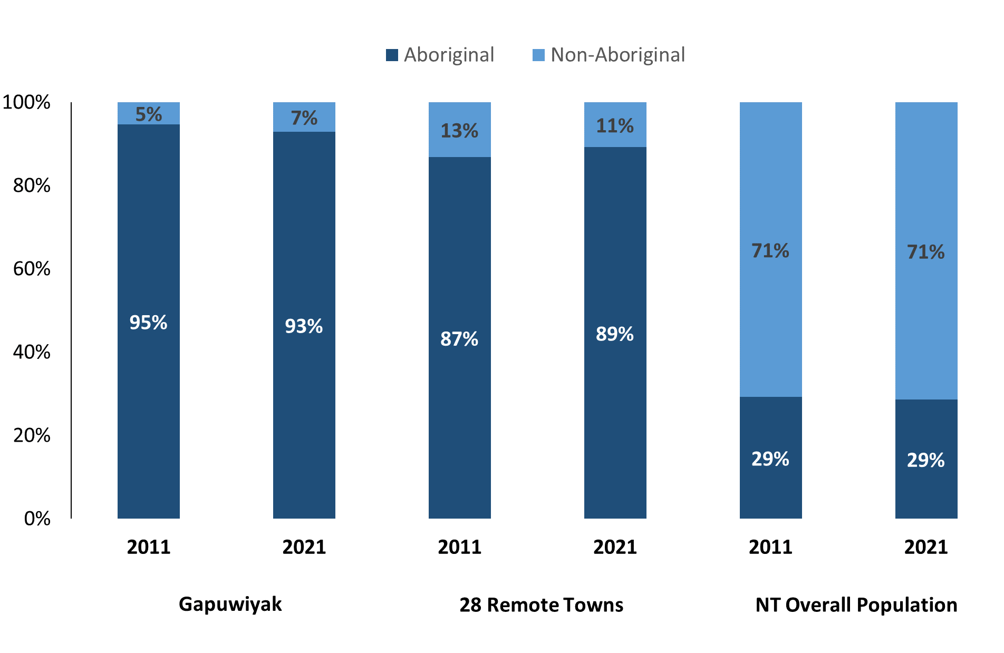

*Source: Australian Bureau of Statistics*

In 2021 in Gapuwiyak:

* 93% of the population in Gapuwiyak were **Aboriginal**, compared to 95% in 2011
* 89% of the population across the 28 remote towns were **Aboriginal**
* 29% of the NT population were **Aboriginal**.

**Table 37: Unemployment and Aboriginal participation rates (q)**

|  |  |  |  |  |  |  |
| --- | --- | --- | --- | --- | --- | --- |
|  | **Gapuwiyak** | | | **Northern Territory** | | |
| **Aboriginal** | **Non-Aboriginal** | **Total** | **Aboriginal** | **Non-Aboriginal** | **Total** |
| **Unemployment rate** | 15.5% | 0.0% | 10.9% | 20.8% | 3.2% | 5.6% |
| **Participation rate** | 19.3% | 93.2% | 27.4% | 35.4% | 78.3% | 64.9% |

*Source: Australian Bureau of Statistics*

In 2021 in Gapuwiyak:

* **total unemployment rate** was 10.9% compared to 5.6% for the total Northern Territory
* **Aboriginal unemployment rate** was 15.5% compared to 20.8% for the total Northern Territory
* **non-Aboriginal unemployment rate** was 0.0% compared to 3.2% for the total Northern Territory
* **total participation rate** was 27.4% compared to 64.9% for the total Northern Territory.
* **Aboriginal participation rate** was 19.3% compared to 35.4% for the total Northern Territory
* **non-Aboriginal participation rate** was 93.2% compared to 78.3% for the total Northern Territory

# Community Development Program

**Table 38: Community Development Program Aboriginal Job Seekers, 31 December 2023 (o)**

|  |  |  |
| --- | --- | --- |
| **Indicator** | **Aboriginal** | |
| **No.** | **%** |
| **Total Aboriginal Job Seekers** | 377 | N/A |
| **Age (years)** | | |
| 15-24 | 105 | 27.8% |
| 25-44 | 191 | 50.7% |
| 45+ | 81 | 21.5% |
| **Total** | 377 | 100.0% |
| **Gender** | | |
| Male | 186 | 49.3% |
| Female | 191 | 50.7% |
| **Total** | 377 | 100.0% |
| **Employment Outcome – 1 January 2023 to 31 December 2023** | | |
| 13 Weeks | <20 | N/A |
| 26 Weeks | <20 | N/A |

*Source: Department of Prime Minister and Cabinet*

**Chart 14: Community Development Program Aboriginal Job Seekers by Gender and Age Group, 31 December 2023 (o)**

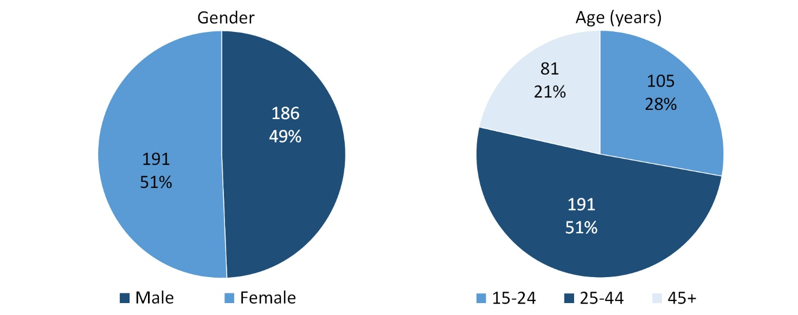

*Source: Department of Prime Minister and Cabinet*

As at 31 December 2023, in Gapuwiyak, there were 377 CDP **Aboriginal** job seekers, of these:

* 186 (49.3%) were male and 191 (50.7%) were female
* 105 (27.8%) were aged 15-24 years, 191 (50.7%) were aged 25-44 years, and 81 (21.5%) were aged 45+ years
* between 1 January 2023 to 31 December 2023, less than had reached the 13-week reporting milestone and less than had reached the 26-week reporting milestone.

# Businesses

**Table 39: Businesses by sector (d)(s)**

|  |  |  |  |  |
| --- | --- | --- | --- | --- |
| **Business Name** | **Reported on in 2011** | **Reported on in 2014** | **Reported on in 2017** | **Reported on in 2023** |
| **PUBLIC SECTOR** | | | | |
| **Department of Education** | Yes | Yes | Yes | **Yes** |
| Department of Health | Yes | Yes | Yes | No |
| Department of the Prime Minister and Cabinet | Yes | Yes | Yes | No |
| **East Arnhem Regional Council** | Yes | Yes | Yes | **Yes** |
| **Northern Territory Police, Fire Emergency Services** | Yes | Yes | Yes | **Yes** |
| **Territory Families** | No | No | No | **Yes** |
| **PRIVATE SECTOR** | | | | |
| Bukmak Constructions - ALPA | No | No | Yes | No |
| **East Arnhem Real Estate** | No | No | No | **Yes** |
| Gapaguchi Pty Ltd | No | Yes | No | No |
| Gapuwiyak Culture and Arts Aboriginal Corporation | Yes | Yes | Yes | No |
| MAF International trading as Mission Aviation Fellowship | Yes | Yes | Yes | No |
| Menzies School of Health Research | Yes | No | No | No |
| Miwatj Employment and Participation Ltd | No | Yes | Yes | No |
| **Miwatj Health Aboriginal Corporation** | No | No | Yes | **Yes** |
| **The Arnhem Land Progress Aboriginal Corporation (ALPA)** | Yes | Yes | Yes | **Yes** |
| **Milindji Aboriginal Corporation** | No | No | No | **Yes** |
| **Traditional Credit Union (TCU)** | Yes | Yes | Yes | **Yes** |
| YBE (2) Pty Ltd | No | No | Yes | No |

*Source: Northern Territory Department of Industry, Tourism and Trade*

*Note: Business names captured across the four survey periods have been identified by the current 2023 Business ABN name listed as at 2023.*

In 2023 in Gapuwiyak:

* there were 9 businesses reported on, of which:
* 4 businesses were from the Public Sector (44%)
* 5 businesses were from the Private Sector (56%)
* there were 3 businesses operating that were not operation in 2017.

# Notes

1. These counts represent numbers of filled jobs and not the number of people. As such the totals represent the total number of filled jobs, not the total number of employees. This count is not directly comparable to the total number of employed people as a person may have several jobs or one job may be shared by more than one person.
2. Full-time is defined as a job usually requiring 35 hours or more per week or that required 35 hours or more work during the reference week. Part-time is defined as a job usually requiring less than 35 hours per week or that required less than 35 hours work during the reference week. The reference week refers to the period that respondents were asked to provide information about. In most instances it would be the week prior to the week the questionnaire was completed. Questionnaires were predominantly conducted in June and July.
3. Care needs to be taken when analysing the counts of filled jobs by Aboriginal people. Aboriginality was reported by the business representative completing the questionnaire.
4. Sector was classified using the Standard Economic Sector of Classifications of Australia (SESCA), 2008.
5. Job permanency is classified according to what the business believes the level of job permanency is based on guidelines provided by data collectors. Those guidelines state a permanent job has paid annual and/or sick leave entitlements while a temporary job includes casual and fixed-term contract jobs.
6. Classified according to the Australian and New Zealand Standard Classification of Occupations (ANZSCO), 2006, major occupation level.
7. Other Occupations include jobs where occupation was not stated, not known or inadequately described.
8. Classified using the Australian and New Zealand Standard Industrial Classification (ANZSIC), 2006, division level.
9. Care needs to be taken when analysing the counts of filled jobs by the gender of people in the jobs. The gender of the person employed in a job is reported by the business representative completing the questionnaire.
10. Care needs to be taken when analysing the counts of filled jobs by the age of people in the jobs. The age of the person employed in a job is reported by the business representative completing the questionnaire.
11. Students represent the number of individual clients that enrolled in a Vocational Education and Training unit during the calendar year.
12. Unit enrolments represent the count of individual units that students enrolled in during the calendar year.
13. Nominal hours delivered is the sum of the nominal hours of the units commenced during the calendar year regardless of when the course enrolment commenced.
14. Unit completions are the count of all successfully completed units reported in the calendar year regardless of the year of commencement of the units.
15. The Community Development Program (CDP) supports job seekers in remote Australia to build skills, address barriers and contribute to their communities through a range of flexible activities. Under the CDP, job seekers with activity requirements are expected to do up to 25 hours per week of work-like activities that benefit their community. It should be noted that some CDP participants may be reported on within the profile if they are attached to a filled position with an employer captured in the survey. Due to confidentiality issues, data below 20 people is not published.
16. Population estimates for both 2011 and 2021 are taken from the estimated resident population (ERP) data produced by the Australian Bureau of Statistics (ABS) and based on Australian Statistical Geography Standard (ASGS) Statistical Area Level 1 (SA1) regions. ERP are official estimates of the Australian population, which link people to a place of usual residence with Australia. All ERP data sources, including the Census of Population and Housing (Census), are subject to error (including inaccuracies in collection, recording and processing data) and should be used with caution.
17. Indigenous population proportions, unemployment and workforce participation rates are based on ABS Census counts at ASGS Indigenous Locations (ILOCs) for each remote town.
18. Working-age population includes all residents aged 15 years and over (commonly referred to as the civilian population) and consists of people that are employed, unemployed or not in the labour force.
19. A ‘business’ has been defined as any organisation that has undertaken productive activities in the last year, including companies, non-profit organisations, government departments and enterprises operating within the designated remote geography (town), and has one or more employees in paid employment and an Australian Business Number (ABN).

# Abbreviations and Acronyms

ABN Australian Business Number

ABS Australian Bureau of Statistics

ANZSCO Australian and New Zealand Standard Classification of Occupations

ANZSIC Australian and New Zealand Standard Industrial Classification

ASGS Australian Statistical Geography Standard

ERP Estimated Resident Population

ILOC Indigenous Locations

nec Not Elsewhere Classified

No. Number

Perm Permanent

ppt Percentage point

RJCP Remote Jobs and Communities Program

Temp Temporary

SA1 Statistical Area Level 1

VET Vocational Education and Training

1. The number of filled jobs does not represent the number of people as a person may have several jobs or one job may be shared by more than one person.
2. 3 Aboriginal filled jobs gender status not identified in 2017