Mineral Titles Act 2010
NOTICE OF LAND CEASING TO BE A MINERAL TITLE AREA
Title Type and Number: | Exploration Licence 33605
Area Ceased on: | 22 January 2025
Area: | 250 Blocks, 787.21 km²
Locality: | NONGRA
Name of Applicant(s)/Holder(s): | 100% IGO NEWSEARCH PTY LTD [ACN. 142 192 701]
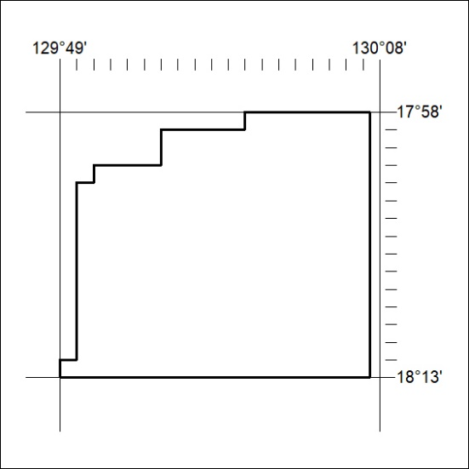

41/25

