Mineral Titles Act 2010
NOTICE OF LAND CEASING TO BE A MINERAL TITLE AREA
Title Type and Number: | Exploration Licence 32546
Area Ceased on: | 24 December 2024
Area: | 249 Blocks, 763.38 km²
Locality: | LIGNUM
Name of Applicant(s)/Holder(s): | 100% TECK AUSTRALIA PTY LTD [ACN. 091 271 911]
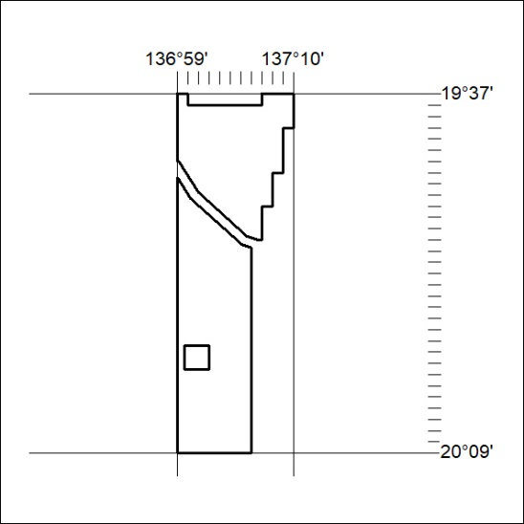

476/24

Mineral Titles Act 2010
NOTICE OF LAND CEASING TO BE A MINERAL TITLE AREA
Title Type and Number: | Exploration Licence 32550
Area Ceased on: | 24 December 2024
Area: | 237 Blocks, 765.38 km²
Locality: | LIGNUM
Name of Applicant(s)/Holder(s): | 100% TECK AUSTRALIA PTY LTD [ACN. 091 271 911]
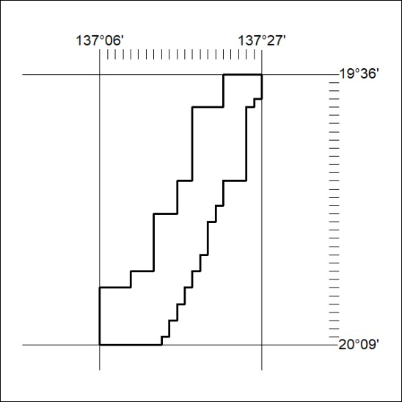

477/24

Mineral Titles Act 2010
NOTICE OF LAND CEASING TO BE A MINERAL TITLE AREA
Title Type and Number: | Exploration Licence 32551
Area Ceased on: | 24 December 2024
Area: | 228 Blocks, 731.50 km²
Locality: | LIGNUM
Name of Applicant(s)/Holder(s): | 100% TECK AUSTRALIA PTY LTD [ACN. 091 271 911]
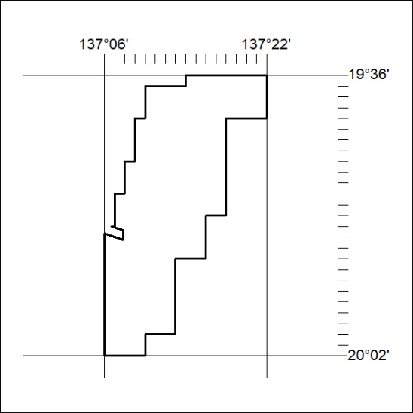

478/24

Mineral Titles Act 2010
NOTICE OF LAND CEASING TO BE A MINERAL TITLE AREA
Title Type and Number: | Exploration Licence 32734
Area Ceased on: | 24 December 2024
Area: | 201 Blocks, 649.07 km²
Locality: | MIKADO
Name of Applicant(s)/Holder(s): | 100% TECK AUSTRALIA PTY LTD [ACN. 091 271 911]
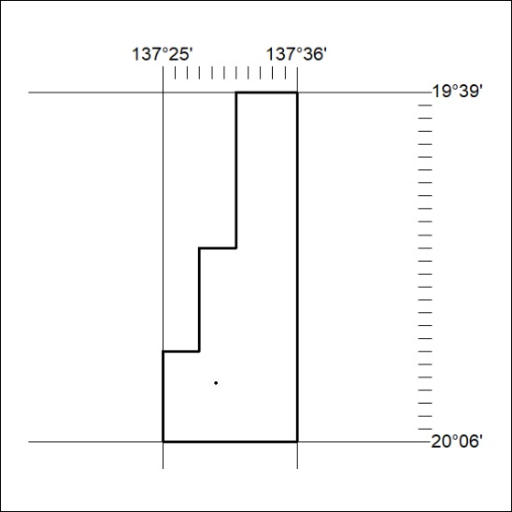

479/24

