Mineral Titles Act 2010
NOTICE OF LAND CEASING TO BE A MINERAL TITLE AREA
Title Type and Number: | Exploration Licence 30731
Area Ceased on: | 10 October 2024
Area: | 209 Blocks, 660.12 km²
Locality: | EHRENBERG
Name of Applicant(s)/Holder(s): | 100% PRODIGY GOLD NL* [ACN. 009 127 020]
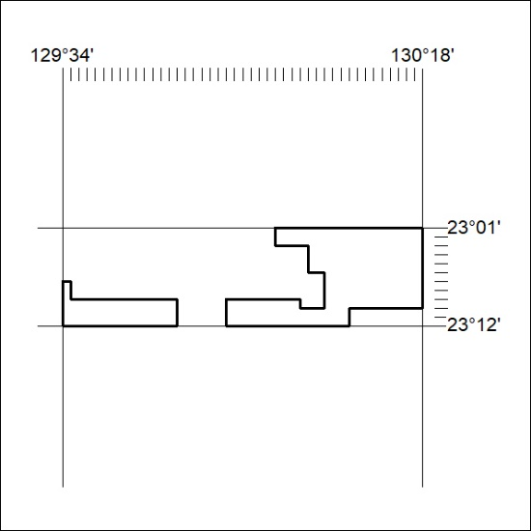

350/24

Mineral Titles Act 2010
NOTICE OF LAND CEASING TO BE A MINERAL TITLE AREA
Title Type and Number: | Exploration Licence 31967
Area Ceased on: | 10 October 2024
Area: | 250 Blocks, 822.47 km²
Locality: | FLAT TOP HILL
Name of Applicant(s)/Holder(s): | 100% FUTURE ENERGY MINERALS LIMITED [ACN. 678 599 230]
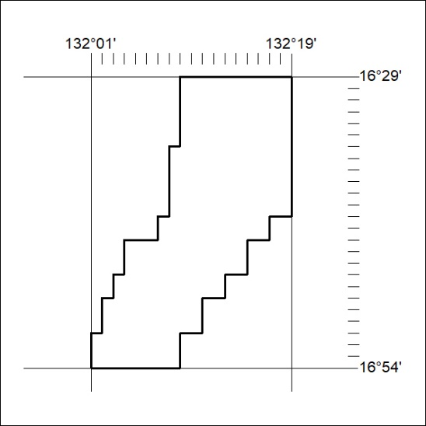

351/24

Mineral Titles Act 2010
NOTICE OF LAND CEASING TO BE A MINERAL TITLE AREA
Title Type and Number: | Exploration Licence 31971
Area Ceased on: | 10 October 2024
Area: | 220 Blocks, 723.73 km²
Locality: | FLAT TOP HILL
Name of Applicant(s)/Holder(s): | 100% FUTURE ENERGY MINERALS LIMITED [ACN. 678 599 230]
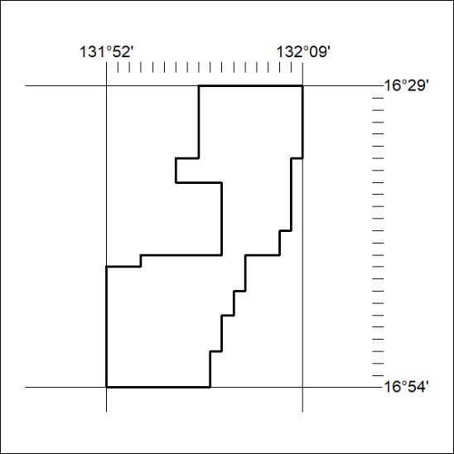

352/24

Mineral Titles Act 2010
NOTICE OF LAND CEASING TO BE A MINERAL TITLE AREA
Title Type and Number: | Exploration Licence 32114
Area Ceased on: | 10 October 2024
Area: | 200 Blocks, 658.86 km²
Locality: | NELLY CREEK
Name of Applicant(s)/Holder(s): | 100% FUTURE ENERGY MINERALS LIMITED [ACN. 678 599 230]
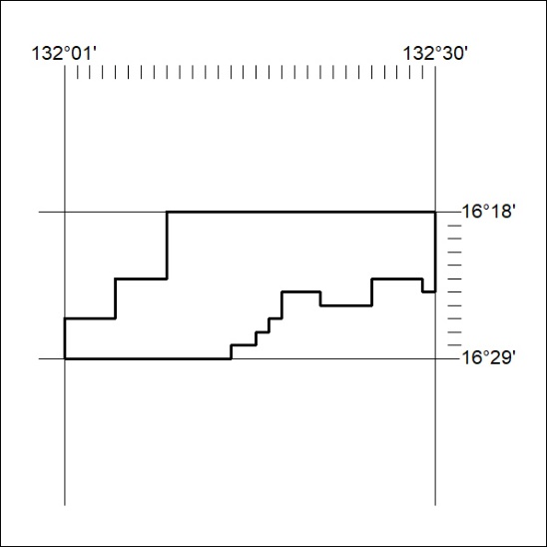

353/24

Mineral Titles Act 2010
NOTICE OF LAND CEASING TO BE A MINERAL TITLE AREA
Title Type and Number: | Exploration Licence 32248
Area Ceased on: | 10 October 2024
Area: | 121 Blocks, 398.30 km²
Locality: | FLAT TOP HILL
Name of Applicant(s)/Holder(s): | 100% FUTURE ENERGY MINERALS LIMITED [ACN. 678 599 230]
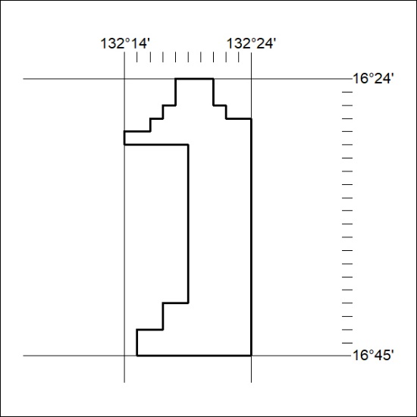

354/24

Mineral Titles Act 2010
NOTICE OF LAND CEASING TO BE A MINERAL TITLE AREA
Title Type and Number: | Exploration Licence 32518
Area Ceased on: | 10 October 2024
Area: | 242 Blocks, 795.92 km²
Locality: | FLAT TOP HILL
Name of Applicant(s)/Holder(s): | 100% FUTURE ENERGY MINERALS LIMITED [ACN. 678 599 230]
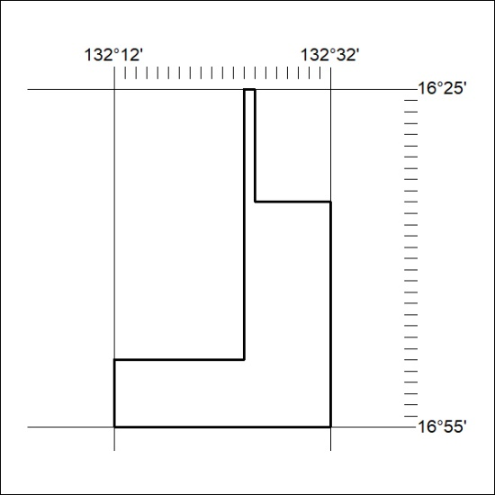

355/24

Mineral Titles Act 2010
NOTICE OF LAND CEASING TO BE A MINERAL TITLE AREA
Title Type and Number: | Exploration Licence 32519
Area Ceased on: | 10 October 2024
Area: | 250 Blocks, 822.21 km²
Locality: | HIDDEN VALLEY
Name of Applicant(s)/Holder(s): | 100% FUTURE ENERGY MINERALS LIMITED [ACN. 678 599 230]
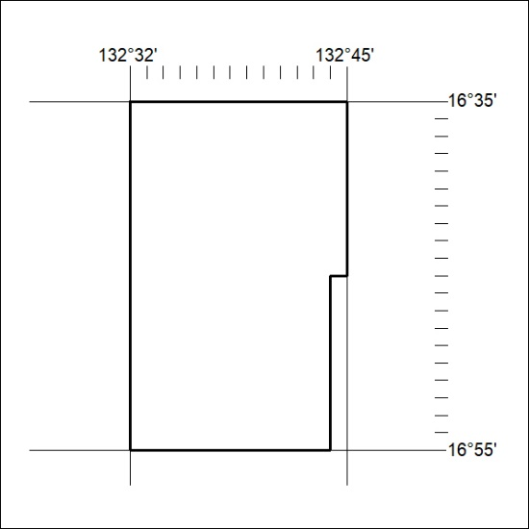

356/27

Mineral Titles Act 2010
NOTICE OF LAND CEASING TO BE A MINERAL TITLE AREA
Title Type and Number: | Exploration Licence 32520
Area Ceased on: | 10 October 2024
Area: | 26 Blocks, 85.54 km²
Locality: | HIDDEN VALLEY
Name of Applicant(s)/Holder(s): | 100% FUTURE ENERGY MINERALS LIMITED [ACN. 678 599 230]
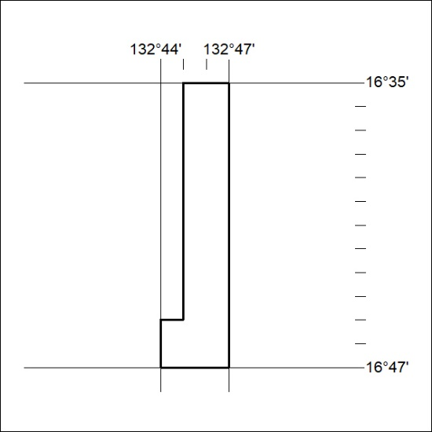

357/27

Mineral Titles Act 2010
NOTICE OF LAND CEASING TO BE A MINERAL TITLE AREA
Title Type and Number: | Exploration Licence 32858
Area Ceased on: | 10 October 2024
Area: | 69 Blocks, 213.38 km²
Locality: | VICTORY
Name of Applicant(s)/Holder(s): | 100% HAVELOCK MINING PTY LTD [ACN. 628 961 142]
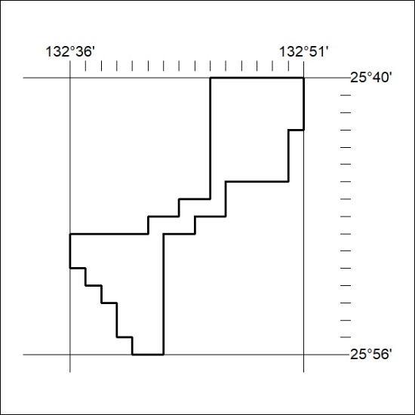

358/24

Mineral Titles Act 2010
NOTICE OF LAND CEASING TO BE A MINERAL TITLE AREA
Title Type and Number: | Exploration Licence 32859
Area Ceased on: | 10 October 2024
Area: | 108 Blocks, 334.01 km²
Locality: | SENTINEL BORE
Name of Applicant(s)/Holder(s): | 100% HAVELOCK MINING PTY LTD [ACN. 628 961 142]
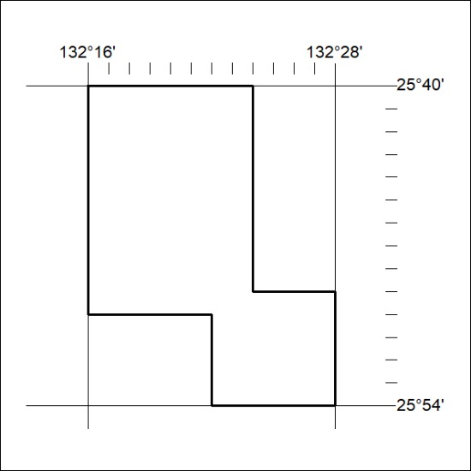

359/24

Mineral Titles Act 2010
NOTICE OF LAND CEASING TO BE A MINERAL TITLE AREA
Title Type and Number: | Exploration Licence 33348
Area Ceased on: | 10 October 2024
Area: | 198 Blocks, 563.45 km²
Locality: | MONTEJINNI
Name of Applicant(s)/Holder(s): | 100% FUTURE ENERGY MINERALS LIMITED [ACN. 678 599 230]
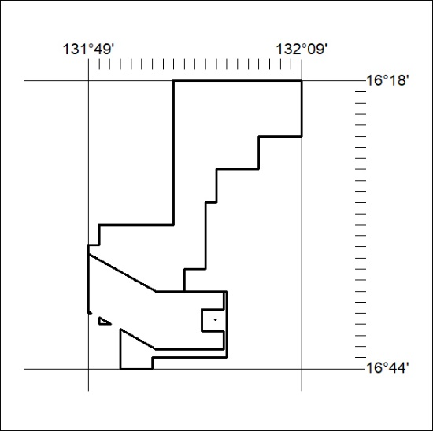

360/24

Mineral Titles Act 2010
NOTICE OF LAND CEASING TO BE A MINERAL TITLE APPLICATION AREA
Title Type and Number: | Exploration Licence 27919
Area Ceased on: | 11 October 2024
Area: | 4 Blocks, 4.09 km²
Locality: | PARSONS
Name of Applicant(s)/Holder(s): | 100% RIO TINTO EXPLORATION PTY LIMITED [ACN. 000 057 125]
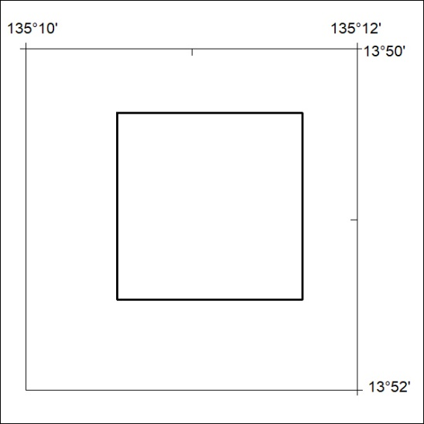

361/24

Mineral Titles Act 2010
NOTICE OF LAND CEASING TO BE A MINERAL TITLE APPLICATION AREA
Title Type and Number: | Exploration Licence 27920
Area Ceased on: | 11 October 2024
Area: | 36 Blocks, 98.83 km²
Locality: | PARSONS
Name of Applicant(s)/Holder(s): | 100% RIO TINTO EXPLORATION PTY LIMITED [ACN. 000 057 125]
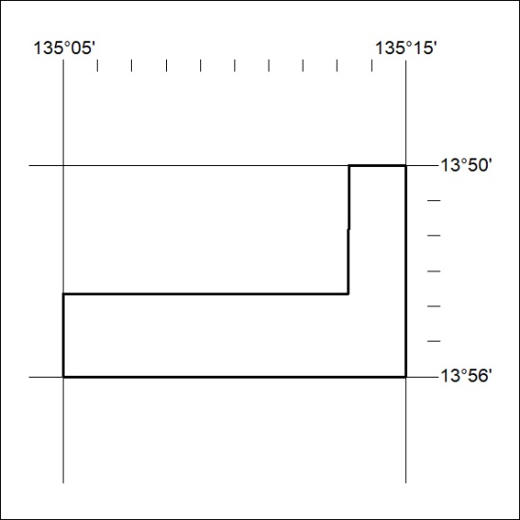

362/24

Mineral Titles Act
NOTICE OF GRANT OF A MINERAL TITLE
Title Type and Number: | Exploration Licence 33756
Granted: | 27 September 2024, for a period of 6 Years
Area: | 181 Blocks, 566.49 km²
Locality: | SANDOVER
Name of Holder/s: | 100% GEMPART (NT) PTY LTD* [ACN. 081 859 896]
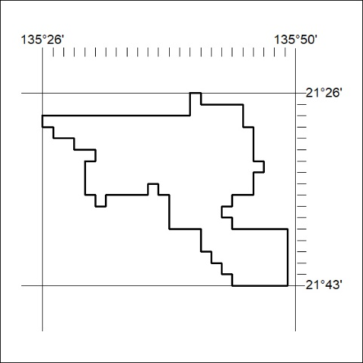
Area granted is indicated above. The titleholder is not permitted to exercise occupational rights on any land that is subject to a development title, or an application for a development title. Any land the subject of a Reserved Land gazettal under the Mineral Titles Act and all land vested in the Commonwealth of Australia is also excluded by description but not excised from the grant area.

363/24

