Mineral Titles Act 2010
NOTICE OF LAND CEASING TO BE A MINERAL TITLE AREA
Title Type and Number: | Exploration Licence 33208
Area Ceased on: | 19 August 2024
Area: | 200 Blocks, 666.90 km²
Locality: | GREENWOOD
Name of Applicant(s)/Holder(s): | 100% WEST COBAR METALS LIMITED [ACN. 649 994 669]
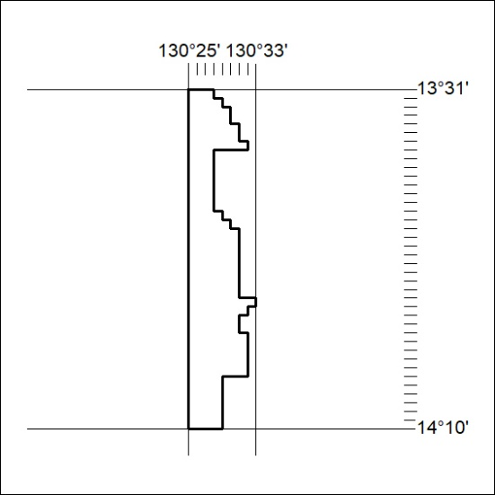
253/24

Mineral Titles Act 2010
NOTICE OF LAND CEASING TO BE A MINERAL TITLE AREA
Title Type and Number: | Mineral Lease (Northern) 883
Area ceased on: | 15 August 2024
Area: | 8.00 Hectare
Locality: | BATCHELOR
Name of Applicants(s)Holder(s): | 100% NT MINING OPERATIONS PTY LTD* [ACN. 136 525 990]
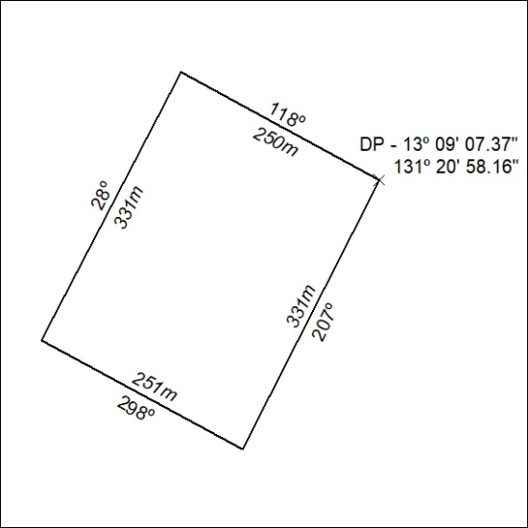
(Area now amalgamated into Mineral Lease 33937 under s102)
254/24

Mineral Titles Act 2010
NOTICE OF LAND CEASING TO BE A MINERAL TITLE AREA
Title Type and Number: | Mineral Lease (Northern) 882
Area ceased on: | 15 August 2024
Area: | 9.00 Hectare
Locality: | BATCHELOR
Name of Applicants(s)Holder(s): | 100% NT MINING OPERATIONS PTY LTD* [ACN. 136 525 990]
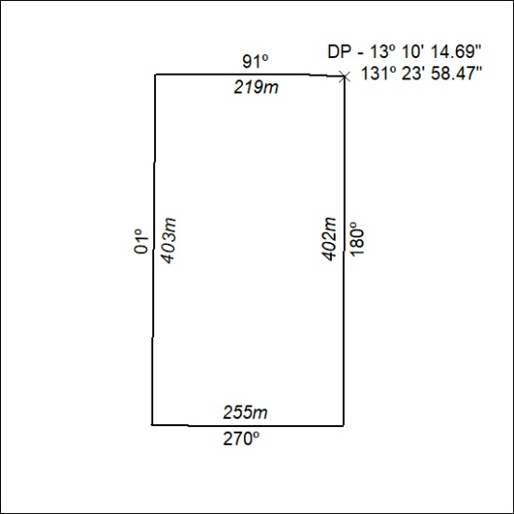
(Area now amalgamated into Mineral Lease 33938 under s102)
255/24

Mineral Titles Act 2010
NOTICE OF LAND CEASING TO BE A MINERAL TITLE AREA
Title Type and Number: | Mineral Lease (Northern) 881
Area ceased on: | 15 August 2024
Area: | 7.00 Hectare
Locality: | BATCHELOR
Name of Applicants(s)Holder(s): | 100% NT MINING OPERATIONS PTY LTD* [ACN. 136 525 990]
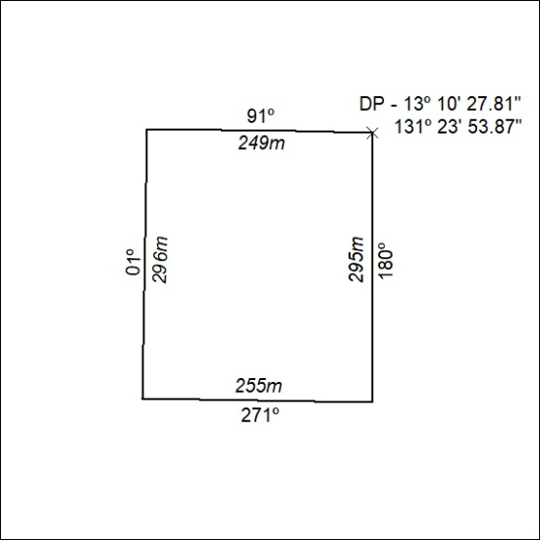
(Area now amalgamated into Mineral Lease 33938 under s102)
256/24

Mineral Titles Act 2010
NOTICE OF LAND CEASING TO BE A MINERAL TITLE AREA
Title Type and Number: | Mineral Lease (Northern) 880
Area ceased on: | 15 August 2024
Area: | 9.00 Hectare
Locality: | BATCHELOR
Name of Applicants(s)Holder(s): | 100% NT MINING OPERATIONS PTY LTD* [ACN. 136 525 990]
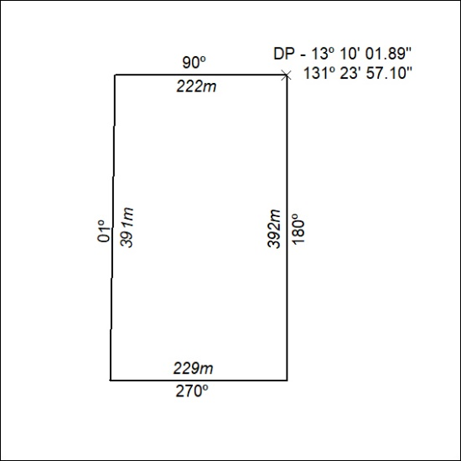
(Area now amalgamated into Mineral Lease 33938 under s102)
257/24

Mineral Titles Act 2010
NOTICE OF LAND CEASING TO BE A MINERAL TITLE AREA
Title Type and Number: | Mineral Lease (Northern) 877
Area ceased on: | 15 August 2024
Locality: | BATCHELOR
Name of Applicants(s)Holder(s): | 100% NT MINING OPERATIONS PTY LTD* [ACN. 136 525 990]
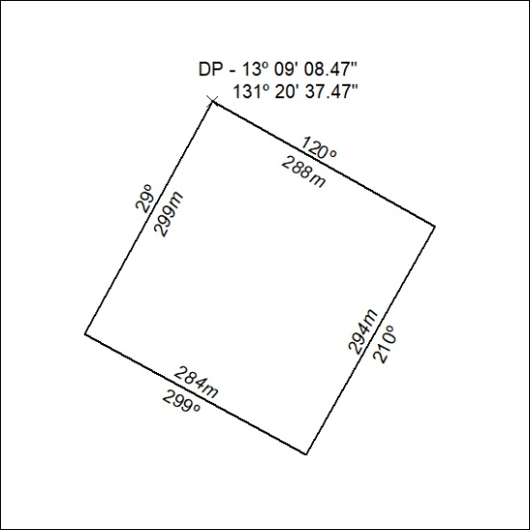
(Area now amalgamated into Mineral Lease 33937 under s102)
258/24

Mineral Titles Act 2010
NOTICE OF LAND CEASING TO BE A MINERAL TITLE AREA
Title Type and Number: | Mineral Lease (Northern) 876
Area ceased on: | 15 August 2024
Area: | 10.00 Hectare
Locality: | BATCHELOR
Name of Applicants(s)Holder(s): | 100% NT MINING OPERATIONS PTY LTD* [ACN. 136 525 990]
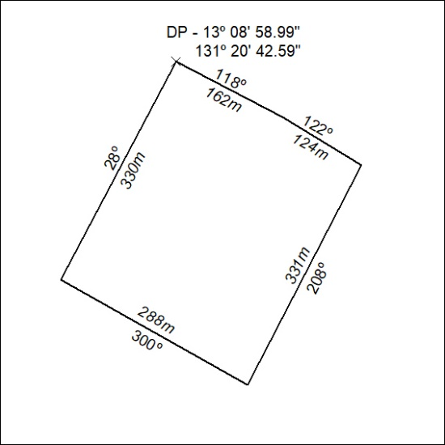
(Area now amalgamated into Mineral Lease 33937 under s102)
259/24

Mineral Titles Act 2010
NOTICE OF LAND CEASING TO BE A MINERAL TITLE AREA
Title Type and Number: | Mineral Lease (Northern) 875
Area ceased on: | 15 August 2024
Area: | 8.00 Hectare
Locality: | BATCHELOR
Name of Applicants(s)Holder(s): | 100% NT MINING OPERATIONS PTY LTD* [ACN. 136 525 990]
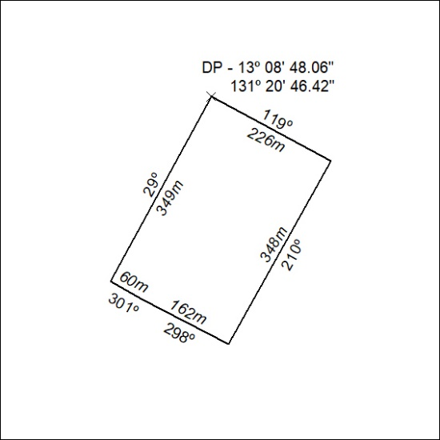
(Area now amalgamated into Mineral Lease 33937 under s102)
260/24

Mineral Titles Act 2010
NOTICE OF LAND CEASING TO BE A MINERAL TITLE AREA
Title Type and Number: | Mineral Lease (Northern) 874
Area ceased on: | 15 August 2024
Area: | 8.00 Hectare
Locality: | BATCHELOR
Name of Applicants(s)Holder(s): | 100% NT MINING OPERATIONS PTY LTD* [ACN. 136 525 990]
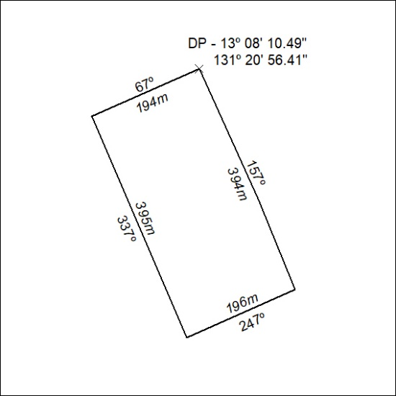
(Area now amalgamated into Mineral Lease 33936 under s102)
261/24

Mineral Titles Act 2010
NOTICE OF LAND CEASING TO BE A MINERAL TITLE AREA
Title Type and Number: | Mineral Lease (Northern) 873
Area ceased on: | 15 August 2024
Area: | 8.00 Hectare
Locality: | BATCHELOR
Name of Applicants(s)Holder(s): | 100% NT MINING OPERATIONS PTY LTD* [ACN. 136 525 990]
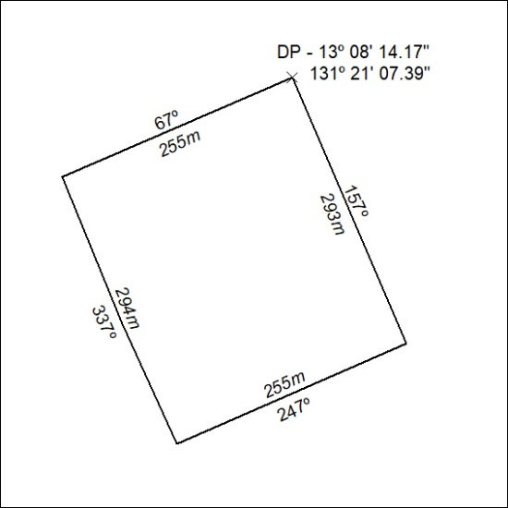
(Area now amalgamated into Mineral Lease 33936 under s102)
262/24

Mineral Titles Act 2010
NOTICE OF LAND CEASING TO BE A MINERAL TITLE AREA
Title Type and Number: | Mineral Lease (Northern) 872
Area ceased on: | 15 August 2024
Area: | 8.00 Hectare
Locality: | BATCHELOR
Name of Applicants(s)Holder(s): | 100% NT MINING OPERATIONS PTY LTD* [ACN. 136 525 990]
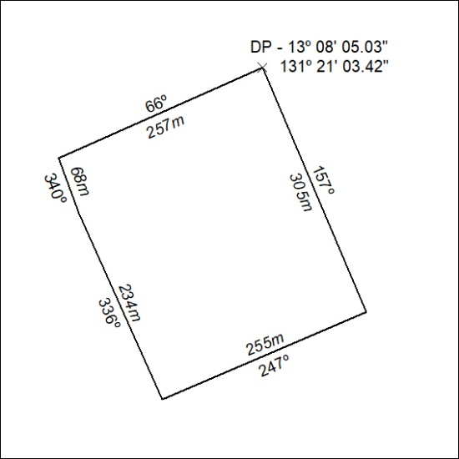
(Area now amalgamated into Mineral Lease 33936 under s102)
263/24

Mineral Titles Act 2010
NOTICE OF LAND CEASING TO BE A MINERAL TITLE AREA
Title Type and Number: | Extractive Mineral Exploration Licence 33147
Area Ceased on: | 18 August 2024
Area: | 1 Block, 2.58 km²
Locality: | BYNOE
Name of Applicant(s)/Holder(s): | 100% KING Allan Ronald
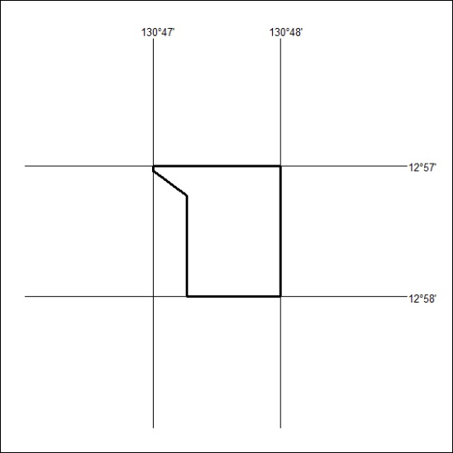
264/24

