Mineral Titles Act 2010
NOTICE OF LAND CEASING TO BE A MINERAL TITLE AREA
Title Type and Number: | Mineral Lease 28341
Area ceased on: | 02 July 2024
Area: | 329.00 Hectares
Locality: | ANNINGIE
Name of Applicants(s)Holder(s): | 100% ENIGMA MINING LIMITED [ACN. 009 225 558]
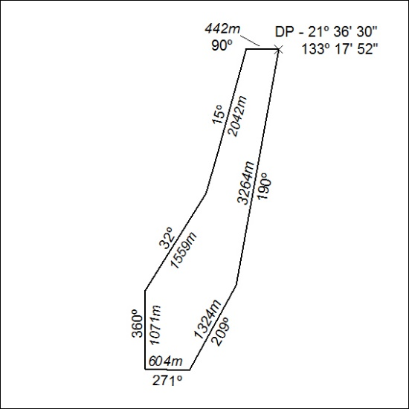
272/24

Mineral Titles Act 2010
NOTICE OF LAND CEASING TO BE A MINERAL TITLE AREA
Title Type and Number: | Exploration Licence 31896
Area Ceased on: | 02 July 2024
Area: | 61 Blocks, 185.96 km²
Locality: | BARROW
Name of Applicant(s)/Holder(s): | 100% TIVAN LIMITED* [ACN. 000 817 023]
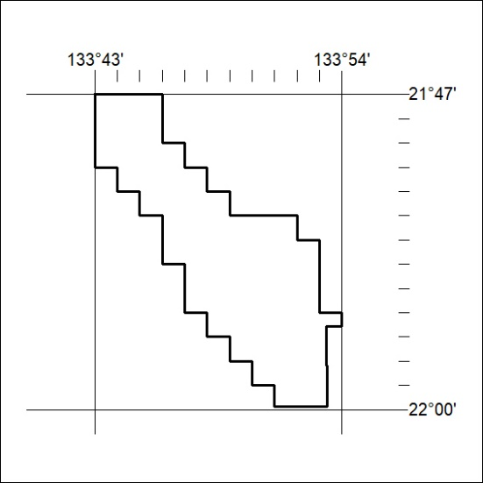
273/24

Mineral Titles Act 2010
NOTICE OF LAND CEASING TO BE A MINERAL TITLE AREA
Title Type and Number: | Exploration Licence 30483
Area Ceased on: | 02 July 2024
Area: | 7 Blocks, 22.31 km²
Locality: | HOME OF BULLION
Name of Applicant(s)/Holder(s): | 100% ENIGMA MINING LIMITED [ACN. 009 225 558]
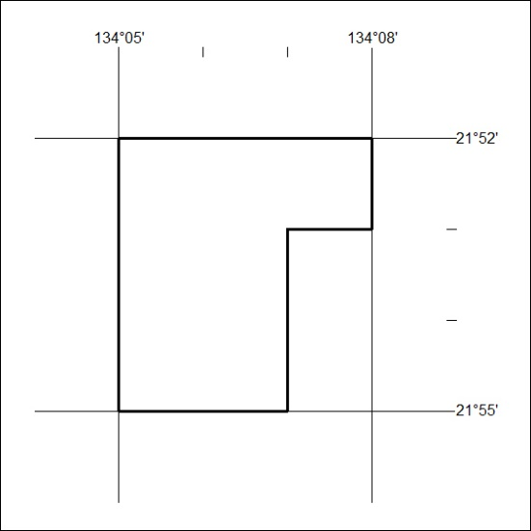
274/24

Mineral Titles Act 2010
NOTICE OF LAND CEASING TO BE A MINERAL TITLE AREA
Title Type and Number: | Exploration Licence 29578
Area Ceased on: | 02 July 2024
Area: | 34 Blocks, 102.96 km²
Locality: | ANNINGIE
Name of Applicant(s)/Holder(s): | 100% ENIGMA MINING LIMITED [ACN. 009 225 558]
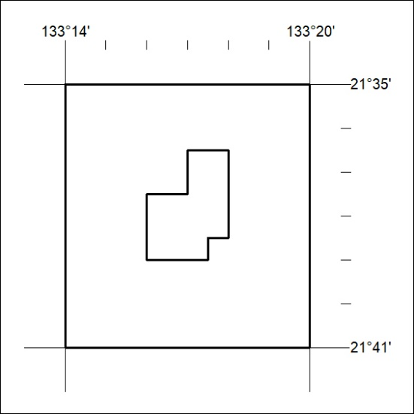
275/24

Mineral Titles Act 2010
NOTICE OF LAND CEASING TO BE A MINERAL TITLE AREA
Title Type and Number: | Exploration Licence 27941
Area Ceased on: | 02 July 2024
Area: | 6 Blocks, 19.16 km²
Locality: | BARROW
Name of Applicant(s)/Holder(s): | 100% ENIGMA MINING LIMITED [ACN. 009 225 558]
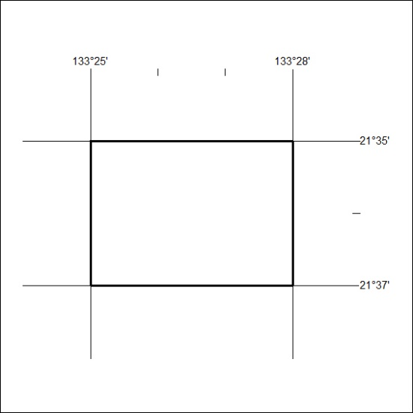
276/24

Mineral Titles Act 2010
NOTICE OF LAND CEASING TO BE A MINERAL TITLE AREA
Title Type and Number: | Exploration Licence 27069
Area Ceased on: | 02 July 2024
Area: | 21 Blocks, 67.04 km²
Locality: | ANNINGIE
Name of Applicant(s)/Holder(s): | 100% ENIGMA MINING LIMITED [ACN. 009 225 558]
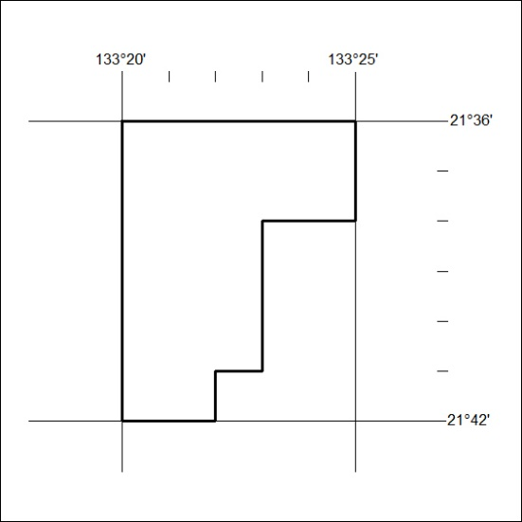
277/24

