Mineral Titles Act 2010
NOTICE OF LAND CEASING TO BE A MINERAL TITLE AREA
Title Type and Number: | Exploration Licence 31389
Area Ceased on: | 25 June 2024
Area: | 89 Blocks, 284.56 km²
Locality: | CONICAL HILL
Name of Applicant(s)/Holder(s): | 100% ENIGMA MINING LIMITED [ACN. 009 225 558]
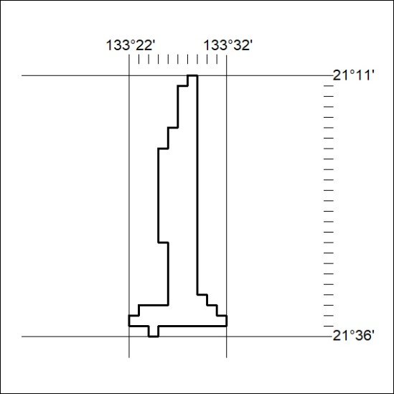
261/24

