Mineral Titles Act 2010
NOTICE OF LAND CEASING TO BE A MINERAL TITLE AREA
Title Type and Number: | Exploration Licence 26938
Area Ceased on: | 19 June 2024
Area: | 75 Blocks, 247.52 km²
Locality: | BATTEN
Name of Applicant(s)/Holder(s): | 100% SANDFIRE RESOURCES LIMITED* [ACN. 105 154 185]
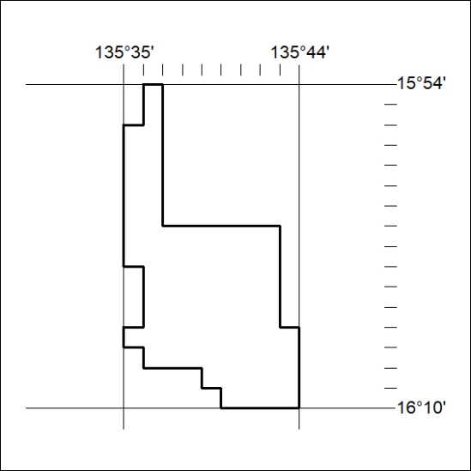
258/24

Mineral Titles Act 2010
NOTICE OF LAND CEASING TO BE A MINERAL TITLE AREA
Title Type and Number: | Exploration Licence 26939
Area Ceased on: | 19 June 2024
Area: | 35 Blocks, 115.77 km²
Locality: | MANTUNGULA
Name of Applicant(s)/Holder(s): | 100% SANDFIRE RESOURCES LIMITED* [ACN. 105 154 185]
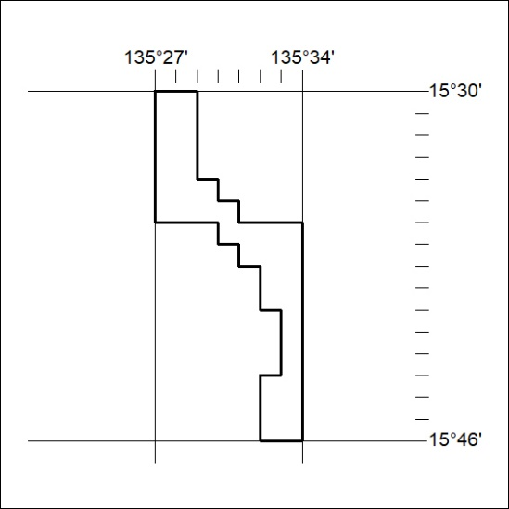
259/24

