Mineral Titles Act 2010
NOTICE OF LAND CEASING TO BE A MINERAL TITLE APPLICATION AREA
Title Type and Number: | Exploration Licence 32703
Area Ceased on: | 02 May 2024
Area: | 250 Blocks, 756.11 km²
Locality: | KEKWICK
Name of Applicant(s)/Holder(s): | 100% BAUDIN RESOURCES PTY LTD [ACN. 618 455 593]
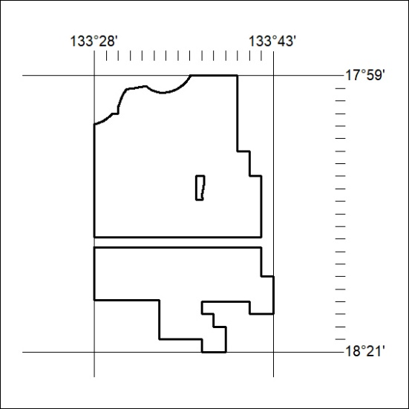

180/24

Mineral Titles Act 2010
NOTICE OF LAND CEASING TO BE A MINERAL TITLE APPLICATION AREA
Title Type and Number: | Exploration Licence 32729
Area Ceased on: | 02 May 2024
Area: | 209 Blocks, 672.64 km²
Locality: | NEWCASTLE WATERS
Name of Applicant(s)/Holder(s): | 100% BAUDIN RESOURCES PTY LTD [ACN. 618 455 593]
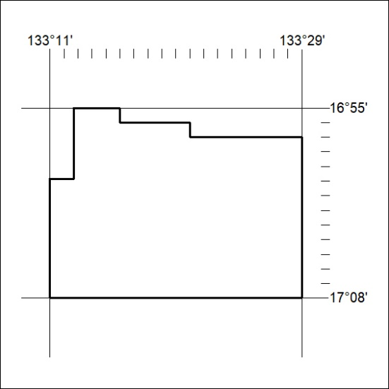

181/24
Mineral Titles Act 2010
NOTICE OF LAND CEASING TO BE A MINERAL TITLE APPLICATION AREA
Title Type and Number: | Exploration Licence 32730
Area Ceased on: | 02 May 2024
Area: | 231 Blocks, 757.92 km²
Locality: | NEWCASTLE WATERS
Name of Applicant(s)/Holder(s): | 100% BAUDIN RESOURCES PTY LTD [ACN. 618 455 593]
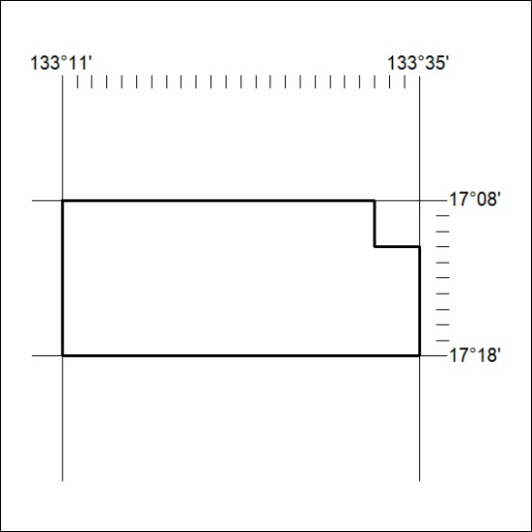

182/24

