Mineral Titles Act 2010
NOTICE OF LAND CEASING TO BE A MINERAL TITLE AREA
Title Type and Number: | Exploration Licence 31545
Area Ceased on: | 26 April 2024
Area: | 7 Blocks, 23.06 km²
Locality: | KILLARNEY
Name of Applicant(s)/Holder(s): | 100% WRIGHT Anthony
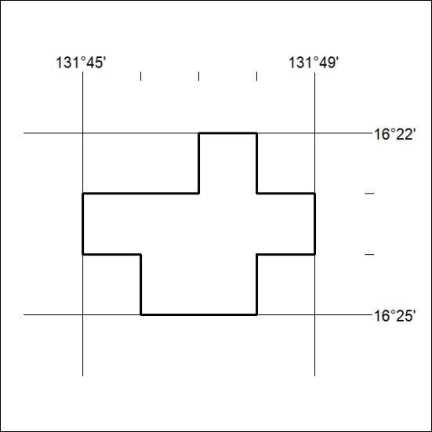

173/24

Mineral Titles Act 2010
NOTICE OF LAND CEASING TO BE A MINERAL TITLE AREA
Title Type and Number: | Exploration Licence 32344
Area Ceased on: | 24 April 2024
Area: | 49 Blocks, 157.23 km²
Locality: | DAVENPORT RANGE
Name of Applicant(s)/Holder(s): | 100% TREASURE CREEK PTY LTD [ACN. 619 057 644]
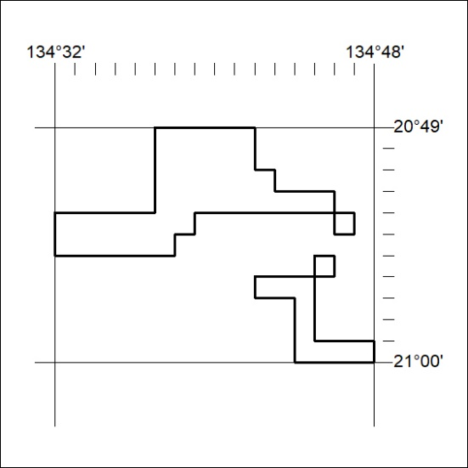

174/24
Mineral Titles Act 2010
NOTICE OF LAND CEASING TO BE A MINERAL TITLE AREA
Title Type and Number: | Exploration Licence 32345
Area Ceased on: | 24 April 2024
Area: | 68 Blocks, 217.80 km²
Locality: | MURRAY DOWNS
Name of Applicant(s)/Holder(s): | 100% TREASURE CREEK PTY LTD [ACN. 619 057 644]
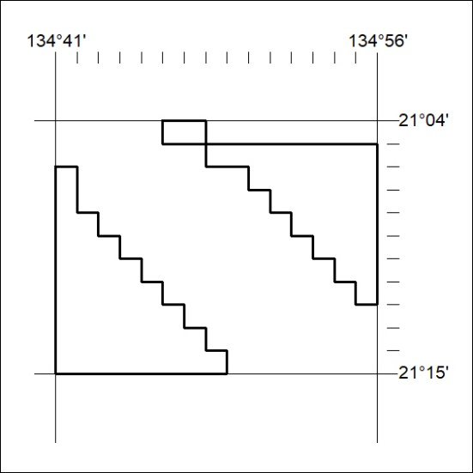

175/24

