Mineral Titles Act 2010
NOTICE OF LAND CEASING TO BE A MINERAL TITLE AREA
Title Type and Number: | Mineral Lease (Northern) 182
Area ceased on: | 24 April 2024
Area: | 2.00 Hectare
Locality: | PINE CREEK
Name of Applicants(s)Holder(s): | 100% WOODLEIGH NOMINEES PTY LIMITED [ACN. 050 120 057]
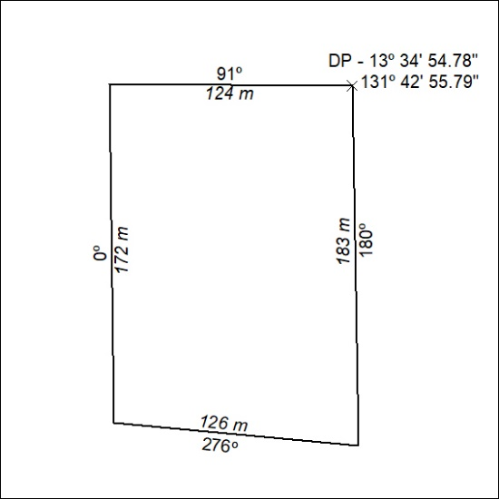
(Area now amalgamated into Mineral Lease 33762 under s102)

164/24

Mineral Titles Act 2010
NOTICE OF LAND CEASING TO BE A MINERAL TITLE AREA
Title Type and Number: | Mineral Lease 31677
Area ceased on: | 24 April 2024
Area: | 21.00 Hectare
Locality: | PINE CREEK
Name of Applicants(s)Holder(s): | 100% WOODLEIGH NOMINEES PTY LIMITED [ACN. 050 120 057]
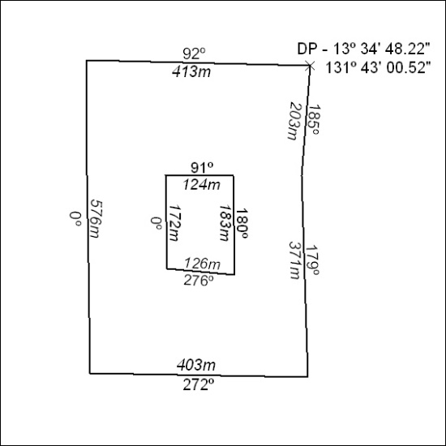
(Area now amalgamated into Mineral Lease 33762 under s102)

165/24

Mineral Titles Act
NOTICE OF GRANT OF A MINERAL TITLE
Title Type and Number: | Exploration Licence 33626
Granted: | 24 April 2024, for a period of 6 Years
Area: | 250 Blocks, 820.03 km²
Locality: | WATERLOO
Name of Holder/s: | 100% BAUDIN RESOURCES PTY LTD [ACN. 618 455 593]
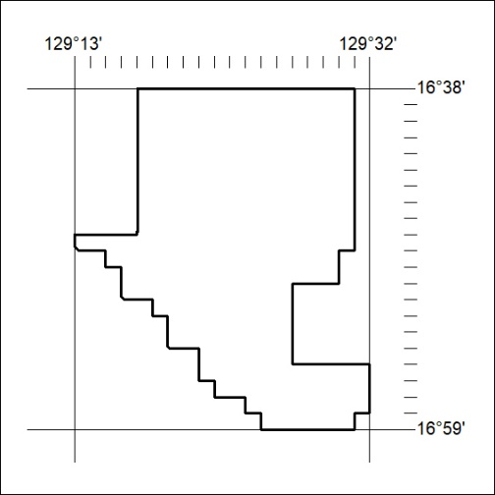
Area granted is indicated above. The titleholder is not permitted to exercise occupational rights on any land that is subject to a development title, or an application for a development title. Any land the subject of a Reserved Land gazettal under the Mineral Titles Act and all land vested in the Commonwealth of Australia is also excluded by description but not excised from the grant area.

166/24

Mineral Titles Act
NOTICE OF GRANT OF A MINERAL TITLE
Title Type and Number: | Exploration Licence 33627
Granted: | 24 April 2024, for a period of 6 Years
Area: | 250 Blocks, 821.90 km²
Locality: | KIMON
Name of Holder/s: | 100% BAUDIN RESOURCES PTY LTD [ACN. 618 455 593]
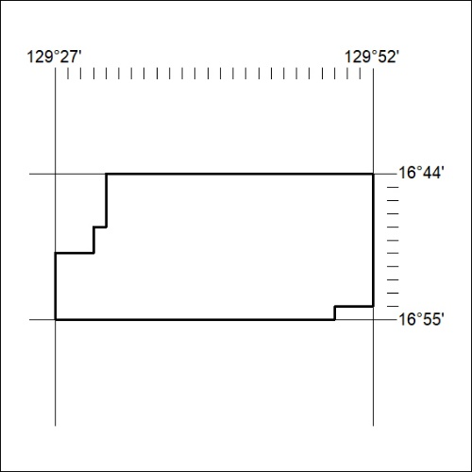
Area granted is indicated above. The titleholder is not permitted to exercise occupational rights on any land that is subject to a development title, or an application for a development title. Any land the subject of a Reserved Land gazettal under the Mineral Titles Act and all land vested in the Commonwealth of Australia is also excluded by description but not excised from the grant area.

167/24

Mineral Titles Act
NOTICE OF GRANT OF A MINERAL TITLE
Title Type and Number: | Exploration Licence 33642
Granted: | 23 April 2024, for a period of 6 Years
Area: | 53 Blocks, 151.91 km²
Locality: | DOREEN
Name of Holder/s: | 100% CHALCO RESOURCES PTY LTD [ACN. 648 662 346]
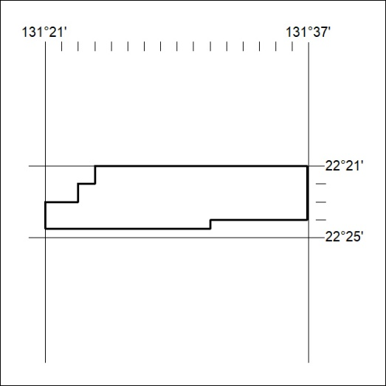
Area granted is indicated above. The titleholder is not permitted to exercise occupational rights on any land that is subject to a development title, or an application for a development title. Any land the subject of a Reserved Land gazettal under the Mineral Titles Act and all land vested in the Commonwealth of Australia is also excluded by description but not excised from the grant area.

168/24

Mineral Titles Act
NOTICE OF GRANT OF A MINERAL TITLE
Title Type and Number: | Exploration Licence 33644
Granted: | 23 April 2024, for a period of 6 Years
Area: | 16 Blocks, 40.24 km²
Locality: | DOREEN
Name of Holder/s: | 100% CHALCO RESOURCES PTY LTD [ACN. 648 662 346]
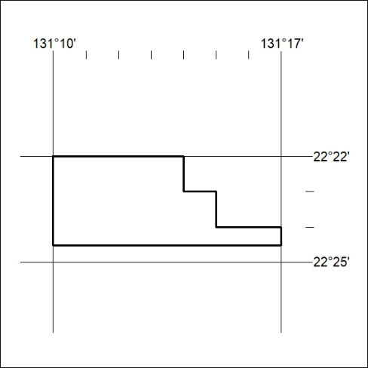
Area granted is indicated above. The titleholder is not permitted to exercise occupational rights on any land that is subject to a development title, or an application for a development title. Any land the subject of a Reserved Land gazettal under the Mineral Titles Act and all land vested in the Commonwealth of Australia is also excluded by description but not excised from the grant area.

169/24

Mineral Titles Act
NOTICE OF GRANT OF A MINERAL TITLE
Title Type and Number: | Exploration Licence 33646
Granted: | 23 April 2024, for a period of 6 Years
Area: | 22 Blocks, 69.06 km²
Locality: | YUENDUMU
Name of Holder/s: | 100% CHALCO RESOURCES PTY LTD [ACN. 648 662 346]
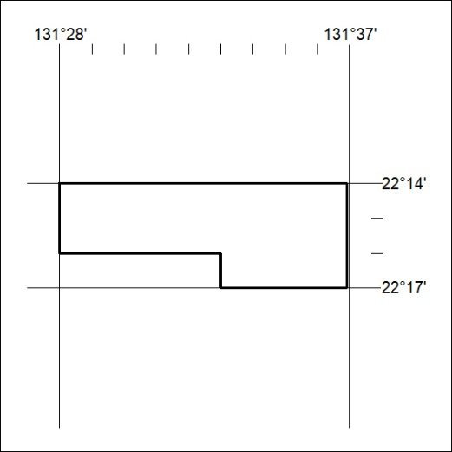
Area granted is indicated above. The titleholder is not permitted to exercise occupational rights on any land that is subject to a development title, or an application for a development title. Any land the subject of a Reserved Land gazettal under the Mineral Titles Act and all land vested in the Commonwealth of Australia is also excluded by description but not excised from the grant area.

170/24

