Mineral Titles Act 2010
NOTICE OF LAND CEASING TO BE A MINERAL TITLE AREA
Title Type and Number: | Exploration Licence 32041
Area Ceased on: | 21 February 2024
Area: | 9 Blocks, 20.34 km²
Locality: | NOONAMAH
Name of Applicant(s)/Holder(s): | 100% ALDEBARAN CONTRACTING PTY LTD [ACN. 128 020 299]
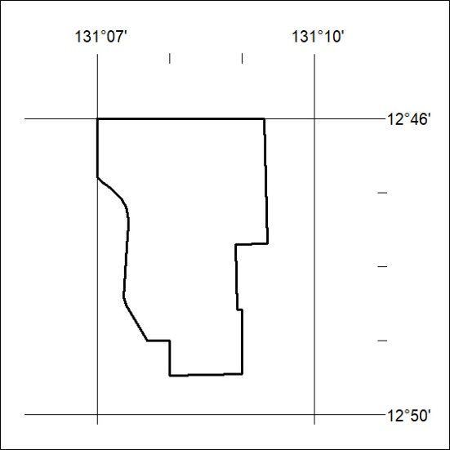

41/24

Mineral Titles Act 2010
NOTICE OF LAND CEASING TO BE A MINERAL TITLE AREA
Title Type and Number: | Extractive Mineral Exploration Licence 32874
Area Ceased on: | 20 February 2024
Area: | 4 Blocks, 13.23 km²
Locality: | WESTERN CREEK
Name of Applicant(s)/Holder(s): | 100% TERRITORY SANDS PTY LTD [ACN. 632 797 972]
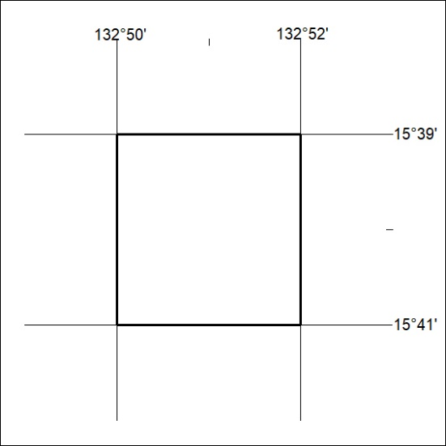

42/24

Mineral Titles Act 2010
NOTICE OF LAND CEASING TO BE A MINERAL TITLE AREA
Title Type and Number: | Extractive Mineral Exploration Licence 32875
Area Ceased on: | 20 February 2024
Area: | 4 Blocks, 13.23 km²
Locality: | WESTERN CREEK
Name of Applicant(s)/Holder(s): | 100% TERRITORY SANDS PTY LTD [ACN. 632 797 972]
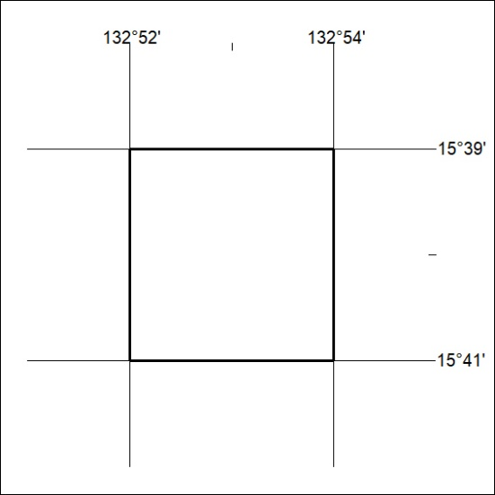

43/24

