Mineral Titles Act 2010
NOTICE OF LAND CEASING TO BE A MINERAL TITLE AREA
Title Type and Number: | Exploration Licence 31980
Area Ceased on: | 27 November 2023
Area: | 68 Blocks, 217.96 km²
Locality: | ARNOLD RIVER
Name of Applicant(s)/Holder(s): | 100% PENNANT RESOURCES PTY LTD [ACN. 150 501 492]
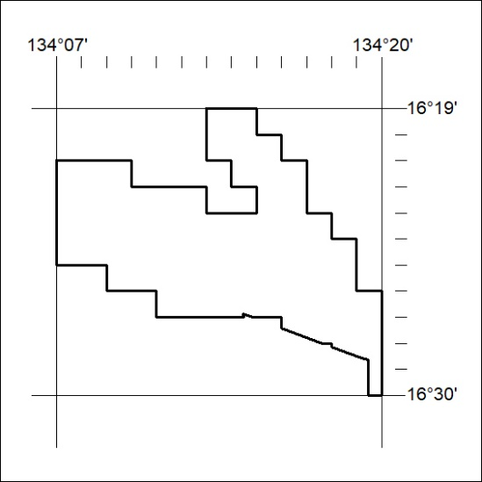

483/23

Mineral Titles Act 2010
NOTICE OF LAND CEASING TO BE A MINERAL TITLE AREA
Title Type and Number: | Exploration Licence 31981
Area Ceased on: | 27 November 2023
Area: | 129 Blocks, 421.43 km²
Locality: | OCTOBER
Name of Applicant(s)/Holder(s): | 100% PENNANT RESOURCES PTY LTD [ACN. 150 501 492]
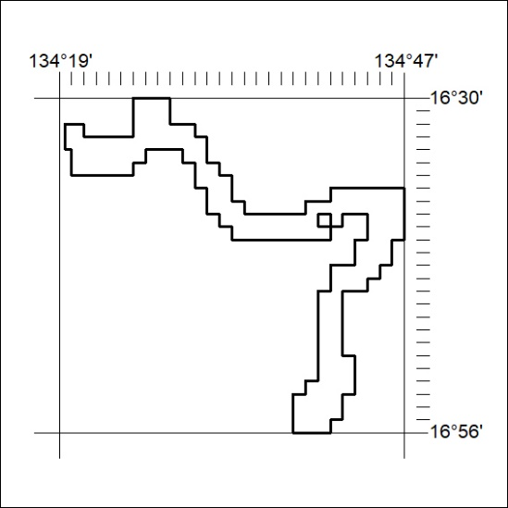

484/23
Mineral Titles Act 2010
NOTICE OF LAND CEASING TO BE A MINERAL TITLE AREA
Title Type and Number: | Exploration Licence 32002
Area Ceased on: | 27 November 2023
Area: | 167 Blocks, 549.85 km²
Locality: | OCTOBER
Name of Applicant(s)/Holder(s): | 100% PENNANT RESOURCES PTY LTD [ACN. 150 501 492]
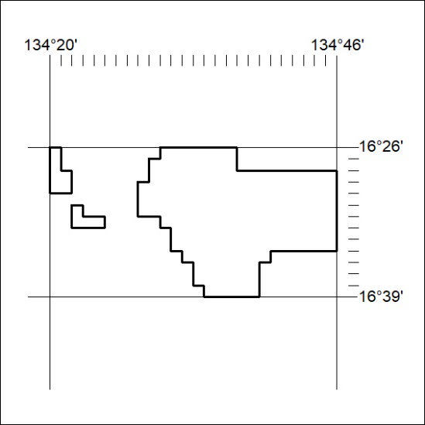

485/23

Mineral Titles Act 2010
NOTICE OF LAND CEASING TO BE A MINERAL TITLE AREA
Title Type and Number: | Exploration Licence 32006
Area Ceased on: | 27 November 2023
Area: | 73 Blocks, 240.56 km²
Locality: | VICTORIA RIVER DOWNS
Name of Applicant(s)/Holder(s): | 100% PENNANT RESOURCES PTY LTD [ACN. 150 501 492]
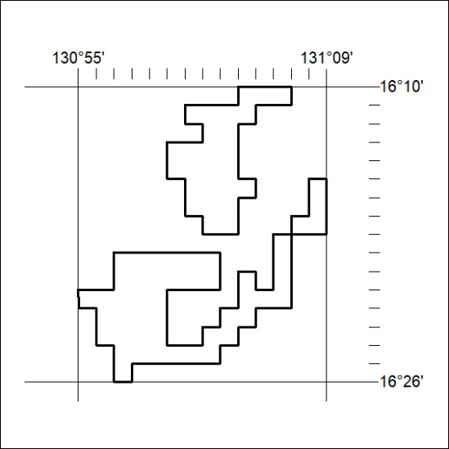

486/23
Mineral Titles Act 2010
NOTICE OF LAND CEASING TO BE A MINERAL TITLE AREA
Title Type and Number: | Exploration Licence 32008
Area Ceased on: | 27 November 2023
Area: | 200 Blocks, 658.77 km²
Locality: | ARNOLD RIVER
Name of Applicant(s)/Holder(s): | 100% PENNANT RESOURCES PTY LTD [ACN. 150 501 492]
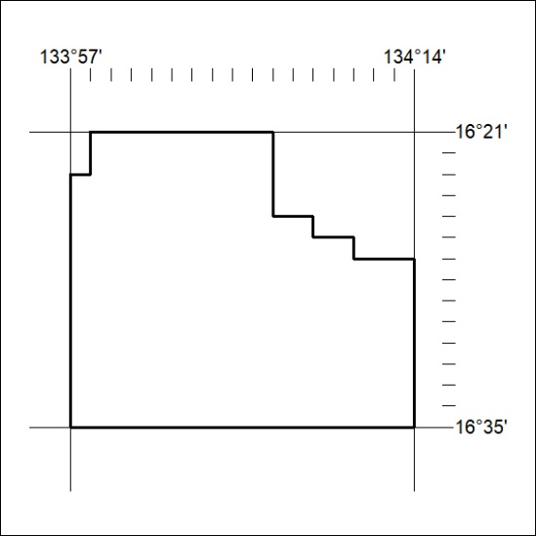

487/23

Mineral Titles Act 2010
NOTICE OF LAND CEASING TO BE A MINERAL TITLE AREA
Title Type and Number: | Exploration Licence 32009
Area Ceased on: | 27 November 2023
Area: | 103 Blocks, 339.70 km²
Locality: | ARNOLD RIVER
Name of Applicant(s)/Holder(s): | 100% PENNANT RESOURCES PTY LTD [ACN. 150 501 492]
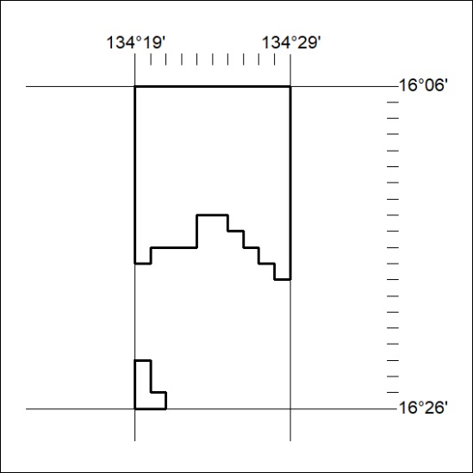

488/23
Mineral Titles Act 2010
NOTICE OF LAND CEASING TO BE A MINERAL TITLE AREA
Title Type and Number: | Exploration Licence 32010
Area Ceased on: | 27 November 2023
Area: | 194 Blocks, 639.63 km²
Locality: | TANUMBIRINI
Name of Applicant(s)/Holder(s): | 100% PENNANT RESOURCES PTY LTD [ACN. 150 501 492]
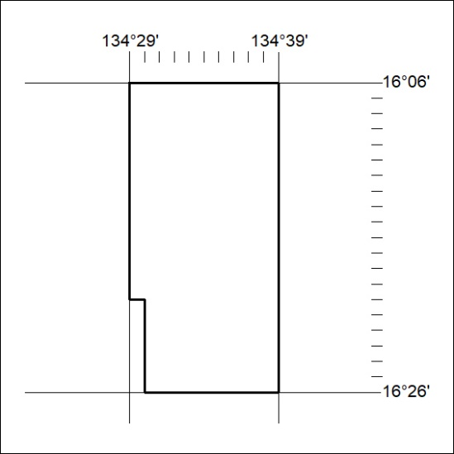

489/23

Mineral Titles Act 2010
NOTICE OF LAND CEASING TO BE A MINERAL TITLE AREA
Title Type and Number: | Exploration Licence 32011
Area Ceased on: | 27 November 2023
Area: | 195 Blocks, 642.76 km²
Locality: | TANUMBIRINI
Name of Applicant(s)/Holder(s): | 100% PENNANT RESOURCES PTY LTD [ACN. 150 501 492]
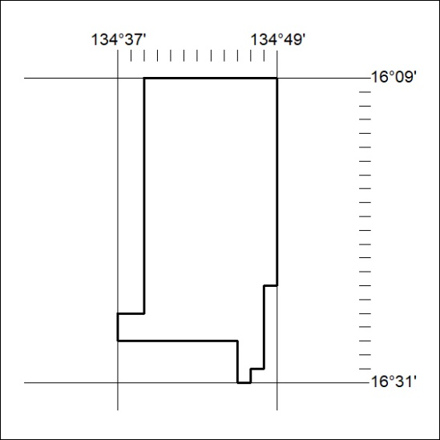

490/23
Mineral Titles Act 2010
NOTICE OF LAND CEASING TO BE A MINERAL TITLE AREA
Title Type and Number: | Exploration Licence 32012
Area Ceased on: | 27 November 2023
Area: | 128 Blocks, 421.74 km²
Locality: | TANUMBIRINI
Name of Applicant(s)/Holder(s): | 100% PENNANT RESOURCES PTY LTD [ACN. 150 501 492]
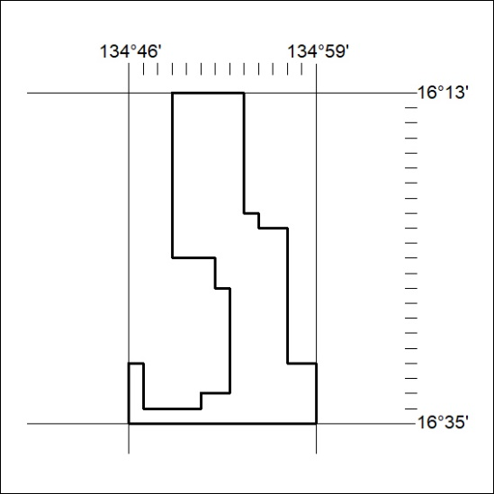

491/23

Mineral Titles Act 2010
NOTICE OF LAND CEASING TO BE A MINERAL TITLE AREA
Title Type and Number: | Exploration Licence 32013
Area Ceased on: | 27 November 2023
Area: | 198 Blocks, 651.37 km²
Locality: | OCTOBER
Name of Applicant(s)/Holder(s): | 100% PENNANT RESOURCES PTY LTD [ACN. 150 501 492]
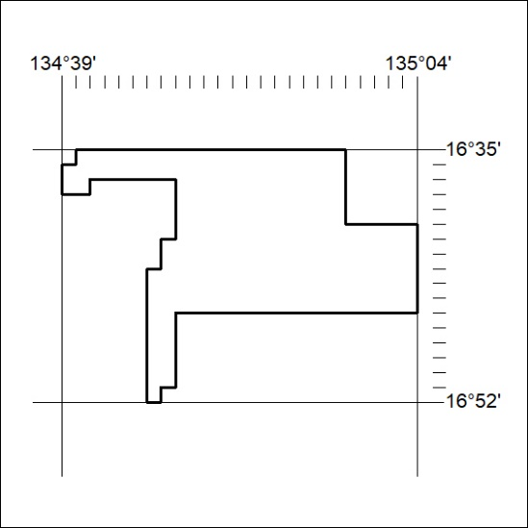

492/23
Mineral Titles Act 2010
NOTICE OF LAND CEASING TO BE A MINERAL TITLE AREA
Title Type and Number: | Exploration Licence 32014
Area Ceased on: | 27 November 2023
Area: | 209 Blocks, 687.29 km²
Locality: | OCTOBER
Name of Applicant(s)/Holder(s): | 100% PENNANT RESOURCES PTY LTD [ACN. 150 501 492]
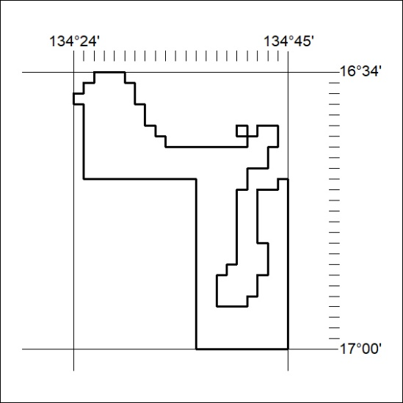

493/23

