Mineral Titles Act 2010
NOTICE OF LAND CEASING TO BE A MINERAL TITLE AREA
Title Type and Number: | Exploration Licence 24851
Area Ceased on: | 08 November 2023
Area: | 12 Blocks, 40.34 km²
Locality: | BATHURST ISLAND
Name of Applicant(s)/Holder(s): | 100% TIWI RESOURCES PTY LTD [ACN. 054 667 051]
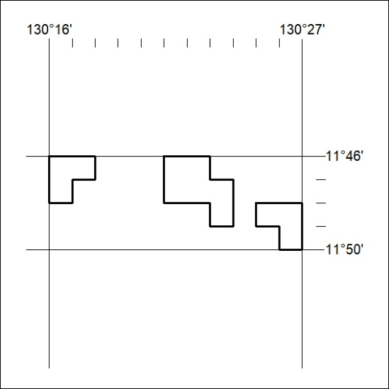

468/23

Mineral Titles Act 2010
NOTICE OF LAND CEASING TO BE A MINERAL TITLE AREA
Title Type and Number: | Exploration Licence 31983
Area Ceased on: | 07 November 2023
Area: | 16 Blocks, 44.87 km²
Locality: | LAUGHLEN
Name of Applicant(s)/Holder(s): | 100% MATSON Paul Richard
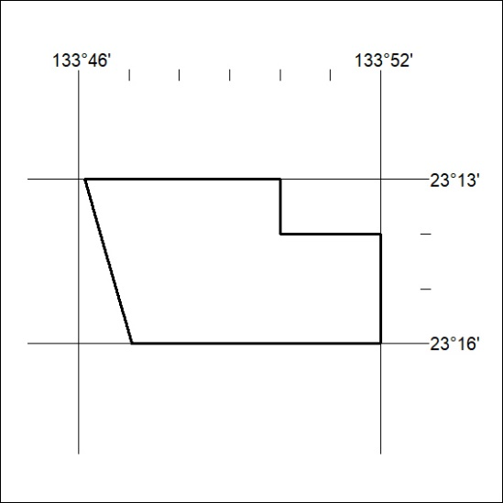

469/23
Mineral Titles Act 2010
NOTICE OF LAND CEASING TO BE A MINERAL TITLE AREA
Title Type and Number: | Exploration Licence 32427
Area Ceased on: | 07 November 2023
Area: | 27 Blocks, 85.19 km²
Locality: | BURT
Name of Applicant(s)/Holder(s): | 100% MATSON Paul Richard
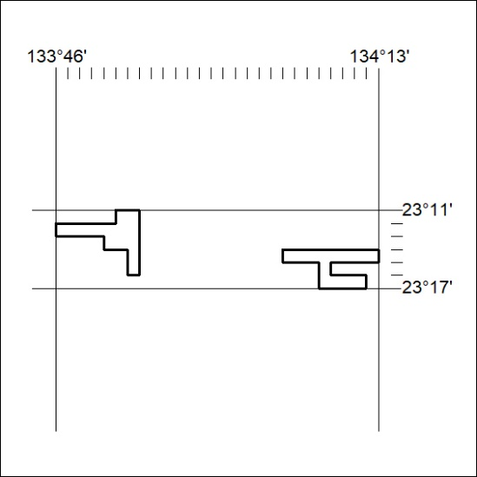

470/23

Mineral Titles Act 2010
NOTICE OF LAND CEASING TO BE A MINERAL TITLE APPLICATION AREA
Title Type and Number: | Exploration Licence 33593
Area Ceased on: | 07 November 2023
Area: | 80 Blocks, 253.11 km²
Locality: | ALCOOTA
Name of Applicant(s)/Holder(s): | 100% WILUNA WEST GOLD PTY LTD [ACN. 116 550 111]
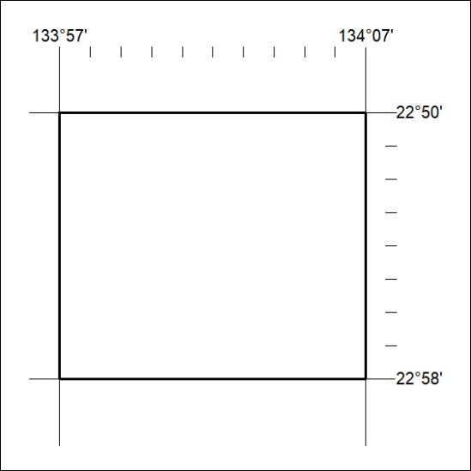

471/23

