Mineral Titles Act 2010
NOTICE OF LAND CEASING TO BE A MINERAL TITLE AREA
Title Type and Number: | Exploration Licence 32478
Area Ceased on: | 11 October 2023
Area: | 250 Blocks, 798.52 km²
Locality: | FLYNN
Name of Applicant(s)/Holder(s): | 100% BAUDIN RESOURCES PTY LTD [ACN. 618 455 593]
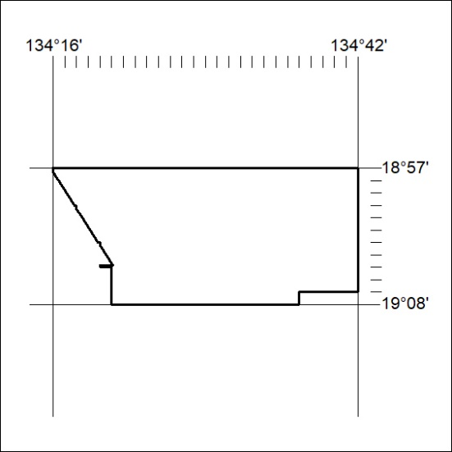

420/23

Mineral Titles Act 2010
NOTICE OF LAND CEASING TO BE A MINERAL TITLE AREA
Title Type and Number: | Extractive Mineral Permit 29378
Area ceased on: | 11 October 2023
Area: | 8.00 Hectare
Locality: | NOONAMAH
Name of Applicants(s)Holder(s): | 100% BOB KERR TRANSPORT PTY LTD [ACN. 109 115 059]
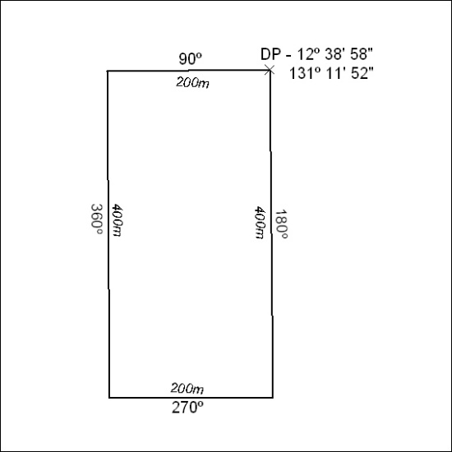

421/23

Mineral Titles Act 2010
NOTICE OF LAND CEASING TO BE A MINERAL TITLE AREA
Title Type and Number: | Extractive Mineral Permit 29379
Area ceased on: | 11 October 2023
Area: | 6.00 Hectare
Locality: | NOONAMAH
Name of Applicants(s)Holder(s): | 100% BOB KERR TRANSPORT PTY LTD [ACN. 109 115 059]
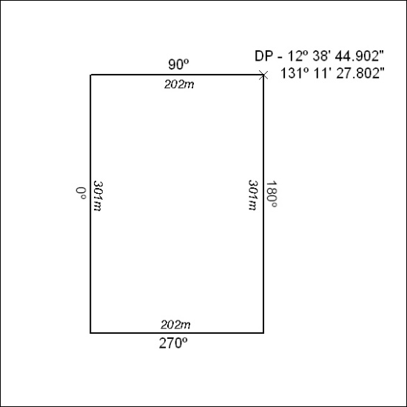

422/23

Mineral Titles Act 2010
NOTICE OF LAND CEASING TO BE A MINERAL TITLE AREA
Title Type and Number: | Extractive Mineral Permit (Northern) 1056
Area ceased on: | 11 October 2023
Area: | 8.00 Hectare
Locality: | NOONAMAH
Name of Applicants(s)Holder(s): | 100% BOB KERR TRANSPORT PTY LTD [ACN. 109 115 059]
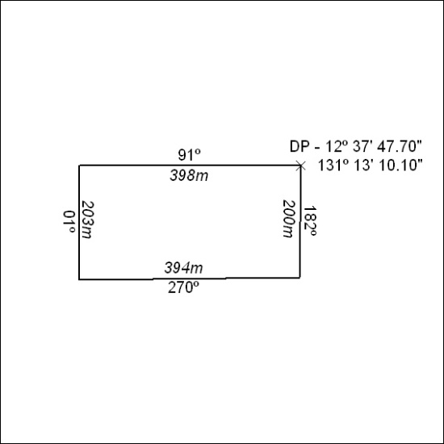

423/23

Mineral Titles Act 2010
NOTICE OF LAND CEASING TO BE A MINERAL TITLE AREA
Title Type and Number: | Mineral Authority 24742
Area ceased on: | 11 October 2023
Area: | 22.00 Hectare
Locality: | BYNOE
Name of Applicants(s)Holder(s): | 100% BOB KERR TRANSPORT PTY LTD [ACN. 109 115 059]
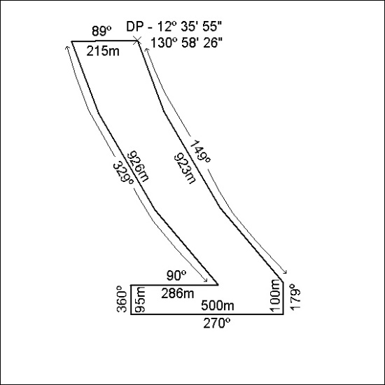

424/23

