Mineral Titles Act 2010
NOTICE OF LAND CEASING TO BE A MINERAL TITLE APPLICATION AREA
Title Type and Number: | Exploration Licence 24260
Area Ceased on: | 29 September 2023
Area: | 143 Blocks, 462.27 km²
Locality: | ELDER
Name of Applicant(s)/Holder(s): | 100% TODD RIVER METALS PTY LTD [ACN. 600 314 038]
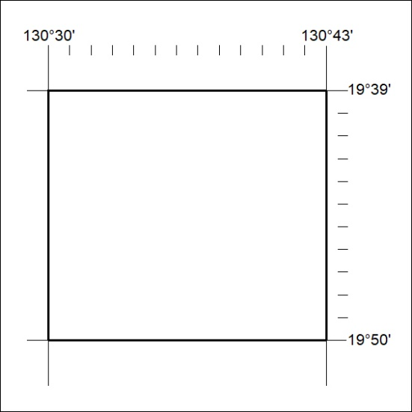

386/23

Mineral Titles Act 2010
NOTICE OF LAND CEASING TO BE A MINERAL TITLE APPLICATION AREA
Title Type and Number: | Exploration Licence 28509
Area Ceased on: | 29 September 2023
Area: | 9 Blocks, 29.55 km²
Locality: | BLOODWOOD CREEK
Name of Applicant(s)/Holder(s): | 100% TODD RIVER METALS PTY LTD [ACN. 600 314 038]
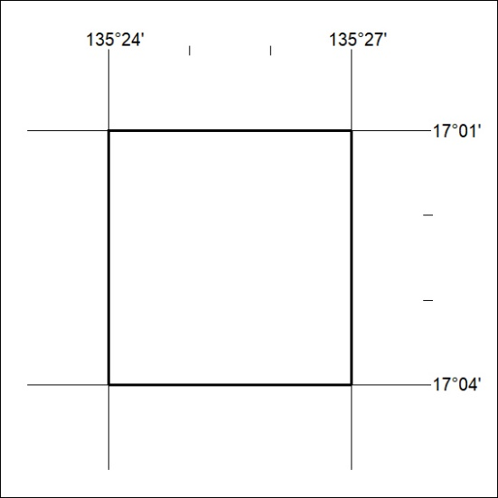

387/23
Mineral Titles Act 2010
NOTICE OF LAND CEASING TO BE A MINERAL TITLE APPLICATION AREA
Title Type and Number: | Exploration Licence 29164
Area Ceased on: | 29 September 2023
Area: | 62 Blocks, 140.87 km²
Locality: | CROKER
Name of Applicant(s)/Holder(s): | 100% TODD RIVER METALS PTY LTD [ACN. 600 314 038]
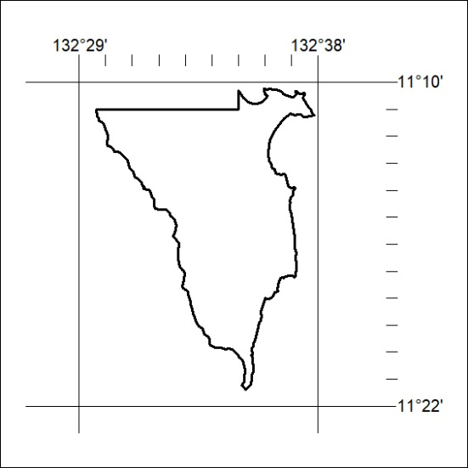

388/23

Mineral Titles Act 2010
NOTICE OF LAND CEASING TO BE A MINERAL TITLE APPLICATION AREA
Title Type and Number: | Exploration Licence 32479
Area Ceased on: | 27 September 2023
Area: | 245 Blocks, 820.60 km²
Locality: | MITCHELL RANGES
Name of Applicant(s)/Holder(s): | 100% ENIGMA MINING LIMITED [ACN. 009 225 558]
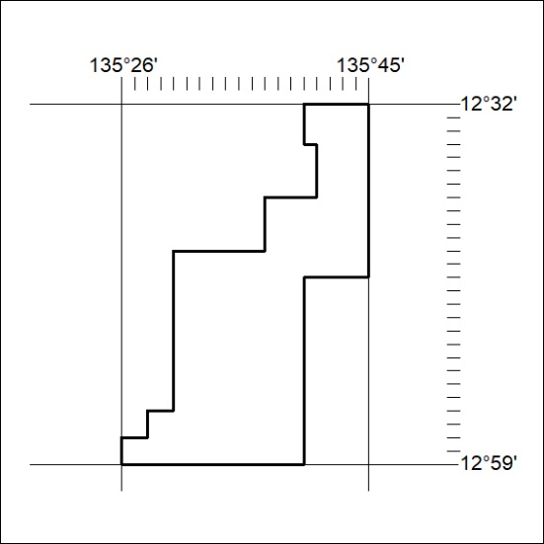

389/23
Mineral Titles Act 2010
NOTICE OF LAND CEASING TO BE A MINERAL TITLE APPLICATION AREA
Title Type and Number: | Exploration Licence 32480
Area Ceased on: | 27 September 2023
Area: | 248 Blocks, 829.54 km²
Locality: | FLEMING
Name of Applicant(s)/Holder(s): | 100% ENIGMA MINING LIMITED [ACN. 009 225 558]
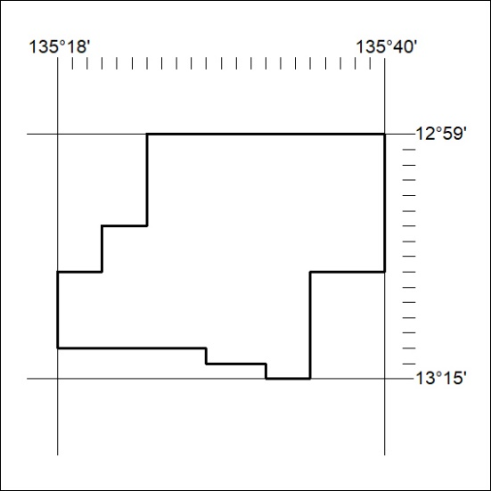

390/23

Mineral Titles Act 2010
NOTICE OF LAND CEASING TO BE A MINERAL TITLE APPLICATION AREA
Title Type and Number: | Exploration Licence 32481
Area Ceased on: | 27 September 2023
Area: | 249 Blocks, 832.09 km²
Locality: | FLEMING
Name of Applicant(s)/Holder(s): | 100% ENIGMA MINING LIMITED [ACN. 009 225 558]
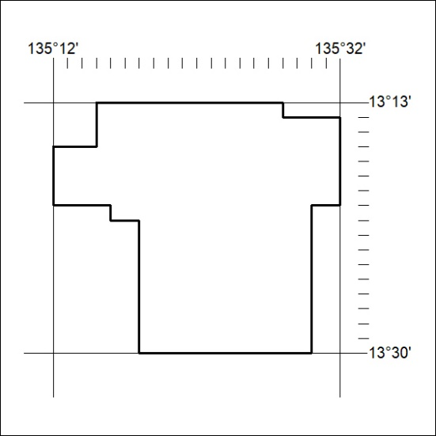

391/23
Mineral Titles Act 2010
NOTICE OF LAND CEASING TO BE A MINERAL TITLE APPLICATION AREA
Title Type and Number: | Exploration Licence 32482
Area Ceased on: | 27 September 2023
Area: | 250 Blocks, 834.80 km²
Locality: | PARSONS
Name of Applicant(s)/Holder(s): | 100% ENIGMA MINING LIMITED [ACN. 009 225 558]
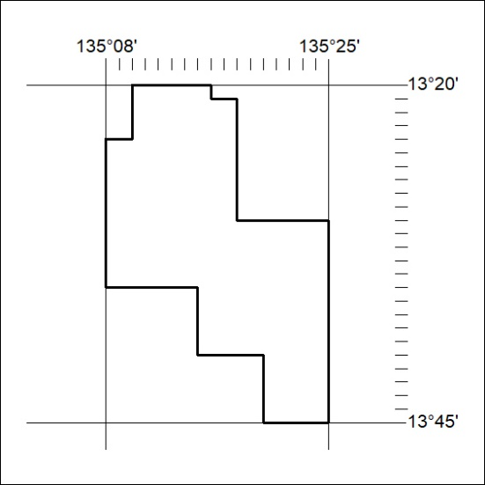

392/23

Mineral Titles Act 2010
NOTICE OF LAND CEASING TO BE A MINERAL TITLE APPLICATION AREA
Title Type and Number: | Exploration Licence 32483
Area Ceased on: | 27 September 2023
Area: | 35 Blocks, 117.08 km²
Locality: | KOOLATONG
Name of Applicant(s)/Holder(s): | 100% ENIGMA MINING LIMITED [ACN. 009 225 558]
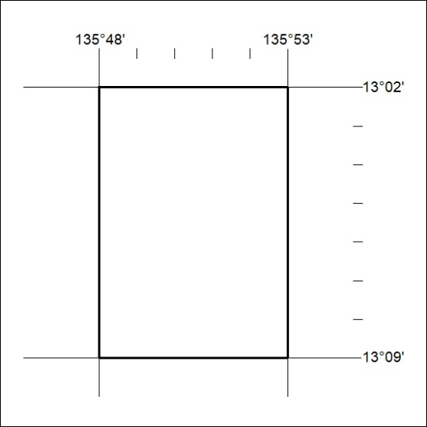

393/23
Mineral Titles Act 2010
NOTICE OF LAND CEASING TO BE A MINERAL TITLE APPLICATION AREA
Title Type and Number: | Exploration Licence 32484
Area Ceased on: | 27 September 2023
Area: | 32 Blocks, 107.06 km²
Locality: | BLANE
Name of Applicant(s)/Holder(s): | 100% ENIGMA MINING LIMITED [ACN. 009 225 558]
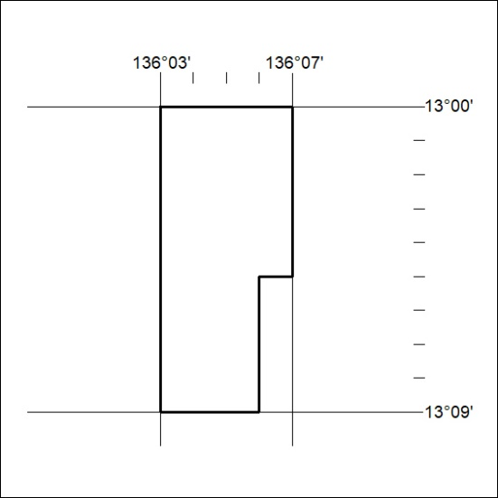

394/23

Mineral Titles Act 2010
NOTICE OF LAND CEASING TO BE A MINERAL TITLE APPLICATION AREA
Title Type and Number: | Exploration Licence 33372
Area Ceased on: | 01 August 2023
Area: | 224 Blocks, 734.81 km²
Locality: | NEWCASTLE WATERS
Name of Applicant(s)/Holder(s): | 100% TERRITORY SANDS PTY LTD [ACN. 632 797 972]
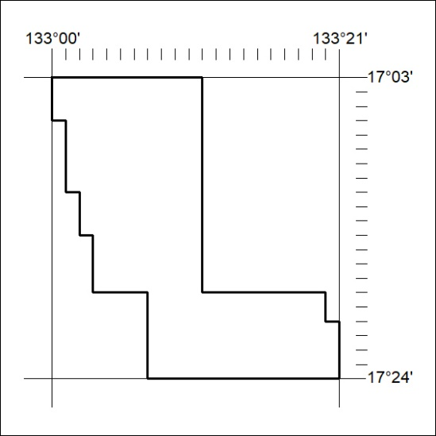

395/23

Mineral Titles Act
NOTICE OF GRANT OF A MINERAL TITLE
Title Type and Number: | Exploration Licence 33388
Granted: | 29 September 2023, for a period of 6 Years
Area: | 6 Blocks, 18.95 km²
Locality: | RIDDOCH
Name of Holder/s: | 100% GEMPART (NT) PTY LTD* [ACN. 081 859 896]
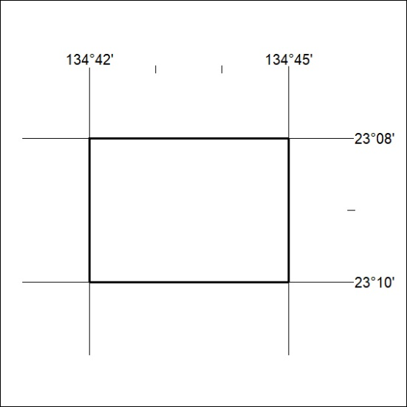
Area granted is indicated above. The titleholder is not permitted to exercise occupational rights on any land that is subject to a development title, or an application for a development title. Any land the subject of a Reserved Land gazettal under the Mineral Titles Act and all land vested in the Commonwealth of Australia is also excluded by description but not excised from the grant area.

396/23

