Mineral Titles Act 2010
NOTICE OF LAND CEASING TO BE A MINERAL TITLE AREA
Title Type and Number: | Exploration Licence 32181
Area Ceased on: | 12 September 2023
Area: | 86 Blocks, 279.58 km²
Locality: | GLYDE
Name of Applicant(s)/Holder(s): | 100% CERBERUS RESOURCES PTY LTD [ACN. 615 192 535]
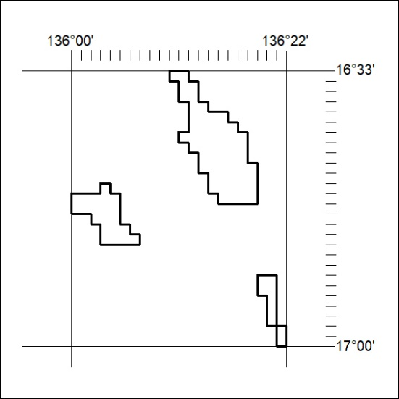

370/23

Mineral Titles Act 2010
NOTICE OF LAND CEASING TO BE A MINERAL TITLE AREA
Title Type and Number: | Exploration Licence 32182
Area Ceased on: | 12 September 2023
Area: | 175 Blocks, 574.68 km²
Locality: | LANCEWOOD
Name of Applicant(s)/Holder(s): | 100% CERBERUS RESOURCES PTY LTD [ACN. 615 192 535]
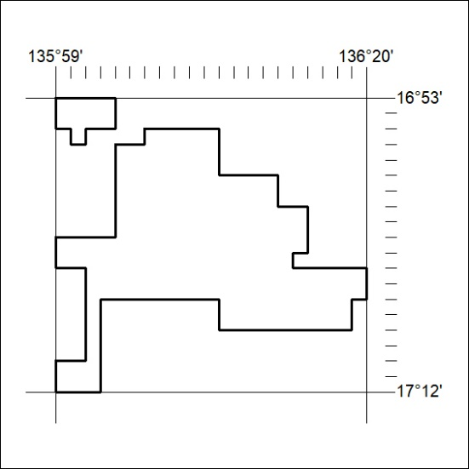

371/23
Mineral Titles Act 2010
NOTICE OF LAND CEASING TO BE A MINERAL TITLE AREA
Title Type and Number: | Exploration Licence 32183
Area Ceased on: | 12 September 2023
Area: | 24 Blocks, 78.50 km²
Locality: | MALLAPUNYAH
Name of Applicant(s)/Holder(s): | 100% CERBERUS RESOURCES PTY LTD [ACN. 615 192 535]
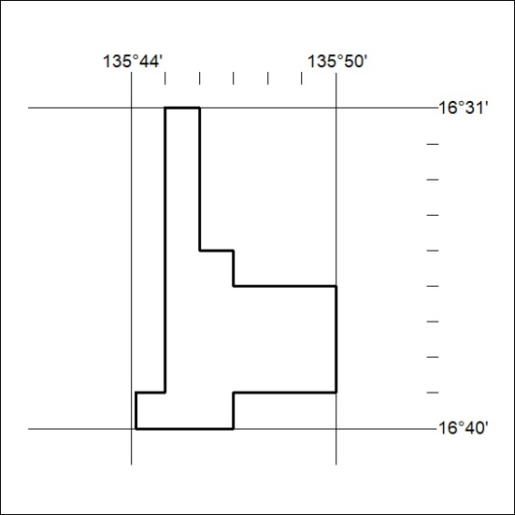

372/23

Mineral Titles Act 2010
NOTICE OF LAND CEASING TO BE A MINERAL TITLE AREA
Title Type and Number: | Exploration Licence 32330
Area Ceased on: | 12 September 2023
Area: | 73 Blocks, 241.14 km²
Locality: | BING BONG
Name of Applicant(s)/Holder(s): | 100% CERBERUS RESOURCES PTY LTD [ACN. 615 192 535]
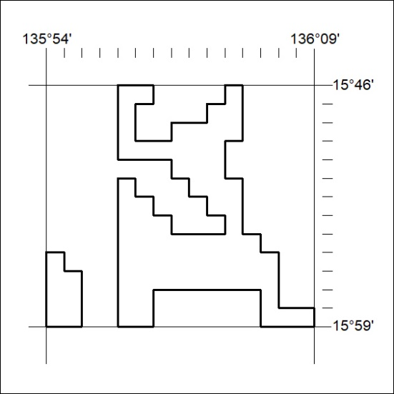

373/23

Mineral Titles Act
NOTICE OF GRANT OF A MINERAL TITLE
Title Type and Number: | Exploration Licence 33470
Granted: | 11 September 2023, for a period of 6 Years
Area: | 20 Blocks, 66.85 km²
Locality: | BATCHELOR
Name of Holder/s: | 100% BACCHUS RESOURCES PTY LTD [ACN. 606 340 872]
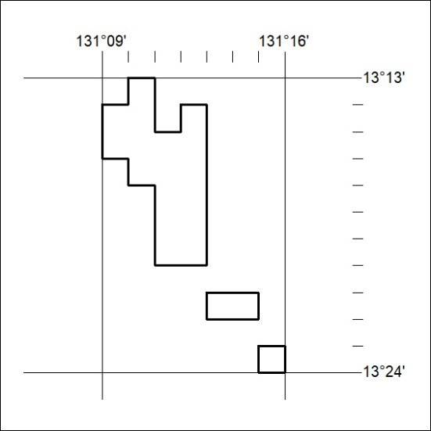
Area granted is indicated above. The titleholder is not permitted to exercise occupational rights on any land that is subject to a development title, or an application for a development title. Any land the subject of a Reserved Land gazettal under the Mineral Titles Act and all land vested in the Commonwealth of Australia is also excluded by description but not excised from the grant area.

374/23

