Mineral Titles Act 2010
NOTICE OF LAND CEASING TO BE A MINERAL TITLE AREA
Title Type and Number: | Exploration Licence 32006
Area Ceased on: | 30 August 2023
Area: | 31 Blocks, 102.00 km²
Locality: | VICTORIA RIVER DOWNS
Name of Applicant(s)/Holder(s): | 100% PENNANT RESOURCES PTY LTD [ACN. 150 501 492]
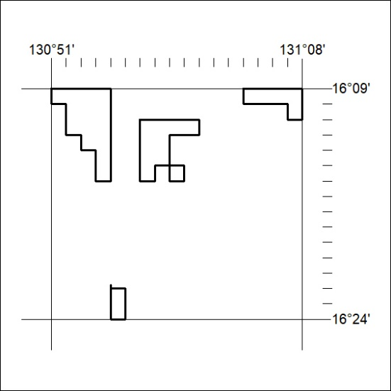

354/23

Mineral Titles Act
NOTICE OF GRANT OF A MINERAL TITLE
Title Type and Number: | Extractive Mineral Exploration Licence 33518
Granted: | 29 August 2023, for a period of 2 Years
Area: | 4 Blocks, 10.71 km²
Locality: | MANBULLOO
Name of Holder/s: | 50% CONNOP Wayne Andrew, 50% NEILSEN Deborah Ann
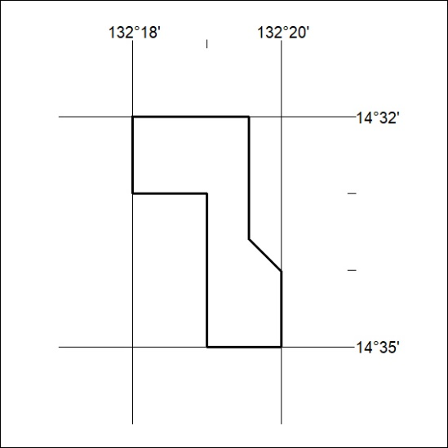
Area granted is indicated above. The titleholder is not permitted to exercise occupational rights on any land that is subject to a development title, or an application for a development title. Any land the subject of a Reserved Land gazettal under the Mineral Titles Act and all land vested in the Commonwealth of Australia is also excluded by description but not excised from the grant area.

355/23

