Thiourea
- Section 87 of the NT Agricultural and Veterinary Chemicals (Control of Use) Act 2004 requires the Chemical Coordinator to provide written directions to stop a specified action when it is necessary to protect the health of the public, the environment or the users of a chemical product, fertiliser or stock food.
- Over the past 20 years the chemical substance Thiourea has been incorrectly used in the NT as a foliar sprayed fertiliser. Given the significant risk and impact to human health and environmental harm to waterways, the foliar use of Thiourea is banned in the Northern Territory.

Classification
- Thiourea is a Schedule 6 Poison – a harmful substances with a moderate potential for causing harm which can be reduced with strong warnings and safety directions on labels. Chem Alert classifies Thiourea an amber level Chemical Substance:
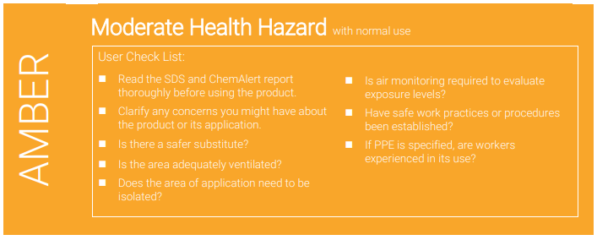

Harm
- Toxicological information is available which indicates that “Thiourea is harmful if swallowed, skin contact may result in drying and defatting of the skin, rash and dermatitis and contact with the eyes may result in irritation, lacrimation, pain and redness. Of particular concern is that Thiourea is carcinogenic in humans and can cause reproductive issues including damaging unborn children”.
- Thioruea is toxic to aquatic life with long lasting effects; the chemical is water soluble and may spread if introduced into water systems. Therefore Thiourea must be prevented from entering drains and waterways.

Offences

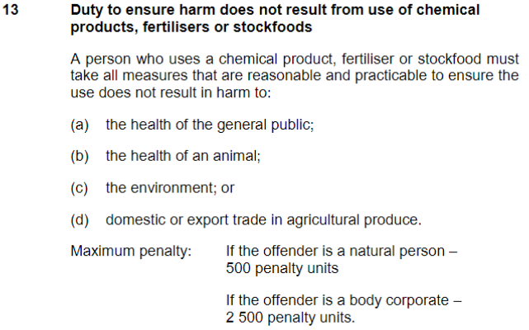
The use and deployment of Thiourea through foliar spray equipment or associated activities constitutes an offence under Section 13 of the Agricultural and Veterinary Chemicals (Control of Use) Act 2004.

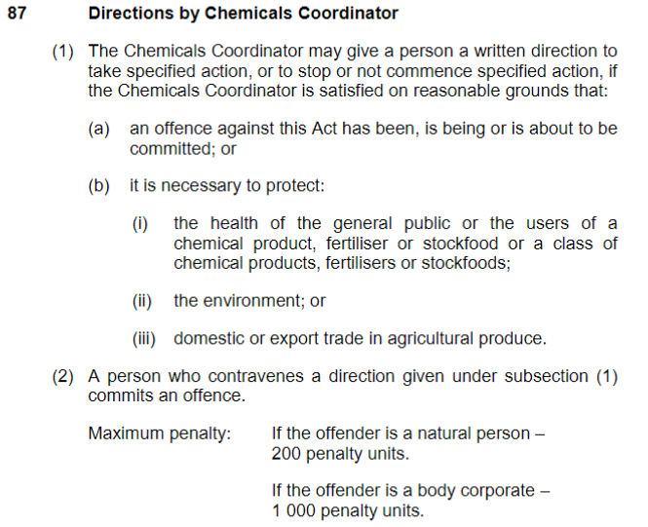
Furthermore a person who contravenes a direction by the Chemical Coordinator commits a further offence under Section 87 of the Agricultural and Veterinary Chemicals (Control of Use) Act 2004.

Further Information
- The attached Safety Data Sheet and Product Label provides further safety and handling information.

Thermo Fisher Product Label and SDS

