Mineral Titles Act 2010
NOTICE OF LAND CEASING TO BE A MINERAL TITLE APPLICATION AREA
Title Type and Number: | Exploration Licence 25771
Area Ceased on: | 01 August 2023
Area: | 2 Blocks, 2.71 km²
Locality: | ADAM
Name of Applicant(s)/Holder(s): | 100% GOLD FX PTY LTD [ACN. 114 195 345]
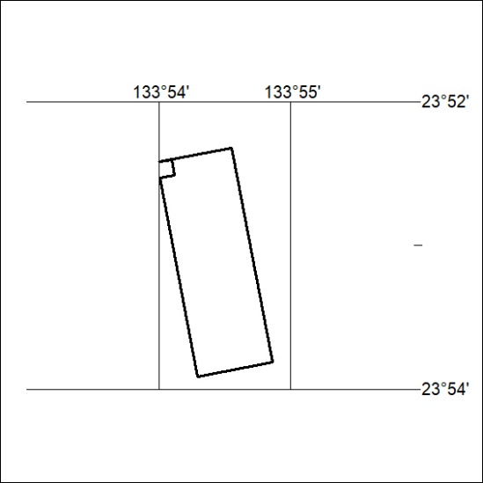

334/23

Mineral Titles Act
NOTICE OF GRANT OF A MINERAL TITLE
Title Type and Number: | Mineral Lease 33107
Granted: | 01 August 2023, for a period of 22 Years
Area: | 164.50 Hectares
Locality: | AILERON
Name of Holder/s: | 100% ARAFURA NOLANS PROJECT PTY LTD* [ACN. 118 158 900]
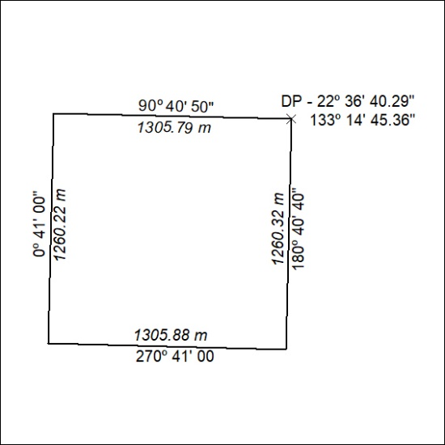

335/23

