Mineral Titles Act 2010
NOTICE OF LAND CEASING TO BE A MINERAL TITLE AREA
Title Type and Number: | Extractive Mineral Exploration Licence 32656
Area Ceased on: | 05 July 2023
Area: | 4 Blocks, 13.12 km²
Locality: | NEWCASTLE WATERS
Name of Applicant(s)/Holder(s): | 100% TERRITORY SANDS PTY LTD [ACN. 632 797 972]
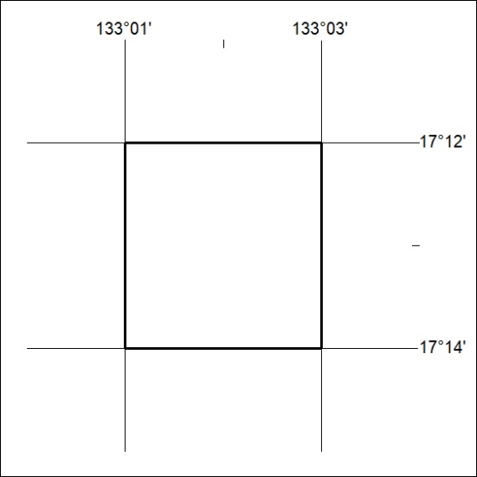

251/23

Mineral Titles Act 2010
NOTICE OF LAND CEASING TO BE A MINERAL TITLE AREA
Title Type and Number: | Extractive Mineral Exploration Licence 32657
Area Ceased on: | 05 July 2023
Area: | 4 Blocks, 13.12 km²
Locality: | NEWCASTLE WATERS
Name of Applicant(s)/Holder(s): | 100% TERRITORY SANDS PTY LTD [ACN. 632 797 972]
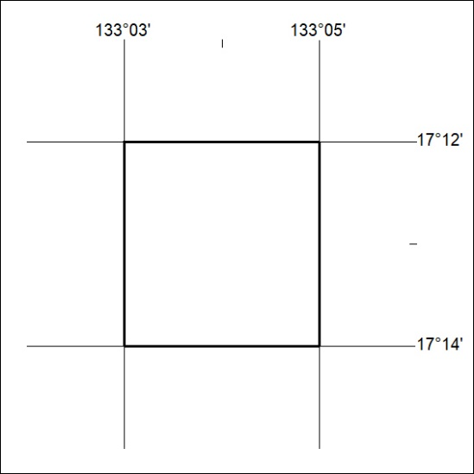

252/23
Mineral Titles Act 2010
NOTICE OF LAND CEASING TO BE A MINERAL TITLE AREA
Title Type and Number: | Extractive Mineral Exploration Licence 32662
Area Ceased on: | 05 July 2023
Area: | 4 Blocks, 13.13 km²
Locality: | MURRANJI
Name of Applicant(s)/Holder(s): | 100% TERRITORY SANDS PTY LTD [ACN. 632 797 972]
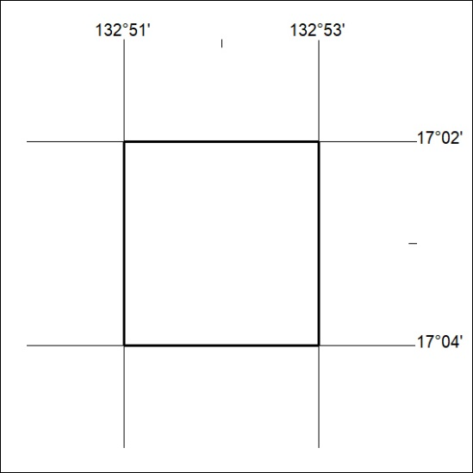

253/23

Mineral Titles Act 2010
NOTICE OF LAND CEASING TO BE A MINERAL TITLE AREA
Title Type and Number: | Extractive Mineral Exploration Licence 32663
Area Ceased on: | 05 July 2023
Area: | 4 Blocks, 13.13 km²
Locality: | MURRANJI
Name of Applicant(s)/Holder(s): | 100% TERRITORY SANDS PTY LTD [ACN. 632 797 972]
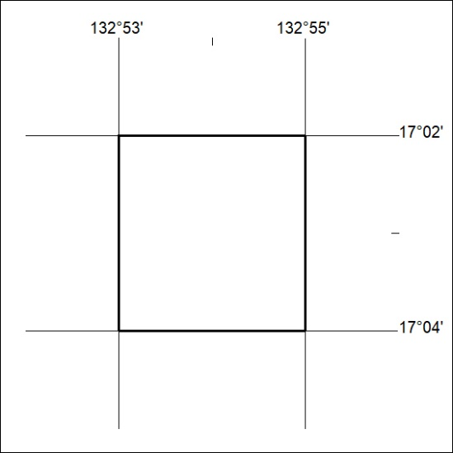

254/23
Mineral Titles Act 2010
NOTICE OF LAND CEASING TO BE A MINERAL TITLE AREA
Title Type and Number: | Exploration Licence 32529
Area Ceased on: | 05 July 2023
Area: | 116 Blocks, 380.10 km²
Locality: | LIMBUNYA
Name of Applicant(s)/Holder(s): | 100% TRANSITION MINERALS LIMITED* [ACN. 641 565 139]
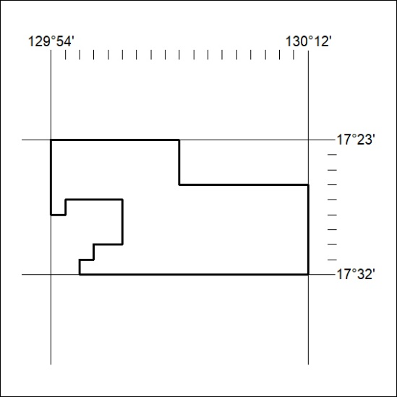

255/23

Mineral Titles Act 2010
NOTICE OF LAND CEASING TO BE A MINERAL TITLE AREA
Title Type and Number: | Exploration Licence 32530
Area Ceased on: | 05 July 2023
Area: | 183 Blocks, 599.30 km²
Locality: | INVERWAY
Name of Applicant(s)/Holder(s): | 100% TRANSITION MINERALS LIMITED* [ACN. 641 565 139]
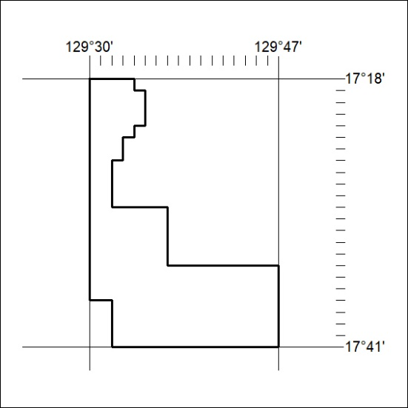

256/23
Mineral Titles Act 2010
NOTICE OF LAND CEASING TO BE A MINERAL TITLE AREA
Title Type and Number: | Exploration Licence 32531
Area Ceased on: | 05 July 2023
Area: | 237 Blocks, 753.63 km²
Locality: | NAPIER
Name of Applicant(s)/Holder(s): | 100% TRANSITION MINERALS LIMITED* [ACN. 641 565 139]
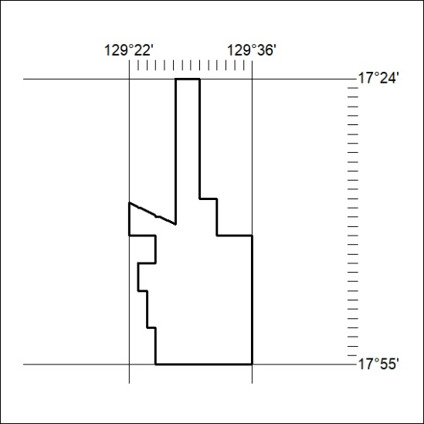

257/23

Mineral Titles Act 2010
NOTICE OF LAND CEASING TO BE A MINERAL TITLE AREA
Title Type and Number: | Exploration Licence 32988
Area Ceased on: | 05 July 2023
Area: | 80 Blocks, 253.11 km²
Locality: | ALCOOTA
Name of Applicant(s)/Holder(s): | 100% JOHANNSEN Lindsay Andrew
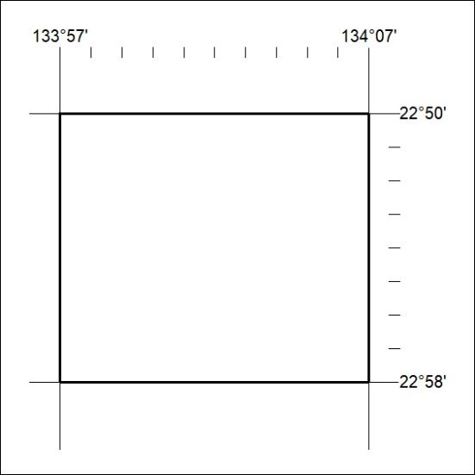

258/23

