Mineral Titles Act 2010
NOTICE OF LAND CEASING TO BE A MINERAL TITLE AREA
Title Type and Number: | Mineral Lease 29855
Area ceased on: | 29 June 2023
Area: | 1464.00 Hectares
Locality: | ANNINGIE
Name of Applicants(s)Holder(s): | 100% ENIGMA MINING LIMITED [ACN. 009 225 558]
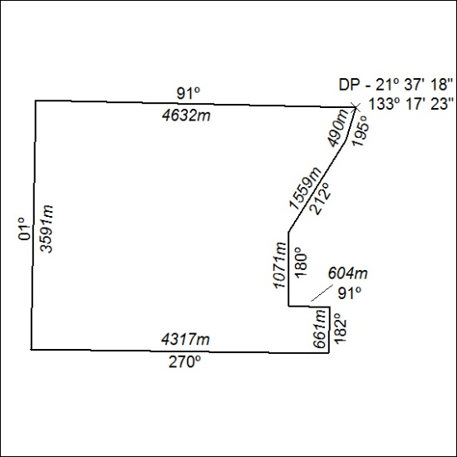

235/23

Mineral Titles Act 2010
NOTICE OF LAND CEASING TO BE A MINERAL TITLE AREA
Title Type and Number: | Mineral Lease 29856
Area ceased on: | 29 June 2023
Area: | 165.00 Hectares
Locality: | ANNINGIE
Name of Applicants(s)Holder(s): | 100% ENIGMA MINING LIMITED [ACN. 009 225 558]
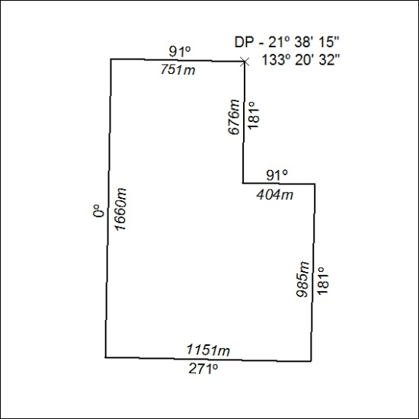

236/23

Mineral Titles Act 2010
NOTICE OF LAND CEASING TO BE A MINERAL TITLE AREA
Title Type and Number: | Mineral Lease 30686
Area ceased on: | 29 June 2023
Area: | 104.00 Hectares
Locality: | HOME OF BULLION
Name of Applicants(s)Holder(s): | 100% ENIGMA MINING LIMITED [ACN. 009 225 558]
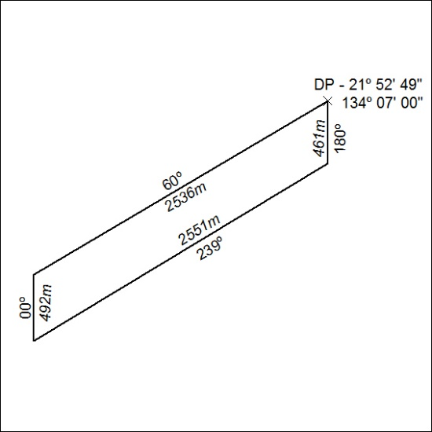

237/23

