Mineral Titles Act
NOTICE OF GRANT OF A MINERAL TITLE
Title Type and Number: | Exploration Licence 33382
Granted: | 15 June 2023, for a period of 6 Years
Area: | 161 Blocks, 471.20 km²
Locality: | YALOOGARRIE
Name of Holder/s: | 100% TERRITORY MINERALS LTD* [ACN. 121 200 299]
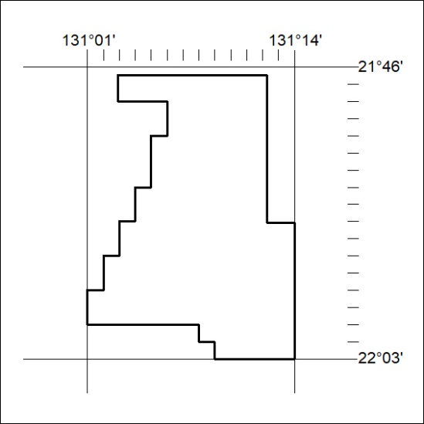
Area granted is indicated above. The titleholder is not permitted to exercise occupational rights on any land that is subject to a development title, or an application for a development title. Any land the subject of a Reserved Land gazettal under the Mineral Titles Act and all land vested in the Commonwealth of Australia is also excluded by description but not excised from the grant area.
214/23

Mineral Titles Act
NOTICE OF GRANT OF A MINERAL TITLE
Title Type and Number: | Exploration Licence 33385
Granted: | 15 June 2023, for a period of 6 Years
Area: | 250 Blocks, 769.40 km²
Locality: | BURT
Name of Holder/s: | 100% TERRITORY MINERALS LTD* [ACN. 121 200 299]
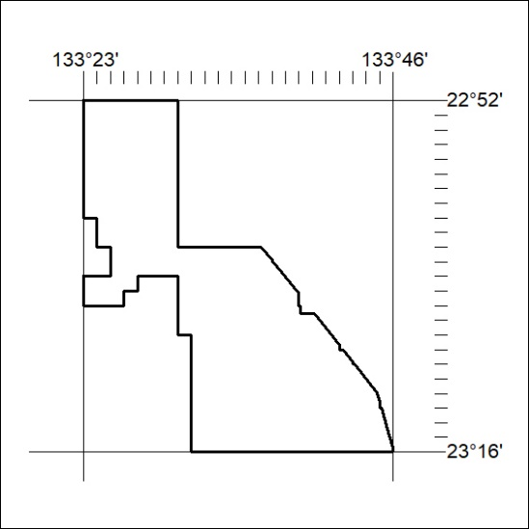
Area granted is indicated above. The titleholder is not permitted to exercise occupational rights on any land that is subject to a development title, or an application for a development title. Any land the subject of a Reserved Land gazettal under the Mineral Titles Act and all land vested in the Commonwealth of Australia is also excluded by description but not excised from the grant area.
215/23

Mineral Titles Act
NOTICE OF GRANT OF A MINERAL TITLE
Title Type and Number: | Exploration Licence 33387
Granted: | 15 June 2023, for a period of 6 Years
Area: | 46 Blocks, 146.40 km²
Locality: | DENISON
Name of Holder/s: | 100% TERRITORY MINERALS LTD* [ACN. 121 200 299]
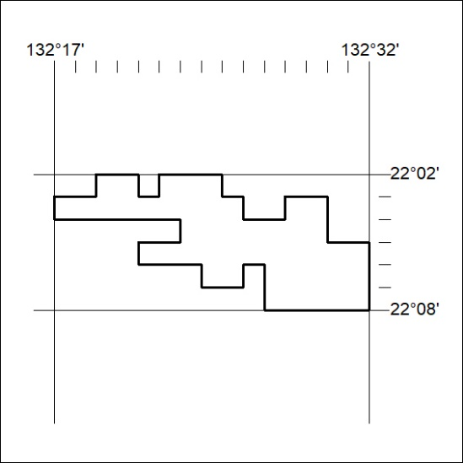
Area granted is indicated above. The titleholder is not permitted to exercise occupational rights on any land that is subject to a development title, or an application for a development title. Any land the subject of a Reserved Land gazettal under the Mineral Titles Act and all land vested in the Commonwealth of Australia is also excluded by description but not excised from the grant area.
216/23

