Mineral Titles Act 2010
NOTICE OF LAND CEASING TO BE A MINERAL TITLE APPLICATION AREA
Title Type and Number: | Exploration Licence 33380
Area Ceased on: | 02 June 2023
Area: | 225 Blocks, 724.50 km²
Locality: | BARRY CAVES
Name of Applicant(s)/Holder(s): | 100% SPARK MINERALS PTY LTD [ACN. 662 906 783]
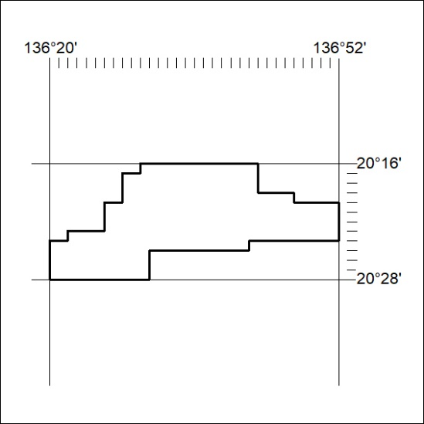

172/23

Mineral Titles Act 2010
NOTICE OF LAND CEASING TO BE A MINERAL TITLE APPLICATION AREA
Title Type and Number: | Exploration Licence 33381
Area Ceased on: | 02 June 2023
Area: | 225 Blocks, 723.84 km²
Locality: | BARRY CAVES
Name of Applicant(s)/Holder(s): | 100% SPARK MINERALS PTY LTD [ACN. 662 906 783]
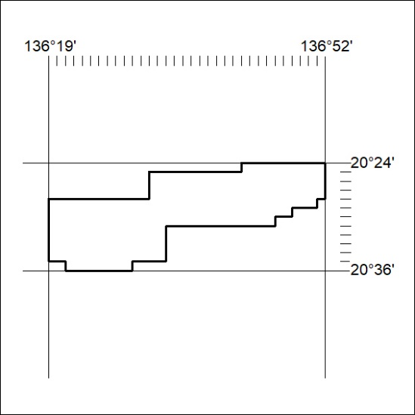

173/23

