Mineral Titles Act 2010
NOTICE OF LAND CEASING TO BE A MINERAL TITLE APPLICATION AREA
Title Type and Number: | Exploration Licence 32083
Area Ceased on: | 16 May 2023
Area: | 64 Blocks, 165.27 km²
Locality: | MARCHIN BAR
Name of Applicant(s)/Holder(s): | 100% MEGA MINES AUSTRALIA PTY LTD [ACN. 629 516 909]
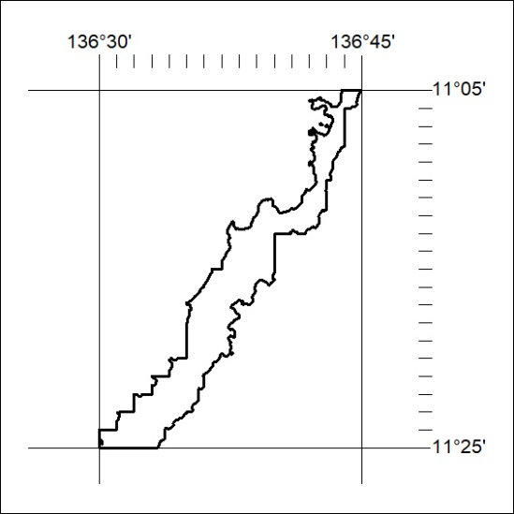

149/23

Mineral Titles Act
NOTICE OF GRANT OF A MINERAL TITLE
Title Type and Number: | Exploration Licence 33001
Granted: | 12 May 2023, for a period of 6 Years
Area: | 231 Blocks, 768.61 km²
Locality: | DALY RIVER
Name of Holder/s: | 100% URO CORPORATION PTY LTD [ACN. 653 927 998]
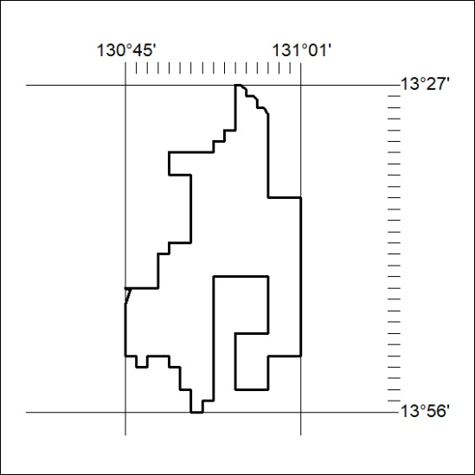
Area granted is indicated above. The titleholder is not permitted to exercise occupational rights on any land that is subject to a development title, or an application for a development title. Any land the subject of a Reserved Land gazettal under the Mineral Titles Act and all land vested in the Commonwealth of Australia is also excluded by description but not excised from the grant area.

150/23

