Mineral Titles Act 2010
NOTICE OF LAND CEASING TO BE A MINERAL TITLE AREA
Title Type and Number: | Exploration Licence 31545
Area Ceased on: | 26 April 2023
Area: | 18 Blocks, 59.31 km²
Locality: | KILLARNEY
Name of Applicant(s)/Holder(s): | 100% WRIGHT Anthony
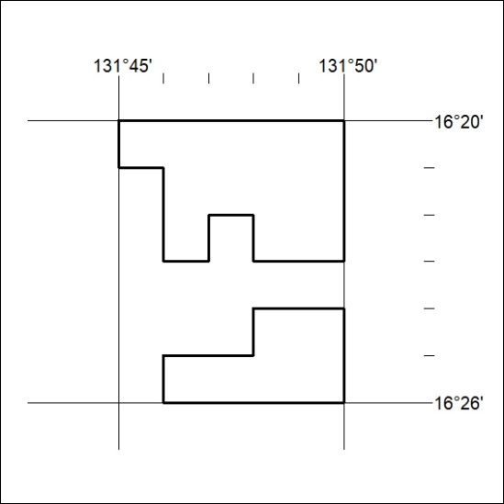

111/23

Mineral Titles Act 2010
NOTICE OF LAND CEASING TO BE A MINERAL TITLE AREA
Title Type and Number: | Exploration Licence 32117
Area Ceased on: | 26 April 2023
Area: | 150 Blocks, 476.34 km²
Locality: | ALGAMBA
Name of Applicant(s)/Holder(s): | 100% ELEMENTZONE PTY LTD [ACN. 633 108 906]
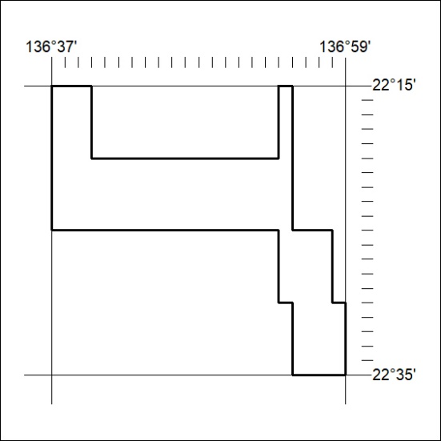

112/23
Mineral Titles Act 2010
NOTICE OF LAND CEASING TO BE A MINERAL TITLE AREA
Title Type and Number: | Exploration Licence 32418
Area Ceased on: | 22 April 2023
Area: | 20 Blocks, 64.87 km²
Locality: | RANFORD HILL
Name of Applicant(s)/Holder(s): | 100% KINGSLAND MINERALS LIMITED [ACN. 647 904 014]
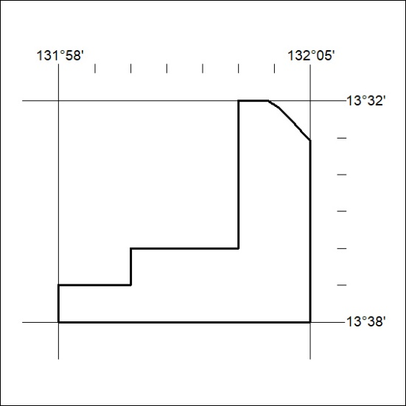

113/23

Mineral Titles Act 2010
NOTICE OF LAND CEASING TO BE A MINERAL TITLE AREA
Title Type and Number: | Mineral Lease 29916
Area ceased on: | 22 April 2023
Area: | 6.00 Hectare
Locality: | PINE CREEK
Name of Applicants(s)Holder(s): | 100% DOHERTY Raymond Francis
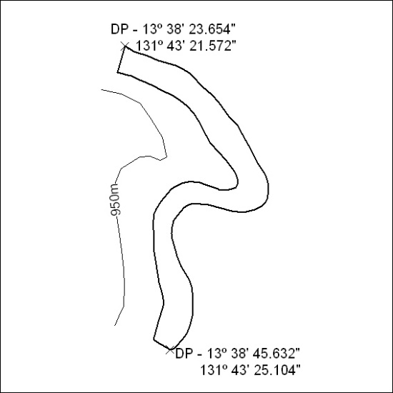

114/23

