Mineral Titles Act
NOTICE OF GRANT OF A MINERAL TITLE
Title Type and Number: | Exploration Licence 32812
Granted: | 24 February 2023, for a period of 6 Years
Area: | 7 Blocks, 23.40 km²
Locality: | McKINLAY RIVER
Name of Holder/s: | 100% BACCHUS RESOURCES PTY LTD [ACN. 606 340 872]
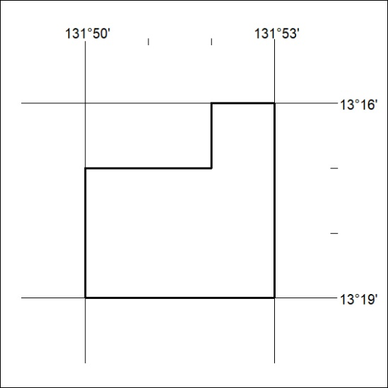
Area granted is indicated above. The titleholder is not permitted to exercise occupational rights on any land that is subject to a development title, or an application for a development title. Any land the subject of a Reserved Land gazettal under the Mineral Titles Act and all land vested in the Commonwealth of Australia is also excluded by description but not excised from the grant area.

061/23

