Mineral Titles Act
NOTICE OF GRANT OF A MINERAL TITLE
Title Type and Number: | Exploration Licence 33273
Granted: | 24 January 2023, for a period of 6 Years
Area: | 113 Blocks, 328.66 km²
Locality: | PELLINORE
Name of Holder/s: | 100% ECOSSAUS LIMITED [ACN. 653 988 419]
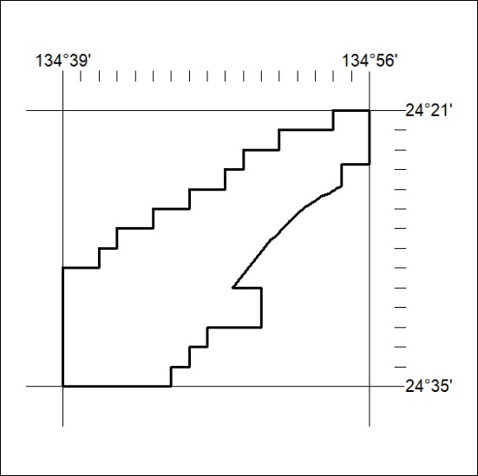
Area granted is indicated above. The titleholder is not permitted to exercise occupational rights on any land that is subject to a development title, or an application for a development title. Any land the subject of a Reserved Land gazettal under the Mineral Titles Act and all land vested in the Commonwealth of Australia is also excluded by description but not excised from the grant area.

027/23

