Mineral Titles Act 2010
NOTICE OF LAND CEASING TO BE A MINERAL TITLE APPLICATION AREA
Title Type and Number: | Exploration Licence 25501
Area Ceased on: | 20 January 2023
Area: | 37 Blocks, 113.86 km²
Locality: | BORROLOOLA
Name of Applicant(s)/Holder(s): | 100% SANDFIRE RESOURCES LIMITED* [ACN. 105 154 185]
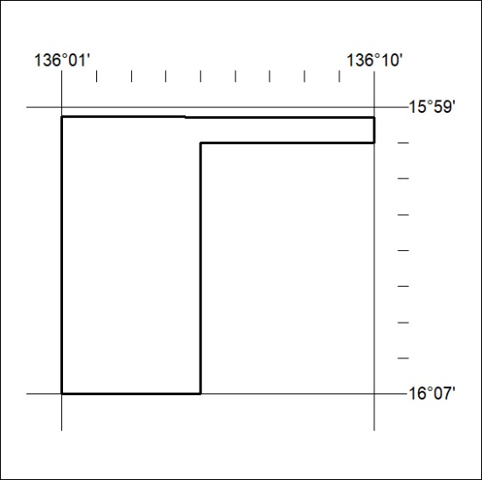

024/23

Mineral Titles Act 2010
NOTICE OF LAND CEASING TO BE A MINERAL TITLE APPLICATION AREA
Title Type and Number: | Exploration Licence 26299
Area Ceased on: | 20 January 2023
Area: | 52 Blocks, 154.13 km²
Locality: | BORROLOOLA
Name of Applicant(s)/Holder(s): | 100% SANDFIRE RESOURCES LIMITED* [ACN. 105 154 185]
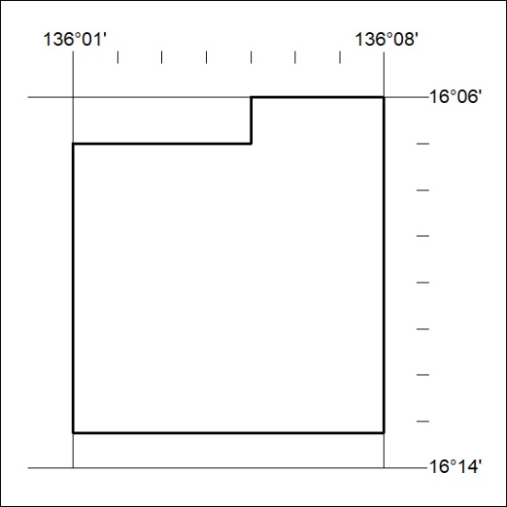

025/23

Mineral Titles Act
NOTICE OF GRANT OF A MINERAL TITLE
Title Type and Number: | Exploration Licence 33225
Granted: | 03 January 2023, for a period of 6 Years
Area: | 26 Blocks, 80.86 km²
Locality: | TIPPERARY
Name of Holder/s: | 100% MANGUSTA MINERALS PTY LTD [ACN. 653 950 522]
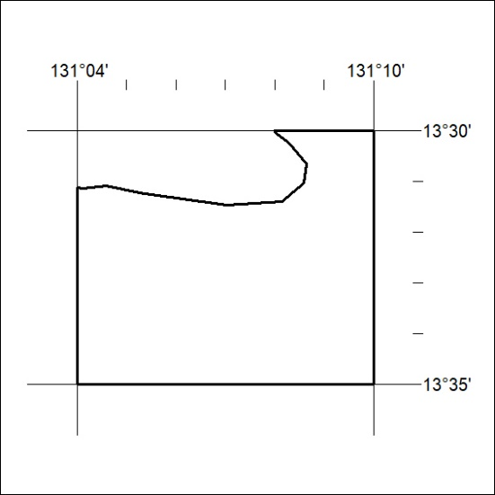
Area granted is indicated above. The titleholder is not permitted to exercise occupational rights on any land that is subject to a development title, or an application for a development title. Any land the subject of a Reserved Land gazettal under the Mineral Titles Act and all land vested in the Commonwealth of Australia is also excluded by description but not excised from the grant area.

026/23

