Mineral Titles Act 2010
NOTICE OF LAND CEASING TO BE A MINERAL TITLE AREA
Title Type and Number: | Exploration Licence 32506
Area Ceased on: | 26 May 2022
Area: | 10 Blocks, 31.58 km²
Locality: | QUARTZ
Name of Applicant(s)/Holder(s): | 100% GUNDERSEN Patrick Boschmans
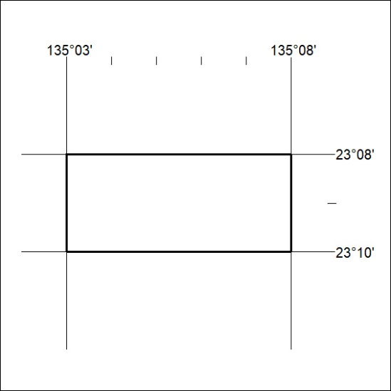
(Area now divided into Exploration Licence 33228 under s101 – EL moratorium period does not apply)

171/22

Mineral Titles Act
NOTICE OF GRANT OF A MINERAL TITLE
Title Type and Number: | Extractive Mineral Exploration Licence 32953
Granted: | 30 May 2022, for a period of 2 Years
Area: | 4 Blocks, 13.36 km²
Locality: | McKINLAY RIVER
Name of Holder/s: | 100% TANK BIZ PTY LTD [ACN. 155 050 749]
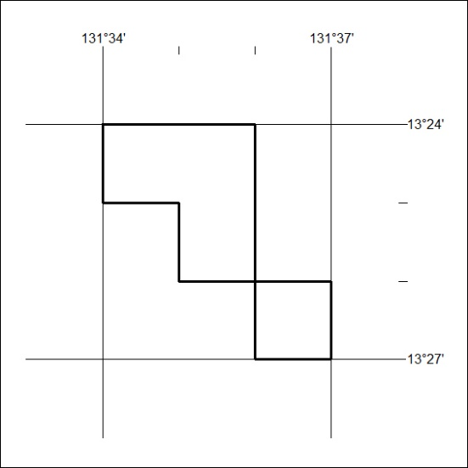
Area granted is indicated above. The titleholder is not permitted to exercise occupational rights on any land that is subject to a development title, or an application for a development title. Any land the subject of a Reserved Land gazettal under the Mineral Titles Act and all land vested in the Commonwealth of Australia is also excluded by description but not excised from the grant area.

172/22

