Mineral Titles Act 2010
NOTICE OF LAND CEASING TO BE A MINERAL TITLE AREA
Title Type and Number: | Extractive Mineral Permit 29568
Area ceased on: | 14 December 2021
Area: | 8.00 Hectare
Locality: | BYNOE
Name of Applicants(s)Holder(s): | 100% RISK William Maxwell
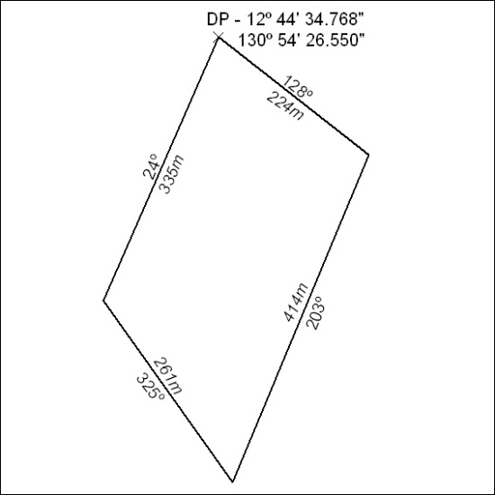

471/21

Mineral Titles Act 2010
NOTICE OF LAND CEASING TO BE A MINERAL TITLE AREA
Title Type and Number: | Mineral Lease 30676
Area ceased on: | 09 December 2021
Area: | 226.00 Hectares
Locality: | ALEXANDRIA
Name of Applicants(s)Holder(s): | 100% NORTHERN CEMENT LIMITED [ACN. 009 593 515]
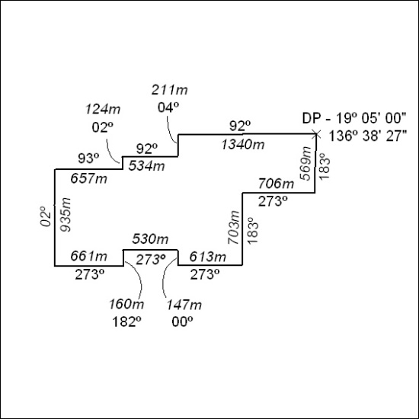

472/21

