Mineral Titles Act 2010
NOTICE OF LAND CEASING TO BE A MINERAL TITLE APPLICATION AREA
Title Type and Number: | Exploration Licence 32817
Area Ceased on: | 03 December 2021
Area: | 4 Blocks, 10.73 km²
Locality: | DALMORE
Name of Applicant(s)/Holder(s): | 100% BARKLY OPERATIONS PTY LTD [ACN. 641 856 706]
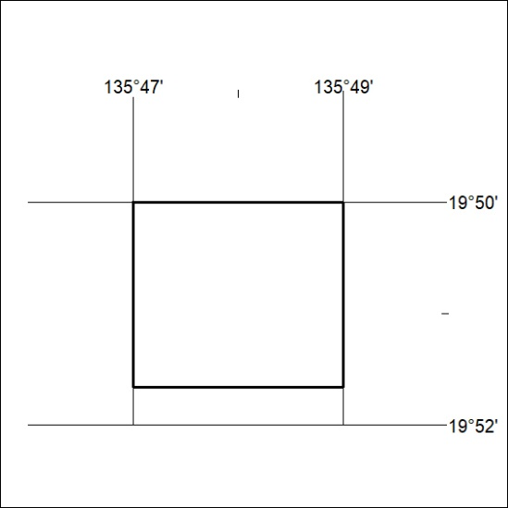

444/21

Mineral Titles Act 2010
NOTICE OF LAND CEASING TO BE A MINERAL TITLE APPLICATION AREA
Title Type and Number: | Exploration Licence 32818
Area Ceased on: | 03 December 2021
Area: | 4 Blocks, 12.94 km²
Locality: | WONARAH
Name of Applicant(s)/Holder(s): | 100% BARKLY OPERATIONS PTY LTD [ACN. 641 856 706]
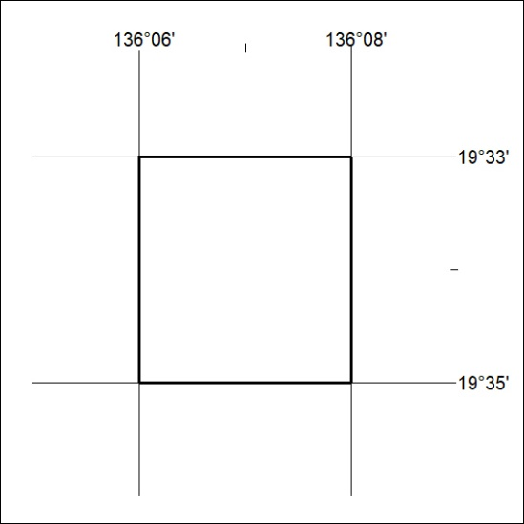

445/21
Mineral Titles Act 2010
NOTICE OF LAND CEASING TO BE A MINERAL TITLE APPLICATION AREA
Title Type and Number: | Exploration Licence 32819
Area Ceased on: | 03 December 2021
Area: | 4 Blocks, 12.95 km²
Locality: | WONARAH
Name of Applicant(s)/Holder(s): | 100% BARKLY OPERATIONS PTY LTD [ACN. 641 856 706]
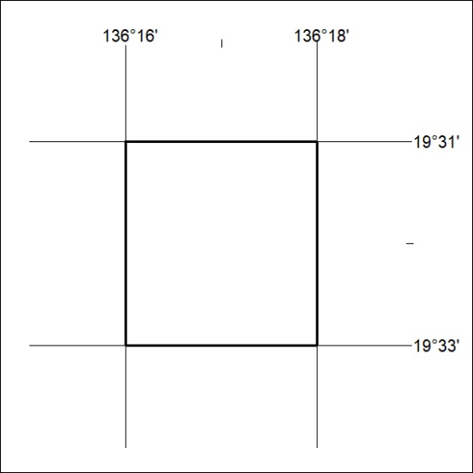

446/21

Mineral Titles Act 2010
NOTICE OF LAND CEASING TO BE A MINERAL TITLE APPLICATION AREA
Title Type and Number: | Exploration Licence 32822
Area Ceased on: | 03 December 2021
Area: | 8 Blocks, 25.95 km²
Locality: | ALROY
Name of Applicant(s)/Holder(s): | 100% MLM DRILLING PTY LTD [ACN. 130 013 562]
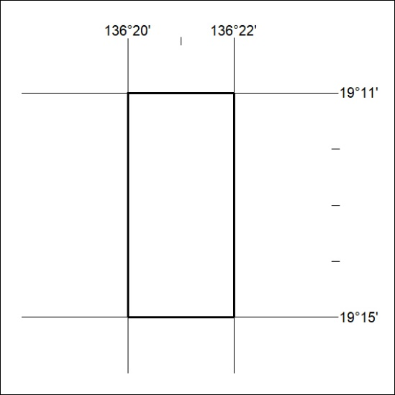

447/21

Mineral Titles Act
NOTICE OF GRANT OF A MINERAL TITLE
Title Type and Number: | Exploration Licence 32249
Granted: | 30 November 2021, for a period of 6 Years
Area: | 165 Blocks, 509.84 km²
Locality: | CURTIN
Name of Holder/s: | 100% TERRITORY POTASH PTY LTD* [ACN. 116 070 207]
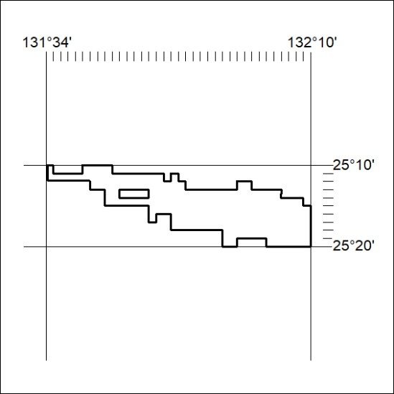
Area granted is indicated above. The titleholder is not permitted to exercise occupational rights on any land that is subject to a development title, or an application for a development title. Any land the subject of a Reserved Land gazettal under the Mineral Titles Act and all land vested in the Commonwealth of Australia is also excluded by description but not excised from the grant area.
448/21

Mineral Titles Act
NOTICE OF GRANT OF A MINERAL TITLE
Title Type and Number: | Exploration Licence 32250
Granted: | 30 November 2021, for a period of 6 Years
Area: | 173 Blocks, 537.05 km²
Locality: | ANGAS
Name of Holder/s: | 100% TERRITORY POTASH PTY LTD* [ACN. 116 070 207]
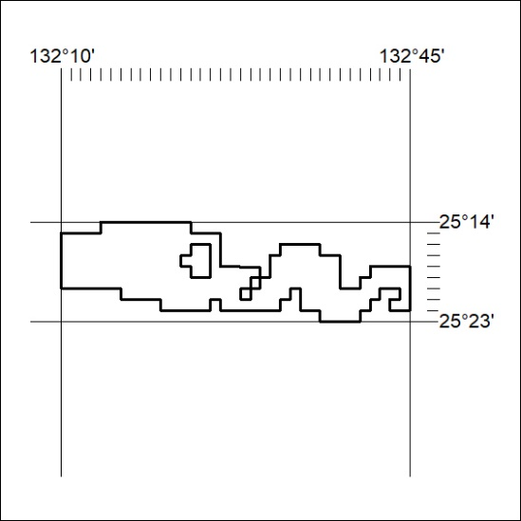
Area granted is indicated above. The titleholder is not permitted to exercise occupational rights on any land that is subject to a development title, or an application for a development title. Any land the subject of a Reserved Land gazettal under the Mineral Titles Act and all land vested in the Commonwealth of Australia is also excluded by description but not excised from the grant area.
449/21

Mineral Titles Act
NOTICE OF GRANT OF A MINERAL TITLE
Title Type and Number: | Exploration Licence 32251
Granted: | 30 November 2021, for a period of 6 Years
Area: | 20 Blocks, 62.08 km²
Locality: | EBENEZER
Name of Holder/s: | 100% TERRITORY POTASH PTY LTD* [ACN. 116 070 207]
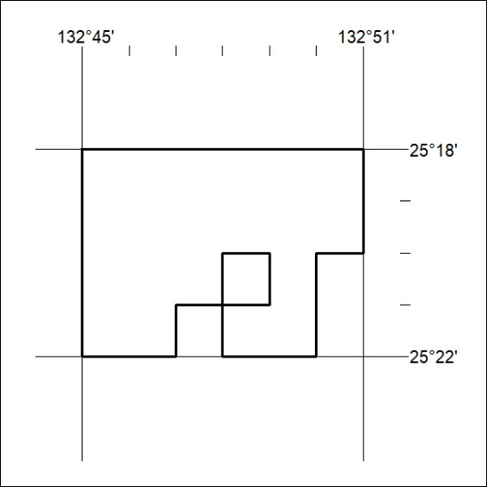
Area granted is indicated above. The titleholder is not permitted to exercise occupational rights on any land that is subject to a development title, or an application for a development title. Any land the subject of a Reserved Land gazettal under the Mineral Titles Act and all land vested in the Commonwealth of Australia is also excluded by description but not excised from the grant area.
450/21

