Mineral Titles Act
NOTICE OF GRANT OF A MINERAL TITLE
Title Type and Number: | Exploration Licence 32344
Granted: | 28 October 2020, for a period of 6 Years
Area: | 211 Blocks, 669.17 km²
Locality: | DAVENPORT RANGE
Name of Holder/s: | 100% TREASURE CREEK PTY LTD [ACN. 619 057 644]
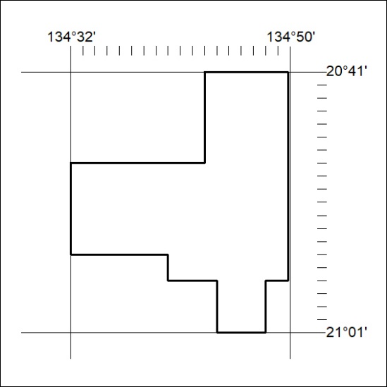
Area granted is indicated above. The titleholder is not permitted to exercise occupational rights on any land that is subject to a development title, or an application for a development title. Any land the subject of a Reserved Land gazettal under the Mineral Titles Act and all land vested in the Commonwealth of Australia is also excluded by description but not excised from the grant area.
353/20

Mineral Titles Act
NOTICE OF GRANT OF A MINERAL TITLE
Title Type and Number: | Exploration Licence 32345
Granted: | 28 October 2020, for a period of 6 Years
Area: | 157 Blocks, 502.92 km²
Locality: | MURRAY DOWNS
Name of Holder/s: | 100% TREASURE CREEK PTY LTD [ACN. 619 057 644]
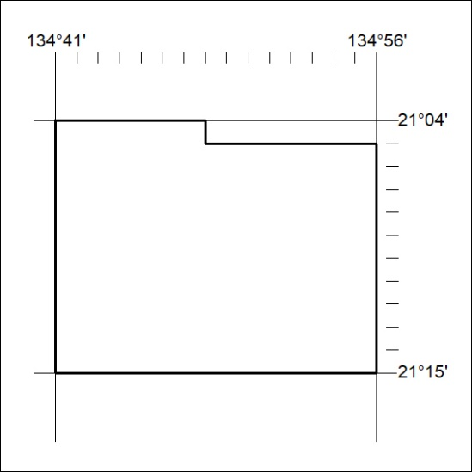
Area granted is indicated above. The titleholder is not permitted to exercise occupational rights on any land that is subject to a development title, or an application for a development title. Any land the subject of a Reserved Land gazettal under the Mineral Titles Act and all land vested in the Commonwealth of Australia is also excluded by description but not excised from the grant area.
354/20

