Cover crops are an essential part of best management practice for horticultural cropping systems in the Northern Territory, particularly in the Top End. They are typically grown during the wet season to protect soil from erosion and to improve the structure, chemistry and biological health of soils. The selection of cover crops is dependent on the desired outcomes with different species providing different benefits to soil health and the management of natural resources.

Benefits
Soils in the Top End typically have poor structure. If left exposed to tropical rainfall events, without sufficient ground cover, erosion and further loss of structure can result. The use of cover crops limits erosion and improves the structure of soil leading to greater aeration and less compaction. They also support higher populations of beneficial microorganisms, reducing the severity and prevalence of soil-borne pests and diseases.
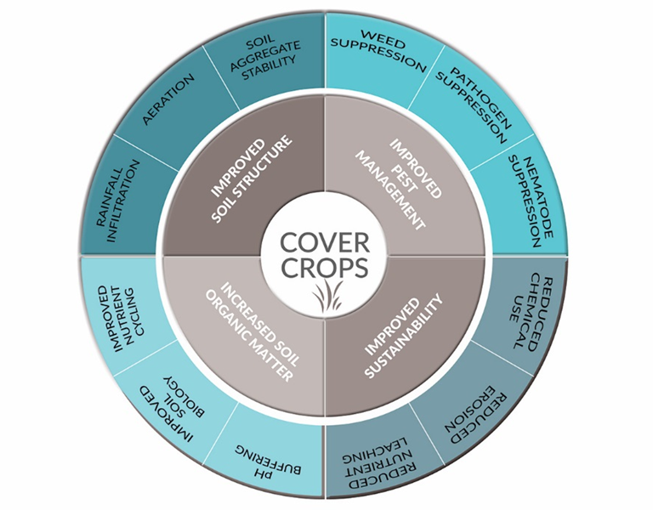
Cover crops which have a deep root system are able to recover nutrients which have been leached below the rooting zone of crops. These nutrients are recycled when the cover crop is mulched into the soil prior to the next cropping cycle. Legumes can also be used to increase soil nitrogen levels but they will return less biomass to the soil when compared to millet or sorghum.
A teaspoon of soil can contain billions of micro-organisms living in complex, dynamic relationships with each other. Changes to the soil through increased carbon, aeration and filtration affect the micro-organisms living within the soil. As such, soil health is something that should be checked and re-adjusted every few years.

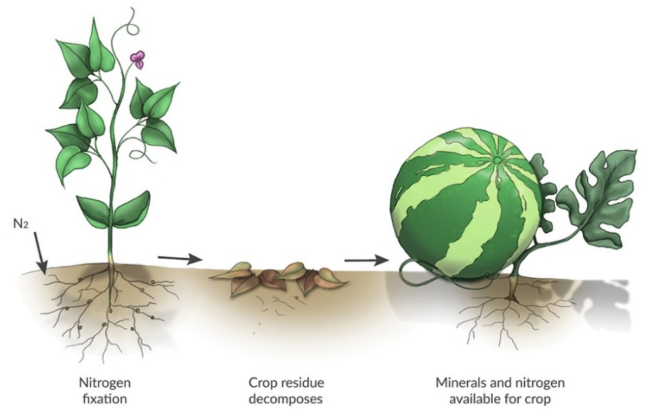

Selecting cover crops
To achieve the maximum benefits from planting cover crops, they must be an essential part of your cropping system. There are three broad types of cover crops appropriate for the Northern Territory, (i) those which produce large amounts of organic matter, such as millet and sorghum, (ii) legumes which improve soil fertility by adding nitrogen, such as lab-lab and cowpea, and (iii) a mixture of species where a number of seeds are sown to provide a range of desirable characteristics, such as combined plantings of millet and lab-lab.

Types
Pearl millet and sorghum are typically recommended for horticultural purposes in the Top End as they provide a high level of biomass.
A number or sorghum hybrids such as Jumbo are nematode resistant, so where nematodes are a problem, their numbers may be supressed by the use of these plants within crop rotations.

Millet
Katherine and Ingrid pearl millet are more drought tolerant than forage sorghum but cannot tolerate prolonged periods of waterlogging. Early growth is typically slow and flowering occurs earlier than sorghum towards the end of the wet season.
Seeds are viable and can become a weed if the cover crop is not incorporated early enough. The cover crop should also be slashed to promote subsequent growth and help to reduce the thickening of stems. Cover crops of millet can produce 8-15 t/ha dry matter depending on nitrogen inputs.

Sorghum
Forage sorghum is typically fast growing and late flowing in the Top End. It can be slashed several times before incorporation. It has excellent regrowth following slashing and can yield 8-15 t/ha dry matter depending on nitrogen inputs. Visit our YouTube channel to see a video on jumbo Sorghum in the Top End.
It is recommend that slashing occurs to prevent the stem from getting thick and woody, which can cause difficulties during decomposition of the residue. It can tolerate short periods of waterlogging which is a desirable characteristic during monsoonal periods.
Legumes
Legumes which are well suited to the wet season include lab-lab, dolichos pea and cowpea. These plants are able to increase soil nitrogen levels but produce a lower amount of biomass compared to higher biomass crops such as millet and sorghum.
Lab-lab will set seed in May, which is not an issue if the crop is incorporated in March/April. It can produce 5-7 t/ha dry matter, while cowpea yields between 3-4 t/ha dry matter. Plants should be slashed during the wet season when conditions permit. One of the advantages of climbing legumes is that when they are planted in a mixed cover crop, they can use taller plants such as millet for support. Non-climbing legumes such as clover cannot compete in a mixed cover crop where taller more vigorous crops such as millet outperform and smother plants.

Caliente
Caliente is used in Southern Australia and is a newer biofumigant cover crop which is starting to be used in the Top End by vegetable growers to return high levels of biomass to the soil and to supress soil-borne pests and diseases.
The leaves and stem contain a group of compounds known as glucosinolates. When the crop is chopped and incorporated into the soil, glucosinolates are converted to isothiocyanates which can control numerous crop pests including nematodes, disease causing pathogens and weeds. This process suppresses microorganisms in general, including those that are beneficial. Short-term targeted use of this crop to suppress disease levels is ideal. However prolonged use can cause a build-up of toxic compounds in the soil which may affect plant growth.
Mixed
Mixed species cover crops can provide improved benefits to the soil. Cover crops with desirable traits can be selected for specific outcomes. As a result, superior outcomes can be attained when compared to a single species cover crop. For example, millet can be sown to produce high biomass, while a climbing legume such as lab-lab can be used to fix atmospheric nitrogen. The disadvantage of this approach is that multiple passes of seeding machinery may be required to account for differences in seed size. i.e., millet versus lab-lab.
See the following page for relative ranking of cover crops for specific outcomes (1 = some benefit, 2 = good benefit, 3 = excellent benefit).*
Crop | Improve soil structure | Soil pest and disease suppression | Recycle and store leached nutrients | Weed control | Prevent erosion | Add nitrogen
Peal millet | 3 | 2 | 3 | 3 | 3 | 1
Forage sorghum | 3 | 3 | 3 | 3 | 3 | 1
Lab-lab | 1 | 1 | 1 | 2 | 2 | 3
Caliente | 2 | 3 | 2 | 2 | 2 | 1
Mixed (millet, lab-lab) | 3 | 3 | 3 | 3 | 3 | 3

*Ranking targets the system as a whole, it doesn’t take into account the complex interactions between different types of micro-organisms and is not specific to a specific organism, but rather general soil health.

Sowing and management
Crops should be sown after early rains by deep ripping to 40-50 cm and then cultivating soil to a coarse texture. During December/January sow seeds into moist soil when the early monsoon rains are imminent.
Crop | Soil | Sowing (kg/ha) | Ease of establishment | Management advantages | Management challenges | Potential dry biomass (t/ha)
Pearl millet | Cannot tolerate prolonged water logging | 8-12 | Small seed need moist seedbed for successful establishment  Easy to broadcast, may need special small seed machinery | Tolerant of dry conditions after establishment | Goes to seed before sorghum  Must be cut to prevent thick stems | ≤ 15
Forage sorghum | Most soils | 10-20 | Seed size suits most machinery | Late seeding and easy to grow | Will develop thick stalks at low densities | ≤ 15
Lab-lab | Most soils | 15-20 | Fresh inoculum needed for best results | Tolerance to periods of heat and moisture stress | Birds can eat seed and seedlings at planting | ≤ 7
Caliente | Cannot tolerate water logging | 10-15 | Similar seed size to millet | Control of soil borne pests and diseases through a process of biofumigation of soil when incorporated | Must be immediately incorporated into soil to achieve the maximum benefit from biofumigant properties | ≤ 8

Contact us
Dr Matt Hall
Department of Primary Industry and Resources
Darwin
Phone: +61 8 8999 2043
Email: matt.hall@nt.gov.au
Dr Danilo Guinto
Department of Primary Industry and Resources
Katherine
Phone: +61 8 8993 9735
Email: danilo.guinto@nt.gov.au
Website: dpir.nt.gov.au
YouTube: dpir.nt.gov.au/youtube

