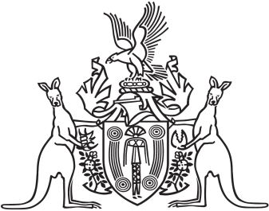
Northern Territory of Australia

Government Gazette
ISSN-0157-833X
No. S110 20 December 2018
Assent to Proposed Law
Her Honour the Administrator has declared assent to the following proposed law:
5 December 2018
Births, Deaths and Marriages Registration and Other Legislation Amendment Act 2018 (Act No. 30 of 2018).
Michael Tatham
Clerk of the Legislative Assembly
20 December 2018

