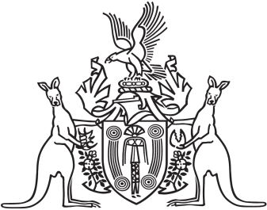
Northern Territory of Australia

Government Gazette
ISSN-0157-833X
No. S101 11 December 2018
Northern Territory of Australia

Interpretation Legislation Amendment Act 2018
Commencement Notice
I, Vicki Susan O'Halloran, Administrator of the Northern Territory of Australia, under section 2 of the Interpretation Legislation Amendment Act 2018 (No. 22 of 2018), fix the day on which this notice is published in the Gazette as the day on which the Act, other than Part 2 and sections 19, 20, 25, 26 and 27, commences.
Dated 22 November 2018
V. S. O'Halloran
Administrator

