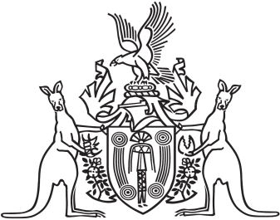

Northern Territory of Australia

Government Gazette

ISSN-0157-833X

No. S97 5 December 2018

Resolution authorising transfer of property of an association 